

**MINISTRY OF EDUCATION AND TRAINING**

**FPT UNIVERSITY**

Capstone Project Document

**Build an Information Management System for a datacenter**

|  |  |
| --- | --- |
| **Group 1** | |
| **Group members** | Lê Thị Thu Hà – SE60943  Huỳnh Lâm Hà Tiên – SE60932  Cao Hồng Nam – SE61061 – Dropped out  Huỳnh Hiếu Bảo– SE60708 – Dropped out |
| **Supervisor** | Ngô Đăng Hà An |
| **Ext. Supervisor** | N/A |
| **Capstone Project Code** | IMS |

- Ho Chi Minh City, 05 April 2016 -

This page is intentionally left blank

Table of Contents

Table of Contents 3

List of Tables 8

List of Figures 11

Definitions, Acronyms, and Abbreviations 15

A. Introduction 16

1. Project Information 16

2. Introduction 16

3. Current Situation 16

4. Problem Definition 16

5. Proposed Solution 17

5.1. Feature functions 17

5.2. Advantages and disadvantages 17

6. Functional Requirements 18

7. Roles and Responsibility 19

B. Software Project Management Plan 20

1. Problem Definition 20

1.1. Name of this Capstone Project 20

1.2. Problem Abstract 20

1.3. Project Overview 20

2. Project organization 23

2.1. Software Process Model 23

2.2. Roles and responsibilities 24

2.3. Tools and Techniques 25

3. Project Management Plan 25

3.1. Software development life cycle 25

3.2. Phase Detail 26

3.3. All Meeting Minutes 27

4. Coding Convention 27

C. Software Requirement Specification 29

1. User Requirement Specification 29

1.1. Guest requirement 29

1.2. Customer requirement 29

1.3. Staff requirement 29

1.4. Manager requirement 30

2. System Requirement Specification 31

2.1. External Interface Requirement 31

2.2. System Overview Use Case 31

2.3. List of Use Case 33

3. Software System Attribute 134

3.1. Usability 134

3.2. Reliability 134

3.3. Availability 134

3.4. Security 134

3.5. Maintainability 134

3.6. Portability 134

3.7. Performance 134

4. Conceptual Diagram 135

D. Software Design Description 137

1. Design Overview 137

2. System Architecture Design 138

2.1. Web Application architecture description 138

3. Component Diagram 139

4. Detailed Description 140

4.1. Class Diagram 140

4.2. Class Diagram Explanation 143

4.3. Interactive Diagram 155

5. User Interface Design 213

5.1 User Login 213

5.2 Order A Product 214

5.3 Add to cart a product 214

5.4 Check cart 215

5.5 View information in cart 216

5.6 Confirm order 217

5.7 Add customer information to order 218

5.8 View order list 219

5.9 Staff add product to order 220

5.10 Add customer to order 221

5.11 Check out with new customer 222

5.12 View input bill list 223

5.13 Add new input bill 224

5.14 View input material list 225

5.15 View input material detail 226

5.16 Add new input material 227

5.17 Review income by time 229

5.18 Review income weekly detail 230

5.19 VAT Tax Declaration – Appendix 1 231

6. Database Design 233

6.1 Entity relationship diagram 233

6.2 Entity Dictionary 235

7. Algorithms 248

7.1 Order State 248

E. 番５のレポート。システムの展開とテスト 250

1. はじめに 250

1.1 概要 250

1.2 テストアプローチ 250

2. データベース関係ダイアグラム 250

2.1 ウェブアプリケーション物理的なダイアグラム 250

2.2 ウェブアプリケーションデータ辞書 252

3. パフォーマンス対策 271

3.1 製品検索、メンバーのパフォーマンス 271

3.2 送り状リストが展示されるパフォーマンス 271

3.3 収入統計など展示されるパフォーマンス 271

4. テスト計画 271

4.1 テストする機能 271

4.2 テストされない機能 272

5. システムテストのテストケース 272

5.1 ウェブシステムのテストケース 272

F. 番６のレポート。ソフトウェアユーザーズマニュアル 319

1. インストレーションガイド 319

1.1. サーパ側の環境を設定 319

1.2. サーパ側で展開 319

1.3. クライアント側の環境の設定 323

2. ユーザーガイド 324

2.1. ログイン 324

2.2. 製品を注文すること 325

2.3. カートに製品を追加すること 326

2.4. かーとをチェックすること 326

2.5. カーとの精細 327

2.6. 送り状を確認すること 328

2.7. 送り状に顧客の情報を充実すること 329

2.8. 送り状のリストを見ること 330

2.9. 「人員」送り状を造ること 331

2.10. 送り状に顧客を追加すること 332

2.11. 新い顧客の口座で送り状をチェックアウト 333

2.12. 入力法案 リスク 334

2.13. 新入力法案を造ること 335

2.14. 入力原料 リスクを見る 336

2.15. 入力原料 の精細を見ること 337

2.16. 新入力原料を造ること 339

G. Appendix 341

List of Tables

Table 1: Definitions, Acronyms, and Abbreviations 13

Table 2: Roles and Responsibility 16

Table 3: Hardware requirement for Web Server 20

Table 4: Hardware requirement for Web Server 20

Table 5 : Software requirement 20

Table 6: Roles and responsibilities 21

Table 7: Tools and Techniques 22

Table 8: Use case UG01 - <Guest> Login 32

Table 9: Use case UG02 - <Guest> Search product 33

Table 10: Use case UG03 - <Guest> View product detail 34

Table 11: Use case UG04 - <Guest> Make order 37

Table 12: Use case UA01 - <Authenticated user> Logout 38

Table 13: Use case UA02 - < Authenticated user> Search product 39

Table 14: Use case UA03 - < Authenticated user> View product detail 41

Table 15: Use case UA04 - <Authenticated user> Change personal information 42

Table 16: Use case UA05 - <Authenticated user> Change password 44

Table 17: Use case UA06 - <Authenticated user> Reset password 47

Table 18: Use case C01 - <System> Get notification 49

Table 18: Use case UC01 - <Customer> Make Order 52

Table 19: Use case UC02 - <Customer> Edit order 55

Table 20: Use case UC03 - <Customer> View order detail 56

Table 21: Use case UC04 - <Customer> Cancel Order 57

Table 22: Use case UC05 - <Customer> Confirm order 59

Table 23: Use case US01- <Staff> Edit order 64

Table 24: Use case US01- <Staff> Edit order 67

Table 25: Use case US03- <Staff> View order detail 68

Table 26: Use case US04- <Staff> Approve order 71

Table 27: Use case US05 - <Staff> Change order state 73

Table 28: Use case US06 - <Staff> Export bill 75

Table 29: Use case US07 - <Staff> Cancel order 77

Table 30: Use case US08- <Staff> Export more material for order 78

Table 31: Use case US09 - <Staff> Add input material 80

Table 32: Use case US10 - <Staff> Edit input material 82

Table 33: Use case US11 - <Staff> Change input material state 84

Table 34: Use case US12 - <Staff> Add input bill 86

Table 35: Use case US13 - <Staff> Edit input bill 88

Table 36: Use case US14 - <Staff> Change material status 89

Table 37: Use case US15 - <Staff> Add material 91

Table 38: Use case US16 - <Staff> Edit material 92

Table 39: Use case US17 - <Staff> Add product 96

Table 40: Use case US18 - <Staff> Edit product 99

Table 41: Use case US19 - <Staff> Change product status 100

Table 42: Use case UM01 - <Manager> Edit store information 104

Table 43: Use case UM02 - <Manager> Edit store config 108

Table 44: Use case UM03 - <Manager> Add new staff 110

Table 45: Use case UM04 - <Manager> Change staff status 111

Table 46: Use case UM05 - <Manager> Change customer status 112

Table 47: Use case UM06 - <Manager> Change customer account to loyal 113

Table 48: Use case UM07 - <Manager> Add new supplier 115

Table 49: Use case UM08 - <Manager> Add new supplier 117

Table 50: Use case UM09 - <Manager> Change supplier status 118

Table 51: Use case UM10 - <Manager> Update VAT tax rate 119

Table 52: Use case UM11 - <Manager> Update Excise tax rate 121

Table 53: Use case UM12 - <Manager> Review income by time 122

Table 54: Use case UM13 - <Manager> Review income by product 124

Table 55: Use case UM14 - <Manager> Review revenue by customer 125

Table 56: Use case UM15 - <Manager> Create VAT Tax Declaration 127

Table 57: Use case UM16 - <Manager> Create Excise Tax Declaration 128

Table 58: Component Dictionary 135

Table 59 Class dictionary 137

Table 60 : Entity dictionary 228

Table 61 : Detail data dictionary 240

Table 62: Contract State Dictionary 241

Table 62 : ウェブデータ•ディクショナリ 244

Table 64: ウェブ属性データディクショナリ 261

テーブル64: ログインポップアップ 309

テーブル 65:　製品を注文する 310

テーブル 66: カートに製品を追加する 311

テーブル 67: かーとをチェックすること 311

テーブル 68: カートの精細 312

テーブル 69: 送り状を確認すること 313

テーブル 70: 送り状に顧客の情報を充実すること 314

テーブル 71: 送り状のリストを見ること 315

テーブル 72: 「人員」送り状を造ること 315

テーブル 73: 送り状に顧客を追加すること 316

テーブル 74: 新顧客の口座で送り状をチェックアウト 318

テーブル 75:入力法案 リスク 318

テーブル 76: 新入力法案を造ること 319

テーブル 77: 入力原料リスク 320

テーブル 78:入力原料の精細を見ること 321

テーブル 79:入力原料を造ること 323

List of Figures

Figure 1: Modified Waterfall Development Model 21

Figure 2: System Overview Use Case 29

Figure 3: <Guest> Overview Use Case 30

Figure 4:< Guest> Login 30

Figure 5: <Guest> Search product 32

Figure 6: <Guest> View product detail 33

Figure 7: <Guest> Make order 34

Figure 8: <Authenticated user> Overview Use Case 37

Figure 9: <Authenticated user> Logout 37

Figure 10: <Authenticated user> Search product 38

Figure 11: < Authenticated user> View product detail 40

Figure 12: <Authenticated user> Change personal information 41

Figure 13: <Authenticated user> Change password 43

Figure 14: <Authenticated user> Reset password 45

Figure 15 <System> Overview Use Case 47

Figure 16: <System> Get notification 47

Figure 15 <Customer> Overview Use Case 50

Figure 16: <Customer> Make Order 50

Figure 17: <Customer> Edit Order 53

Figure 18: <Customer> View order detail 55

Figure 19: <Customer> Cancel Order 56

Figure 20: <Customer> Confirm Order 58

Figure 21: <Staff> Overview Use Case 60

Figure 22: <Staff> Add Order 61

Figure 23: <Staff> Edit Order 65

Figure 24: <Staff> View order detail 67

Figure 25: <Staff> Approve order 68

Figure 26: <Staff> Change order state 72

Figure 27: <Staff> Export bill 74

Figure 28: <Staff> Cancel order 75

Figure 29 <Staff> Export more material for order 77

Figure 30: <Staff> Add input material 78

Figure 31: < Staff> Edit input material 80

Figure 32: <Staff> Discard input material 82

Figure 33: <Staff> Add input bill 84

Figure 34: <Staff> Edit input bill 86

Figure 35: <Staff> Change material status 88

Figure 36: <Staff> Add material 89

Figure 37: <Staff> Edit material 91

Figure 38: <Staff> Add product 93

Figure 39: <Customer> Edit product 96

Figure 40: <Staff> Change product status 99

Figure 41: <Manager> Manager Overview Usecase 101

Figure 42: <Manager> Edit store information 102

Figure 43: <Manager>Edit store config 104

Figure 44: <Manager> Add new staff 108

Figure 45: <Manager> Change staff status 110

Figure 46: <Manager> Change customer status 111

Figure 47: <Manager> Change customer account to loyal 112

Figure 48: <Manager> Add new supplier 113

Figure 49 <Manager> Edit supplier information 115

Figure 50: <Manager> Change supplier status 117

Figure 51: <Manager> Update VAT tax rate 118

Figure 52: <Manager> Update Excise tax rate 120

Figure 53: <Manager> Review income by time 121

Figure 54: <Manager> Review income by product 123

Figure 55: <Manager> Review revenue by customer 124

Figure 56: <Manager> Create VAT Tax Declaration 126

Figure 57: <Manager> Create Excise Tax Declaration 127

Figure 58: Conceptual Diagram 130

Figure 59: System architecture design 133

Figure 60 : Component Diagram 134

Figure 61 : Sequence diagram - <Guest> Make order 151

Figure 62 : Sequence diagram - <Authenticated User> Change password 152

Figure 62 : Sequence diagram - <Authenticated User> Change personal information 153

Figure 62 : Sequence diagram - <Authenticated User> Reset password 154

Figure 62 : Sequence diagram - <Authenticated User> Search product 155

Figure 62 : Sequence diagram - <Authenticated User> View product detail 156

Figure 62 : Sequence diagram - <System> Get notification 157

Figure 62 : Sequence diagram - <Customer> Make order 158

Figure 63 : Sequence diagram - <Customer> Confirm order 159

Figure 64 : Sequence diagram - <Customer> Cancel order 161

Figure 65 : Sequence diagram - <Customer> Edit order 163

Figure 66 : Sequence diagram - <Staff> Approve order 165

Figure 67 : Sequence diagram - <Staff> Add order 165

Figure 68 : Sequence diagram - <Staff> Cancel order 167

Figure 69 : Sequence diagram - <Staff> Edit order 168

Figure 70 : Sequence diagram - <Staff> Change order status 170

Figure 71 : Sequence diagram - <Staff> Export Bill 170

Figure 72 : Sequence diagram - <Staff> Export More Material For Order 171

Figure 73 : Sequence diagram - <Staff> 4.3.1.3.8. Add input material 173

Figure 74 : Sequence diagram - <Staff> Edit input material 174

Figure 75 : Sequence diagram - <Staff> Discard input material 175

Figure 76 : Sequence diagram - <Staff> Add input bill 177

Figure 77 : Sequence diagram - <Staff> Edit input bill 178

Figure 78 : Sequence diagram - <Staff> Change material status 179

Figure 79 : Sequence diagram - <Staff> Add material 181

Figure 80 : Sequence diagram - <Staff> Edit material 182

Figure 81 : Sequence diagram - <Staff> Add product 184

Figure 82 : Sequence diagram - <Staff> Edt product 185

Figure 83 : Sequence diagram - <Staff> Change product status 186

Figure 84 : Sequence diagram - <Manager> Edit store information 187

Figure 85 : Sequence diagram - <Manager> Edit store config 188

Figure 86 : Sequence diagram - <Manager> Add new staff 190

Figure 87 : Sequence diagram - <Manager> Change staff status 190

Figure 88 : Sequence diagram - <Manager> Change customer status 191

Figure 89 : Sequence diagram - <Manager> Change customer account to loyal 192

Figure 90 : Sequence diagram - <Manager> Add new supplier 193

Figure 91 : Sequence diagram - <Manager> Edit supplier information 194

Figure 92 : Sequence diagram - <Manager> Change supplier status 195

Figure 93 : Sequence diagram - <Manager> Update VAT Tax Rate 196

Figure 94 : Sequence diagram - <Manager> Update Excise Tax Rate 197

Figure 95 : Sequence diagram - <Manager> Review income by time 199

Figure 96 : Sequence diagram - <Manager> Review income by product 201

Figure 97 : Sequence diagram - <Manager> Review revenue by customer 203

Figure 98 : Sequence diagram - <Manager> Create VAT Tax Declaration 205

Figure 99 : Sequence diagram - <Manager> Create Excise Tax Declaration 206

Figure 100: Login popup 207

Figure 101: Order Product 208

Figure 102: Add to cart a product 208

Figure 103: Check cart 209

Figure 104: View information in cart 210

Figure 105: Confirm order 211

Figure 106: Add customer information to order 212

Figure 107: View order list 212

Figure 108: Staff add product to order 213

Figure 109: Add customer to order 214

Figure 110: Check out with new customer 215

Figure 111: View input bill list 216

Figure 112: Add new input bill 217

Figure 113: Input material list 218

Figure 114: View input material detail 219

Figure 115: Add new input material 220

Figure 116: Review income by time 221

Figure 117: Review income weekly detail 223

Figure 118: VAT Tax Declaration – Appendix 1 224

Figure 119 : Entity relationship diagram 227

Figure 120: Order State Chart 240

Figure 121: ウェブサイトアプリケーション物理的なダイアグラム 243

Figure 128: 「ゲスト」製品を注文すること 263

Figure 129: 「顧客」製品を注文すること 263

Figure 130: 「人員」送り状を造ること 264

Figure 130: 「人員」送り状を造ること 264

Figure 132: 「人員」送り状の状態を変化すること 265

Figure 133: 「人員」入力原料を付加すること 265

Figure 134: 「人員」入力原料を捨てること 266

Figure 135: 「人員」新製品を造る前に、この製品の原料が無能にすること 266

Figure 135: 「人員」新製品を造ったら、この製品の原料が無能にすること 266

Figure 135: 「人員」注文することが終了する前に、この注文の製品が無能にすること 267

図面122: ログインポップアップ 309

図面 123:製品を注文すること 310

図面 124: カートに製品を追加すること 311

図面 125: かーとをチェックすること 311

図面 126: カートの精細 312

図面 127: 送り状を確認すること 313

図面 128: 送り状に顧客の情報を充実すること 314

図面 129: 送り状のリストを見ること 314

図面 130: 「人員」送り状を造ること 315

図面 131: 送り状に顧客を追加すること 316

図面 132: 新顧客の口座で送り状をチェックアウト 317

図面 133: 入力法案 リスク 318

図面 134: 新入力法案を造ること 319

図面 135: 入力原料 リスク 320

図面 136:入力原料 の精細を見ること 321

図面 137: 新入力原料を造ること 322

Definitions, Acronyms, and Abbreviations

|  |  |
| --- | --- |
| Name | Definition |
| IMS | Information Management System |

Table 1: Definitions, Acronyms, and Abbreviations

# Introduction

## Project Information

* + Project name: **Build an Information Management System for a datacenter**
  + Project Code: **IMS-datacenter**
  + Product Type: **Website**
  + Start Date: **4th January, 2016**
  + End Date:

## Introduction

In the “Information technology age”, the need of using servers as data storage, uploading website to the internet or even to archive useful software. Normally, people prefer rental server or entrusting their servers in data center. One of the reasons is because the cost to buy and maintain server is so expensive, and other related problems such as monitoring temperature in server room, fire prevention, management of electronic and cable system, network connection, and security(copy data, computer burglary,..). In order to cut down amount of expenses, the individuals or companies often entrust their servers or rent servers at the prestigious data center.

Data center is the place that has good condition to run and maintain server. In current situation, data management of data center is still facing many difficulties. For instance, customer information, sever configuration or IP address mostly managed by Excel or Word. It causes a lot of time and efforts not only for staff in data center, but also the customer.

## Current Situation

Management of a huge system as data center is really a big deal. There are not only 24/24 server monitoring, but also manage and maintain other infrastructure such as network, temperature, cables and so on. Manually managing will take a lot of time and efforts, even more human errors. It will be annoying to customer if their server information is tracked incorrectly. They would be in trouble with lots of nonsensical procedure. Or when IP address of a server is changed, staff has to find the server’s location to change the IP tag on it. It must take time to find the location even in a small data center.

## Problem Definition

Below are disadvantages of current situation:

* Information of data center can be lost.
* Must have a large storage to save information.
* Waste lots of time of data center’s staff and customers.
* Waste lots of efforts of data center’s staff and customers.
* Sometimes cause conflict between data center’s staff and customers.
* Cause dissatisfaction to the customers when they use data center’s service.
* Very difficult to manage information when too many servers are entrusted.
* Unprofessional process, losing trust with customers.
* Need many staff to manage.

## Proposed Solution

The solution of these problems is to build a website named “Information Management System for a data center”. This website can help the moderators of data center to search and handle customer information, server information, and server placement, IP address allocation faster and easier. Information can be stored and accessed quickly and safely.

IMS has following functions:

### Feature functions

* **Customer information management**:
* Only shift manager can create and update customer’s information. If customer stops using data center’s service, shift manager will deactivate his account and.
* **Server information management**:
* Customer can be able to view their servers’ information. In data center’s side, staff can be able to view all server entrusted in the center
* Staff is not allowed to change server’s information without customer’s request.
* **Server location management**:
  + - * + Staff can add rack (where server is placed) to the system. Each rack has 42 location ( unit is U)
        + Server location is managed entirely by data center.
* **IP address management**:
* Staff can add new range of IP address into the system. They also can block or unblock IP address if necessary
* This system supports staff to record the IP address assigned to server and search available/unavailable IP address
* **IP address blocked time report**
* This system can help staff to create report of blocked IP address.

### Advantages and disadvantages

* Advantages:
* Support staff managing information easier and faster, save time and reduce effort of staff.
* Customer can view information of their servers immediately by this system.
* Reduce conflicts, satisfy customer by meeting their need.
* Avoid losing information of data center.
* Can create report to make a fast decision.
* Disadvantages:
* Initially, it takes time to input information into the system.
* The staff must spend time to learn how to use the system and practice to use expertly.
* A few problems arising can happen and the system cannot cover all of the functions.

## Functional Requirements

* 1. Manage customer information:
     1. Add/Update/Active or Deactivate customer information
     2. Record time customer go into data center
  2. Manage server information:
     1. Add/Edit/Search/Delete configuration of a server
     2. Record history of a server: carry on/out server room
     3. Create report of server delivery
     4. Record time server which was upgraded configuration.
  3. Manage placement of server:
     1. Add/ Update/ Search/ Delete location of server on a rack
     2. Add network configuration of server
     3. Record time server is moved from a rack to a rack
     4. Create report of server moving.
  4. Manage IP address allocation:
     1. Add new IP address
     2. Update usage status of IP address
     3. Record IP address assigned to server. IP assignment can be done manually or automatically
     4. Search available/ unavailable IP addresses
  5. Report usage history of IP address.
     1. Report blocked IP address
     2. Report free IP address
     3. Statistic IP addresses being used by customers

## Roles and Responsibility

|  |  |  |  |  |
| --- | --- | --- | --- | --- |
| No | Full Name | Role | Position | Contact |
| 1 | Ngô Đăng Hà An | Project Manager | Supervisor | anndh@fpt.edu.vn |
| 2 | Lê Thị Thu Hà | Developer | Leader | halttse60943@fpt.edu.vn |
| 3 | Huỳnh Lâm Hà Tiên | Developer | Member | tienhlhse60932@fpt.edu.vn |
| 4 | Cao Hồng Nam – Dropped out | Developer | Member | namchse61061@fpt.edu.vn |
| 5 | Huỳnh Hiếu Bảo – Dropped out | Developer | Member | baohhse60708@fpt.edu.vn |

Table 2: Roles and Responsibility

# Software Project Management Plan

## Problem Definition

### Name of this Capstone Project

* **Official name**: Build an Information Management System for a data centre
* **Vietnamese name**: Hệ thống quản lý thông tin của một trung tâm dữ liệu
* **Abbreviation**: IMS

### Problem Abstract

In current situation, the information management system of several small-scale data centres are still facing some problems. All of processes are being handled manually with Excel, Word, etc. Therefore, the staff of data centre have to spend a lot of time and efforts to manage customer information, server configuration, server location, IP address and so on. In addition, this is easy to cause a loss of data, affect to customer satisfaction and reduce work performance.

To overcome these problems, we provide a convenient system for the data centre. Firstly, this system helps staff to manage information easier, work faster and enhance the accuracy. Secondly, it helps the admin of data centre to manage staff, tracking several activities of data centre. Finally, it helps customers to have an usable interface to manage their server information and interact with the centre easier.

### Project Overview

#### Current Situation

Below are the problems encountered in this project:

* **Depend on an existed data centre**: In developing time, we must contact to this data center to study about their workplace, how they are working and rules in data center. From that, understand their problems and find the best solution for them.
* **Knowledge about network configuration:** To deal with function named “Add network configuration of server”, the members of teams have to spend time to research about network configuration.
* **Testing:** hardly to test cover all of the cases which can happen, must list as many as possible test cases.
* **Absent of team members:** team members get sick or unexpected problems. Working time and learning time are different among members.
* **Ability of team members:** working abilities are different among members. Therefore, the leader must know about the ability of each member and assign task appropriately.

#### The Proposed System

From current issues, combined with research results in data center at QTSC, we create a system which is user-friendly and strictly designed to avoid as many errors as possible. It must support the most needs in information management and provide reports and logs of all basic activities or changes which take place at data center.

##### Customer information

* Shift manager can add/update customer information.
* Shift manager can active/ deactivate customer account.
* Customer can send request to go into data center and shift head or staff will response their request

##### Server information

* Staff can add/edit/search/delete configuration of a server.
* Staff can comply with the necessary formalities when a server was carried on/out server room by customer.
* Customers can search and view the information and history of their servers.

##### Server placement

* Staff can add/update/search/delete location of server on a rack.
* Staff can add network configuration of server.
* The system can record time when server is moved from a rack to a rack.
* The system can create report of server moving.

##### IP address location

* Staff can add new IP addresses.
* Staff can update usage status of IP address.
* Staff can comply with the necessary formalities when IP address assigned to server.
* Staff can search available/ unavailable IP addresses.

##### Usage history of IP address

* The system can report blocked IP address.
* The system can report free IP address.
* The system can create statistic IP addresses being used by customers.

#### Boundaries of the System

* The system could be used by staff and customer with a laptop, PC or MAC.
* The used language of the system is English.
* The complete product includes:
* The website
* All the process document involved.

#### Future Plans

In the future, the function named “Record time customer go into data center” can be enhanced by the customer can use the electronic card or fingerprint to check the time they go into data center. By this way, the system will become more convenient and saving time is more accurate.

#### Development Environment

##### Hardware requirement

For client:

|  |  |  |
| --- | --- | --- |
| Hardware | Minimum Requirements | Recommended |
| Operating System | Windows 7 | Windows 7, 8, 10 |
| Computer Processor | Intel® Core 2(TM) i3 CPU M370 @2.4GHz 3.39GHz | Intel® Core(TM) i5-2410M CPU @ 2.30GHz |
| Computer Memory | 2GB RAM | 4GB or more |
| Internet Connection | Cable, Wi-Fi (2 Mbps) | Cable, Wi-Fi (12 Mbps) |

Table 3: Hardware requirement for client

For server:

|  |  |  |
| --- | --- | --- |
| Hardware | Minimum Requirements | Recommended |
| Operating System | Window Server 2008 | Window Server 2008 |
| Computer Processor | CPU Intel Xeon E3 2.0GHz | 2.0 GHz CPU 6 core E5-2620 |
| Computer Memory | 2 GB RAM DDR3 | 4 GB RAM DDR2 |
| HDD | 100 GB HDD Raid 0,1 | 500 GB HDD Raid 0,1 |
| Bandwidth | 300Mbps | 500Mbps |
| International bandwidth | 2Mbps | 10Mbps |

Table 4: Hardware requirement for server

##### Software requirement

|  |  |
| --- | --- |
| Software | Name / Version |
| Operating system | Windows 7 or above |
| Modeling tool | StartUML, Gliffy |
| DBMS | SQL Server 2012 |
| Source control | GitHub, Source Tree 1.7.0.32509 |
| Web browser | Google Chrome |
| Team Collaboration | Slack |
| Issues and Task Management | GitHub and Trello |
| Implement web-application | Visual Studio 2015 |

Table 5 : Software requirement

## Project organization

### Software Process Model

Project is developed under Sashimi Waterfall Model.



Figure 1: Sashimi Waterfall Model

For more information: <http://www.waterfall-model.com/sashimi-waterfall-model/>

The purpose of applying Sashimi Waterfall model for IMS-datacenter is because of:

* Requirements of the project may be made clearly and difficult to change.
* In current phrase, if the error which in previous phrase or the update occur, we can return and fix it.

### Roles and responsibilities

|  |  |  |  |
| --- | --- | --- | --- |
| No | Full name | Role in Group | Responsibilities |
| 1 | Ngo Dang Ha An | Project manager | * Specify user requirement * Control the development process * Give out technique and business analysis support |
| 2 | Le Thi Thu Ha | Team Leader, BA, DEV, Tester | * Managing process * Designing database * Clarifying requirements * Prepare documents * GUI Design * Create test plan * Coding * Testing |
| 3 | Huynh Lam Ha Tien | Team Member, BA, DEV, Tester | * Designing database * Clarifying requirements * Prepare documents * GUI Design * Create test plan * Coding * Testing |

Table 6: Roles and responsibilities

### Tools and Techniques

* Front-end technologies: HTML5, CSS3, JavaScript, jQuery
* Application is built on .NET platform.
* Web Server: Microsoft IIS version 7.
* Database Management System: MS SQL Server 2012

## Project Management Plan

### Software development life cycle

|  |  |  |  |  |  |
| --- | --- | --- | --- | --- | --- |
| Phase | Description | Deliverables | Resource needed | Dependencies and Constrains | Risks |
| Requirement Analysis | - Collect requirements base on user’s behaviours  - Identify and clarify requirements for the system in general | - Introduction of project  - Software requirement specification  - Project task plan  - Prototypes | 40 man-days | N/A | - Missing requirement  - Unclear scope  - Not have a clear understanding about business process |
| Design | - Design system Architecture  - Design component Diagram, conceptual diagram  - Detail design | - Software design description  - Technology notes | 60 man-days | Depend on  “Requirement  Analysis” | - Lack of experience  - Not full fill requirements |
| Implementation | - Implement physical database  - Coding  system core  functions and  other feature  with GUI  - Unit test | - Physical database diagram  - Main user’s  functions on  website | 80 man-days | Depend on  “Design” | - Lack of experience  - Human mistake |
| Testing | - Write test case  - Do Integration  test the system test  - Do Alpha test  - Correct bugs  - Beta test  - Acceptance  test | - Test  document | 40 man-days | Depend on  “Implementation” | - Lack of experience  - Missing  test case |
| Maintenance | - Deploy on  sever | - Installation guide  - User Manual | 20 man-days | Depend on  “Testing” | - Lack of  experience |

Table 7: Software Development Life Cycle Detail

### Phase Detail

##### Phase 1: Requirement Analysis

|  |  |  |
| --- | --- | --- |
| Task | Description | Author |
| 1. Collect requirements | - Analysis real user’s behaviours  - Find which systems currently  provide similar service, their  strengths and weaknesses | HaLTT, TienHLH |
| 2. Identify and clarify  main functions | - Define which main functions system  should provide | HaLTT, TienHLH |
| 3. Create System  Introduction | - Create Introduction Report. | HaLTT, TienHLH |
| 4. Software Project  Management Plan | - Create Project Management Plan | HaLTT, TienHLH |
| 5. Prototype | - Build a prototype of propose  website | TienHLH |
| 6. SRS | - Create SRS document | HaLTT, TienHLH |

Table 8: Phase 1 - Requirement Analysis

##### Phase 2: Design

|  |  |  |
| --- | --- | --- |
| Task | Description | Author |
| 1.Design system Architecture | - Design system architecture  - Design component diagram | HaLTT, TienHLH |
| 2. Database Design | - Based on parsed data to  recommendation  - Based on other needs to  recommendation | HaLTT, TienHLH |
| 3.Detail design | - Design for each function | HaLTT, TienHLH |
| 4. Technology  research | - Note some technology will be applied in project | HaLTT |
| 5. Design Document | - Create software design document | HaLTT, TienHLH |

Table 9: Phase 2 - Design

##### Phase 3: Implementation

|  |  |  |
| --- | --- | --- |
| Task | Description | Author |
| 1. Physical database | - Implement physical database | HaLTT |
| 2. Front-end web  functions | - Implement front-end functions  on web | HaLTT, TienHLH |
| 3. Back-end web  functions | - Implement back-end functions on  web | HaLTT, TienHLH |
| 4. Unit testing | - Write test case and testing for  web functions | HaLTT, TienHLH |

*Table 8: Phase 3 - Implementation*

##### Phase 4: Testing

|  |  |  |
| --- | --- | --- |
| Task | Description | Author |
| 1. Integration testing | - Write test case and testing  Modules | HaLTT, TienHLH |
| 2. System testing | - Write test case and testing  System | HaLTT, TienHLH |
| 2. Alpha testing | - Do alpha test with customer | HaLTT, TienHLH |

*Table 9: Phase 4 - Testing*

##### Phase 5: Maintenance

|  |  |  |
| --- | --- | --- |
| Task | Description | Author |
| 1. Installation guide | - Write installation guide | HaLTT, TienHLH |
| 2. User manual | - Write user manual | HaLTT, TienHLH |

Table 10: Phase 5 - Maintenance

### All Meeting Minutes

Refer to “Meeting minutes” folder.

## Coding Convention

Using C# language to develop website:

* Naming Convention:
* Using Camel Case for method arguments and local variables.
* Using Pascal Case for class names and method names.
* Layout Convention:
* Write only one statement per line.
  + Write only one declaration per line.
  + If continuation lines are not indented automatically, indent them one tab stop (four spaces).
  + Add at least one blank line between method definitions and property definitions.
  + Use parentheses to make clauses in an expression apparent, as shown in the following code
* Commenting Convention:
* Place the comment on a separate line, not at the end of a line of code.
* Begin comment text with an uppercase letter.
* End comment text with a period.
* Insert one space between the comment delimiter (//) and the comment text, as shown in the following example.

Ex: // Here is your comment.

* Do not create formatted blocks of asterisks around comments.

Using C# Coding Convention from:

https://msdn.microsoft.com/en-us/library/ff926074.aspx

# Software Requirement Specification

## User Requirement Specification

### Shift Head requirement

* A group has one shift head and two staff. Shift head has higher authority of using the system than staff. Shift head can use the following functions:
  + View request detail
  + Accept request
  + Process request
  + Reject request
  + View server detail
  + View IP Address
  + View list location
  + View report
  + View daily schedule
  + Add IP Address
  + Add rack
  + Change server’s location
  + Receive notification (customer’s request status, unfinished task)
  + Export procedure
  + Assign task
  + Reassign task
  + Write note about “Pending” and “Processing” requests
  + View profile
  + Change password

### Staff requirement

* Staff is a person who supports shift head to observe data centre’s information. Staff can only view data and be able to process a request if assigned. These are some functions staff can use:
  + View request detail
  + Process request (if assigned)
  + Reject request (if assigned)
  + View server detail
  + View IP Address
  + View list location
  + View report
  + View daily schedule
  + Add IP Address
  + Add rack
  + Change server’s location
  + Receive notification (task only)
  + Export procedure (if assigned)
  + View profile
  + Change password

### Shift Manager requirement

* There’s only one manager who takes charge in managing this system. He is super user who can use more functions than shift head as below:
  + Create customer account
  + Update customer account
  + Create staff account
  + Update staff account
  + Deactivate account
  + Configure system

### Customer requirement

* Customer is a person who owns servers and want to keep it in a good condition. Customer interacts with the system when he wants to make a request or observe his server’s information. With customer role, the system will support some functions as below:
  + Create request “Add server”, “Bring Server Away”, “Assign IP Address”, “Change IP Address”, “Return IP Address”, “Rent Rack”, Return Rack”
  + Cancel request
  + View request history
  + View his server’s information
  + View profile
  + Change password

## System Requirement Specification

### External Interface Requirement

#### User interface

* General requirement for graphics user interface of website is the GUI should be simple, clear, intuitive, and reminiscent.
* Some design principle will be taken into consideration:
* UI for business web applications - Janko Jovanovic [Ref: Appendix 1]
* Ten principles of effective web design – Vitaly Friedman [Ref: Appendix 2]

#### Hardware Interface

* N/A

#### Software Interface

* Chromes (version 41.0.2272.118), Firefox (version 37.0.1) with resolution (1024 x 768) or bigger and must support JavaScript and HTML5.

#### Communication Protocol

* Using HTTP/HTTPS and SMTP protocol.

### System Overview Use Case

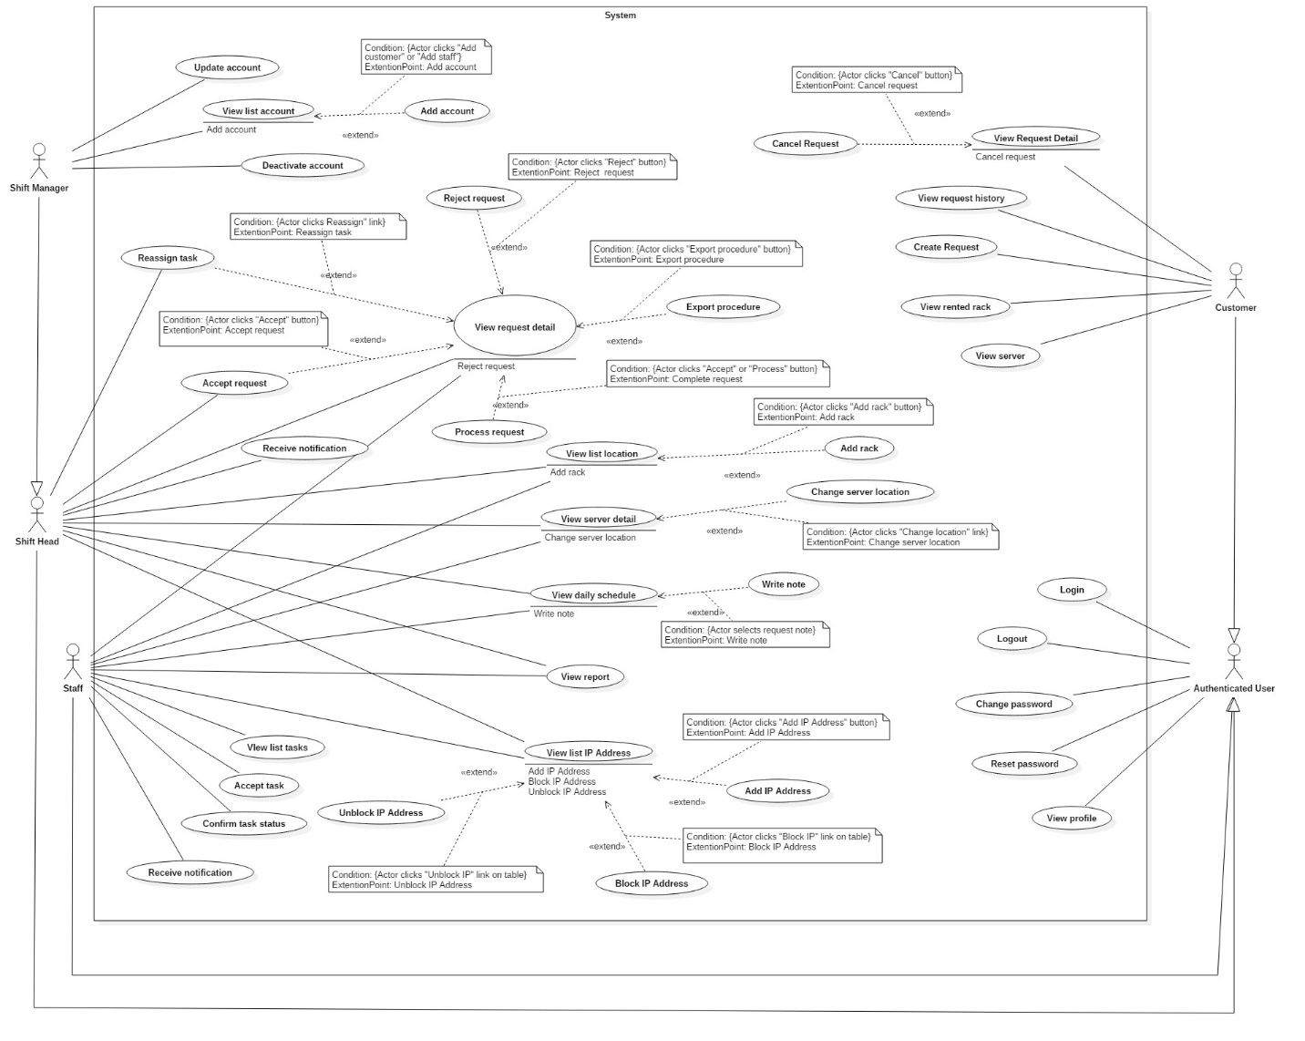

Figure 2: System Overview Use Case

### List of Use Case

##### <Shift Head> Overview Use Case

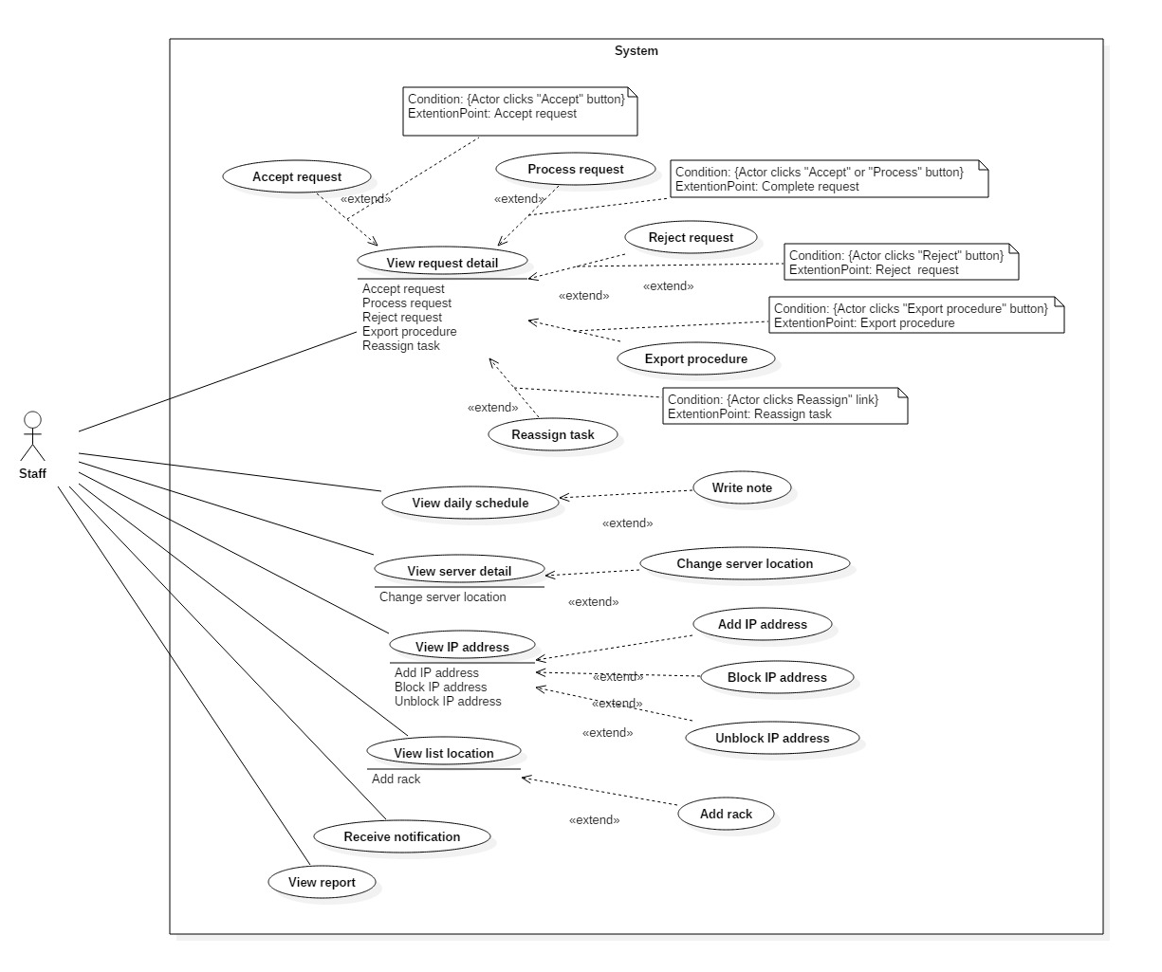Figure 5: <Shift Head> Overview Use Case

###### <Shift Head> View request detail

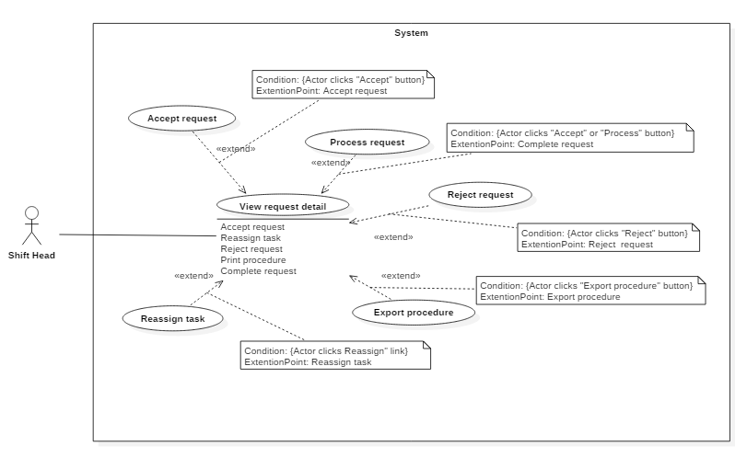

Figure 8 <Shift Head> View request detail

|  |  |  |  |
| --- | --- | --- | --- |
| USE CASE – IMS001 | | | |
| Use Case No. | IMS001 | **Use Case Version** | 2.0 |
| Use Case Name | View request detail | | |
| Author | Lê Thị Thu Hà | | |
| Date | 18/01/2016 | **Priority** | Normal |
| Actor:   * Shift Head   Summary:   * This use case allows Shift Head to view request detail.   Goal:   * Shift Head can access to appropriate request detail.   Triggers:   * Shift head clicks view notification or “Request” page in sidebar.   Precondition:   * The Shift Head must login to the system with Shift Head role at right shift.   Post Conditions:   * Success: Shift Head can view request detail * Fail: Nothing will be created. Show message error with specified content.   Main Success Scenario:   |  |  |  | | --- | --- | --- | | Step | Actor Action | System Response | | 1 | Shift head clicks on notification in header | Navigate to appropriate request detail |   Alternative Scenario:   |  |  |  | | --- | --- | --- | | Step | Actor Action | System Response | | 1 | Shift head clicks “Request” tab in sidebar | List of requests will be displayed. New request is placed on the first line of the table |  |  |  |  | | --- | --- | --- | | Step | Actor Action | System Response | | 1 | Shift head clicks “Server” tab in sidebar | If request has information related to “Server”, there’s a link of this request displayed in “Action” field. |   Exceptions: N/A  Relationships: Extend to Accept request, Process request, Reject request, Export procedure, Reassign task  Business Rules:   * In “Server” page, link of the request only appeared when this request status is “Pending”, “Waiting” and “Processing” | | | |

Table 19: Use case IMS001 - <Shift Head> Write note

###### <Shift Head> Accept request “Add Server”



Figure 8 <Shift Head> Accept request “Add Server”

|  |  |  |  |
| --- | --- | --- | --- |
| USE CASE – IMS004 | | | |
| Use Case No. | IMS004 | **Use Case Version** | 2.0 |
| Use Case Name | Accept request “Add Server” | | |
| Author | Lê Thị Thu Hà | | |
| Date | 19/01/2016 | **Priority** | medium |
| Actor:   * Shift Head.   Summary:   * This use case allows Shift Head to accept request “Add Server” from customer.   Goal:   * Request status changes from “Pending” to “Waiting”, button “Process” will appear to ready when customer arrives. After “Accept” button is clicked, customer will immediately receive notification from this system and also via email.   Triggers:   * Shift head clicks “Accept” button on request detail page.   Preconditions:   * User logins will Shift Head role. * Request status is “Pending”.   Post Conditions:   * Success: System shows message “Success! You’ve ACCEPTED Request Add Server.” * Fail: System shows error message.   Main Success Scenario:   |  |  |  | | --- | --- | --- | | Step | Actor Action | System Response | | 1 | Shift Head clicks on not-viewed notification on the header panel. | Navigated to “Add Server” request detail page. | | 2 | Shift Head checks request detail and clicks on “Accept” button at the bottom of the page. | * System shows message “Success! You’ve ACCEPTED Request Add Server.” * Request status changes to “Waiting” * Assignee drop down list and “Process” button are showed. * Changed request status is notified to customer via both system and email. |   Alternative Scenario: N/A.  Exceptions:   |  |  |  | | --- | --- | --- | | No | Actor Action | System Response | | 1 | Connect to Internet fail | Show message “Cannot send email to customer, please connect to the Internet and try again!” |   Relationships: Extend to View request detail detail.  Business Rules:   * When Shift Head accepts the request, system will log the time when he changed the request status from “Pending” to “Waiting”. * Four shift heads of data center can be able to click on the “Accept” button of a request anytime. But as the rule, only the one who is responsible for confirming request at current shift is authorized. Unauthorized person will be discovered by log system. | | | |

Table 19: Use case IMS002 - <Shift Head> Accept request “Add Server”

###### <Shift Head> Accept request “Bring Server Away”

Figure 8 <Shift Head> Assign task

|  |  |  |  |
| --- | --- | --- | --- |
| USE CASE – IMS004 | | | |
| Use Case No. | IMS004 | **Use Case Version** | 2.0 |
| Use Case Name | Accept request “Bring Server Away” | | |
| Author | Lê Thị Thu Hà | | |
| Date | 19/01/2016 | **Priority** | medium |
| Actor:   * Shift Head.   Summary:   * This use case allows Shift Head to accept request “Bring Server Away” from customer.   Goal:   * Request status changes from “Pending” to “Waiting”, button “Process” will appear to ready when customer arrives. After “Accept” button is clicked, customer will immediately receive notification from this system and also via email.   Triggers:   * Shift head clicks “Accept” button on request detail page.   Preconditions:   * User logins will Shift Head role. * Request status is “Pending”.   Post Conditions:   * Success: System shows message “Success! You’ve ACCEPTED Request Bring Server Away.” * Fail: System shows error message.   Main Success Scenario:   |  |  |  | | --- | --- | --- | | Step | Actor Action | System Response | | 1 | Shift Head clicks on not-viewed notification on the header panel. | Navigated to “Bring Server Away” request detail page. | | 2 | Shift Head checks request detail and clicks on “Accept” button at the bottom of the page. | * System shows message “Success! You’ve ACCEPTED Request Bring Server Away.” * Request status changes to “Waiting” * Assignee drop down list and “Process” button are showed. * Changed request status is notified to customer via both system and email. |   Alternative Scenario: N/A.  Exceptions:   |  |  |  | | --- | --- | --- | | No | Actor Action | System Response | | 1 | Connect to Internet fail | Show message “Cannot send email to customer, please connect to the Internet and try again!” |   Relationships: Extend to View request detail detail.  Business Rules:   * When Shift Head accepts the request, system will log the time when he changed the request status from “Pending” to “Waiting”. * Four shift heads of data center can be able to click on the “Accept” button of a request anytime. But as the rule, only the one who is responsible for confirming request at current shift is authorized. Unauthorized person will be discovered by log system. | | | |

Table 19: Use case IMS002 - <Shift Head> Assign task

###### <Shift Head> Accept request “Assign IP Address”

Figure 8 <Shift Head> Assign task

Table 19: Use case IMS002 - <Shift Head> Assign task

|  |  |  |  |
| --- | --- | --- | --- |
| USE CASE – IMS004 | | | |
| Use Case No. | IMS004 | **Use Case Version** | 2.0 |
| Use Case Name | Accept request “Assign IP Address” | | |
| Author | Lê Thị Thu Hà | | |
| Date | 19/01/2016 | **Priority** | medium |
| Actor:   * Shift Head.   Summary:   * This use case allows Shift Head to accept request “Assign IP Address” from customer.   Goal:   * Request status changes from “Pending” to “Processing”, button “Complete” will appear right that. After “Accept” button is clicked, customer will immediately receive notification from this system and also via email.   Triggers:   * Shift head clicks “Accept” button on request detail page.   Preconditions:   * User logins will Shift Head role. * Request status is “Pending”.   Post Conditions:   * Success: System shows message “Success! You’ve ACCEPTED Request Assign IP Address.” * Fail: System shows error message.   Main Success Scenario:   |  |  |  | | --- | --- | --- | | Step | Actor Action | System Response | | 1 | Shift Head clicks on not-viewed notification on the header panel. | Navigated to “Assign IP Address” request detail page. | | 2 | Shift Head checks request detail and clicks on “Accept” button at the bottom of the page without reselect assignee. | * System shows message “Success! You’ve ACCEPTED Request Assign IP Address.” * Request status changes to “Processing” * “Complete” button is replaced for “Accept” button * Shift head is default assignee. * Changed request status is notified to customer via both system and email. |   Alternative Scenario:   |  |  |  | | --- | --- | --- | | Step | Actor Action | System Response | | 1 | Shift Head clicks on not-viewed notification on the header panel. | Navigated to “Assign IP Address” request detail page. | | 2 | * Shift Head selects who will process this request * Shift Head checks request detail and clicks on “Accept” button at the bottom of the page. | * System shows message “Success! You’ve ACCEPTED Request Assign IP Address.” * Request status changes to “Processing” * “Complete” button is replaced for “Accept” button * Selected member will take charge in processing this request * Changed request status is notified to customer via both system and email. |   Exceptions:   |  |  |  | | --- | --- | --- | | No | Actor Action | System Response | | 1 | Connect to Internet fail | Show message “Cannot send email to customer, please connect to the Internet and try again!” |   Relationships: Extend to View request detail detail.  Business Rules:   * When Shift Head accepts the request, system will log the time when he changed the request status from “Pending” to “Processing”. * Four shift heads of data center can be able to click on the “Accept” button of a request anytime. But as the rule, only the one who is responsible for confirming request at current shift is authorized. Unauthorized person will be discovered by log system. * If Shift Head is busy and can’t process the request or assign it to another staff, Shift Manager will take over it | | | |

###### <Shift Head> Accept request “Change IP Address”

Figure 8 <Shift Head> Assign task

|  |  |  |  |
| --- | --- | --- | --- |
| USE CASE – IMS004 | | | |
| Use Case No. | IMS004 | **Use Case Version** | 2.0 |
| Use Case Name | Accept request “Change IP Address” | | |
| Author | Lê Thị Thu Hà | | |
| Date | 19/01/2016 | **Priority** | medium |
| Actor:   * Shift Head.   Summary:   * This use case allows Shift Head to accept request “Change IP Address” from customer.   Goal:   * Request status changes from “Pending” to “Processing”, button “Complete” will appear right that. After “Accept” button is clicked, customer will immediately receive notification from this system and also via email.   Triggers:   * Shift head clicks “Accept” button on request detail page.   Preconditions:   * User logins will Shift Head role. * Request status is “Pending”.   Post Conditions:   * Success: System shows message “Success! You’ve ACCEPTED Request Change IP Address.” * Fail: System shows error message.   Main Success Scenario:   |  |  |  | | --- | --- | --- | | Step | Actor Action | System Response | | 1 | Shift Head clicks on not-viewed notification on the header panel. | Navigated to “Change IP Address” request detail page. | | 2 | Shift Head checks request detail and clicks on “Accept” button at the bottom of the page without reselect assignee. | * System shows message “Success! You’ve ACCEPTED Request Change IP Address.” * Request status changes to “Processing” * “Complete” button is replaced for “Accept” button * Shift head is default assignee. * Changed request status is notified to customer via both system and email. |   Alternative Scenario:   |  |  |  | | --- | --- | --- | | Step | Actor Action | System Response | | 1 | Shift Head clicks on not-viewed notification on the header panel. | Navigated to “Change IP Address” request detail page. | | 2 | * Shift Head selects who will process this request * Shift Head checks request detail and clicks on “Accept” button at the bottom of the page. | * System shows message “Success! You’ve ACCEPTED Request Change IP Address.” * Request status changes to “Processing” * “Complete” button is replaced for “Accept” button * Selected member will take charge in processing this request * Changed request status is notified to customer via both system and email. |   Exceptions:   |  |  |  | | --- | --- | --- | | No | Actor Action | System Response | | 1 | Connect to Internet fail | Show message “Cannot send email to customer, please connect to the Internet and try again!” |   Relationships: Extend to View request detail detail.  Business Rules:   * When Shift Head accepts the request, system will log the time when he changed the request status from “Pending” to “Processing”. * Four shift heads of data center can be able to click on the “Accept” button of a request anytime. But as the rule, only the one who is responsible for confirming request at current shift is authorized. Unauthorized person will be discovered by log system. * If Shift Head is busy and can’t process the request or assign it to another staff, Shift Manager will take over it | | | |

Table 19: Use case IMS002 - <Shift Head> Assign task

###### <Shift Head> Accept request “Return IP Address”

Figure 8 <Shift Head> Return IP Address

|  |  |  |  |
| --- | --- | --- | --- |
| USE CASE – IMS004 | | | |
| Use Case No. | IMS004 | **Use Case Version** | 2.0 |
| Use Case Name | Accept request “Return IP Address” | | |
| Author | Lê Thị Thu Hà | | |
| Date | 19/01/2016 | **Priority** | medium |
| Actor:   * Shift Head.   Summary:   * This use case allows Shift Head to accept request “Return IP Address” from customer.   Goal:   * Request status changes from “Pending” to “Processing”, button “Complete” will appear right that. After “Accept” button is clicked, customer will immediately receive notification from this system and also via email.   Triggers:   * Shift head clicks “Accept” button on request detail page.   Preconditions:   * User logins will Shift Head role. * Request status is “Pending”.   Post Conditions:   * Success: System shows message “Success! You’ve ACCEPTED Request Return IP Address.” * Fail: System shows error message.   Main Success Scenario:   |  |  |  | | --- | --- | --- | | Step | Actor Action | System Response | | 1 | Shift Head clicks on not-viewed notification on the header panel. | Navigated to “Return IP Address” request detail page. | | 2 | Shift Head checks request detail and clicks on “Accept” button at the bottom of the page without reselect assignee. | * System shows message “Success! You’ve ACCEPTED Request Return IP Address.” * Request status changes to “Processing” * “Complete” button is replaced for “Accept” button * Shift head is default assignee. * Changed request status is notified to customer via both system and email. |   Alternative Scenario:   |  |  |  | | --- | --- | --- | | Step | Actor Action | System Response | | 1 | Shift Head clicks on not-viewed notification on the header panel. | Navigated to “Return IP Address” request detail page. | | 2 | * Shift Head selects who will process this request * Shift Head checks request detail and clicks on “Accept” button at the bottom of the page. | * System shows message “Success! You’ve ACCEPTED Request Return IP Address.” * Request status changes to “Processing” * “Complete” button is replaced for “Accept” button * Selected member will take charge in processing this request * Changed request status is notified to customer via both system and email. |   Exceptions:   |  |  |  | | --- | --- | --- | | No | Actor Action | System Response | | 1 | Connect to Internet fail | Show message “Cannot send email to customer, please connect to the Internet and try again!” |   Relationships: Extend to View request detail detail.  Business Rules:   * When Shift Head accepts the request, system will log the time when he changed the request status from “Pending” to “Processing”. * Four shift heads of data center can be able to click on the “Accept” button of a request anytime. But as the rule, only the one who is responsible for confirming request at current shift is authorized. Unauthorized person will be discovered by log system. * If Shift Head is busy and can’t process the request or assign it to another staff, Shift Manager will take over it | | | |

Table 19: Use case IMS002 - <Shift Head> Return IP Address

###### <Shift Head> Accept request “Rent Rack”

Figure 8 <Shift Head> Accept request “Rent Rack”

|  |  |  |  |
| --- | --- | --- | --- |
| USE CASE – IMS004 | | | |
| Use Case No. | IMS004 | **Use Case Version** | 2.0 |
| Use Case Name | Accept request “Rent Rack” | | |
| Author | Lê Thị Thu Hà | | |
| Date | 19/01/2016 | **Priority** | medium |
| Actor:   * Shift Head.   Summary:   * This use case allows Shift Head to accept request “Rent Rack” from customer.   Goal:   * Request status changes from “Pending” to “Processing”, button “Complete” will appear right that. After “Accept” button is clicked, customer will immediately receive notification from this system and also via email.   Triggers:   * Shift head clicks “Accept” button on request detail page.   Preconditions:   * User logins will Shift Head role. * Request status is “Pending”.   Post Conditions:   * Success: System shows message “Success! You’ve ACCEPTED Request Rent Rack.” * Fail: System shows error message.   Main Success Scenario:   |  |  |  | | --- | --- | --- | | Step | Actor Action | System Response | | 1 | Shift Head clicks on not-viewed notification on the header panel. | Navigated to “Rent Rack” request detail page. | | 2 | Shift Head checks request detail and clicks on “Accept” button at the bottom of the page without reselect assignee. | * System shows message “Success! You’ve ACCEPTED Request Rent Rack.” * Request status changes to “Processing” * “Complete” button is replaced for “Accept” button * Shift head is default assignee. * Changed request status is notified to customer via both system and email. |   Alternative Scenario:   |  |  |  | | --- | --- | --- | | Step | Actor Action | System Response | | 1 | Shift Head clicks on not-viewed notification on the header panel. | Navigated to “Rent Rack” request detail page. | | 2 | * Shift Head selects who will process this request * Shift Head checks request detail and clicks on “Accept” button at the bottom of the page. | * System shows message “Success! You’ve ACCEPTED Request Rent Rack.” * Request status changes to “Processing” * “Complete” button is replaced for “Accept” button * Selected member will take charge in processing this request * Changed request status is notified to customer via both system and email. |   Exceptions:   |  |  |  | | --- | --- | --- | | No | Actor Action | System Response | | 1 | Connect to Internet fail | Show message “Cannot send email to customer, please connect to the Internet and try again!” |   Relationships: Extend to View request detail detail.  Business Rules:   * When Shift Head accepts the request, system will log the time when he changed the request status from “Pending” to “Processing”. * Four shift heads of data center can be able to click on the “Accept” button of a request anytime. But as the rule, only the one who is responsible for confirming request at current shift is authorized. Unauthorized person will be discovered by log system. * If Shift Head is busy and can’t process the request or assign it to another staff, Shift Manager will take over it | | | |

Table 19: Use case IMS002 - <Shift Head> Accept request “Rent Rack”

###### <Shift Head> Accept request “Return Rack”

Figure 8 <Shift Head> Accept request “Return Rack”

|  |  |  |  |
| --- | --- | --- | --- |
| USE CASE – IMS004 | | | |
| Use Case No. | IMS004 | **Use Case Version** | 2.0 |
| Use Case Name | Accept request “Return Rack” | | |
| Author | Lê Thị Thu Hà | | |
| Date | 19/01/2016 | **Priority** | medium |
| Actor:   * Shift Head.   Summary:   * This use case allows Shift Head to accept request “Return Rack” from customer.   Goal:   * Request status changes from “Pending” to “Processing”, button “Complete” will appear right that. After “Accept” button is clicked, customer will immediately receive notification from this system and also via email.   Triggers:   * Shift head clicks “Accept” button on request detail page.   Preconditions:   * User logins will Shift Head role. * Request status is “Pending”.   Post Conditions:   * Success: System shows message “Success! You’ve ACCEPTED Request Return Rack.” * Fail: System shows error message.   Main Success Scenario:   |  |  |  | | --- | --- | --- | | Step | Actor Action | System Response | | 1 | Shift Head clicks on not-viewed notification on the header panel. | Navigated to “Return Rack” request detail page. | | 2 | Shift Head checks request detail and clicks on “Accept” button at the bottom of the page without reselect assignee. | * System shows message “Success! You’ve ACCEPTED Request Return Rack.” * Request status changes to “Processing” * “Complete” button is replaced for “Accept” button * Shift head is default assignee. * Changed request status is notified to customer via both system and email. |   Alternative Scenario:   |  |  |  | | --- | --- | --- | | Step | Actor Action | System Response | | 1 | Shift Head clicks on not-viewed notification on the header panel. | Navigated to “Return Rack” request detail page. | | 2 | * Shift Head selects who will process this request * Shift Head checks request detail and clicks on “Accept” button at the bottom of the page. | * System shows message “Success! You’ve ACCEPTED Request Return Rack.” * Request status changes to “Processing” * “Complete” button is replaced for “Accept” button * Selected member will take charge in processing this request * Changed request status is notified to customer via both system and email. |   Exceptions:   |  |  |  | | --- | --- | --- | | No | Actor Action | System Response | | 1 | Connect to Internet fail | Show message “Cannot send email to customer, please connect to the Internet and try again!” |   Relationships: Extend to View request detail detail.  Business Rules:   * When Shift Head accepts the request, system will log the time when he changed the request status from “Pending” to “Processing”. * Four shift heads of data center can be able to click on the “Accept” button of a request anytime. But as the rule, only the one who is responsible for confirming request at current shift is authorized. Unauthorized person will be discovered by log system. * If Shift Head is busy and can’t process the request or assign it to another staff, Shift Manager will take over it | | | |

Table 19: Use case IMS002 - <Shift Head> Accept request “Return Rack”

###### <Shift Head> Process request “Add Server”

Figure 8 <Shift Head> Process request “Add Server”

|  |  |  |  |
| --- | --- | --- | --- |
| USE CASE – IMS009 | | | |
| Use Case No. | IMS009 | **Use Case Version** | 2.0 |
| Use Case Name | Process request “Add Server” | | |
| Author | Lê Thị Thu Hà | | |
| Date | 21/01/2016 | **Priority** | medium |
| Actor:   * Shift Head.   Summary:   * This use case allows Shift Head to process request “Add Server”, recording customer officially brought his servers into the data center. Furthermore, necessary information as Default IP Address and Server Location are also processed in this phase.   Goal:   * Complete the request with “Done” status. Customer’s servers are already placed in a rack of data center.   Triggers:   * Shift Head accesses to the appropriate request detail page.   Preconditions:   * Shift Head must login into the system with role Shift Head. * The request was sent to data center by customer.   Post Conditions:   * Success: Server status will be changed from “Waiting” to “Running”. Request status is updated to “Done”. Notification will be sent automatically to customer via system and also email * Fail: System shows error message   Main Success Scenario:   |  |  |  | | --- | --- | --- | | Step | Actor Action | System Response | | 1 | Shift Head clicks on not-viewed notification on the header panel. | The system will display “Add Server” request detail | | 2 | Shift Head clicks on “Add IP” | The picked up IP Address Popup will be displayed. | | 3 | Shift Head searches suitable IP Address, select it and clicks “OK” button. | Return to Request Add New Server Page and the selected IP Address will be display on field “Default IP” | | 4 | Shift Head clicks on “Add location” | The picked up Location Popup will be displayed. | | 5 | Shift Head selects suitable location and clicks “OK” button. | Return to Request Add New Server Page and the selected location will be display on field “Location” | | 6 | Shift Head clicks on “Complete” button | * System will save new information of this server into database. * System will change status of this server(s) to “Running” * System will log who processed the request at this time |   Alternatives Scenario: N/A  Exceptions:   |  |  |  | | --- | --- | --- | | Step | Cause | System Response | | 1 | Shift Head not assign default IP to server | System will show message: “You must assign default IP Address to server.” | | 2 | Shift Head not assign location to server | System will show message: “You must assign location to server.” | | 3 | Connect to Internet fail | Show message “Cannot send email to customer, please connect to the Internet and try again!” |   Relationships: Extend to View request detail  Business Rules:   * When customer want to entrust his servers to datacenter, he must input server configuration by himself using the “Add Server” request. * After finishing setting up servers, then Shift Head will assign Default IP Address to each server and decide where to place the servers to data center. * In data center, Default IP is an identity of server. On each server will be tagged Default IP | | | |

Table 19: Use case IMS003 - <Shift Head> Process request “Add Server”

###### <Shift Head> Process request “Bring Server Away”

Figure 8 <Shift Head> View request

|  |  |  |  |
| --- | --- | --- | --- |
| USE CASE – IMS009 | | | |
| Use Case No. | IMS009 | **Use Case Version** | 2.0 |
| Use Case Name | Process request “Bring Server Away” | | |
| Author | Lê Thị Thu Hà | | |
| Date | 21/01/2016 | **Priority** | medium |
| Actor:   * Shift Head.   Summary:   * This use case allows Shift Head to process request “Bring Server Away”, he can check server’s information before customer brings their servers away.   Goal:   * Complete the request with “Done” status. Server status changed to “Deactivate” and all information related to this server such as IP Address, location,.. will be set to “Available”   Triggers:   * Shift Head accesses to the appropriate request detail page.   Preconditions:   * Shift Head must login into the system with role Shift Head. * The request was sent to data center by customer.   Post Conditions:   * Success: Server status will be changed from “Running” to “Deactivate”. Request status is updated to “Done”. Notification will be sent automatically to customer via both IMS system and email * Fail: System shows error message   Main Success Scenario:   |  |  |  | | --- | --- | --- | | Step | Actor Action | System Response | | 1 | Shift Head clicks on not-viewed notification on the header panel. | The system will display “Bring Server Away” request detail | | 2 | Shift Head clicks on “Complete” button | * System will change server status to “Deactivate”. * IP Address and location related to this server will be reset to “Available” * Request status changed to “Done” * System will log who processed the request at this time |   Alternatives Scenario: N/A  Exceptions:   |  |  |  | | --- | --- | --- | | No | Actor Action | System Response | | 1 | Connect to Internet fail | Show message “Cannot send email to customer, please connect to the Internet and try again!” |   Relationships: Extend to View request detail detail  Business Rules:   * This system doesn’t handle whether customer paid enough money before he finishes the service at data center. Shift Head will confirm with sale man beforehand. | | | |

Table 19: Use case IMS003 - <Shift Head> Process request “Bring Server Away”

###### <Shift Head> Process request “Assign IP Address”



Figure 8 <Shift Head> View request

|  |  |  |  |
| --- | --- | --- | --- |
| USE CASE – IMS009 | | | |
| Use Case No. | IMS009 | **Use Case Version** | 2.0 |
| Use Case Name | Process request “Assign IP Address” | | |
| Author | Lê Thị Thu Hà | | |
| Date | 21/01/2016 | **Priority** | medium |
| Actor:   * Shift Head.   Summary:   * This use case allows Shift Head to process request “Assign IP Address”, he can select which IP Address to assign to requested server. The number of IP Address is allocated by customer.   Goal:   * Complete the request with “Done” status. New IP Addresses are assigned to appointed server   Triggers:   * Shift Head accesses to the appropriate request detail page.   Preconditions:   * Shift Head must login into the system with role Shift Head. * The request was sent to data center by customer.   Post Conditions:   * Success: Assigned IP Address will be changed its status from “Available” to “Used”. Request status is updated to “Done”. Notification will be sent automatically to customer via both IMS system and email * Fail: System shows error message   Main Success Scenario:   |  |  |  | | --- | --- | --- | | Step | Actor Action | System Response | | 1 | Shift Head clicks on not-viewed notification on the header panel. | The system will display “Assign IP Address” request detail | | 2 | Shift Head checks request detail and necessary action for this request | IP Address will be randomly selected by the system, and the number of it is equals to the number appointed by customer. | | 3 | Shift Head clicks on “Complete” button | * System will change IP Address status to “Used”. * New IP Address is assign to appropriate server * Request status changed to “Done” * System will log who processed the request at this time |   Alternatives Scenario:   |  |  |  | | --- | --- | --- | | Step | Actor Action | System Response | | 1 | Shift Head clicks on not-viewed notification on the header panel. | The system will display “Assign IP Address” request detail | | 2 | Shift Head selects available IP Address to assign |  | | 3 | Shift Head clicks on “Complete” button | * System will change IP Address status to “Used”. * New IP Address is assign to appropriate server * Request status changed to “Done” * System will log who processed the request at this time |   Exceptions:   |  |  |  | | --- | --- | --- | | No | Actor Action | System Response | | 1 | Shift Head assigns the number of IP Address more or less than customer requirement | System shows message “You need to choose the number of IP Address as customer requirement. Please try again.” | | 2 | Number of available IP Addresses is less than customer requirement | System shows message “Number of available IP Address is less than required number. Please confirm with customer to change IP range.” | | 3 | Connect to Internet fail | Show message “Cannot send email to customer, please connect to the Internet and try again!” |   Relationships: Extend to View request detail detail  Business Rules:   * This system doesn’t handle whether customer paid enough money before he finishes the service at data center. Shift Head will confirm with sale man beforehand. | | | |

Table 19: Use case IMS003 - <Shift Head> Process request “Assign IP Address”

###### <Shift Head> Process request “Change IP Address”



Figure 8 <Shift Head> Process request “Change IP Address”

|  |  |  |  |
| --- | --- | --- | --- |
| USE CASE – IMS009 | | | |
| Use Case No. | IMS009 | **Use Case Version** | 2.0 |
| Use Case Name | Process request “Change IP Address” | | |
| Author | Lê Thị Thu Hà | | |
| Date | 21/01/2016 | **Priority** | medium |
| Actor:   * Shift Head.   Summary:   * This use case allows Shift Head to process request “Change IP Address”, he will change selected IP Addresses to the new ones that are in the same range.   Goal:   * Complete the request with “Done” status. New IP Addresses are assigned to appointed server. Old IP Addresses will be changed status to “Available”.   Triggers:   * Shift Head accesses to the appropriate request detail page.   Preconditions:   * Shift Head must login into the system with role Shift Head. * The request was sent to data center by customer.   Post Conditions:   * Success: Assigned IP Address will be changed its status from “Available” to “Used”. Old IP Addresses will be changed status to “Available”. Notification will be sent automatically to customer via both IMS system and email * Fail: System shows error message   Main Success Scenario:   |  |  |  | | --- | --- | --- | | Step | Actor Action | System Response | | 1 | Shift Head clicks on not-viewed notification on the header panel. | The system will display “Change IP Address” request detail | | 2 | Shift Head selects IP Address to assign for each IP Address that customer wants to change. |  | | 3 | Shift Head clicks on “Complete” button | * System will change new IP Address status to “Used”. * System will change old IP Address status to “Available”. * Request status changed to “Done” * System will log who processed the request at this time |   Alternatives Scenario: N/A.  Exceptions:   |  |  |  | | --- | --- | --- | | No | Actor Action | System Response | | 1 | Shift Head forgot to select new IP Address from drop down list | System shows message “You need to select new IP Address. Please try again.” | | 2 | Number of available IP Addresses is less than customer requirement | System shows message “Number of available IP Address is less than required number. Please confirm with customer to change IP range.” | | 3 | Connect to Internet fail | Show message “Cannot send email to customer, please connect to the Internet and try again!” |   Relationships: Extend to View request detail  Business Rules:   * This system doesn’t handle whether customer paid enough money before he finishes the service at data center. Shift Head will confirm with sale man beforehand. | | | |

Table 19: Use case IMS003 - <Shift Head> Process request “Change IP Address”

###### <Shift Head> Process request “Return IP Address”

Figure 8 <Shift Head> Process request “Return IP Address”

|  |  |  |  |
| --- | --- | --- | --- |
| USE CASE – IMS009 | | | |
| Use Case No. | IMS009 | **Use Case Version** | 2.0 |
| Use Case Name | Process request “Return IP Address” | | |
| Author | Lê Thị Thu Hà | | |
| Date | 21/01/2016 | **Priority** | medium |
| Actor:   * Shift Head.   Summary:   * This use case allows Shift Head to process request “Return IP Address”, he will approve IP Addresses that customer wants to return to data center.   Goal:   * Complete the request with “Done” status. IP Addresses will be returned to data center with status “Available”   Triggers:   * Shift Head accesses to the appropriate request detail page.   Preconditions:   * Shift Head must login into the system with role Shift Head. * The request was sent to data center by customer.   Post Conditions:   * Success: IP Address will be changed its status from “Used” to “Available”. Request status is updated to “Done”. Notification will be sent automatically to customer via both IMS system and email * Fail: System shows error message   Main Success Scenario:   |  |  |  | | --- | --- | --- | | Step | Actor Action | System Response | | 1 | Shift Head clicks on not-viewed notification on the header panel. | The system will display “Return IP Address” request detail | | 2 | Shift Head checks request detail |  | | 3 | Shift Head clicks on “Complete” button | * System will change IP Address status to “Available”. * Request status changed to “Done” * System will log who processed the request at this time |   Alternatives Scenario: N/A.  Exceptions:   |  |  |  | | --- | --- | --- | | No | Actor Action | System Response | | 1 | Connect to Internet fail | Show message “Cannot send email to customer, please connect to the Internet and try again!” |   Relationships: Extend to View request detail detail  Business Rules:   * This system doesn’t handle whether customer paid enough money before he finishes the service at data center. Shift Head will confirm with sale man beforehand. | | | |

Table 19: Use case IMS003 - <Shift Head> Process request “Return IP Address”

###### <Shift Head> Process request “Rent Rack”

Figure 8 <Shift Head> Process request “Rent Rack”

|  |  |  |  |
| --- | --- | --- | --- |
| USE CASE – IMS009 | | | |
| Use Case No. | IMS009 | **Use Case Version** | 2.0 |
| Use Case Name | Process request “Rent Rack” | | |
| Author | Lê Thị Thu Hà | | |
| Date | 21/01/2016 | **Priority** | medium |
| Actor:   * Shift Head.   Summary:   * This use case allows Shift Head to process request “Rent Rack”, he will select rack for customer to rent.   Goal:   * Complete the request with “Done” status. Rack status will be changed to “Rented”   Triggers:   * Shift Head accesses to the appropriate request detail page.   Preconditions:   * Shift Head must login into the system with role Shift Head. * The request was sent to data center by customer.   Post Conditions:   * Success: Rack status will be changed from “Available” to “Rented”. Request status is updated to “Done”. Notification will be sent automatically to customer via both IMS system and email * Fail: System shows error message   Main Success Scenario:   |  |  |  | | --- | --- | --- | | Step | Actor Action | System Response | | 1 | Shift Head clicks on not-viewed notification on the header panel. | The system will display “Rent Rack” request detail | | 2 | Shift Head selects number of racks as customer requirement |  | | 3 | Shift Head clicks on “Complete” button | * System will change rack status to “Rented”. * Request status changed to “Done” * System will log who processed the request at this time |   Alternatives Scenario:   |  |  |  | | --- | --- | --- | | Step | Actor Action | System Response | | 1 | Shift Head clicks on not-viewed notification on the header panel. | The system will display “Rent Rack” request detail | | 2 | Shift Head selects alphabet letter that ruled as the first character of rack name. | The system will return appropriate racks with the first letter as selected. | | 3 | Shift Head selects number of racks as customer requirement |  | | 3 | Shift Head clicks on “Complete” button | * System will change rack status to “Rented”. * Request status changed to “Done” * System will log who processed the request at this time |   Exceptions:   |  |  |  | | --- | --- | --- | | No | Actor Action | System Response | | 1 | Shift Head forgot to select rack | System shows message “You need to select rack for rent. Please try again.” | | 2 | Shift Head selected the number of racks that is different from customer requirement | System shows message “Please select the number of racks equal to customer requirement.” | | 3 | Available racks are less than customer requirement | System shows message “Available racks are not enough for rent. Please add more racks to the system.” | | 4 | Connect to Internet fail | Show message “Cannot send email to customer, please connect to the Internet and try again!” |   Relationships: Extend to View request detail detail  Business Rules:   * This system doesn’t handle whether customer paid enough money before he finishes the service at data center. Shift Head will confirm with sale man beforehand. | | | |

Table 19: Use case IMS003 - <Shift Head> Process request “Rent Rack”

###### <Shift Head> Process request “Return Rack”

Figure 8 <Shift Head> Process request “Return Rack”

|  |  |  |  |
| --- | --- | --- | --- |
| USE CASE – IMS009 | | | |
| Use Case No. | IMS009 | **Use Case Version** | 2.0 |
| Use Case Name | Process request “Return Rack” | | |
| Author | Lê Thị Thu Hà | | |
| Date | 21/01/2016 | **Priority** | medium |
| Actor:   * Shift Head.   Summary:   * This use case allows Shift Head to process request “Return Rack”.   Goal:   * Complete the request with “Done” status. Rack status will be changed to “Available”.   Triggers:   * Shift Head accesses to the appropriate request detail page.   Preconditions:   * Shift Head must login into the system with role Shift Head. * The request was sent to data center by customer.   Post Conditions:   * Success: Rack status will be changed from “Returning” to “Available”. Request status is updated to “Done”. Notification will be sent automatically to customer via both IMS system and email * Fail: System shows error message   Main Success Scenario:   |  |  |  | | --- | --- | --- | | Step | Actor Action | System Response | | 1 | Shift Head clicks on not-viewed notification on the header panel. | The system will display “Return Rack” request detail | | 2 | Shift Head checks request detail |  | | 3 | Shift Head clicks on “Complete” button | * System will change rack status to “Available”. * Request status changed to “Done” * System will log who processed the request at this time |   Alternatives Scenario: N/A.  Exceptions:   |  |  |  | | --- | --- | --- | | No | Actor Action | System Response | | 1 | Connect to Internet fail | Show message “Cannot send email to customer, please connect to the Internet and try again!” |   Relationships: Extend to View request detail detail  Business Rules:   * This system doesn’t handle whether customer paid enough money before he finishes the service at data center. Shift Head will confirm with sale man beforehand. | | | |

Table 19: Use case IMS003 - <Shift Head> Process request “Return Rack”

###### <Shift Head> Reject request “Add Server”

 Figure 25 <Shift Head> Reject request “Add Server”

|  |  |  |  |
| --- | --- | --- | --- |
| USE CASE – IMS017 | | | |
| Use Case No. | IMS017 | **Use Case Version** | 2.0 |
| Use Case Name | Reject request “Add Server” | | |
| Author | Lê Thị Thu Hà | | |
| Date | 23/01/2016 | **Priority** | medium |
| Actor:   * Shift Head.   Summary:   * This use case allows Shift Head to reject request “Add Server”.   Goal:   * Reject request “Add Server” which was sent by customer.   Triggers:   * Shift Head accesses to the appropriate request detail page.   Preconditions:   * Shift Head must login into the system with role Shift Head. * The request was sent to data center by customer.   Post Conditions:   * Success:   Customer will receive notification about reject request.  Request status will be changed to “Rejected”.  Server information will be removed from database.   * Fail: Show error message with specified content.   Main Success Scenario:   |  |  |  | | --- | --- | --- | | Step | Actor Action | System Response | | 1 | Shift Head clicks on not-viewed notification on the header panel. | The system will display “Add Server” request detail | | 2 | Shift Head clicks on “Reject” button | System shows pop-up to confirm | | 3 | Shift Head clicks “OK” button | * The new server information which customer sent will be deleted from database. * Request status will be changed to “Rejected”. * Customer will receive notification via both IMS system and email. |   Alternatives Scenario:   |  |  |  | | --- | --- | --- | | Step | Actor Action | System Response | | 1 | Shift Head clicks on not-viewed notification on the header panel. | The system will display “Add Server” request detail | | 2 | Shift Head clicks on “Reject” button | System shows pop-up to confirm | | 3 | Shift Head clicks “Cancel” button | “Add Server” request detail displays again. |   Exceptions:   |  |  |  | | --- | --- | --- | | No | Cause | System Response | | 1 | Connect to Internet fail | Show message “Cannot send request, please connect to the Internet!” |   Relationships: Extend to View request detail.  Business Rules:   * “Reject” button appears when request status is “Pending”, “Waiting” or “Processing” * The system only deletes the information of new server which customer sent, does not delete different information of this request. | | | |

Table 20: Use case IMS004 - <Shift Head> Reject request “Add Server”

###### <Shift Head> Reject request “Bring Server Away”

 Figure 25 <Shift Head> Reject request “Bring Server Away”

|  |  |  |  |
| --- | --- | --- | --- |
| USE CASE – IMS017 | | | |
| Use Case No. | IMS017 | **Use Case Version** | 2.0 |
| Use Case Name | Reject request “Bring Server Away” | | |
| Author | Lê Thị Thu Hà | | |
| Date | 23/01/2016 | **Priority** | medium |
| Actor:   * Shift Head.   Summary:   * This use case allows Shift Head to reject request “Bring Server Away”.   Goal:   * Reject request “Bring Server Away” successfully.   Triggers:   * Shift Head accesses to the appropriate request detail page.   Preconditions:   * Shift Head must login into the system with role Shift Head. * The request was sent to data center by customer.   Post Conditions:   * Success:   Customer will receive notification about reject request.  Request status will be changed to “Rejected”.  Server information will be removed from database.   * Fail: Show error message with specified content.   Main Success Scenario:   |  |  |  | | --- | --- | --- | | Step | Actor Action | System Response | | 1 | Shift Head clicks on not-viewed notification on the header panel. | The system will display “Bring Server Away” request detail | | 2 | Shift Head clicks on “Reject” button | System shows pop-up to confirm | | 3 | Shift Head clicks “OK” button | * Servers that customer wants to bring away will be changed its status from “Bringing away” to “Running” * Request status will be changed to “Rejected”. * Customer will receive notification via both IMS system and email. |   Alternatives Scenario:   |  |  |  | | --- | --- | --- | | Step | Actor Action | System Response | | 1 | Shift Head clicks on not-viewed notification on the header panel. | The system will display “Bring Server Away” request detail | | 2 | Shift Head clicks on “Reject” button | System shows pop-up to confirm | | 3 | Shift Head clicks “Cancel” button | “Bring Server Away” request detail displays again. |   Exceptions:   |  |  |  | | --- | --- | --- | | No | Cause | System Response | | 1 | Connect to Internet fail | Show message “Cannot send request, please connect to the Internet!” |   Relationships: Extend to View request detail.  Business Rules:   * “Reject” button appears when request status is “Pending”, “Waiting” or “Processing” * The system only deletes the information of new server which customer sent, does not delete different information of this request. | | | |

Table 20: Use case IMS004 - <Shift Head> Reject request “Bring Server Away”

###### <Shift Head> Reject request “Add IP Address”

 Figure 25 <Shift Head> Reject request “Assign IP Address”

|  |  |  |  |
| --- | --- | --- | --- |
| USE CASE – IMS017 | | | |
| Use Case No. | IMS017 | **Use Case Version** | 2.0 |
| Use Case Name | Reject request “Assign IP Address” | | |
| Author | Lê Thị Thu Hà | | |
| Date | 23/01/2016 | **Priority** | medium |
| Actor:   * Shift Head.   Summary:   * This use case allows Shift Head to reject request “Assign IP Address”.   Goal:   * Reject request “Assign IP Address” successfully.   Triggers:   * Shift Head accesses to the appropriate request detail page.   Preconditions:   * Shift Head must login into the system with role Shift Head. * The request was sent to data center by customer.   Post Conditions:   * Success:   Customer will receive notification about reject request.  Request status will be changed to “Rejected”.  Server information will be removed from database.   * Fail: Show error message with specified content.   Main Success Scenario:   |  |  |  | | --- | --- | --- | | Step | Actor Action | System Response | | 1 | Shift Head clicks on not-viewed notification on the header panel. | The system will display “Assign IP Address” request detail | | 2 | Shift Head clicks on “Reject” button | System shows pop-up to confirm | | 3 | Shift Head clicks “OK” button | * Request status will be changed to “Rejected”. * Customer will receive notification via both IMS system and email. |   Alternatives Scenario:   |  |  |  | | --- | --- | --- | | Step | Actor Action | System Response | | 1 | Shift Head clicks on not-viewed notification on the header panel. | The system will display “Assign IP Address” request detail | | 2 | Shift Head clicks on “Reject” button | System shows pop-up to confirm | | 3 | Shift Head clicks “Cancel” button | “Assign IP Address” request detail displays again. |   Exceptions:   |  |  |  | | --- | --- | --- | | No | Cause | System Response | | 1 | Connect to Internet fail | Show message “Cannot send request, please connect to the Internet!” |   Relationships: Extend to View request detail.  Business Rules:   * “Reject” button appears when request status is “Pending”” or “Processing” * The system only deletes the information of new server which customer sent, does not delete different information of this request. | | | |

Table 20: Use case IMS004 - <Shift Head> Accept request

###### <Shift Head> Reject request “Change IP Address”

Figure 25 <Shift Head> Reject request “Change IP Address”

|  |  |  |  |
| --- | --- | --- | --- |
| USE CASE – IMS017 | | | |
| Use Case No. | IMS017 | **Use Case Version** | 2.0 |
| Use Case Name | Reject request “Change IP Address” | | |
| Author | Lê Thị Thu Hà | | |
| Date | 23/01/2016 | **Priority** | medium |
| Actor:   * Shift Head.   Summary:   * This use case allows Shift Head to reject request “Change IP Address”.   Goal:   * Reject request “Change IP Address” successfully.   Triggers:   * Shift Head accesses to the appropriate request detail page.   Preconditions:   * Shift Head must login into the system with role Shift Head. * The request was sent to data center by customer.   Post Conditions:   * Success:   Customer will receive notification about reject request.  Request status will be changed to “Rejected”.  Server information will be removed from database.   * Fail: Show error message with specified content.   Main Success Scenario:   |  |  |  | | --- | --- | --- | | Step | Actor Action | System Response | | 1 | Shift Head clicks on not-viewed notification on the header panel. | The system will display “Change IP Address” request detail | | 2 | Shift Head clicks on “Reject” button | System shows pop-up to confirm | | 3 | Shift Head clicks “OK” button | * Request status will be changed to “Rejected”. * Customer will receive notification via both IMS system and email. |   Alternatives Scenario:   |  |  |  | | --- | --- | --- | | Step | Actor Action | System Response | | 1 | Shift Head clicks on not-viewed notification on the header panel. | The system will display “Change IP Address” request detail | | 2 | Shift Head clicks on “Reject” button | System shows pop-up to confirm | | 3 | Shift Head clicks “Cancel” button | “Change IP Address” request detail displays again. |   Exceptions:   |  |  |  | | --- | --- | --- | | No | Cause | System Response | | 1 | Connect to Internet fail | Show message “Cannot send request, please connect to the Internet!” |   Relationships: Extend to View request detail.  Business Rules:   * “Reject” button appears when request status is “Pending”” or “Processing” * The system only deletes the information of new server which customer sent, does not delete different information of this request. | | | |

Table 20: Use case IMS004 - <Shift Head> Reject request “Change IP Address”

###### <Shift Head> Reject request “Return IP Address”

 Figure 25 <Shift Head> Reject request “Return IP Address”

|  |  |  |  |
| --- | --- | --- | --- |
| USE CASE – IMS017 | | | |
| Use Case No. | IMS017 | **Use Case Version** | 2.0 |
| Use Case Name | Reject request “Return IP Address” | | |
| Author | Lê Thị Thu Hà | | |
| Date | 23/01/2016 | **Priority** | medium |
| Actor:   * Shift Head.   Summary:   * This use case allows Shift Head to reject request “Return IP Address”.   Goal:   * Reject request “Return IP Address” successfully.   Triggers:   * Shift Head accesses to the appropriate request detail page.   Preconditions:   * Shift Head must login into the system with role Shift Head. * The request was sent to data center by customer.   Post Conditions:   * Success:   Customer will receive notification about reject request.  Request status will be changed to “Rejected”.  Server information will be removed from database.   * Fail: Show error message with specified content.   Main Success Scenario:   |  |  |  | | --- | --- | --- | | Step | Actor Action | System Response | | 1 | Shift Head clicks on not-viewed notification on the header panel. | The system will display “Return IP Address” request detail | | 2 | Shift Head clicks on “Reject” button | System shows pop-up to confirm | | 3 | Shift Head clicks “OK” button | * Request status will be changed to “Rejected”. * Customer will receive notification via both IMS system and email. |   Alternatives Scenario:   |  |  |  | | --- | --- | --- | | Step | Actor Action | System Response | | 1 | Shift Head clicks on not-viewed notification on the header panel. | The system will display “Return IP Address” request detail | | 2 | Shift Head clicks on “Reject” button | System shows pop-up to confirm | | 3 | Shift Head clicks “Cancel” button | “Change IP Address” request detail displays again. |   Exceptions:   |  |  |  | | --- | --- | --- | | No | Cause | System Response | | 1 | Connect to Internet fail | Show message “Cannot send request, please connect to the Internet!” |   Relationships: Extend to View request detail.  Business Rules:   * “Reject” button appears when request status is “Pending”” or “Processing” * The system only deletes the information of new server which customer sent, does not delete different information of this request. | | | |

Table 20: Use case IMS004 - <Shift Head> Reject request “Return IP Address”

###### <Shift Head> Reject request “Rent Rack”

 Figure 25 <Shift Head> Reject request “Rent Rack”

|  |  |  |  |
| --- | --- | --- | --- |
| USE CASE – IMS017 | | | |
| Use Case No. | IMS017 | **Use Case Version** | 2.0 |
| Use Case Name | Reject request “Rent Rack” | | |
| Author | Lê Thị Thu Hà | | |
| Date | 23/01/2016 | **Priority** | medium |
| Actor:   * Shift Head.   Summary:   * This use case allows Shift Head to reject request “Rent Rack”.   Goal:   * Reject request “Rent Rack” successfully.   Triggers:   * Shift Head accesses to the appropriate request detail page.   Preconditions:   * Shift Head must login into the system with role Shift Head. * The request was sent to data center by customer.   Post Conditions:   * Success:   Customer will receive notification about reject request.  Request status will be changed to “Rejected”.  Server information will be removed from database.   * Fail: Show error message with specified content.   Main Success Scenario:   |  |  |  | | --- | --- | --- | | Step | Actor Action | System Response | | 1 | Shift Head clicks on not-viewed notification on the header panel. | The system will display “Rent Rack” request detail | | 2 | Shift Head clicks on “Reject” button | System shows pop-up to confirm | | 3 | Shift Head clicks “OK” button | * Request status will be changed to “Rejected”. * Customer will receive notification via both IMS system and email. |   Alternatives Scenario:   |  |  |  | | --- | --- | --- | | Step | Actor Action | System Response | | 1 | Shift Head clicks on not-viewed notification on the header panel. | The system will display “Return IP Address” request detail | | 2 | Shift Head clicks on “Reject” button | System shows pop-up to confirm | | 3 | Shift Head clicks “Cancel” button | “Rent Rack” request detail displays again. |   Exceptions:   |  |  |  | | --- | --- | --- | | No | Cause | System Response | | 1 | Connect to Internet fail | Show message “Cannot send request, please connect to the Internet!” |   Relationships: Extend to View request detail.  Business Rules:   * “Reject” button appears when request status is “Pending”” or “Processing” * The system only deletes the information of new server which customer sent, does not delete different information of this request. | | | |

Table 20: Use case IMS004 - <Shift Head> Reject request “Rent Rack”

###### <Shift Head> Reject request “Return Rack”

 Figure 25 <Shift Head> Reject request “Return Rack”

|  |  |  |  |
| --- | --- | --- | --- |
| USE CASE – IMS017 | | | |
| Use Case No. | IMS017 | **Use Case Version** | 2.0 |
| Use Case Name | Reject request “Return Rack” | | |
| Author | Lê Thị Thu Hà | | |
| Date | 23/01/2016 | **Priority** | medium |
| Actor:   * Shift Head.   Summary:   * This use case allows Shift Head to reject request “Return Rack”.   Goal:   * Reject request “Return Rack” successfully.   Triggers:   * Shift Head accesses to the appropriate request detail page.   Preconditions:   * Shift Head must login into the system with role Shift Head. * The request was sent to data center by customer.   Post Conditions:   * Success:   Customer will receive notification about reject request.  Request status will be changed to “Rejected”.  Server information will be removed from database.   * Fail: Show error message with specified content.   Main Success Scenario:   |  |  |  | | --- | --- | --- | | Step | Actor Action | System Response | | 1 | Shift Head clicks on not-viewed notification on the header panel. | The system will display “Return Rack” request detail | | 2 | Shift Head clicks on “Reject” button | System shows pop-up to confirm | | 3 | Shift Head clicks “OK” button | * Request status will be changed to “Rejected”. * Customer will receive notification via both IMS system and email. |   Alternatives Scenario:   |  |  |  | | --- | --- | --- | | Step | Actor Action | System Response | | 1 | Shift Head clicks on not-viewed notification on the header panel. | The system will display “Return Rack” request detail | | 2 | Shift Head clicks on “Reject” button | System shows pop-up to confirm | | 3 | Shift Head clicks “Cancel” button | “Return Rack” request detail displays again. |   Exceptions:   |  |  |  | | --- | --- | --- | | No | Cause | System Response | | 1 | Connect to Internet fail | Show message “Cannot send request, please connect to the Internet!” |   Relationships: Extend to View request detail.  Business Rules:   * “Reject” button appears when request status is “Pending”” or “Processing” * The system only deletes the information of new server which customer sent, does not delete different information of this request. | | | |

Table 20: Use case IMS004 - <Shift Head> Reject request “Return Rack”

###### <Shift Head> Export procedure

 Figure 11: <Shift Head> Export Procedure

|  |  |  |  |
| --- | --- | --- | --- |
| USE CASE – IMS014 | | | |
| Use Case No. | IMS014 | **Use Case Version** | 2.0 |
| Use Case Name | Export procedure | | |
| Author | Lê Thị Thu Hà | | |
| Date | 23/01/2016 | **Priority** | medium |
| Actor:   * Shift Head.   Summary:   * This use case allows Shift Head to export procedure after completing request “Add Server”   Goal:   * Export procedure successfully and hand it to customer   Triggers:   * Shift Head clicks on “Export procedure” button on “Add Server” request detail page   Preconditions:   * Shift Head must login into the system with role Shift Head. * The request must be already completed.   Post Conditions:   * Success: Export file word corresponding to request content. * Fail: Show message with specified content.   Main Success Scenario:   |  |  |  | | --- | --- | --- | | Step | Actor Action | System Response | | 1 | Shift Head clicks on “Export procedure” button. | The system will fill the request information in the procedure and export file word. |   Alternatives Scenario: N/A.  Exceptions:   |  |  |  | | --- | --- | --- | | Step | Cause | System Response | | 1 | Template file is not placed in the right folder | System will show message: “Export file is not successful. Please try again.” |   Relationships:   * Extend to View request detail.   Business Rules:   * File procedure is only exported when the request was completed. * Staff can export procedure more than one time. All the action will be logged. | | | |

*Table 23: Use case IMS016 - <Shift Head> Assign IP to server.*

###### <Shift Head> Reassign task

 Figure 19: <Shift Head> Reassign task

|  |  |  |  |
| --- | --- | --- | --- |
| USE CASE – IMS002 | | | |
| Use Case No. | IMS002 | **Use Case Version** | 2.0 |
| Use Case Name | Reassign task | | |
| Author | Lê Thị Thu Hà | | |
| Date | 18/01/2016 | **Priority** | Normal |
| Actor:   * Shift Head   Summary:   * This use case allows Shift Head to reassign task that was assigned but still not be accepted by staff.   Goal:   * Reassign task successfully.   Triggers:   * Shift head clicks “Reassign task” link on request detail page.   Precondition:   * Shift Head must login into the system with role Shift Head. * The request was sent to data center by customer. * Request is already assigned.   Post Conditions:   * Success: This task will be assigned to corresponding Staff. Staff will have notification about this assignment. * Fail: Show message error with specified content.   Main Success Scenario:   |  |  |  | | --- | --- | --- | | Step | Actor Action | System Response | | 1 | Shift head clicks “Reassign task” link on request detail page | Pop-up will display and show info:   * Assigned staff * Task status * Drop down list: includes name of member in current group. | | 2 | Shift Head selects himself in the drop down list | * Shift Head will be able to process this request. * If pre-assigned staff is not shift head, he will receive notification about his task status * Shift Head won’t receive notification about task. |   Alternative Scenario:   |  |  |  | | --- | --- | --- | | Step | Actor Action | System Response | | 1 | Shift head clicks “Reassign task” link on request detail page | Pop-up will display and show info:   * Assigned staff * Task status * Drop down list: includes name of member in current group. | | 2 | Shift Head selects another staff in the drop down list | * Selected staff will be able to process this request. * If pre-assigned staff is not shift head, he will receive notification about his task status * New-assigned staff will receive notification about new task. |   Exceptions: N/A.  Relationships: Extend to View request detail.  Business Rules:   * Shift Head can only assign task for members in the same group. * If Shift Head assigns task for himself, he won’t receive notification related to task * Shift Head can reassign task until assigned staff clicks “Accept task”. * One request is just edited by one person. | | | |

*Table 29: Use case IMS018 - <Shift Head> Reassign task*

###### <Shift Head> View daily schedule

 Figure 15: <Shift Head> View daily schedule

|  |  |  |  |
| --- | --- | --- | --- |
| USE CASE – IMS006 | | | |
| Use Case No. | IMS006 | **Use Case Version** | 2.0 |
| Use Case Name | View daily schedule | | |
| Author | Lê Thị Thu Hà | | |
| Date | 18/01/2016 | **Priority** | medium |
| Actor:   * Shift Head.   Summary:   * This use case allows Shift Head to view all of the today’s appointments and note from previous shift.   Goal:   * System provides schedule which helps Shift Head to control the appointments with customers.   Triggers:   * When Shift Head login to the system, the page contains daily schedule and the note of previous shift will be showed.   Preconditions:   * The Shift Head must login to the system with Shift Head role.   Post Conditions:   * Success: The daily schedule and note will be showed. * Fail: N/A   Main Success Scenario:   |  |  |  | | --- | --- | --- | | Step | Actor Action | System Response | | 1 | Shift Head login to the system | The page contains daily schedule and note will be showed. |   Alternative Scenario:   |  |  |  | | --- | --- | --- | | Step | Actor Action | System Response | | 1 | Shift Head login to the system and today does not have any customer’s arrival. | A message will be showed “Today does not have any appointment!” |   Exceptions: N/A  Relationships:   * Extended by Write note.   Business Rules:   * The customer link in daily schedule will be showed when today has appointments. | | | |

Table 26: Use case IMS011 - <Shift Head> View daily schedule

###### <Shift Head> Write note

 Figure 19: <Shift Head> Write note

|  |  |  |  |
| --- | --- | --- | --- |
| USE CASE – IMS001 | | | |
| Use Case No. | IMS001 | **Use Case Version** | 2.0 |
| Use Case Name | Write note | | |
| Author | Lê Thị Thu Hà | | |
| Date | 18/01/2016 | **Priority** | Normal |
| Actor:   * Shift Head   Summary:   * This use case allows Shift Head to write note about customer’s arrival for the next shift.   Goal:   * Creating note about customer’s arrival for the next shift.   Triggers:   * Shift head clicks “Write note for the next shift” link on the Daily Schedule Page.   Precondition:   * The Shift Head must login to the system with Shift Head role at right shift.   Post Conditions:   * Success: The note of this shift will be created. * Fail: Nothing will be created. Show message error with specified content.   Main Success Scenario:   |  |  |  | | --- | --- | --- | | Step | Actor Action | System Response | | 1 | Shift head clicks “Write note for the next shift” link on the Daily Schedule Page. | The popup contains blank note will be showed. | | 2 | Shift head inputs data and clicks “Submit note” button | The note of this shift will be created. |   Alternative Scenario:   |  |  |  | | --- | --- | --- | | Step | Actor Action | System Response | | 1 | Shift head clicks “Write note for the next shift” link on the Daily Schedule Page. | The popup contains blank note will be showed. | | 2 | Shift head inputs data and clicks “Cancel” button | Return to Daily Schedule Page. |   Exceptions:   |  |  |  | | --- | --- | --- | | Step | Cause | System Response | | 1 | The note is blank | Show message error: “The note is blank. Please input data!” |   Relationships: Extend to View daily Schedule.  Business Rules:   * The time when the note was created and the created Shift Head must be saved into database. * If the Shift Head login to the system at different people’s shift, the link “Write note for the next shift” is disabled. | | | |

*Table 29: Use case IMS019 - <Shift Head> Write note*

###### <Shift Head> View server detail

  
 Figure 10: <Shift Head> View server detail

|  |  |  |  |
| --- | --- | --- | --- |
| USE CASE – IMS015 | | | |
| Use Case No. | IMS015 | **Use Case Version** | 2.0 |
| Use Case Name | View server detail | | |
| Author | Lê Thị Thu Hà | | |
| Date | 23/01/2016 | **Priority** | medium |
| Actor:   * Shift Head.   Summary:   * This use case allows Shift Head to view each server information of customers.   Goal:   * View each server information.   Triggers:   * Shift Head clicks a row in the Server Table.   Preconditions:   * Shift Head must login into the system with role Shift Head.   Post Conditions:   * Success: Server detail will be showed. * Fail: Server detail will not be showed. Show error message with specified content.   Main Success Scenario:   |  |  |  | | --- | --- | --- | | Step | Actor Action | System Response | | 1 | Shift Head clicks a row on Server Table in Server Index page | Navigate to Server Detail Page. |   Alternative Scenario: N/A.  Exceptions: N/A.  Relationships: Extended to Change Server Location.  Business Rules: N/A. | | | |

Table 22: Use case IMS006 - <Shift Head> View server detail

###### <Shift Head> Change server location

 Figure 15: <Shift Head> Change server location

|  |  |  |  |
| --- | --- | --- | --- |
| USE CASE – IMS016 | | | |
| Use Case No. | IMS016 | **Use Case Version** | 2.0 |
| Use Case Name | Change server location | | |
| Author | Lê Thị Thu Hà | | |
| Date | 23/01/2016 | **Priority** | medium |
| Actor:   * Shift Head.   Summary:   * This use case allows Shift Head to change location of server in data center   Goal:   * Change location of server successfully.   Triggers:   * Shift Head clicks on “Change location” link in “Server Detail” page   Preconditions:   * Shift Head must login into the system with role Shift Head.   Post Conditions:   * Success: New location of server is updated successfully. * Fail: N/A.   Main Success Scenario:   |  |  |  | | --- | --- | --- | | Step | Actor Action | System Response | | 1 | Shift Head clicks on “Change location” link in “Server Detail” page | Navigate to “Change Location” page to select available location | | 2 | Shift Head selects suitable location and clicks “Save” button. | Redirect to the previous “Server Detail” page. “Location” field will be updated |   Alternative Scenario:   |  |  |  | | --- | --- | --- | | Step | Actor Action | System Response | | 1 | Shift Head clicks on “Change location” link in “Server Detail” page | Navigate to “Change Location” page to select available location | | 2 | Shift Head clicks “Cancel” button. | Return to Request Page. |   Exceptions: N/A.  Relationships:   * Extended to View server detail.   Business Rules:   * Shift Head makes sure that information saved in the system is the same with reality * All members in data center can update server location. Action will be logged. | | | |

*Table 26: Use case IMS014 - <Shift Head> Change server location*

###### <Shift Head> View IP address

 Figure 11: <Shift Head> View IP Address

|  |  |  |  |
| --- | --- | --- | --- |
| USE CASE – IMS012 | | | |
| Use Case No. | IMS020 | **Use Case Version** | 2.0 |
| Use Case Name | View IP Address | | |
| Author | Lê Thị Thu Hà | | |
| Date | 23/01/2016 | **Priority** | medium |
| Actor:   * Shift Head.   Summary:   * This use case allows Shift Head to view all IP address in the center   Goal:   * View and Search all IP Address in the system.   Triggers:   * Shift Head clicks “IP Address” tab on the Sidebar   Preconditions:   * Shift Head must login into the system with role Shift Head.   Post Conditions:   * Success: IP address information will be showed. * Fail: IP address information will not be showed. Show error message with specified content.   Main Success Scenario:   |  |  |  | | --- | --- | --- | | Step | Actor Action | System Response | | 1 | Shift Head clicks “IP Address” tab on the Sidebar | Navigate to View IP information page which contains:   * IP Address: label * Status: link * Gateway: label * Subnet mask: label * Status duration: label |   Alternative Scenario: N/A.  Exceptions: N/A.  Relationships: Extend to Add IP Address.  Business Rules:   * The first, the last IP address and gateway are special IP addresses. It cannot be able to use. | | | |

Table 23: Use case IMS007 - <Shift Head> View IP Address

###### <Shift Head> Add IP address

 Figure 15: <Shift Head> Add IP Address

|  |  |  |  |
| --- | --- | --- | --- |
| USE CASE – IMS011 | | | |
| Use Case No. | IMS011 | **Use Case Version** | 2.0 |
| Use Case Name | Add IP Address | | |
| Author | Lê Thị Thu Hà | | |
| Date | 23/01/2016 | **Priority** | medium |
| Actor:   * Shift Head.   Summary:   * This use case allows Shift Head to add range of IP address to the pool   Goal:   * Add information of IP address quickly.   Triggers:   * Shift Head clicks on “Add IP Address” on “IP Address” page   Preconditions:   * Shift Head must login into the system with role Shift Head.   Post Conditions:   * Success: Shift Head enter the IP address, and the system automatically generate other IP address in the range. Shift Head click “Save” to save all of generated IP addresses to database * Fail: Show error message with specified content.   Main Success Scenario:   |  |  |  | | --- | --- | --- | | Step | Actor Action | System Response | | 1 | Shift Head clicks on “Add IP Address” on “IP Address” page | System will display Add IP Address pop-up | | 2 | Input IP address and default gateway | After entering IP address range, system automatically return the subnet mask code | | 3 | Click “OK” | System generates all of IP address in the same range and return to previous “IP address” page |   Alternatives Scenario:   |  |  |  | | --- | --- | --- | | Step | Actor Action | System Response | | 1 | Shift Head clicks on “Add IP Address” on “IP Address” page | System will display Add IP Address pop-up | | 2 | Input IP address and default gateway | After entering IP address range, system automatically return the subnet mask code | | 3 | Click “Cancel” | Return to view “IP Address” without changed information |   Exceptions: N/A.  Relationships: N/A.  Business Rules: N/A. | | | |

*Table 26: Use case IMS012 - <Shift Head> Add IP Address*

###### <Shift Head> Block IP address

 Figure 15: <Shift Head> Block IP Address

|  |  |  |  |
| --- | --- | --- | --- |
| USE CASE – IMS008 | | | |
| Use Case No. | IMS008 | **Use Case Version** | 2.0 |
| Use Case Name | Block IP Address | | |
| Author | Lê Thị Thu Hà | | |
| Date | 23/01/2016 | **Priority** | medium |
| Actor:   * Shift Head.   Summary:   * This use case allows Shift Head to change IP address status from “Available” to “Blocked”   Goal:   * Change IP address status to “Blocked”. It can’t be used to assign until unblocked.   Triggers:   * Shift Head clicks “Block” link on a row on the table in “IP Address” page.   Preconditions:   * Shift Head must login into the system with role Shift Head.   Post Conditions:   * Success: The status of IP address will be changed to “Blocked”. * Fail: The status of IP address will not be changed. Show error message with specified content.   Main Success Scenario:   |  |  |  | | --- | --- | --- | | Step | Actor Action | System Response | | 1 | Shift Head clicks “Block” link on a row on the table in “IP Address” page. | Confirmation pop-up will display | | 2 | Click “OK” | Return to previous page with updated status of selected IP address. |   Alternatives Scenario:   |  |  |  | | --- | --- | --- | | Step | Actor Action | System Response | | 1 | Shift Head clicks “Block” link on a row on the table in “IP Address” page. | Confirmation pop-up will display | | 2 | Click “Cancel” | Return to previous page with nothing changed. |   Exceptions: N/A.  Relationships: N/A.  Business Rules:   * Only “blocked” status is able to be updated manually | | | |

*Table 26: Use case IMS012 - <Shift Head> Block IP Address*

###### <Shift Head> Unblock IP address

 Figure 15: <Shift Head> Unblock IP Address

|  |  |  |  |
| --- | --- | --- | --- |
| USE CASE – IMS008 | | | |
| Use Case No. | IMS008 | **Use Case Version** | 2.0 |
| Use Case Name | Unblock IP Address | | |
| Author | Lê Thị Thu Hà | | |
| Date | 23/01/2016 | **Priority** | medium |
| Actor:   * Shift Head.   Summary:   * This use case allows Shift Head to change IP address status from “Blocked” to “Available”   Goal:   * Selected IP address status will be changed to “Available”.   Triggers:   * Shift Head clicks “Unblock” link on a row on the table in “IP Address” page.   Preconditions:   * Shift Head must login into the system with role Shift Head.   Post Conditions:   * Success: The status of IP address will be changed to “Available”. * Fail: The status of IP address will not be changed. Show error message with specified content.   Main Success Scenario:   |  |  |  | | --- | --- | --- | | Step | Actor Action | System Response | | 1 | Shift Head clicks “Unblock” link on a row on the table in “IP Address” page. | Confirmation pop-up will display | | 2 | Click “OK” | Return to previous page with updated status of selected IP address. |   Alternatives Scenario:   |  |  |  | | --- | --- | --- | | Step | Actor Action | System Response | | 1 | Shift Head clicks “Unblock” link on a row on the table in “IP Address” page. | Confirmation pop-up will display | | 2 | Click “Cancel” | Return to previous page with nothing changed. |   Exceptions: N/A.  Relationships: N/A.  Business Rules:   * Only “Blocked” status is able to be updated manually | | | |

*Table 26: Use case IMS012 - <Shift Head> Unblock IP Address*

###### <Shift Head> View list location

 Figure 15: <Shift Head> View list location

|  |  |  |  |
| --- | --- | --- | --- |
| USE CASE – IMS012 | | | |
| Use Case No. | IMS021 | **Use Case Version** | 2.0 |
| Use Case Name | View list location | | |
| Author | Lê Thị Thu Hà | | |
| Date | 23/01/2016 | **Priority** | medium |
| Actor:   * Shift Head.   Summary:   * This use case allows Shift Head to view list all location of the system   Goal:   * View location and filtered by rack name.   Triggers:   * Shift Head clicks on “Location” tab on the sidebar.   Preconditions:   * Shift Head must login into the system with role Shift Head.   Post Conditions:   * Success: All location information will be showed. * Fail: N/A.   Main Success Scenario:   |  |  |  | | --- | --- | --- | | Step | Actor Action | System Response | | 1 | Shift Head clicks on “Location” tab on the sidebar. | Navigate to View location information page |   Alternative Scenario: N/A.  Exceptions: N/A.  Relationships: Extend to Add Rack.  Business Rules:   * A rack has 42 location. * A server size can take 1,2 or 4 location. | | | |

Table 26: Use case IMS009 - <Shift Head> Approve request Add New Server

###### <Shift Head> Add rack

 Figure 15: <Shift Head> Add rack

|  |  |  |  |
| --- | --- | --- | --- |
| USE CASE – IMS011 | | | |
| Use Case No. | IMS011 | **Use Case Version** | 2.0 |
| Use Case Name | Add rack | | |
| Author | Lê Thị Thu Hà | | |
| Date | 23/01/2016 | **Priority** | medium |
| Actor:   * Shift Head.   Summary:   * This use case allows Shift Head add new rack information to database.   Goal:   * Add new location to the center quickly and easily manage   Triggers:   * Shift Head clicks on “Add rack” on “Location” page   Preconditions:   * Shift Head must login into the system with role Shift Head.   Post Conditions:   * Success: Shift Head add new location successfully * Fail: Show error message with specified content.   Main Success Scenario:   |  |  |  | | --- | --- | --- | | Step | Actor Action | System Response | | 1 | Customer clicks on “Add location” on “Location” page | System will display Popup | | 2 | Input rack name |  | | 3 | Click “OK” | System will automatically generate 42 location by each rack added and save to database |   Alternatives Scenario:   |  |  |  | | --- | --- | --- | | Step | Actor Action | System Response | | 1 | Customer clicks on “Add location” on “Location” page | System will display Popup | | 2 | Input rack name |  | | 3 | Click “Cancel” | Return to previous view with nothing changed |   Exceptions:   |  |  |  | | --- | --- | --- | | No | Cause | System Response | | 1 | Input existed rack name | System shows message “Rack name is existed.” |   Relationships: N/A.  Business Rules:   * Rack name is ruled by the data center | | | |

*Table 26: Use case IMS013 - <Shift Head> Add rack*

###### <Shift Head> Receive notification

 Figure 11: <Shift Head> Receive notification

|  |  |  |  |
| --- | --- | --- | --- |
| USE CASE – IMS013 | | | |
| Use Case No. | IMS013 | **Use Case Version** | 2.0 |
| Use Case Name | Receive Notification | | |
| Author |  | | |
| Date | 18/01/2016 | **Priority** | medium |
| Actor:   * Shift Head.   Summary:   * This use case allows Shift Head to receive notification.   Goal:   * View new request from customer.   Triggers:   * Shift Head clicks on a bell symbol on the header of website   Preconditions:   * Shift Head must login into the system with role Shift Head.   Post Conditions:   * Success: Shift Head can view new request fast * Fail: System shows error message.   Main Success Scenario:   |  |  |  | | --- | --- | --- | | Step | Actor Action | System Response | | 1 | Shift Head clicks on a bell symbol on the header of website | List of new notification will be scrolled down. | | 2 | Shift Head clicks on an item in this list | Redirect to appropriate request detail. |   Alternatives Scenario:   |  |  |  | | --- | --- | --- | | Step | Actor Action | System Response | | 1 | Shift Head clicks on a bell symbol on the header of website | List of new notification will be scrolled down. | | 2 | Shift Head clicks on “View All” notification | Redirect to list all notification. Unread notification will be highlighted. |   Exceptions: N/A.  Relationships: N/A.  Business Rules:   * Each role will receive different content of notification * Only Shift Head who is working in current shift can be able to receive notification. Other Shift Heads don’t receive notification, but they can check new requests by accessing to request list. | | | |

Table 23: Use case IMS015 - <Shift Head> Receive notification

###### <Shift Head> View report Blocked IP Address

 Figure 15: <Shift Head> View report Blocked IP Address

|  |  |  |  |
| --- | --- | --- | --- |
| USE CASE – IMS014 | | | |
| Use Case No. | IMS014 | **Use Case Version** | 2.0 |
| Use Case Name | View report Blocked IP Address | | |
| Author |  | | |
| Date | 18/01/2016 | **Priority** | medium |
| Actor:   * Shift Head.   Summary:   * This use case allows Shift Head to view report related to blocked IP address.   Goal:   * View IP address which was block and still be blocked.   Triggers:   * Shift Head clicks “Report” tab on the sidebar   Preconditions:   * Shift Head must login into the system with role Shift Head.   Post Conditions:   * Success: Report of blocked IP addresses is showed * Fail: System shows error message.   Main Success Scenario:   |  |  |  | | --- | --- | --- | | Step | Actor Action | System Response | | 1 | Shift Head clicks “Report” tab on the sidebar  Report” link on the panel. | Redirect to “Blocked IP report” page.  List all blocked IP address will be displayed |   Alternatives Scenario: N/A.  Exceptions: N/A.  Relationships: N/A.  Business Rules:   * Shift Head can view report block IP address to observe which IP address is blocked for a long time. * This page is only for view. If Shift Head want to unblock an IP address, he must access “IP Address” page. | | | |

Table 26: Use case IMS0010 - <Shift Head> View report Blocked IP Address

##### <Staff> Overview Use Case



Figure 13: <Staff> Overview Use Case

###### <Staff> View request detail



Figure 8 <Staff> View request detail

|  |  |  |  |
| --- | --- | --- | --- |
| USE CASE – IMS001 | | | |
| Use Case No. | IMS001 | **Use Case Version** | 2.0 |
| Use Case Name | View request detail | | |
| Author | Lê Thị Thu Hà | | |
| Date | 18/01/2016 | **Priority** | Normal |
| Actor:   * Staff   Summary:   * This use case allows Staff to view request detail.   Goal:   * Staff can access to appropriate request detail.   Triggers:   * Staff clicks view notification or “Request” page in sidebar.   Precondition:   * The Staff must login to the system with Staff role at right shift.   Post Conditions:   * Success: Staff can view request detail * Fail: Nothing will be created. Show message error with specified content.   Main Success Scenario:   |  |  |  | | --- | --- | --- | | Step | Actor Action | System Response | | 1 | Staff clicks on notification in header | Navigate to appropriate request detail |   Alternative Scenario:   |  |  |  | | --- | --- | --- | | Step | Actor Action | System Response | | 1 | Staff clicks “Request” tab in sidebar | List of requests will be displayed. New request is placed on the first line of the table |  |  |  |  | | --- | --- | --- | | Step | Actor Action | System Response | | 1 | Staff clicks “Server” tab in sidebar | If request has information related to “Server”, there’s a link of this request displayed in “Action” field. |   Exceptions: N/A  Relationships: Extend to Accept request, Process request, Reject request, Export procedure, Reassign task  Business Rules:   * In “Server” page, link of the request only appeared when this request status is “Pending”, “Waiting” and “Processing” | | | |

Table 19: Use case IMS001 - <Staff> Write note

###### <Staff> Process request “Add Server”

Figure 8 <Staff> Process request “Add Server”

|  |  |  |  |
| --- | --- | --- | --- |
| USE CASE – IMS009 | | | |
| Use Case No. | IMS009 | **Use Case Version** | 2.0 |
| Use Case Name | Process request “Add Server” | | |
| Author | Lê Thị Thu Hà | | |
| Date | 21/01/2016 | **Priority** | medium |
| Actor:   * Staff.   Summary:   * This use case allows Staff to process request “Add Server”, recording customer officially brought his servers into the data center. Furthermore, necessary information as Default IP Address and Server Location are also processed in this phase.   Goal:   * Complete the request with “Done” status. Customer’s servers are already placed in a rack of data center.   Triggers:   * Staff accesses to the appropriate request detail page.   Preconditions:   * Staff must login into the system with role Staff. * The request was sent to data center by customer.   Post Conditions:   * Success: Server status will be changed from “Waiting” to “Running”. Request status is updated to “Done”. Notification will be sent automatically to customer via system and also email * Fail: System shows error message   Main Success Scenario:   |  |  |  | | --- | --- | --- | | Step | Actor Action | System Response | | 1 | Staff clicks on not-viewed notification on the header panel. | The system will display “Add Server” request detail | | 2 | Staff clicks on “Add IP” | The picked up IP Address Popup will be displayed. | | 3 | Staff searches suitable IP Address, select it and clicks “OK” button. | Return to Request Add New Server Page and the selected IP Address will be display on field “Default IP” | | 4 | Staff clicks on “Add location” | The picked up Location Popup will be displayed. | | 5 | Staff selects suitable location and clicks “OK” button. | Return to Request Add New Server Page and the selected location will be display on field “Location” | | 6 | Staff clicks on “Complete” button | * System will save new information of this server into database. * System will change status of this server(s) to “Running” * System will log who processed the request at this time |   Alternatives Scenario: N/A  Exceptions:   |  |  |  | | --- | --- | --- | | Step | Cause | System Response | | 1 | Staff not assign default IP to server | System will show message: “You must assign default IP Address to server.” | | 2 | Staff not assign location to server | System will show message: “You must assign location to server.” | | 3 | Connect to Internet fail | Show message “Cannot send email to customer, please connect to the Internet and try again!” |   Relationships: Extend to View request detail  Business Rules:   * When customer want to entrust his servers to datacenter, he must input server configuration by himself using the “Add Server” request. * After finishing setting up servers, then Staff will assign Default IP Address to each server and decide where to place the servers to data center. * In data center, Default IP is an identity of server. On each server will be tagged Default IP | | | |

Table 19: Use case IMS003 - <Staff> Process request “Add Server”

###### <Staff> Process request “Bring Server Away”

Figure 8 <Staff> View request

|  |  |  |  |
| --- | --- | --- | --- |
| USE CASE – IMS009 | | | |
| Use Case No. | IMS009 | **Use Case Version** | 2.0 |
| Use Case Name | Process request “Bring Server Away” | | |
| Author | Lê Thị Thu Hà | | |
| Date | 21/01/2016 | **Priority** | medium |
| Actor:   * Staff.   Summary:   * This use case allows Staff to process request “Bring Server Away”, he can check server’s information before customer brings their servers away.   Goal:   * Complete the request with “Done” status. Server status changed to “Deactivate” and all information related to this server such as IP Address, location,.. will be set to “Available”   Triggers:   * Staff accesses to the appropriate request detail page.   Preconditions:   * Staff must login into the system with role Staff. * The request was sent to data center by customer.   Post Conditions:   * Success: Server status will be changed from “Running” to “Deactivate”. Request status is updated to “Done”. Notification will be sent automatically to customer via both IMS system and email * Fail: System shows error message   Main Success Scenario:   |  |  |  | | --- | --- | --- | | Step | Actor Action | System Response | | 1 | Staff clicks on not-viewed notification on the header panel. | The system will display “Bring Server Away” request detail | | 2 | Staff clicks on “Complete” button | * System will change server status to “Deactivate”. * IP Address and location related to this server will be reset to “Available” * Request status changed to “Done” * System will log who processed the request at this time |   Alternatives Scenario: N/A  Exceptions:   |  |  |  | | --- | --- | --- | | No | Actor Action | System Response | | 1 | Connect to Internet fail | Show message “Cannot send email to customer, please connect to the Internet and try again!” |   Relationships: Extend to View request detail detail  Business Rules:   * This system doesn’t handle whether customer paid enough money before he finishes the service at data center. Staff will confirm with sale man beforehand. | | | |

Table 19: Use case IMS003 - <Staff> Process request “Bring Server Away”

###### <Staff> Process request “Assign IP Address”



Figure 8 <Staff> View request

|  |  |  |  |
| --- | --- | --- | --- |
| USE CASE – IMS009 | | | |
| Use Case No. | IMS009 | **Use Case Version** | 2.0 |
| Use Case Name | Process request “Assign IP Address” | | |
| Author | Lê Thị Thu Hà | | |
| Date | 21/01/2016 | **Priority** | medium |
| Actor:   * Staff.   Summary:   * This use case allows Staff to process request “Assign IP Address”, he can select which IP Address to assign to requested server. The number of IP Address is allocated by customer.   Goal:   * Complete the request with “Done” status. New IP Addresses are assigned to appointed server   Triggers:   * Staff accesses to the appropriate request detail page.   Preconditions:   * Staff must login into the system with role Staff. * The request was sent to data center by customer.   Post Conditions:   * Success: Assigned IP Address will be changed its status from “Available” to “Used”. Request status is updated to “Done”. Notification will be sent automatically to customer via both IMS system and email * Fail: System shows error message   Main Success Scenario:   |  |  |  | | --- | --- | --- | | Step | Actor Action | System Response | | 1 | Staff clicks on not-viewed notification on the header panel. | The system will display “Assign IP Address” request detail | | 2 | Staff checks request detail and necessary action for this request | IP Address will be randomly selected by the system, and the number of it is equals to the number appointed by customer. | | 3 | Staff clicks on “Complete” button | * System will change IP Address status to “Used”. * New IP Address is assign to appropriate server * Request status changed to “Done” * System will log who processed the request at this time |   Alternatives Scenario:   |  |  |  | | --- | --- | --- | | Step | Actor Action | System Response | | 1 | Staff clicks on not-viewed notification on the header panel. | The system will display “Assign IP Address” request detail | | 2 | Staff selects available IP Address to assign |  | | 3 | Staff clicks on “Complete” button | * System will change IP Address status to “Used”. * New IP Address is assign to appropriate server * Request status changed to “Done” * System will log who processed the request at this time |   Exceptions:   |  |  |  | | --- | --- | --- | | No | Actor Action | System Response | | 1 | Staff assigns the number of IP Address more or less than customer requirement | System shows message “You need to choose the number of IP Address as customer requirement. Please try again.” | | 2 | Number of available IP Addresses is less than customer requirement | System shows message “Number of available IP Address is less than required number. Please confirm with customer to change IP range.” | | 3 | Connect to Internet fail | Show message “Cannot send email to customer, please connect to the Internet and try again!” |   Relationships: Extend to View request detail detail  Business Rules:   * This system doesn’t handle whether customer paid enough money before he finishes the service at data center. Staff will confirm with sale man beforehand. | | | |

Table 19: Use case IMS003 - <Staff> Process request “Assign IP Address”

###### <Staff> Process request “Change IP Address”



Figure 8 <Staff> Process request “Change IP Address”

|  |  |  |  |
| --- | --- | --- | --- |
| USE CASE – IMS009 | | | |
| Use Case No. | IMS009 | **Use Case Version** | 2.0 |
| Use Case Name | Process request “Change IP Address” | | |
| Author | Lê Thị Thu Hà | | |
| Date | 21/01/2016 | **Priority** | medium |
| Actor:   * Staff.   Summary:   * This use case allows Staff to process request “Change IP Address”, he will change selected IP Addresses to the new ones that are in the same range.   Goal:   * Complete the request with “Done” status. New IP Addresses are assigned to appointed server. Old IP Addresses will be changed status to “Available”.   Triggers:   * Staff accesses to the appropriate request detail page.   Preconditions:   * Staff must login into the system with role Staff. * The request was sent to data center by customer.   Post Conditions:   * Success: Assigned IP Address will be changed its status from “Available” to “Used”. Old IP Addresses will be changed status to “Available”. Notification will be sent automatically to customer via both IMS system and email * Fail: System shows error message   Main Success Scenario:   |  |  |  | | --- | --- | --- | | Step | Actor Action | System Response | | 1 | Staff clicks on not-viewed notification on the header panel. | The system will display “Change IP Address” request detail | | 2 | Staff selects IP Address to assign for each IP Address that customer wants to change. |  | | 3 | Staff clicks on “Complete” button | * System will change new IP Address status to “Used”. * System will change old IP Address status to “Available”. * Request status changed to “Done” * System will log who processed the request at this time |   Alternatives Scenario: N/A.  Exceptions:   |  |  |  | | --- | --- | --- | | No | Actor Action | System Response | | 1 | Staff forgot to select new IP Address from drop down list | System shows message “You need to select new IP Address. Please try again.” | | 2 | Number of available IP Addresses is less than customer requirement | System shows message “Number of available IP Address is less than required number. Please confirm with customer to change IP range.” | | 3 | Connect to Internet fail | Show message “Cannot send email to customer, please connect to the Internet and try again!” |   Relationships: Extend to View request detail  Business Rules:   * This system doesn’t handle whether customer paid enough money before he finishes the service at data center. Staff will confirm with sale man beforehand. | | | |

Table 19: Use case IMS003 - <Staff> Process request “Change IP Address”

###### <Staff> Process request “Return IP Address”

Figure 8 <Staff> Process request “Return IP Address”

|  |  |  |  |
| --- | --- | --- | --- |
| USE CASE – IMS009 | | | |
| Use Case No. | IMS009 | **Use Case Version** | 2.0 |
| Use Case Name | Process request “Return IP Address” | | |
| Author | Lê Thị Thu Hà | | |
| Date | 21/01/2016 | **Priority** | medium |
| Actor:   * Staff.   Summary:   * This use case allows Staff to process request “Return IP Address”, he will approve IP Addresses that customer wants to return to data center.   Goal:   * Complete the request with “Done” status. IP Addresses will be returned to data center with status “Available”   Triggers:   * Staff accesses to the appropriate request detail page.   Preconditions:   * Staff must login into the system with role Staff. * The request was sent to data center by customer.   Post Conditions:   * Success: IP Address will be changed its status from “Used” to “Available”. Request status is updated to “Done”. Notification will be sent automatically to customer via both IMS system and email * Fail: System shows error message   Main Success Scenario:   |  |  |  | | --- | --- | --- | | Step | Actor Action | System Response | | 1 | Staff clicks on not-viewed notification on the header panel. | The system will display “Return IP Address” request detail | | 2 | Staff checks request detail |  | | 3 | Staff clicks on “Complete” button | * System will change IP Address status to “Available”. * Request status changed to “Done” * System will log who processed the request at this time |   Alternatives Scenario: N/A.  Exceptions:   |  |  |  | | --- | --- | --- | | No | Actor Action | System Response | | 1 | Connect to Internet fail | Show message “Cannot send email to customer, please connect to the Internet and try again!” |   Relationships: Extend to View request detail detail  Business Rules:   * This system doesn’t handle whether customer paid enough money before he finishes the service at data center. Staff will confirm with sale man beforehand. | | | |

Table 19: Use case IMS003 - <Staff> Process request “Return IP Address”

###### <Staff> Process request “Rent Rack”

Figure 8 <Staff> Process request “Rent Rack”

|  |  |  |  |
| --- | --- | --- | --- |
| USE CASE – IMS009 | | | |
| Use Case No. | IMS009 | **Use Case Version** | 2.0 |
| Use Case Name | Process request “Rent Rack” | | |
| Author | Lê Thị Thu Hà | | |
| Date | 21/01/2016 | **Priority** | medium |
| Actor:   * Staff.   Summary:   * This use case allows Staff to process request “Rent Rack”, he will select rack for customer to rent.   Goal:   * Complete the request with “Done” status. Rack status will be changed to “Rented”   Triggers:   * Staff accesses to the appropriate request detail page.   Preconditions:   * Staff must login into the system with role Staff. * The request was sent to data center by customer.   Post Conditions:   * Success: Rack status will be changed from “Available” to “Rented”. Request status is updated to “Done”. Notification will be sent automatically to customer via both IMS system and email * Fail: System shows error message   Main Success Scenario:   |  |  |  | | --- | --- | --- | | Step | Actor Action | System Response | | 1 | Staff clicks on not-viewed notification on the header panel. | The system will display “Rent Rack” request detail | | 2 | Staff selects number of racks as customer requirement |  | | 3 | Staff clicks on “Complete” button | * System will change rack status to “Rented”. * Request status changed to “Done” * System will log who processed the request at this time |   Alternatives Scenario:   |  |  |  | | --- | --- | --- | | Step | Actor Action | System Response | | 1 | Staff clicks on not-viewed notification on the header panel. | The system will display “Rent Rack” request detail | | 2 | Staff selects alphabet letter that ruled as the first character of rack name. | The system will return appropriate racks with the first letter as selected. | | 3 | Staff selects number of racks as customer requirement |  | | 3 | Staff clicks on “Complete” button | * System will change rack status to “Rented”. * Request status changed to “Done” * System will log who processed the request at this time |   Exceptions:   |  |  |  | | --- | --- | --- | | No | Actor Action | System Response | | 1 | Staff forgot to select rack | System shows message “You need to select rack for rent. Please try again.” | | 2 | Staff selected the number of racks that is different from customer requirement | System shows message “Please select the number of racks equal to customer requirement.” | | 3 | Available racks are less than customer requirement | System shows message “Available racks are not enough for rent. Please add more racks to the system.” | | 4 | Connect to Internet fail | Show message “Cannot send email to customer, please connect to the Internet and try again!” |   Relationships: Extend to View request detail detail  Business Rules:   * This system doesn’t handle whether customer paid enough money before he finishes the service at data center. Staff will confirm with sale man beforehand. | | | |

Table 19: Use case IMS003 - <Staff> Process request “Rent Rack”

###### <Staff> Process request “Return Rack”

Figure 8 <Staff> Process request “Return Rack”

|  |  |  |  |
| --- | --- | --- | --- |
| USE CASE – IMS009 | | | |
| Use Case No. | IMS009 | **Use Case Version** | 2.0 |
| Use Case Name | Process request “Return Rack” | | |
| Author | Lê Thị Thu Hà | | |
| Date | 21/01/2016 | **Priority** | medium |
| Actor:   * Staff.   Summary:   * This use case allows Staff to process request “Return Rack”.   Goal:   * Complete the request with “Done” status. Rack status will be changed to “Available”.   Triggers:   * Staff accesses to the appropriate request detail page.   Preconditions:   * Staff must login into the system with role Staff. * The request was sent to data center by customer.   Post Conditions:   * Success: Rack status will be changed from “Returning” to “Available”. Request status is updated to “Done”. Notification will be sent automatically to customer via both IMS system and email * Fail: System shows error message   Main Success Scenario:   |  |  |  | | --- | --- | --- | | Step | Actor Action | System Response | | 1 | Staff clicks on not-viewed notification on the header panel. | The system will display “Return Rack” request detail | | 2 | Staff checks request detail |  | | 3 | Staff clicks on “Complete” button | * System will change rack status to “Available”. * Request status changed to “Done” * System will log who processed the request at this time |   Alternatives Scenario: N/A.  Exceptions:   |  |  |  | | --- | --- | --- | | No | Actor Action | System Response | | 1 | Connect to Internet fail | Show message “Cannot send email to customer, please connect to the Internet and try again!” |   Relationships: Extend to View request detail detail  Business Rules:   * This system doesn’t handle whether customer paid enough money before he finishes the service at data center. Staff will confirm with sale man beforehand. | | | |

Table 19: Use case IMS003 - <Staff> Process request “Return Rack”

###### <Staff> Reject request “Add Server”

 Figure 25 <Staff> Reject request “Add Server”

|  |  |  |  |
| --- | --- | --- | --- |
| USE CASE – IMS017 | | | |
| Use Case No. | IMS017 | **Use Case Version** | 2.0 |
| Use Case Name | Reject request “Add Server” | | |
| Author | Lê Thị Thu Hà | | |
| Date | 23/01/2016 | **Priority** | medium |
| Actor:   * Staff.   Summary:   * This use case allows Staff to reject request “Add Server”.   Goal:   * Reject request “Add Server” which was sent by customer.   Triggers:   * Staff accesses to the appropriate request detail page.   Preconditions:   * Staff must login into the system with role Staff. * The request was sent to data center by customer.   Post Conditions:   * Success:   Customer will receive notification about reject request.  Request status will be changed to “Rejected”.  Server information will be removed from database.   * Fail: Show error message with specified content.   Main Success Scenario:   |  |  |  | | --- | --- | --- | | Step | Actor Action | System Response | | 1 | Staff clicks on not-viewed notification on the header panel. | The system will display “Add Server” request detail | | 2 | Staff clicks on “Reject” button | System shows pop-up to confirm | | 3 | Staff clicks “OK” button | * The new server information which customer sent will be deleted from database. * Request status will be changed to “Rejected”. * Customer will receive notification via both IMS system and email. |   Alternatives Scenario:   |  |  |  | | --- | --- | --- | | Step | Actor Action | System Response | | 1 | Staff clicks on not-viewed notification on the header panel. | The system will display “Add Server” request detail | | 2 | Staff clicks on “Reject” button | System shows pop-up to confirm | | 3 | Staff clicks “Cancel” button | “Add Server” request detail displays again. |   Exceptions:   |  |  |  | | --- | --- | --- | | No | Cause | System Response | | 1 | Connect to Internet fail | Show message “Cannot send request, please connect to the Internet!” |   Relationships: Extend to View request detail.  Business Rules:   * “Reject” button appears when request status is “Pending”, “Waiting” or “Processing” * The system only deletes the information of new server which customer sent, does not delete different information of this request. | | | |

Table 20: Use case IMS004 - <Staff> Reject request “Add Server”

###### <Staff> Reject request “Bring Server Away”

 Figure 25 <Staff> Reject request “Bring Server Away”

|  |  |  |  |
| --- | --- | --- | --- |
| USE CASE – IMS017 | | | |
| Use Case No. | IMS017 | **Use Case Version** | 2.0 |
| Use Case Name | Reject request “Bring Server Away” | | |
| Author | Lê Thị Thu Hà | | |
| Date | 23/01/2016 | **Priority** | medium |
| Actor:   * Staff.   Summary:   * This use case allows Staff to reject request “Bring Server Away”.   Goal:   * Reject request “Bring Server Away” successfully.   Triggers:   * Staff accesses to the appropriate request detail page.   Preconditions:   * Staff must login into the system with role Staff. * The request was sent to data center by customer.   Post Conditions:   * Success:   Customer will receive notification about reject request.  Request status will be changed to “Rejected”.  Server information will be removed from database.   * Fail: Show error message with specified content.   Main Success Scenario:   |  |  |  | | --- | --- | --- | | Step | Actor Action | System Response | | 1 | Staff clicks on not-viewed notification on the header panel. | The system will display “Bring Server Away” request detail | | 2 | Staff clicks on “Reject” button | System shows pop-up to confirm | | 3 | Staff clicks “OK” button | * Servers that customer wants to bring away will be changed its status from “Bringing away” to “Running” * Request status will be changed to “Rejected”. * Customer will receive notification via both IMS system and email. |   Alternatives Scenario:   |  |  |  | | --- | --- | --- | | Step | Actor Action | System Response | | 1 | Staff clicks on not-viewed notification on the header panel. | The system will display “Bring Server Away” request detail | | 2 | Staff clicks on “Reject” button | System shows pop-up to confirm | | 3 | Staff clicks “Cancel” button | “Bring Server Away” request detail displays again. |   Exceptions:   |  |  |  | | --- | --- | --- | | No | Cause | System Response | | 1 | Connect to Internet fail | Show message “Cannot send request, please connect to the Internet!” |   Relationships: Extend to View request detail.  Business Rules:   * “Reject” button appears when request status is “Pending”, “Waiting” or “Processing” * The system only deletes the information of new server which customer sent, does not delete different information of this request. | | | |

Table 20: Use case IMS004 - <Staff> Reject request “Bring Server Away”

###### <Staff> Reject request “Add IP Address”

 Figure 25 <Staff> Reject request “Assign IP Address”

|  |  |  |  |
| --- | --- | --- | --- |
| USE CASE – IMS017 | | | |
| Use Case No. | IMS017 | **Use Case Version** | 2.0 |
| Use Case Name | Reject request “Assign IP Address” | | |
| Author | Lê Thị Thu Hà | | |
| Date | 23/01/2016 | **Priority** | medium |
| Actor:   * Staff.   Summary:   * This use case allows Staff to reject request “Assign IP Address”.   Goal:   * Reject request “Assign IP Address” successfully.   Triggers:   * Staff accesses to the appropriate request detail page.   Preconditions:   * Staff must login into the system with role Staff. * The request was sent to data center by customer.   Post Conditions:   * Success:   Customer will receive notification about reject request.  Request status will be changed to “Rejected”.  Server information will be removed from database.   * Fail: Show error message with specified content.   Main Success Scenario:   |  |  |  | | --- | --- | --- | | Step | Actor Action | System Response | | 1 | Staff clicks on not-viewed notification on the header panel. | The system will display “Assign IP Address” request detail | | 2 | Staff clicks on “Reject” button | System shows pop-up to confirm | | 3 | Staff clicks “OK” button | * Request status will be changed to “Rejected”. * Customer will receive notification via both IMS system and email. |   Alternatives Scenario:   |  |  |  | | --- | --- | --- | | Step | Actor Action | System Response | | 1 | Staff clicks on not-viewed notification on the header panel. | The system will display “Assign IP Address” request detail | | 2 | Staff clicks on “Reject” button | System shows pop-up to confirm | | 3 | Staff clicks “Cancel” button | “Assign IP Address” request detail displays again. |   Exceptions:   |  |  |  | | --- | --- | --- | | No | Cause | System Response | | 1 | Connect to Internet fail | Show message “Cannot send request, please connect to the Internet!” |   Relationships: Extend to View request detail.  Business Rules:   * “Reject” button appears when request status is “Pending”” or “Processing” * The system only deletes the information of new server which customer sent, does not delete different information of this request. | | | |

Table 20: Use case IMS004 - <Staff> Accept request

###### <Staff> Reject request “Change IP Address”

Figure 25 <Staff> Reject request “Change IP Address”

|  |  |  |  |
| --- | --- | --- | --- |
| USE CASE – IMS017 | | | |
| Use Case No. | IMS017 | **Use Case Version** | 2.0 |
| Use Case Name | Reject request “Change IP Address” | | |
| Author | Lê Thị Thu Hà | | |
| Date | 23/01/2016 | **Priority** | medium |
| Actor:   * Staff.   Summary:   * This use case allows Staff to reject request “Change IP Address”.   Goal:   * Reject request “Change IP Address” successfully.   Triggers:   * Staff accesses to the appropriate request detail page.   Preconditions:   * Staff must login into the system with role Staff. * The request was sent to data center by customer.   Post Conditions:   * Success:   Customer will receive notification about reject request.  Request status will be changed to “Rejected”.  Server information will be removed from database.   * Fail: Show error message with specified content.   Main Success Scenario:   |  |  |  | | --- | --- | --- | | Step | Actor Action | System Response | | 1 | Staff clicks on not-viewed notification on the header panel. | The system will display “Change IP Address” request detail | | 2 | Staff clicks on “Reject” button | System shows pop-up to confirm | | 3 | Staff clicks “OK” button | * Request status will be changed to “Rejected”. * Customer will receive notification via both IMS system and email. |   Alternatives Scenario:   |  |  |  | | --- | --- | --- | | Step | Actor Action | System Response | | 1 | Staff clicks on not-viewed notification on the header panel. | The system will display “Change IP Address” request detail | | 2 | Staff clicks on “Reject” button | System shows pop-up to confirm | | 3 | Staff clicks “Cancel” button | “Change IP Address” request detail displays again. |   Exceptions:   |  |  |  | | --- | --- | --- | | No | Cause | System Response | | 1 | Connect to Internet fail | Show message “Cannot send request, please connect to the Internet!” |   Relationships: Extend to View request detail.  Business Rules:   * “Reject” button appears when request status is “Pending”” or “Processing” * The system only deletes the information of new server which customer sent, does not delete different information of this request. | | | |

Table 20: Use case IMS004 - <Staff> Reject request “Change IP Address”

###### <Staff> Reject request “Return IP Address”

 Figure 25 <Staff> Reject request “Return IP Address”

|  |  |  |  |
| --- | --- | --- | --- |
| USE CASE – IMS017 | | | |
| Use Case No. | IMS017 | **Use Case Version** | 2.0 |
| Use Case Name | Reject request “Return IP Address” | | |
| Author | Lê Thị Thu Hà | | |
| Date | 23/01/2016 | **Priority** | medium |
| Actor:   * Staff.   Summary:   * This use case allows Staff to reject request “Return IP Address”.   Goal:   * Reject request “Return IP Address” successfully.   Triggers:   * Staff accesses to the appropriate request detail page.   Preconditions:   * Staff must login into the system with role Staff. * The request was sent to data center by customer.   Post Conditions:   * Success:   Customer will receive notification about reject request.  Request status will be changed to “Rejected”.  Server information will be removed from database.   * Fail: Show error message with specified content.   Main Success Scenario:   |  |  |  | | --- | --- | --- | | Step | Actor Action | System Response | | 1 | Staff clicks on not-viewed notification on the header panel. | The system will display “Return IP Address” request detail | | 2 | Staff clicks on “Reject” button | System shows pop-up to confirm | | 3 | Staff clicks “OK” button | * Request status will be changed to “Rejected”. * Customer will receive notification via both IMS system and email. |   Alternatives Scenario:   |  |  |  | | --- | --- | --- | | Step | Actor Action | System Response | | 1 | Staff clicks on not-viewed notification on the header panel. | The system will display “Return IP Address” request detail | | 2 | Staff clicks on “Reject” button | System shows pop-up to confirm | | 3 | Staff clicks “Cancel” button | “Change IP Address” request detail displays again. |   Exceptions:   |  |  |  | | --- | --- | --- | | No | Cause | System Response | | 1 | Connect to Internet fail | Show message “Cannot send request, please connect to the Internet!” |   Relationships: Extend to View request detail.  Business Rules:   * “Reject” button appears when request status is “Pending”” or “Processing” * The system only deletes the information of new server which customer sent, does not delete different information of this request. | | | |

Table 20: Use case IMS004 - <Staff> Reject request “Return IP Address”

###### <Staff> Reject request “Rent Rack”

 Figure 25 <Staff> Reject request “Rent Rack”

|  |  |  |  |
| --- | --- | --- | --- |
| USE CASE – IMS017 | | | |
| Use Case No. | IMS017 | **Use Case Version** | 2.0 |
| Use Case Name | Reject request “Rent Rack” | | |
| Author | Lê Thị Thu Hà | | |
| Date | 23/01/2016 | **Priority** | medium |
| Actor:   * Staff.   Summary:   * This use case allows Staff to reject request “Rent Rack”.   Goal:   * Reject request “Rent Rack” successfully.   Triggers:   * Staff accesses to the appropriate request detail page.   Preconditions:   * Staff must login into the system with role Staff. * The request was sent to data center by customer.   Post Conditions:   * Success:   Customer will receive notification about reject request.  Request status will be changed to “Rejected”.  Server information will be removed from database.   * Fail: Show error message with specified content.   Main Success Scenario:   |  |  |  | | --- | --- | --- | | Step | Actor Action | System Response | | 1 | Staff clicks on not-viewed notification on the header panel. | The system will display “Rent Rack” request detail | | 2 | Staff clicks on “Reject” button | System shows pop-up to confirm | | 3 | Staff clicks “OK” button | * Request status will be changed to “Rejected”. * Customer will receive notification via both IMS system and email. |   Alternatives Scenario:   |  |  |  | | --- | --- | --- | | Step | Actor Action | System Response | | 1 | Staff clicks on not-viewed notification on the header panel. | The system will display “Return IP Address” request detail | | 2 | Staff clicks on “Reject” button | System shows pop-up to confirm | | 3 | Staff clicks “Cancel” button | “Rent Rack” request detail displays again. |   Exceptions:   |  |  |  | | --- | --- | --- | | No | Cause | System Response | | 1 | Connect to Internet fail | Show message “Cannot send request, please connect to the Internet!” |   Relationships: Extend to View request detail.  Business Rules:   * “Reject” button appears when request status is “Pending”” or “Processing” * The system only deletes the information of new server which customer sent, does not delete different information of this request. | | | |

Table 20: Use case IMS004 - <Staff> Reject request “Rent Rack”

###### <Staff> Reject request “Return Rack”

 Figure 25 <Staff> Reject request “Return Rack”

|  |  |  |  |
| --- | --- | --- | --- |
| USE CASE – IMS017 | | | |
| Use Case No. | IMS017 | **Use Case Version** | 2.0 |
| Use Case Name | Reject request “Return Rack” | | |
| Author | Lê Thị Thu Hà | | |
| Date | 23/01/2016 | **Priority** | medium |
| Actor:   * Staff.   Summary:   * This use case allows Staff to reject request “Return Rack”.   Goal:   * Reject request “Return Rack” successfully.   Triggers:   * Staff accesses to the appropriate request detail page.   Preconditions:   * Staff must login into the system with role Staff. * The request was sent to data center by customer.   Post Conditions:   * Success:   Customer will receive notification about reject request.  Request status will be changed to “Rejected”.  Server information will be removed from database.   * Fail: Show error message with specified content.   Main Success Scenario:   |  |  |  | | --- | --- | --- | | Step | Actor Action | System Response | | 1 | Staff clicks on not-viewed notification on the header panel. | The system will display “Return Rack” request detail | | 2 | Staff clicks on “Reject” button | System shows pop-up to confirm | | 3 | Staff clicks “OK” button | * Request status will be changed to “Rejected”. * Customer will receive notification via both IMS system and email. |   Alternatives Scenario:   |  |  |  | | --- | --- | --- | | Step | Actor Action | System Response | | 1 | Staff clicks on not-viewed notification on the header panel. | The system will display “Return Rack” request detail | | 2 | Staff clicks on “Reject” button | System shows pop-up to confirm | | 3 | Staff clicks “Cancel” button | “Return Rack” request detail displays again. |   Exceptions:   |  |  |  | | --- | --- | --- | | No | Cause | System Response | | 1 | Connect to Internet fail | Show message “Cannot send request, please connect to the Internet!” |   Relationships: Extend to View request detail.  Business Rules:   * “Reject” button appears when request status is “Pending”” or “Processing” * The system only deletes the information of new server which customer sent, does not delete different information of this request. | | | |

Table 20: Use case IMS004 - <Staff> Reject request “Return Rack”

###### <Staff> Export procedure

 Figure 11: <Staff> Export Procedure

|  |  |  |  |
| --- | --- | --- | --- |
| USE CASE – IMS014 | | | |
| Use Case No. | IMS014 | **Use Case Version** | 2.0 |
| Use Case Name | Export procedure | | |
| Author | Lê Thị Thu Hà | | |
| Date | 23/01/2016 | **Priority** | medium |
| Actor:   * Staff.   Summary:   * This use case allows Staff to export procedure after completing request “Add Server”   Goal:   * Export procedure successfully and hand it to customer   Triggers:   * Staff clicks on “Export procedure” button on “Add Server” request detail page   Preconditions:   * Staff must login into the system with role Staff. * The request must be already completed.   Post Conditions:   * Success: Export file word corresponding to request content. * Fail: Show message with specified content.   Main Success Scenario:   |  |  |  | | --- | --- | --- | | Step | Actor Action | System Response | | 1 | Staff clicks on “Export procedure” button. | The system will fill the request information in the procedure and export file word. |   Alternatives Scenario: N/A.  Exceptions:   |  |  |  | | --- | --- | --- | | Step | Cause | System Response | | 1 | Template file is not placed in the right folder | System will show message: “Export file is not successful. Please try again.” |   Relationships:   * Extend to View request detail.   Business Rules:   * File procedure is only exported when the request was completed. * Staff can export procedure more than one time. All the action will be logged. | | | |

*Table 23: Use case IMS016 - <Staff> Assign IP to server.*

###### <Staff> View daily schedule



Figure 15: <Staff> View daily schedule

|  |  |  |  |
| --- | --- | --- | --- |
| USE CASE – IMS006 | | | |
| Use Case No. | IMS006 | **Use Case Version** | 2.0 |
| Use Case Name | View daily schedule | | |
| Author | Lê Thị Thu Hà | | |
| Date | 18/01/2016 | **Priority** | medium |
| Actor:   * Staff.   Summary:   * This use case allows Staff to view all of the today’s appointments and note from previous shift.   Goal:   * System provides schedule which helps Staff to control the appointments with customers.   Triggers:   * When Staff login to the system, the page contains daily schedule and the note of previous shift will be showed.   Preconditions:   * The Staff must login to the system with Staff role.   Post Conditions:   * Success: The daily schedule and note will be showed. * Fail: N/A   Main Success Scenario:   |  |  |  | | --- | --- | --- | | Step | Actor Action | System Response | | 1 | Staff login to the system | The page contains daily schedule and note will be showed. |   Alternative Scenario:   |  |  |  | | --- | --- | --- | | Step | Actor Action | System Response | | 1 | Staff login to the system and today does not have any customer’s arrival. | A message will be showed “Today does not have any appointment!” |   Exceptions: N/A  Relationships:   * Extended by Write note.   Business Rules:   * The customer link in daily schedule will be showed when today has appointments. | | | |

Table 26: Use case IMS011 - <Staff> View daily schedule

###### <Staff> View server detail

  
 Figure 10: <Staff> View server detail

|  |  |  |  |
| --- | --- | --- | --- |
| USE CASE – IMS015 | | | |
| Use Case No. | IMS015 | **Use Case Version** | 2.0 |
| Use Case Name | View server detail | | |
| Author | Lê Thị Thu Hà | | |
| Date | 23/01/2016 | **Priority** | medium |
| Actor:   * Staff.   Summary:   * This use case allows Staff to view each server information of customers.   Goal:   * View each server information.   Triggers:   * Staff clicks a row in the Server Table.   Preconditions:   * Staff must login into the system with role Staff.   Post Conditions:   * Success: Server detail will be showed. * Fail: Server detail will not be showed. Show error message with specified content.   Main Success Scenario:   |  |  |  | | --- | --- | --- | | Step | Actor Action | System Response | | 1 | Staff clicks a row on Server Table in Server Index page | Navigate to Server Detail Page. |   Alternative Scenario: N/A.  Exceptions: N/A.  Relationships: Extended to Change Server Location.  Business Rules: N/A. | | | |

Table 22: Use case IMS006 - <Staff> View server detail

###### <Staff> Change server location

 Figure 15: <Staff> Change server location

|  |  |  |  |
| --- | --- | --- | --- |
| USE CASE – IMS016 | | | |
| Use Case No. | IMS016 | **Use Case Version** | 2.0 |
| Use Case Name | Change server location | | |
| Author | Lê Thị Thu Hà | | |
| Date | 23/01/2016 | **Priority** | medium |
| Actor:   * Staff.   Summary:   * This use case allows Staff to change location of server in data center   Goal:   * Change location of server successfully.   Triggers:   * Staff clicks on “Change location” link in “Server Detail” page   Preconditions:   * Staff must login into the system with role Staff.   Post Conditions:   * Success: New location of server is updated successfully. * Fail: N/A.   Main Success Scenario:   |  |  |  | | --- | --- | --- | | Step | Actor Action | System Response | | 1 | Staff clicks on “Change location” link in “Server Detail” page | Navigate to “Change Location” page to select available location | | 2 | Staff selects suitable location and clicks “Save” button. | Redirect to the previous “Server Detail” page. “Location” field will be updated |   Alternative Scenario:   |  |  |  | | --- | --- | --- | | Step | Actor Action | System Response | | 1 | Staff clicks on “Change location” link in “Server Detail” page | Navigate to “Change Location” page to select available location | | 2 | Staff clicks “Cancel” button. | Return to Request Page. |   Exceptions: N/A.  Relationships:   * Extended to View server detail.   Business Rules:   * Staff makes sure that information saved in the system is the same with reality * All members in data center can update server location. Action will be logged. | | | |

*Table 26: Use case IMS014 - <Staff> Change server location*

###### <Staff> View IP address

 Figure 11: <Staff> View IP Address

|  |  |  |  |
| --- | --- | --- | --- |
| USE CASE – IMS012 | | | |
| Use Case No. | IMS020 | **Use Case Version** | 2.0 |
| Use Case Name | View IP Address | | |
| Author | Lê Thị Thu Hà | | |
| Date | 23/01/2016 | **Priority** | medium |
| Actor:   * Staff.   Summary:   * This use case allows Staff to view all IP address in the center   Goal:   * View and Search all IP Address in the system.   Triggers:   * Staff clicks “IP Address” tab on the Sidebar   Preconditions:   * Staff must login into the system with role Staff.   Post Conditions:   * Success: IP address information will be showed. * Fail: IP address information will not be showed. Show error message with specified content.   Main Success Scenario:   |  |  |  | | --- | --- | --- | | Step | Actor Action | System Response | | 1 | Staff clicks “IP Address” tab on the Sidebar | Navigate to View IP information page which contains:   * IP Address: label * Status: link * Gateway: label * Subnet mask: label * Status duration: label |   Alternative Scenario: N/A.  Exceptions: N/A.  Relationships: Extend to Add IP Address.  Business Rules:   * The first, the last IP address and gateway are special IP addresses. It cannot be able to use. | | | |

Table 23: Use case IMS007 - <Staff> View IP Address

###### <Staff> Add IP address

 Figure 15: <Staff> Add IP Address

|  |  |  |  |
| --- | --- | --- | --- |
| USE CASE – IMS011 | | | |
| Use Case No. | IMS011 | **Use Case Version** | 2.0 |
| Use Case Name | Add IP Address | | |
| Author | Lê Thị Thu Hà | | |
| Date | 23/01/2016 | **Priority** | medium |
| Actor:   * Staff.   Summary:   * This use case allows Staff to add range of IP address to the pool   Goal:   * Add information of IP address quickly.   Triggers:   * Staff clicks on “Add IP Address” on “IP Address” page   Preconditions:   * Staff must login into the system with role Staff.   Post Conditions:   * Success: Staff enter the IP address, and the system automatically generate other IP address in the range. Staff click “Save” to save all of generated IP addresses to database * Fail: Show error message with specified content.   Main Success Scenario:   |  |  |  | | --- | --- | --- | | Step | Actor Action | System Response | | 1 | Staff clicks on “Add IP Address” on “IP Address” page | System will display Add IP Address pop-up | | 2 | Input IP address and default gateway | After entering IP address range, system automatically return the subnet mask code | | 3 | Click “OK” | System generates all of IP address in the same range and return to previous “IP address” page |   Alternatives Scenario:   |  |  |  | | --- | --- | --- | | Step | Actor Action | System Response | | 1 | Staff clicks on “Add IP Address” on “IP Address” page | System will display Add IP Address pop-up | | 2 | Input IP address and default gateway | After entering IP address range, system automatically return the subnet mask code | | 3 | Click “Cancel” | Return to view “IP Address” without changed information |   Exceptions: N/A.  Relationships: N/A.  Business Rules: N/A. | | | |

*Table 26: Use case IMS012 - <Staff> Add IP Address*

###### <Staff> Block IP address

 Figure 15: <Staff> Block IP Address

|  |  |  |  |
| --- | --- | --- | --- |
| USE CASE – IMS008 | | | |
| Use Case No. | IMS008 | **Use Case Version** | 2.0 |
| Use Case Name | Block IP Address | | |
| Author | Lê Thị Thu Hà | | |
| Date | 23/01/2016 | **Priority** | medium |
| Actor:   * Staff.   Summary:   * This use case allows Staff to change IP address status from “Available” to “Blocked”   Goal:   * Change IP address status to “Blocked”. It can’t be used to assign until unblocked.   Triggers:   * Staff clicks “Block” link on a row on the table in “IP Address” page.   Preconditions:   * Staff must login into the system with role Staff.   Post Conditions:   * Success: The status of IP address will be changed to “Blocked”. * Fail: The status of IP address will not be changed. Show error message with specified content.   Main Success Scenario:   |  |  |  | | --- | --- | --- | | Step | Actor Action | System Response | | 1 | Staff clicks “Block” link on a row on the table in “IP Address” page. | Confirmation pop-up will display | | 2 | Click “OK” | Return to previous page with updated status of selected IP address. |   Alternatives Scenario:   |  |  |  | | --- | --- | --- | | Step | Actor Action | System Response | | 1 | Staff clicks “Block” link on a row on the table in “IP Address” page. | Confirmation pop-up will display | | 2 | Click “Cancel” | Return to previous page with nothing changed. |   Exceptions: N/A.  Relationships: N/A.  Business Rules:   * Only “blocked” status is able to be updated manually | | | |

*Table 26: Use case IMS012 - <Staff> Block IP Address*

###### <Staff> Unblock IP address

 Figure 15: <Staff> Unblock IP Address

|  |  |  |  |
| --- | --- | --- | --- |
| USE CASE – IMS008 | | | |
| Use Case No. | IMS008 | **Use Case Version** | 2.0 |
| Use Case Name | Unblock IP Address | | |
| Author | Lê Thị Thu Hà | | |
| Date | 23/01/2016 | **Priority** | medium |
| Actor:   * Staff.   Summary:   * This use case allows Staff to change IP address status from “Blocked” to “Available”   Goal:   * Selected IP address status will be changed to “Available”.   Triggers:   * Staff clicks “Unblock” link on a row on the table in “IP Address” page.   Preconditions:   * Staff must login into the system with role Staff.   Post Conditions:   * Success: The status of IP address will be changed to “Available”. * Fail: The status of IP address will not be changed. Show error message with specified content.   Main Success Scenario:   |  |  |  | | --- | --- | --- | | Step | Actor Action | System Response | | 1 | Staff clicks “Unblock” link on a row on the table in “IP Address” page. | Confirmation pop-up will display | | 2 | Click “OK” | Return to previous page with updated status of selected IP address. |   Alternatives Scenario:   |  |  |  | | --- | --- | --- | | Step | Actor Action | System Response | | 1 | Staff clicks “Unblock” link on a row on the table in “IP Address” page. | Confirmation pop-up will display | | 2 | Click “Cancel” | Return to previous page with nothing changed. |   Exceptions: N/A.  Relationships: N/A.  Business Rules:   * Only “Blocked” status is able to be updated manually | | | |

*Table 26: Use case IMS012 - <Staff> Unblock IP Address*

###### <Staff> View list location

 Figure 15: <Staff> View list location

|  |  |  |  |
| --- | --- | --- | --- |
| USE CASE – IMS012 | | | |
| Use Case No. | IMS021 | **Use Case Version** | 2.0 |
| Use Case Name | View list location | | |
| Author | Lê Thị Thu Hà | | |
| Date | 23/01/2016 | **Priority** | medium |
| Actor:   * Staff.   Summary:   * This use case allows Staff to view list all location of the system   Goal:   * View location and filtered by rack name.   Triggers:   * Staff clicks on “Location” tab on the sidebar.   Preconditions:   * Staff must login into the system with role Staff.   Post Conditions:   * Success: All location information will be showed. * Fail: N/A.   Main Success Scenario:   |  |  |  | | --- | --- | --- | | Step | Actor Action | System Response | | 1 | Staff clicks on “Location” tab on the sidebar. | Navigate to View location information page |   Alternative Scenario: N/A.  Exceptions: N/A.  Relationships: Extend to Add Rack.  Business Rules:   * A rack has 42 location. * A server size can take 1,2 or 4 location. | | | |

Table 26: Use case IMS009 - <Staff> Approve request Add New Server

###### <Staff> Add rack

 Figure 15: <Staff> Add rack

|  |  |  |  |
| --- | --- | --- | --- |
| USE CASE – IMS011 | | | |
| Use Case No. | IMS011 | **Use Case Version** | 2.0 |
| Use Case Name | Add rack | | |
| Author | Lê Thị Thu Hà | | |
| Date | 23/01/2016 | **Priority** | medium |
| Actor:   * Staff.   Summary:   * This use case allows Staff add new rack information to database.   Goal:   * Add new location to the center quickly and easily manage   Triggers:   * Staff clicks on “Add rack” on “Location” page   Preconditions:   * Staff must login into the system with role Staff.   Post Conditions:   * Success: Staff add new location successfully * Fail: Show error message with specified content.   Main Success Scenario:   |  |  |  | | --- | --- | --- | | Step | Actor Action | System Response | | 1 | Customer clicks on “Add location” on “Location” page | System will display Popup | | 2 | Input rack name |  | | 3 | Click “OK” | System will automatically generate 42 location by each rack added and save to database |   Alternatives Scenario:   |  |  |  | | --- | --- | --- | | Step | Actor Action | System Response | | 1 | Customer clicks on “Add location” on “Location” page | System will display Popup | | 2 | Input rack name |  | | 3 | Click “Cancel” | Return to previous view with nothing changed |   Exceptions:   |  |  |  | | --- | --- | --- | | No | Cause | System Response | | 1 | Input existed rack name | System shows message “Rack name is existed.” |   Relationships: N/A.  Business Rules:   * Rack name is ruled by the data center | | | |

*Table 26: Use case IMS013 - <Staff> Add rack*

###### <Staff> Receive notification

 Figure 11: <Staff> Receive notification

|  |  |  |  |
| --- | --- | --- | --- |
| USE CASE – IMS013 | | | |
| Use Case No. | IMS013 | **Use Case Version** | 2.0 |
| Use Case Name | Receive Notification | | |
| Author |  | | |
| Date | 18/01/2016 | **Priority** | medium |
| Actor:   * Staff.   Summary:   * This use case allows Staff to receive notification.   Goal:   * View new request from customer.   Triggers:   * Staff clicks on a bell symbol on the header of website   Preconditions:   * Staff must login into the system with role Staff.   Post Conditions:   * Success: Staff can view new request fast * Fail: System shows error message.   Main Success Scenario:   |  |  |  | | --- | --- | --- | | Step | Actor Action | System Response | | 1 | Staff clicks on a bell symbol on the header of website | List of new notification will be scrolled down. | | 2 | Staff clicks on an item in this list | Redirect to appropriate request detail. |   Alternatives Scenario:   |  |  |  | | --- | --- | --- | | Step | Actor Action | System Response | | 1 | Staff clicks on a bell symbol on the header of website | List of new notification will be scrolled down. | | 2 | Staff clicks on “View All” notification | Redirect to list all notification. Unread notification will be highlighted. |   Exceptions: N/A.  Relationships: N/A.  Business Rules:   * Each role will receive different content of notification * Only Staff who is working in current shift can be able to receive notification. Other Staffs don’t receive notification, but they can check new requests by accessing to request list. | | | |

Table 23: Use case IMS015 - <Staff> Receive notification

###### <Staff> View report Blocked IP Address

 Figure 15: <Staff> View report Blocked IP Address

|  |  |  |  |
| --- | --- | --- | --- |
| USE CASE – IMS014 | | | |
| Use Case No. | IMS014 | **Use Case Version** | 2.0 |
| Use Case Name | View report Blocked IP Address | | |
| Author |  | | |
| Date | 18/01/2016 | **Priority** | medium |
| Actor:   * Staff.   Summary:   * This use case allows Staff to view report related to blocked IP address.   Goal:   * View IP address which was block and still be blocked.   Triggers:   * Staff clicks “Report” tab on the sidebar   Preconditions:   * Staff must login into the system with role Staff.   Post Conditions:   * Success: Report of blocked IP addresses is showed * Fail: System shows error message.   Main Success Scenario:   |  |  |  | | --- | --- | --- | | Step | Actor Action | System Response | | 1 | Staff clicks “Report” tab on the sidebar  Report” link on the panel. | Redirect to “Blocked IP report” page.  List all blocked IP address will be displayed |   Alternatives Scenario: N/A.  Exceptions: N/A.  Relationships: N/A.  Business Rules:   * Staff can view report block IP address to observe which IP address is blocked for a long time. * This page is only for view. If Staff want to unblock an IP address, he must access “IP Address” page. | | | |

Table 26: Use case IMS0010 - <Staff> View report Blocked IP Address

###### <Staff> View list task



Figure 19: <Staff> View list task

|  |  |  |  |
| --- | --- | --- | --- |
| USE CASE – IMS011 | | | |
| Use Case No. | IMS011 | **Use Case Version** | 2.0 |
| Use Case Name | View list task | | |
| Author | Lê Thị Thu Hà | | |
| Date | 22/01/2016 | **Priority** | medium |
| Actor: Staff  Summary:   * This use case allows Staff to view his tasks.   Goal:   * View all of tasks and its status.   Triggers:   * Staff clicks on “Task” tab on the sidebar   Preconditions:   * Staff must login into the system with role Staff. * Staff was assigned this task.   Post Conditions:   * Success: Staff can see all of his tasks * Fail: Show error message with specified content.   Main Success Scenario:   |  |  |  | | --- | --- | --- | | Step | Actor Action | System Response | | 1 | Staff clicks on “Task” tab on the sidebar | Navigate to “Task” page. List of this staff’s tasks are showed | | 2 | Staff views and searches by task status | Appropriate values are displayed |   Alternatives Scenario: N/A.  Exceptions: N/A.  Relationships: Extend to View daily schedule.  Business Rules:   * Staff in the same group and Shift Manager can assign task to Staff. * Only when task status is “Doing”, staff can be able to edit it. | | | |

*Table 29: Use case IMS011 - <Staff> View list task*

###### <Staff> Accept task



Figure 19: <Staff> Accept task

|  |  |  |  |
| --- | --- | --- | --- |
| USE CASE – IMS011 | | | |
| Use Case No. | IMS011 | **Use Case Version** | 2.0 |
| Use Case Name | Accept task | | |
| Author | Lê Thị Thu Hà | | |
| Date | 22/01/2016 | **Priority** | medium |
| Actor: Staff.  Summary:   * This use case allows Staff to accept task, and then he will be able to process his task.   Goal:   * Task status is changed from “Waiting” to “Doing”. Staff can be able to edit this request.   Triggers:   * Staff clicks “Accept task” link on request detail page   Preconditions:   * Staff must login into the system with role Staff. * Staff was assigned this task.   Post Conditions:   * Success: Staff can be able to process this request. * Fail: Show error message with specified content.   Main Success Scenario:   |  |  |  | | --- | --- | --- | | Step | Actor Action | System Response | | 1 | Staff clicks “Accept task” link on request detail page | Task status will be changed from “Waiting” to “Doing” |   Alternatives Scenario: N/A.  Exceptions: N/A.  Relationships: N/A.  Business Rules:   * Staff have to click “Accept task” to let Staff know that he has started to process the request | | | |

*Table 29: Use case IMS011 - <Staff> Accept task*

###### <Staff> Confirm task status



Figure 19: <Staff> Confirm task status

|  |  |  |  |
| --- | --- | --- | --- |
| USE CASE – IMS011 | | | |
| Use Case No. | IMS011 | **Use Case Version** | 2.0 |
| Use Case Name | Confirm task status | | |
| Author | Lê Thị Thu Hà | | |
| Date | 22/01/2016 | **Priority** | medium |
| Actor: Staff.  Summary:   * This use case allows Staff confirm his current task status   Goal:   * Task status will be changed to “Not Finished” or “Completed”.   Triggers:   * If Staff still not finish his task before he finishes his work, he have to click “Not Finish” link in request detail page. If Staff finished the request by clicking on “Complete” button, his task status will be change to “Completed”.   Preconditions:   * Staff must login into the system with role Staff. * Staff was assigned this task.   Post Conditions:   * Success: Task status is changed to “Not Finished” or “Completed” * Fail: Show error message with specified content.   Main Success Scenario:   |  |  |  | | --- | --- | --- | | Step | Actor Action | System Response | | 1 | Staffclicks on “Not Finish” link in request detail page | Pop-up will display to confirm and note the reason. | | 2 | Staffclicks on “OK” button | * Task status will be changed to “Not Finished”. Staff can’t edit this request anymore * Staff who assigned task to Staff will receive notification about not finished request. |   Alternatives Scenario:   |  |  |  | | --- | --- | --- | | Step | Actor Action | System Response | | 1 | Staffclicks on “Not Finish” link in request detail page | Pop-up will display to confirm and note the reason. | | 2 | Staffclicks on “Cancel” button | Redirect to previous request detail page with nothing changed. |  |  |  |  | | --- | --- | --- | | Step | Actor Action | System Response | | 1 | Staffclicks on “Complete” button in request detail page | * Task status is changed to “Completed” |   Exceptions: N/A.  Relationships: N/A.  Business Rules:   * System will push notification ends to staff who is assigned to process request in current shift. Notification is pushed 30 minutes before the current shift. * If Staff is assigned tasks but can’t finish it on time before he stops working, he must report his work status to Staff. If he not follow this rule, he’ll be punished. | | | |

*Table 29: Use case IMS011 - <Staff> Confirm task status*

##### <Customer> Overview Use Case

. Figure 17: <Customer> Customer Overview Use Case

###### <Customer> View request detail

 Figure 18: <Customer> View request details

|  |  |  |  |
| --- | --- | --- | --- |
| USE CASE – IMS001 | | | |
| Use Case No. | IMS001 | **Use Case Version** | 2.0 |
| Use Case Name | View request detail | | |
| Author | Lê Thị Thu Hà | | |
| Date | 18/01/2016 | **Priority** | Normal |
| Actor:   * Customer   Summary:   * This use case allows Customer to view request detail.   Goal:   * Customer can access to appropriate request detail.   Triggers:   * Customer clicks view notification or “Request” page in sidebar.   Precondition:   * Customer must login to the system with Customer role at right shift.   Post Conditions:   * Success: Customer can view request detail * Fail: Nothing will be created. Show message error with specified content.   Main Success Scenario:   |  |  |  | | --- | --- | --- | | Step | Actor Action | System Response | | 1 | Customer clicks “Request” tab in sidebar | List of requests will be displayed. New request is placed on the first line of the table |   Alternative Scenario:   |  |  |  | | --- | --- | --- | | Step | Actor Action | System Response | | 1 | Customer clicks on notification in header | Navigate to appropriate request detail |   Exceptions: N/A  Relationships: Extend to Cancel request  Business Rules:   * Customer can only view his request. | | | |

Table 28: Use case IMS010 - <Customer> View request detail

###### <Customer> View Request History

 Figure 19: <Customer> View Request History

|  |  |  |  |
| --- | --- | --- | --- |
| USE CASE – IMS011 | | | |
| Use Case No. | IMS011 | **Use Case Version** | 2.0 |
| Use Case Name | View Request History | | |
| Author | Lê Thị Thu Hà | | |
| Date | 23/01/2016 | **Priority** | medium |
| Actor:   * Customer.   Summary:   * This use case allows customers to view history of their requests.   Goal:   * Customer can view history of requests.   Triggers:   * Customer clicks on “Request History” in sidebar.   Preconditions:   * Customer must login into the system with role Customer.   Post Conditions:   * Success: List of history of requests will be displayed. * Fail: Show error message with specified content.   Main Success Scenario:   |  |  |  | | --- | --- | --- | | Step | Actor Action | System Response | | 1 | Customer clicks on “Request History” in sidebar. | List of history of requests will be displayed |   Alternatives Scenario: N/A.  Exceptions: N/A.  Relationships: N/A.  Business Rules: N/A | | | |

Table 29: Use case IMS011 - <Customer> View Request History

###### <Customer> Create request “Add Server”



Figure 19: <Customer> Create request “Add Server”

|  |  |  |  |
| --- | --- | --- | --- |
| USE CASE – IMS011 | | | |
| Use Case No. | IMS011 | **Use Case Version** | 2.0 |
| Use Case Name | Create request “Add Server” | | |
| Author | Lê Thị Thu Hà | | |
| Date | 23/01/2016 | **Priority** | medium |
| Actor:   * Customer.   Summary:   * This use case allows customer to add new server into data center.   Goal:   * Add information of new server quickly.   Triggers:   * Customer clicks on “Create Request” 🡪 “Add Server”   Preconditions:   * Customer must login into the system with role Customer.   Post Conditions:   * Success: Customer send request “Add Server” successfully. * Fail: Show error message with specified content.   Main Success Scenario:   |  |  |  | | --- | --- | --- | | Step | Actor Action | System Response | | 1 | Customer clicks on “Create Request” 🡪 “Add Server” | “Add Server” request detail will be displayed | | 2 | Input data in fields of Request Add Server Popup. Then customer clicks “Add” button on the pop-up | Server information will be displayed in the table “Servers” of “Add server” request detail. | | 3 | Customer clicks “Sent request” | Redirect to “Add Server” request detail page. Request status is “Pending”  Request is sent and system will send notification to current Shift Head. |   Alternatives Scenario:   |  |  |  | | --- | --- | --- | | Step | Actor Action | System Response | | 1 | Customer clicks on “Create Request” 🡪 “Add Server” | “Add Server” request detail will be displayed | | 2 | Input data in fields of Request Add Server Popup. Then customer clicks “Add” button on the pop-up | Server information will be displayed in the table “Servers” of “Add server” request detail. | | 3 | Customer clicks “Edit” on a row of the table. | “Edit” pop-up displays for customer to edit. | | 4 | Customer clicks “OK” on “Edit” pop-up | Updated server information will be displayed in the table of “Add Server” request | | 5 | Customer clicks “Sent request” | Redirect to “Add Server” request detail page. Request status is “Pending”  Request is sent and system will send notification to current Shift Head. |  |  |  |  | | --- | --- | --- | | Step | Actor Action | System Response | | 1 | Customer clicks on “Make request” on the panel and select “Add New Server” | System will display Request Add New Server Popup | | 2 | Input data in fields of Request Add Server Popup. Then customer clicks “Add” button on the pop-up | Server information will be displayed in the table “Servers” of “Add server” request detail. | | 3 | Customer clicks “Delete” on a row of the table. | Pop-up displays to confirm “Delete” action. | | 4 | Customer clicks “OK” on pop-up “Delete” | Return to previous view, the selected server in the table will be removed. | | 5 | Customer clicks “Sent request” | Redirect to “Add Server” request detail page. Request status is “Pending”  Request is sent and system will send notification to current Shift Head. |   Exceptions:   |  |  |  | | --- | --- | --- | | No | Cause | System Response | | 1 | Customer don’t input “Appointment Time” field | Show message “Appointment Time is required. Please select time to go to the center.” | | 2 | Customer don’t add Server | Show message “Please add at least a server.” |   Relationships: N/A.  Business Rules:   * Customer can add one or more new servers in one request. | | | |

Table 29: Use case IMS011 - <Customer> Create request “Add Server”

###### <Customer> Create request “Bring Server Away”

 Figure 19: <Customer> Create request “Bring Server Away”

|  |  |  |  |
| --- | --- | --- | --- |
| USE CASE – IMS011 | | | |
| Use Case No. | IMS011 | **Use Case Version** | 2.0 |
| Use Case Name | Create request “Bring Server Away” | | |
| Author | Lê Thị Thu Hà | | |
| Date | 23/01/2016 | **Priority** | medium |
| Actor:   * Customer.   Summary:   * This use case allows customer to bring his server away.   Goal:   * Bring his server away from data center successfully.   Triggers:   * Customer clicks on “Create Request” 🡪 “Bring Server Away”   Preconditions:   * Customer must login into the system with role Customer.   Post Conditions:   * Success: Customer send request “Bring Server Away” successfully. * Fail: Show error message with specified content.   Main Success Scenario:   |  |  |  | | --- | --- | --- | | Step | Actor Action | System Response | | 1 | Customer clicks on “Create Request” 🡪 “Bring Server Away” | “Bring Server Away” request detail will be displayed.  All servers of customer are displayed in the table | | 2 | Customer select server he wants to bring away from data center and input “Appointment Time” |  | | 3 | Customer clicks “Sent request” | Redirect to “Bring Server Away” request detail page. Request status is “Pending”  Request is sent and system will send notification to current Shift Head. |   Alternatives Scenario:   |  |  |  | | --- | --- | --- | | Step | Actor Action | System Response | | 1 | Customer clicks on “Create Request” 🡪 “Bring Server Away” | “Bring Server Away” request detail will be displayed.  All servers of customer are displayed in the table | | 2 | Customer selects his rented racks by clicking on drop down list | Servers placed in selected rack will be displayed in the table. | |  | Customer select server he wants to bring away from data center and input “Appointment Time” |  | | 3 | Customer clicks “Sent request” | Redirect to “Bring Server Away” request detail page. Request status is “Pending”  Request is sent and system will send notification to current Shift Head. |   Exceptions:   |  |  |  | | --- | --- | --- | | No | Cause | System Response | | 1 | Customer don’t set “Appointment Time” | Show message “Appointment Time is required. Please select time to go to the center.” | | 2 | Customer don’t select server | Show message “Please choose at least one server.” |   Relationships: N/A.  Business Rules:   * Customer can add one or more new servers in one request. | | | |

Table 29: Use case IMS011 - <Customer> Create request “Bring Server Away”

###### <Customer> Create request “Assign IP Address”

 Figure 19: <Customer> Create request “Assign IP Address”

|  |  |  |  |
| --- | --- | --- | --- |
| USE CASE – IMS011 | | | |
| Use Case No. | IMS011 | **Use Case Version** | 2.0 |
| Use Case Name | Create request “Assign IP Address” | | |
| Author | Lê Thị Thu Hà | | |
| Date | 23/01/2016 | **Priority** | medium |
| Actor:   * Customer.   Summary:   * This use case allows customer to add assign IP address.   Goal:   * Rent IP address for his server successfully.   Triggers:   * Customer clicks on “Create Request” 🡪 “Assign IP Address”   Preconditions:   * Customer must login into the system with role Customer.   Post Conditions:   * Success: Customer send request “Assign IP Address” successfully. * Fail: Show error message with specified content.   Main Success Scenario:   |  |  |  | | --- | --- | --- | | Step | Actor Action | System Response | | 1 | Customer clicks on “Create Request” 🡪 “Assign IP Address” | “Assign IP Address” request detail will be displayed. | | 2 | Customer select server that he wants to assign IP by drop down list |  | | 3 | Customer select number of IP he wants to rent |  | | 3 | Customer clicks “Sent request” | Redirect to “Assign IP Address” request detail page. Request status is “Pending”  Request is sent and system will send notification to current Shift Head. |   Alternatives Scenario: N/A.  Exceptions:   |  |  |  | | --- | --- | --- | | No | Cause | System Response | | 1 | Customer don’t select “Server” | Show message “Please select your server.” | | 2 | Customer don’t select “Number of IP Address” | Show message “Please select number of IP Address you want to rent.” |   Relationships: N/A.  Business Rules:   * Customer can add one or more new servers in one request. * Customer can rent 10 IP Addresses for each request “Assign IP Address” * Basically, new IP Address will be in the same range with Default IP Address | | | |

Table 29: Use case IMS011 - <Customer> Create request “Assign IP Address”

###### <Customer> Create request “Change IP Address”

 Figure 19: <Customer> Create request “Change IP Address”

|  |  |  |  |
| --- | --- | --- | --- |
| USE CASE – IMS011 | | | |
| Use Case No. | IMS011 | **Use Case Version** | 2.0 |
| Use Case Name | Create request “Change IP Address” | | |
| Author | Lê Thị Thu Hà | | |
| Date | 23/01/2016 | **Priority** | medium |
| Actor:   * Customer.   Summary:   * This use case allows customer to change IP address.   Goal:   * Change his rented IP address successfully.   Triggers:   * Customer clicks on “Create Request” 🡪 “Change IP Address”   Preconditions:   * Customer must login into the system with role Customer.   Post Conditions:   * Success: Customer send request “Change IP Address” successfully. * Fail: Show error message with specified content.   Main Success Scenario:   |  |  |  | | --- | --- | --- | | Step | Actor Action | System Response | | 1 | Customer clicks on “Create Request” 🡪 “Change IP Address” | “Change IP Address” request detail will be displayed. | | 2 | Customer select server that he wants to change IP by drop down list | IP addresses of selected server will be displayed in a table. Default IP Address is highlighted. | | 3 | Customer select IP Address he wants to change |  | | 3 | Customer clicks “Sent request” | Redirect to “Change IP Address” request detail page. Request status is “Pending”  Request is sent and system will send notification to current Shift Head. |   Alternatives Scenario: N/A.  Exceptions:   |  |  |  | | --- | --- | --- | | No | Cause | System Response | | 1 | Customer don’t select “Server” | Show message “Please select your server.” | | 2 | Customer don’t select IP Address | Show message “Please select at least one IP Address.” |   Relationships: N/A.  Business Rules:   * Customer can add one or more new servers in one request. * Basically, new IP Address will be in the same range with Default IP Address | | | |

Table 29: Use case IMS011 - <Customer> Create request “Change IP Address”

###### <Customer> Create request “Return IP Address”

 Figure 19: <Customer> Create request “Return IP Address”

|  |  |  |  |
| --- | --- | --- | --- |
| USE CASE – IMS011 | | | |
| Use Case No. | IMS011 | **Use Case Version** | 2.0 |
| Use Case Name | Create request “Return IP Address” | | |
| Author | Lê Thị Thu Hà | | |
| Date | 23/01/2016 | **Priority** | medium |
| Actor:   * Customer.   Summary:   * This use case allows customer to return IP address   Goal:   * Return IP address to data center successfully.   Triggers:   * Customer clicks on “Create Request” 🡪 “Return IP Address”   Preconditions:   * Customer must login into the system with role Customer.   Post Conditions:   * Success: Customer send request “Return IP Address” successfully. * Fail: Show error message with specified content.   Main Success Scenario:   |  |  |  | | --- | --- | --- | | Step | Actor Action | System Response | | 1 | Customer clicks on “Create Request” 🡪 “Return IP Address” | “Return IP Address” request detail will be displayed. | | 2 | Customer select server that he wants to return IP by drop down list | IP addresses of selected server will be displayed in a table. Default IP Address is highlighted. | | 3 | Customer select IP Address he wants to return |  | | 3 | Customer clicks “Sent request” | Redirect to “Return IP Address” request detail page. Request status is “Pending”  Request is sent and system will send notification to current Shift Head. |   Alternatives Scenario: N/A.  Exceptions:   |  |  |  | | --- | --- | --- | | No | Cause | System Response | | 1 | Customer don’t select “Server” | Show message “Please select your server.” | | 2 | Customer don’t select “IP Address” | Show message “Please select at least one IP Address.” |   Relationships: N/A.  Business Rules:   * Customer can add one or more new servers in one request. * Basically, new IP Address will be in the same range with Default IP Address | | | |

*Table 29: Use case IMS011 - <Customer> Create request “Return IP Address”*

###### <Customer> Create request “Rent Rack”

 Figure 19: <Customer> Create request “Rent Rack”

|  |  |  |  |
| --- | --- | --- | --- |
| USE CASE – IMS011 | | | |
| Use Case No. | IMS011 | **Use Case Version** | 2.0 |
| Use Case Name | Create request “Rent Rack” | | |
| Author | Lê Thị Thu Hà | | |
| Date | 23/01/2016 | **Priority** | medium |
| Actor:   * Customer.   Summary:   * This use case allows customer to rent rack.   Goal:   * Rent rack of data center successfully.   Triggers:   * Customer clicks on “Create Request” 🡪 “Rent Rack”   Preconditions:   * Customer must login into the system with role Customer.   Post Conditions:   * Success: Customer send request “Rent Rack” successfully. * Fail: Show error message with specified content.   Main Success Scenario:   |  |  |  | | --- | --- | --- | | Step | Actor Action | System Response | | 1 | Customer clicks on “Create Request” 🡪 “Rent Rack” | “Rent Rack” request detail will be displayed. | | 2 | Customer selects number of racks he wants to rent |  | | 3 | Customer clicks “Sent request” | Redirect to “Rent Rack” request detail page. Request status is “Pending”  Request is sent and system will send notification to current Shift Head. |   Alternatives Scenario: N/A.  Exceptions:   |  |  |  | | --- | --- | --- | | No | Cause | System Response | | 1 | Customer don’t select “Number of Rack” | Show message “Please select number of rack.” |   Relationships: N/A.  Business Rules:   * Customer can add one or more new servers in one request. * Maximum number of rack that customer can rent per request is 10. | | | |

Table 29: Use case IMS011 - <Customer> Create request “Rent Rack”

###### <Customer> Create request “Return Rack”

 Figure 19: <Customer> Create request “Return Rack”

|  |  |  |  |
| --- | --- | --- | --- |
| USE CASE – IMS011 | | | |
| Use Case No. | IMS011 | **Use Case Version** | 2.0 |
| Use Case Name | Create request “Return Rack” | | |
| Author | Lê Thị Thu Hà | | |
| Date | 23/01/2016 | **Priority** | medium |
| Actor:   * Customer.   Summary:   * This use case allows customer to return rack.   Goal:   * Return rack to data center successfully.   Triggers:   * Customer clicks on “Create Request” 🡪 “Return Rack”   Preconditions:   * Customer must login into the system with role Customer.   Post Conditions:   * Success: Customer send request “Return Rack” successfully. * Fail: Show error message with specified content.   Main Success Scenario:   |  |  |  | | --- | --- | --- | | Step | Actor Action | System Response | | 1 | Customer clicks on “Create Request” 🡪 “Return Rack” | “Return Rack” request detail will be displayed. All rented rack of this customer will be displayed. | | 2 | Customer selects rack he wants to return |  | | 3 | Customer clicks “Sent request” | Redirect to “Return Rack” request detail page. Request status is “Pending”  Request is sent and system will send notification to current Shift Head. |   Alternatives Scenario: N/A.  Exceptions:   |  |  |  | | --- | --- | --- | | No | Cause | System Response | | 1 | Customer don’t select “Rack” | Show message “Please select at least one rack.” |   Relationships: N/A.  Business Rules:   * Customer can add one or more new servers in one request. * All rack that customer’s using will be displayed. Rack that still has servers can’t selected. | | | |

Table 29: Use case IMS011 - <Customer> Create request “Return Rack”

###### <Customer> Cancel request “Add Server”

 Figure 19: <Customer> Cancel request “Add server”

|  |  |  |  |
| --- | --- | --- | --- |
| USE CASE – IMS011 | | | |
| Use Case No. | IMS011 | **Use Case Version** | 2.0 |
| Use Case Name | Cancel request “Add server” | | |
| Author | Lê Thị Thu Hà | | |
| Date | 24/01/2016 | **Priority** | medium |
| Actor:   * Customer.   Summary:   * This use case allows customer to cancel request Add Server which was sent.   Goal:   * Cancel request “Add Server” which was sent.   Triggers:   * Customer clicks on “Cancel Request” button on “Add Server” request detail.   Preconditions:   * Customer must login into the system with role Customer. * The request which want to cancel was sent to data center.   Post Conditions:   * Success: Shift Head will receive notification about cancel request.   At the same time, the new server information which customer sent will be deleted out of database.  The status of this request in database will be changed.   * Fail: Show error message with specified content.   Main Success Scenario:   |  |  |  | | --- | --- | --- | | Step | Actor Action | System Response | | 1 | Customer clicks on “Cancel Request” button on “Add Server” request detail. | System will display confirmation pop-up with text “Are you sure to CANCEL your request?” | | 2 | Customer clicks on “OK” button | The new server information which customer sent will be deleted out of database.  The status of this request in database will be changed.  Shift Head will receive notification about cancel request. |   Alternatives Scenario:   |  |  |  | | --- | --- | --- | | Step | Actor Action | System Response | | 1 | Customer clicks on “Cancel Request” button on “Add Server” request detail. | System will display confirmation pop-up with text “Are you sure to CANCEL your request?” | | 2 | Customer clicks on “Cancel” button | Return to previous request detail |   Exceptions: N/A.  Relationships: Extended by View request detail.  Business Rules:   * Customer can cancel his request when its status is “Pending”, “Waiting” and “Processing”. | | | |

*Table 29: Use case IMS011 - <Customer> Cancel request “Add Server”*

###### <Customer> Cancel request “Bring Server Away”

 Figure 19: <Customer> Cancel request “Bring Server Away”

|  |  |  |  |
| --- | --- | --- | --- |
| USE CASE – IMS011 | | | |
| Use Case No. | IMS011 | **Use Case Version** | 2.0 |
| Use Case Name | Cancel request “Bring Server Away” | | |
| Author | Lê Thị Thu Hà | | |
| Date | 24/01/2016 | **Priority** | medium |
| Actor:   * Customer.   Summary:   * This use case allows customer to cancel request “Bring Server Away” which was sent.   Goal:   * Cancel request “Bring Server Away” which was sent.   Triggers:   * Customer clicks on “Cancel Request” button on “Bring Server Away” request detail.   Preconditions:   * Customer must login into the system with role Customer. * The request which want to cancel was sent to data center.   Post Conditions:   * Success: Shift Head will receive notification about cancel request.   At the same time, the new server information which customer sent will be deleted out of database. The status of this request in database will be changed.   * Fail: Show error message with specified content.   Main Success Scenario:   |  |  |  | | --- | --- | --- | | Step | Actor Action | System Response | | 1 | Customer clicks on “Cancel Request” button on “Bring Server Away” request detail. | System will display confirmation pop-up with text “Are you sure to CANCEL your request?” | | 2 | Customer clicks on “OK” button | The server information which customer sent will be rolled back, server status returns to “Running”.  The status of this request in database will be changed to “Cancel”.  Shift Head will receive notification about cancel request. |   Alternatives Scenario:   |  |  |  | | --- | --- | --- | | Step | Actor Action | System Response | | 1 | Customer clicks on “Cancel Request” button on “Bring Server Away” request detail. | System will display confirmation pop-up with text “Are you sure to CANCEL your request?” | | 2 | Customer clicks on “Cancel” button | Return to previous request detail |   Exceptions: N/A.  Relationships: Extended by View request detail.  Business Rules:   * Customer can cancel his request when its status is “Pending”, “Waiting” and “Processing”. | | | |

*Table 29: Use case IMS011 - <Customer> Cancel request “Bring Server Away”*

###### <Customer> Cancel request “Assign IP Address”

 Figure 19: <Customer> Cancel request “Assign IP Address”

|  |  |  |  |
| --- | --- | --- | --- |
| USE CASE – IMS011 | | | |
| Use Case No. | IMS011 | **Use Case Version** | 2.0 |
| Use Case Name | Cancel request “Assign IP Address” | | |
| Author | Lê Thị Thu Hà | | |
| Date | 24/01/2016 | **Priority** | medium |
| Actor:   * Customer.   Summary:   * This use case allows customer to cancel request “Assign IP Address” which was sent.   Goal:   * Cancel request “Assign IP Address” which was sent.   Triggers:   * Customer clicks on “Cancel Request” button on “Assign IP Address” request detail.   Preconditions:   * Customer must login into the system with role Customer. * The request which want to cancel was sent to data center.   Post Conditions:   * Success: Shift Head will receive notification about cancel request.   At the same time, the data of assign IP Address which customer sent will be deleted out of database.  The status of this request in database will be changed.   * Fail: Show error message with specified content.   Main Success Scenario:   |  |  |  | | --- | --- | --- | | Step | Actor Action | System Response | | 1 | Customer clicks on “Cancel Request” button on “Assign IP Address” request detail. | System will display confirmation pop-up with text “Are you sure to CANCEL your request?” | | 2 | Customer clicks on “OK” button | The status of this request in database will be changed to “Cancelled”.  Shift Head will receive notification about cancel request. |   Alternatives Scenario:   |  |  |  | | --- | --- | --- | | Step | Actor Action | System Response | | 1 | Customer clicks on “Cancel Request” button on “Assign IP Address” request detail. | System will display confirmation pop-up with text “Are you sure to CANCEL your request?” | | 2 | Customer clicks on “Cancel” button | Return to previous request detail |   Exceptions: N/A.  Relationships: Extended by View request detail.  Business Rules:   * Customer can cancel his request when its status is “Pending” and “Processing”. | | | |

*Table 29: Use case IMS011 - <Customer> Cancel request “Assign IP Address”*

###### <Customer> Cancel request “Change IP Address”

Figure 19: <Customer> Cancel request “Change IP Address”

|  |  |  |  |
| --- | --- | --- | --- |
| USE CASE – IMS011 | | | |
| Use Case No. | IMS011 | **Use Case Version** | 2.0 |
| Use Case Name | Cancel request “Change IP Address” | | |
| Author | Lê Thị Thu Hà | | |
| Date | 24/01/2016 | **Priority** | medium |
| Actor:   * Customer.   Summary:   * This use case allows customer to cancel request “Change IP Address” which was sent.   Goal:   * Cancel request “Change IP Address” which was sent.   Triggers:   * Customer clicks on “Cancel Request” button on “Change IP Address” request detail.   Preconditions:   * Customer must login into the system with role Customer. * The request which want to cancel was sent to data center.   Post Conditions:   * Success: Shift Head will receive notification about cancel request.   At the same time, the data of change IP Address which customer sent will be deleted out of database.  The status of this request in database will be changed.   * Fail: Show error message with specified content.   Main Success Scenario:   |  |  |  | | --- | --- | --- | | Step | Actor Action | System Response | | 1 | Customer clicks on “Cancel Request” button on “Assign IP Address” request detail. | System will display confirmation pop-up with text “Are you sure to CANCEL your request?” | | 2 | Customer clicks on “OK” button | Selected IP address status will be rolled back to “Used”.  The status of this request in database will be changed to “Cancelled”.  Shift Head will receive notification about cancel request. |   Alternatives Scenario:   |  |  |  | | --- | --- | --- | | Step | Actor Action | System Response | | 1 | Customer clicks on “Cancel Request” button on “Change IP Address” request detail. | System will display confirmation pop-up with text “Are you sure to CANCEL your request?” | | 2 | Customer clicks on “Cancel” button | Return to previous request detail |   Exceptions: N/A.  Relationships: Extended by View request detail.  Business Rules:   * Customer can cancel his request when its status is “Pending” and “Processing”. | | | |

*Table 29: Use case IMS011 - <Customer> Cancel request “Change IP Address”*

###### <Customer> Cancel request “Return IP Address”

 Figure 19: <Customer> Cancel request “Return IP Address”

|  |  |  |  |
| --- | --- | --- | --- |
| USE CASE – IMS011 | | | |
| Use Case No. | IMS011 | **Use Case Version** | 2.0 |
| Use Case Name | Cancel request “Return IP Address” | | |
| Author | Lê Thị Thu Hà | | |
| Date | 24/01/2016 | **Priority** | medium |
| Actor:   * Customer.   Summary:   * This use case allows customer to cancel request “Return IP Address” which was sent.   Goal:   * Cancel request “Return IP Address” which was sent.   Triggers:   * Customer clicks on “Cancel Request” button on “Return IP Address” request detail.   Preconditions:   * Customer must login into the system with role Customer. * The request which want to cancel was sent to data center.   Post Conditions:   * Success: Shift Head will receive notification about cancel request.   At the same time, the data of return IP Address which customer sent will be deleted out of database.  The status of this request in database will be changed.   * Fail: Show error message with specified content.   Main Success Scenario:   |  |  |  | | --- | --- | --- | | Step | Actor Action | System Response | | 1 | Customer clicks on “Cancel Request” button on “Assign IP Address” request detail. | System will display confirmation pop-up with text “Are you sure to CANCEL your request?” | | 2 | Customer clicks on “OK” button | Selected IP address status will be rolled back to “Used”.  The status of this request in database will be changed to “Cancelled”.  Shift Head will receive notification about cancel request. |   Alternatives Scenario:   |  |  |  | | --- | --- | --- | | Step | Actor Action | System Response | | 1 | Customer clicks on “Cancel Request” button on “Return IP Address” request detail. | System will display confirmation pop-up with text “Are you sure to CANCEL your request?” | | 2 | Customer clicks on “Cancel” button | Return to previous request detail |   Exceptions: N/A.  Relationships: Extended by View request detail.  Business Rules:   * Customer can cancel his request when its status is “Pending” and “Processing”. | | | |

*Table 29: Use case IMS011 - <Customer> Cancel request “Return IP Address”*

###### <Customer> Cancel request “Rent Rack”

 Figure 19: <Customer> Cancel request “Rent Rack”

|  |  |  |  |
| --- | --- | --- | --- |
| USE CASE – IMS011 | | | |
| Use Case No. | IMS011 | **Use Case Version** | 2.0 |
| Use Case Name | Cancel request “Rent Rack” | | |
| Author | Lê Thị Thu Hà | | |
| Date | 24/01/2016 | **Priority** | medium |
| Actor:   * Customer.   Summary:   * This use case allows customer to cancel request “Rent Rack” which was sent.   Goal:   * Cancel request “Rent Rack” which was sent.   Triggers:   * Customer clicks on “Cancel Request” button on “Rent Rack” request detail.   Preconditions:   * Customer must login into the system with role Customer. * The request which want to cancel was sent to data center.   Post Conditions:   * Success: Shift Head will receive notification about cancel request.   At the same time, the data of request “Rent Rack” which customer sent will be deleted out of database.  The status of this request in database will be changed.   * Fail: Show error message with specified content.   Main Success Scenario:   |  |  |  | | --- | --- | --- | | Step | Actor Action | System Response | | 1 | Customer clicks on “Cancel Request” button on “Rent Rack” request detail. | System will display confirmation pop-up with text “Are you sure to CANCEL your request?” | | 2 | Customer clicks on “OK” button | The status of this request in database will be changed to “Cancelled”.  Shift Head will receive notification about cancel request. |   Alternatives Scenario:   |  |  |  | | --- | --- | --- | | Step | Actor Action | System Response | | 1 | Customer clicks on “Cancel Request” button on “Rent Rack” request detail. | System will display confirmation pop-up with text “Are you sure to CANCEL your request?” | | 2 | Customer clicks on “Cancel” button | Return to previous request detail |   Exceptions: N/A.  Relationships: Extended by View request detail.  Business Rules:   * Customer can cancel his request when its status is “Pending” and “Processing”. | | | |

Table 29: Use case IMS011 - <Customer> Cancel request “Rent Rack”

###### <Customer> Cancel request “Return Rack”

 Figure 19: <Customer> Cancel request “Return Rack”

|  |  |  |  |
| --- | --- | --- | --- |
| USE CASE – IMS011 | | | |
| Use Case No. | IMS011 | **Use Case Version** | 2.0 |
| Use Case Name | Cancel request “Return Rack” | | |
| Author | Lê Thị Thu Hà | | |
| Date | 24/01/2016 | **Priority** | medium |
| Actor:   * Customer.   Summary:   * This use case allows customer to cancel request “Return Rack” which was sent.   Goal:   * Cancel request “Return Rack” which was sent.   Triggers:   * Customer clicks on “Cancel Request” button on “Return Rack” request detail.   Preconditions:   * Customer must login into the system with role Customer. * The request which want to cancel was sent to data center.   Post Conditions:   * Success: Shift Head will receive notification about cancel request.   At the same time, the data of request “Return Rack” which customer sent will be deleted out of database.  The status of this request in database will be changed.   * Fail: Show error message with specified content.   Main Success Scenario:   |  |  |  | | --- | --- | --- | | Step | Actor Action | System Response | | 1 | Customer clicks on “Cancel Request” button on “Return Rack” request detail. | System will display confirmation pop-up with text “Are you sure to CANCEL your request?” | | 2 | Customer clicks on “OK” button | Selected rack status will be rolled back to “Rented”  The status of this request in database will be changed to “Cancelled”.  Shift Head will receive notification about cancel request. |   Alternatives Scenario:   |  |  |  | | --- | --- | --- | | Step | Actor Action | System Response | | 1 | Customer clicks on “Cancel Request” button on “Return Rack” request detail. | System will display confirmation pop-up with text “Are you sure to CANCEL your request?” | | 2 | Customer clicks on “Cancel” button | Return to previous request detail |   Exceptions: N/A.  Relationships: Extended by View request detail.  Business Rules:   * Customer can cancel his request when its status is “Pending” and “Processing”. | | | |

Table 29: Use case IMS011 - <Customer> Cancel request “Return Rack”

###### <Customer> View server

 Figure 19: <Customer> View server

|  |  |  |  |
| --- | --- | --- | --- |
| USE CASE – IMS007 | | | |
| Use Case No. | IMS007 | **Use Case Version** | 2.0 |
| Use Case Name | View server | | |
| Author | Huỳnh Lâm Hà Tiên | | |
| Date | 20/01/2016 | **Priority** | medium |
| Actor:   * Customer.   Summary:   * This use case allows Customer to view list all server information of customers.   Goal:   * View server information.   Triggers:   * Customer clicks on “Server” tab in the sidebar.   Preconditions:   * Customer must login into the system with role Customer.   Post Conditions:   * Success: Server information will be showed. * Fail: Server information will not be showed. Show error message with specified content.   Main Success Scenario:   |  |  |  | | --- | --- | --- | | Step | Actor Action | System Response | | 1 | Customer clicks on “Server” tab in the sidebar. | Servers of customer will display. |   Alternative Scenario: N/A.  Exceptions: N/A.  Relationships: N/A.  Business Rules:   * Identity of server in IMS system is default IP. | | | |

Table 29: Use case IMS011 - <Customer> View server

###### <Customer> View rented rack

 Figure 19: <Customer> View rented rack

|  |  |  |  |
| --- | --- | --- | --- |
| USE CASE – IMS007 | | | |
| Use Case No. | IMS007 | **Use Case Version** | 2.0 |
| Use Case Name | View rented rack | | |
| Author | Huỳnh Lâm Hà Tiên | | |
| Date | 20/01/2016 | **Priority** | medium |
| Actor:   * Customer.   Summary:   * This use case allows Customer to view list of his rented racks.   Goal:   * Customer can view his rented racks.   Triggers:   * Customer clicks on “Server” tab in the sidebar.   Preconditions:   * Customer must login into the system with role Customer.   Post Conditions:   * Success: Server information will be showed. * Fail: Server information will not be showed. Show error message with specified content.   Main Success Scenario:   |  |  |  | | --- | --- | --- | | Step | Actor Action | System Response | | 1 | Customer clicks on “Rack” tab in the sidebar. | Rack that customer has rented will display. |   Alternative Scenario: N/A.  Exceptions: N/A.  Relationships: N/A.  Business Rules: | | | |

Table 29: Use case IMS011 - <Customer> View rented rack

##### <Shift Manager> Overview Use Case



###### <Shift Manager> View list account

*Figure5: <Shift Manager> View list account*

|  |  |  |  |
| --- | --- | --- | --- |
| USE CASE – IMS005 | | | |
| Use Case No. | IMS005 | **Use Case Version** | 2.0 |
| Use Case Name | View list account | | |
| Author |  | | |
| Date | 18/01/2016 | **Priority** | medium |
| Actor:   * Shift Manager.   Summary:   * This use case allows Shift Manager to view staff information.   Goal:   * View staff information.   Triggers:   * Shift Manager clicks on “Account” tab in sidebar   Preconditions:   * Shift Manager must login into the system with role Shift Manager.   Post Conditions:   * Success: Shift Manager can view all accounts * Fail: System shows error message.   Main Success Scenario:   |  |  |  | | --- | --- | --- | | Step | Actor Action | System Response | | 1 | Shift Manager clicks on “Account” tab in sidebar | Systems shows all accounts in the system |   Alternatives Scenario: N/A.  Exceptions: N/A.  Relationships: Extend to Add customer and Add staff  Business Rules: N/A. | | | |

Table5: Use case IMS005 - <Shift Manager> View list account

###### <Shift Manager> Add Customer

*Figure2: <Shift Manager> Add customer*

|  |  |  |  |
| --- | --- | --- | --- |
| USE CASE – IMS002 | | | |
| Use Case No. | IMS002 | **Use Case Version** | 2.0 |
| Use Case Name | Add Customer | | |
| Author |  | | |
| Date | 18/01/2016 | **Priority** | medium |
| Actor:   * Shift Manager.   Summary:   * This use case allows Shift Manager to add customer information.   Goal:   * Customer information saved successfully to the system   Triggers   * Shift Manager clicks “Add customer” button in “Account” page.   Preconditions:   * Shift Manager must login into the system with role Shift Manager.   Post Conditions:   * Success: Add new customer information successfully. * Fail: System shows error message.   Main Success Scenario:   |  |  |  | | --- | --- | --- | | Step | Actor Action | System Response | | 1 | Shift Manager clicks “Add customer” button in “Account” page. | System shows pop-up to add new customer information | | 2 | Input customer information |  | | 3 | Click “OK” button | New customer information will be saved.  Redirect to previous “Account” page |   Alternatives Scenario:   |  |  |  | | --- | --- | --- | | Step | Actor Action | System Response | | 1 | Shift Manager clicks “Add customer” button in “Account” page. | System shows pop-up to add new customer information | | 2 | Input customer information |  | | 3 | Click “Cancel” button | Redirect to previous “Account” page with nothing changed. |   Exceptions:   |  |  |  | | --- | --- | --- | | No | Actor Action | System Response | | 1 | Shift Manager forgot to input required field (marked with ‘*’) | System shows message “This field is required. Please input.” |   Relationships:   * Extend to View list account   Business Rules:   * An email address must be validated by this regular expression:   /^([a-z0-9_\.-]+)@([\da-z\.-]+)\.([a-z\.]{2,6})$/   * Password must be encrypted before save to database. * Account information will be sent to customer via his email. | | | |

Table2: Use case IMS002 - <Shift Manager> Add customer.

###### <Shift Manager> Update customer

*Figure3: <Shift Manager> Update customer*

|  |  |  |  |
| --- | --- | --- | --- |
| USE CASE – IMS003 | | | |
| Use Case No. | IMS003 | **Use Case Version** | 2.0 |
| Use Case Name | Update customer | | |
| Author |  | | |
| Date | 18/01/2016 | **Priority** | medium |
| Actor:   * Shift Manager.   Summary:   * This use case allows Shift Manager to update customer information.   Goal:   * Update customer information.   Triggers:   * Shift Manager clicks on “Edit” link on a row of Account table in “Account” page   Preconditions:   * Shift Manager must login into the system with role Shift Manager.   Post Conditions:   * Success: Update customer information successfully. * Fail: System shows error message.   Main Success Scenario:   |  |  |  | | --- | --- | --- | | Step | Actor Action | System Response | | 1 | Shift Manager clicks on “Edit” link on a row of Account table in “Account” page | “Edit” pop-up displays | | 2 | Edit customer information |  | | 3 | Click “OK” | Customer information will be updated, then system redirects to previous “Account” page. |   Alternatives Scenario:   |  |  |  | | --- | --- | --- | | Step | Actor Action | System Response | | 1 | Shift Manager clicks on “Edit” link on a row of Account table in “Account” page | “Edit” pop-up displays | | 2 | Edit customer information |  | | 3 | Click “Cancel” | System redirects to previous “Account” page with nothing changed |   Exceptions:   |  |  |  | | --- | --- | --- | | No | Actor Action | System Response | | 1 | Edit with required fields are blanked | Show message “You have to input to required field.” |   Relationships: Extended by View list account  Business Rules:   * Only Shift Manager can edit customer information | | | |

Table3: Use case IMS003 - <Shift Manager> Update customer.

###### <Shift Manager> Add Staff

*Figure6: <Shift Manager> Add staff*

|  |  |  |  |
| --- | --- | --- | --- |
| USE CASE – IMS002 | | | |
| Use Case No. | IMS002 | **Use Case Version** | 2.0 |
| Use Case Name | Add staff | | |
| Author |  | | |
| Date | 18/01/2016 | **Priority** | medium |
| Actor:   * Shift Manager.   Summary:   * This use case allows Shift Manager to add staff information.   Goal:   * Staff information saved successfully to the system   Triggers   * Shift Manager clicks “Add staff” button in “Account” page.   Preconditions:   * Shift Manager must login into the system with role Shift Manager.   Post Conditions:   * Success: Add new staff information successfully. * Fail: System shows error message.   Main Success Scenario:   |  |  |  | | --- | --- | --- | | Step | Actor Action | System Response | | 1 | Shift Manager clicks “Add staff” button in “Account” page. | System shows pop-up to add new staff information | | 2 | Input customer information |  | | 3 | Click “OK” button | New staff information will be saved.  Redirect to previous “Account” page |   Alternatives Scenario:   |  |  |  | | --- | --- | --- | | Step | Actor Action | System Response | | 1 | Shift Manager clicks “Add staff” button in “Account” page. | System shows pop-up to add new customer information | | 2 | Input customer information |  | | 3 | Click “Cancel” button | Redirect to previous “Account” page with nothing changed. |   Exceptions:   |  |  |  | | --- | --- | --- | | No | Actor Action | System Response | | 1 | Shift Manager forgot to input required field (marked with ‘*’) | System shows message “This field is required. Please input.” |   Relationships:   * Extend to View list account   Business Rules:   * An email address must be validated by this regular expression:   /^([a-z0-9_\.-]+)@([\da-z\.-]+)\.([a-z\.]{2,6})$/   * Password must be encrypted before save to database. * A group has 3 members, a shift head (kind of staff, but higher authority), and two staff. If a group already has 3 active members, new staff can’t be added to this group. * Account information will be sent to staff via his email. | | | |

Table6: Use case IMS006 - <Shift Manager> Add staff.

###### <Shift Manager> Update Staff

*Figure7: <Shift Manager> Update staff*

|  |  |  |  |
| --- | --- | --- | --- |
| USE CASE – IMS003 | | | |
| Use Case No. | IMS003 | **Use Case Version** | 2.0 |
| Use Case Name | Update staff | | |
| Author |  | | |
| Date | 18/01/2016 | **Priority** | medium |
| Actor:   * Shift Manager.   Summary:   * This use case allows Shift Manager to update staff information.   Goal:   * Update staff information.   Triggers:   * Shift Manager clicks on “Edit” link on a row of Account table in “Account” page   Preconditions:   * Shift Manager must login into the system with role Shift Manager.   Post Conditions:   * Success: Update staff information successfully. * Fail: System shows error message.   Main Success Scenario:   |  |  |  | | --- | --- | --- | | Step | Actor Action | System Response | | 1 | Shift Manager clicks on “Edit” link on a row of Account table in “Account” page | “Edit” pop-up displays | | 2 | Edit staff information |  | | 3 | Click “OK” | Staff information will be updated, then system redirects to previous “Account” page. |   Alternatives Scenario:   |  |  |  | | --- | --- | --- | | Step | Actor Action | System Response | | 1 | Shift Manager clicks on “Edit” link on a row of Account table in “Account” page | “Edit” pop-up displays | | 2 | Edit staff information |  | | 3 | Click “Cancel” | System redirects to previous “Account” page with nothing changed |   Exceptions:   |  |  |  | | --- | --- | --- | | No | Actor Action | System Response | | 1 | Edit with required fields are blanked | Show message “You have to input to required field.” |   Relationships: Extended by View list account  Business Rules:   * Only Shift Manager can edit staff information * A group has 3 members, a shift head (kind of staff, but higher authority), and two staff. If a group already has 3 active members, new staff can’t be added to this group. | | | |

Table7: Use case IMS007 - <Shift Manager> Update staff.

###### <Shift Manager> Deactivate account



*Figure8: <Shift Manager> Deactivate account*

|  |  |  |  |
| --- | --- | --- | --- |
| USE CASE – IMS008 | | | |
| Use Case No. | IMS008 | **Use Case Version** | 2.0 |
| Use Case Name | Deactivate account | | |
| Author |  | | |
| Date | 18/01/2016 | **Priority** | medium |
| Actor:   * Shift Manager.   Summary:   * This use case allows Shift Manager to change status of user to “Deactivate”   Goal:   * Deactivate account successfully.   Triggers:   * Shift Manager clicks on “Change Status” link in “Account detail” page   Preconditions:   * Shift Manager must login into the system with role Shift Manager.   Post Conditions:   * Success: Updated account will have status “Deactivate” * Fail: System shows error message.   Main Success Scenario:   |  |  |  | | --- | --- | --- | | Step | Actor Action | System Response | | 1 | Shift Manager clicks on “Change status” at each staff in Shift Manager Page. | The system will display the table of staff with column Status which can edit. | | 2 | Shift Manager clicks on “Save” button in Shift Manager Page. | The new status will be saved into database and the new status will be displayed on server table. |   Alternatives Scenario: N/A  Exceptions:   |  |  |  | | --- | --- | --- | | No | Actor Action | System Response | | 1 | Connect to database fail | Show message “Error, please try again!” |   Relationships: N/A.  Business Rules:   * Shift Manager can activate the account that had deactivated. But in the case that old customer wants to use data center’s service again, Shift Manager will not reuse the old account. He have to create new account. | | | |

Table8: Use case IMS008 - <Shift Manager> Deactivate account

##### <Authenticated User> Overview Use Case



###### <Authenticated User> Login



*Figure9: <Authenticated User > login*

|  |  |  |  |
| --- | --- | --- | --- |
| USE CASE – IMS009 | | | |
| Use Case No. | IMS009 | **Use Case Version** | 2.0 |
| Use Case Name | Login | | |
| Author | Lê Thị Thu Hà | | |
| Date | 18/01/2016 | **Priority** | Normal |
| Actor:   * Authenticated user.   Summary:   * This use case allows authenticated user to login.   Goal:   * Authenticated user can login to the system.   Triggers:   * Authenticated user clicks on “Login” button   Preconditions:   * Authenticated user must login into the system with role shift manager, shift head, staff or customer.   Post Conditions:   * Success: User logins successfully and redirected to home page   - Fail: System shows error message.  Main Success Scenario:   |  |  |  | | --- | --- | --- | | Step | Actor Action | System Response | | 1 | Authenticated user goes to login view. | System requires identity information from Authenticated user:   * Authenticated user code: free text input. * Password: free text input. | | 2 | Authenticated user inputs information. |  | | 3 | Authenticated user sends login command to system. | If authenticated user logins successfully, he will login system his role.  If he logins fail, system shows error message “Invalid username or password”. |   Alternative Scenario: N/A  Exceptions:   |  |  |  | | --- | --- | --- | | No | Actor Action | System Response | | 1 | Authenticated user not inputs to “Username” field | System shows error message “Username is required.” | | 2 | Authenticated user not inputs to “Password” field | System shows error message “Password is required.” | | 3 | Authenticated user inputs wrong username | System shows error “Username or Password is incorrect. Please try again!” | | 4 | Authenticated user inputs wrong password | System shows error “Username or Password is incorrect. Please try again!” | | 5 | Account is deactivated | System shows error message “Your account is deactivated. Please contact to the administrator for more detail.” |   Relationships: N/A.  Business Rules:   * Only active account can be able to login into the system * Password field displayed “*”. * Encrypt password before being send to server. * After authenticated user login to system successfully, he will been redirected to specified view based on their role on the system: shift manager/shift head/staff or customer. * If role is “Shift Manager”, ”Shift Head” or ”Staff”, the system will display to dashboard view. * If role is “Staff”, the system will display to Staff Dashboard view | | | |

Table9: Use case IMS009 - <Authenticated User> Login.

###### <Authenticated User> Logout

*Figure10: < Authenticated User > Logout*

|  |  |  |  |
| --- | --- | --- | --- |
| USE CASE – IMS010 | | | |
| Use Case No. | IMS010 | **Use Case Version** | 2.0 |
| Use Case Name | Logout | | |
| Author | Lê Thị Thu Hà | | |
| Date | 18/01/2016 | **Priority** | Normal |
| Actor:   * Authenticated user.   Summary:   * This use case allows authenticated user to logout.   Goal:   * Logout.   Triggers:   * Authenticated user clicks on “Logout” button on the top of the website.   Preconditions:   * Authenticated user must login into the system with authenticated role.   Post Conditions:   * Success: User logout successfully and cannot access to the website until he login again.   - Fail: N/A.  Main Success Scenario:   |  |  |  | | --- | --- | --- | | Step | Actor Action | System Response | | 1 | Authenticated user sends logout command. | Authenticated user exits from system. |   Alternative Scenario: N/A  Exceptions: N/A  Relationships: N/A.  Business Rules: N/A | | | |
|  | | | |

Table10: Use case IMS010 - < Authenticated User> Logout.

###### <Authenticated User> Change Password



*Figure11: < Authenticated User > Change password*

|  |  |  |  |
| --- | --- | --- | --- |
| USE CASE – IMS011 | | | |
| Use Case No. | IMS011 | **Use Case Version** | 2.0 |
| Use Case Name | Change Password | | |
| Author | Lê Thị Thu Hà | | |
| Date | 18/01/2016 | **Priority** | Normal |
| Actor:   * Authenticated user.   Summary:   * This use case allows authenticated user to change password.   Goal:   * Change password successfully.   Triggers:   * Authenticated user clicks on “Change Password” link on “View Profile” page.   Preconditions:   * Authenticated user must login into the system with authenticated role.   Post Conditions:  - Success: All data will be saving successfully and show success message “Success! You’ve changed your password.”  - Fail: System shows error message.  Main Success Scenario:   |  |  |  | | --- | --- | --- | | Step | Actor Action | System Response | | 1 | Authenticated user clicks on “Change Password” link on “View Profile” page | Navigate to “Change Password” view | | 2 | Authenticated user inputs old password, new password and confirm again the new password |  | | 3 | Authenticated user sends login command to system. | If authenticated user logins successfully, current page will be redirected to previous “View Profile” page.  If he logins fail, system shows error message. |   Alternatives Scenario: N/A.  Exceptions:   |  |  |  | | --- | --- | --- | | No | Actor Action | System Response | | 1 | If authenticated user not inputs to “Password” field | System shows error “Password is required.” | | 2 | If authenticated user not inputs to “New Password” field | System shows error “New Password is required.” | | 3 | If authenticated user not inputs to “Confirm Password” field | System shows error “Confirm Password is required.” | | 4 | If authenticated user inputs wrong value to “Password” field | System shows error “Your password is wrong. Please try again!” | | 5 | If value of “New Password” and “Confirm Password” are different | System shows error “Confirmation is incorrect. Please try again!” |   Relationships: N/A.  Business Rules:   * “Password”, “New Password” and “Confirm Password” field displayed “*”. * Encrypt password before being send to server. | | | |
|  | | | |

Table11: Use case IMS011 - < Authenticated User> Change password.

###### <Authenticated User> Reset password



*Figure14: < Authenticated User > Reset password*

|  |  |  |  |
| --- | --- | --- | --- |
| USE CASE – IMS014 | | | |
| Use Case No. | IMS014 | **Use Case Version** | 2.0 |
| Use Case Name | Reset password | | |
| Author | Lê Thị Thu Hà | | |
| Date | 18/01/2016 | **Priority** | Normal |
| Actor:   * Authenticated user.   Summary:   * This use case allows authenticated user reset his password.   Goal:   * Reset password successfully and receive new password via email.   Triggers:   * Authenticated user clicks on “Reset password” link on login page.   Preconditions:   * User forgets his password.   Post Conditions:   * Success: System shows success message, and then customer can get new random password via his email.   - Fail: System shows error message.  Main Success Scenario:   |  |  |  | | --- | --- | --- | | Step | Actor Action | System Response | | 1 | Authenticated user clicks on “Reset password” link on login page | System shows success message “New password is sent to your email. Please check it.” |   Alternatives Scenario: N/A.  Exceptions: N/A.  Relationships: N/A.  Business Rules:   * Registered email of customer must be valid to be able to receive new password. If not, he has to contact directly to shift manager to update his email and get new password. * No one can reset password but the owner. New random password is only allocated via email. | | | |

Table14: Use case IMS014 - < Authenticated User> Reset password.

###### <Authenticated User> View profile



*Figure12: < Authenticated User > View profile*

|  |  |  |  |
| --- | --- | --- | --- |
| USE CASE – IMS012 | | | |
| Use Case No. | IMS012 | **Use Case Version** | 2.0 |
| Use Case Name | View Profile | | |
| Author | Lê Thị Thu Hà | | |
| Date | 18/01/2016 | **Priority** | Normal |
| Actor:   * Authenticated user.   Summary:   * This use case allows authenticated user to view his profile.   Goal:   * View personal information such as Phone, Email, Address and so on.   Triggers:   * Authenticated user clicks on “View Profile” button on scrolled-down panel on the top right of the website.   Preconditions:   * Authenticated user must login into the system with authenticated role.   Post Conditions:   * Success: User can enter to the “View Profile” page   - Fail: System shows error message.  Main Success Scenario:   |  |  |  | | --- | --- | --- | | Step | Actor Action | System Response | | 1 | Authenticated user clicks on “View Profile” button | Navigate to “View Profile” page which contains:   * User name: label * Full name: label * Status: label * Phone: label * Email: label * Address: label * Identification: label * Edit Profile: button * Change Password: button |   Alternatives Scenario: N/A.  Exceptions:   |  |  |  | | --- | --- | --- | | No | Actor Action | System Response | | 1 | Connect to database fail | System shows message “Error happened. Try to connect again!” |   Relationships: N/A.  Business Rules:   * Each user can see his profile. * Shift manager is allowed to see and edit profile of all account in the system. * Shift head and staff can only see profile of customer. * No one can change password but the owner | | | |

Table12: Use case IMS012 - < Authenticated User> View profile.

## Software System Attribute

### Usability

#### Graphic User Interface

* Using language should be English.

#### Usability

* All users should need less than one training week to interact with website.

#### Installation

* Customer can deploy successfully and learn to configure, maintain the system within one day of training.
* The attached manual guide must be clear. User can read and do themselves without developer’s help.

### Reliability

* Information related to customer such as server’s upgraded information will be saved by each interaction

### Availability

* The website should be available 24 hours per day, 7 days per week.

### Security

* Only user who has account can access into System.
* Each role of user has a specific permission to interact with system.
* System always checks authorization before process user’s request.

### Maintainability

* Code is easy to maintain and upgrade.

### Portability

* The system can be deployed into many type of servers those have IIS server.

### Performance

* Response time of almost functions should be less than 2s.

## Conceptual Diagram



Figure 60: Conceptual Diagram

**Data Dictionary**

|  |  |
| --- | --- |
| Entity Data dictionary: describe all content of all entities | |
| Entity Name | **Description** |
| Server | Contain the server information in data center. |
| Status | Contain all of statuses of objects in data center. |
| Location | Contain all location information in data center. |
| Rack | Contain all racks information which are putting in data center. |
| Log | Contain all logs about object’s changes in data center. |
| Role | Contain all roles in the system. |
| ServerIP | Contain all of current IP Addresses of server. |
| Request | Contain all request content which was sent by customer. |
| Account | Contain all user information in the system. |
| Note | Contain all note which was wrote by previous shift for the next shift. |
| TempRequest | Contain temporary detail of all requests. |
| IPAddressPool | Contain all IP Addresses information which data center is keeping. |
| RequestType | Contain all types of request. |
| TypeOfLog | Contain all types of log. |
| Group | Contain all shift group of data center. |
| AssignedShift | Contain which group is in which shift each day. |
| Shift | Contain started time and ended time of each shift group. |
| RackOfCustomer | Contain all racks which was rent by customer. |
| Notification | Contain all notification information. |
| Task | Contain all contents of each task. |

# Software Design Description

## Design Overview

* This document describes the technical and user interface design of **Information Management System of a data center**. It includes the architectural design, the detailed design of common functions and business functions.
* The architectural design describes the overall architecture of the system and the architecture of each main component and subsystem.
* The detailed design describes static and dynamic structure for each component and functions. It includes class diagrams, class explanations and sequence diagrams for each use cases.
* The database design describes the relationships between entities and details of each entity.
* Document overview:
* **Section 2:** The overall description of the system architectural design.
* **Section 3:** Component diagrams that describe the connection and integration of the system.
* **Section 4:** Detail design description, which includes class diagram, class explanation, and sequence diagram to describe the functions.
* **Section 5:** The user interface of application.
* **Section 6:** Database design with logical diagram.
* **Section 7:** The algorithms used for academic classification, considering honor, considering upgrading.

## System Architecture Design

Figure 61: System architecture design

We use MVC architecture style to develop IMS web. Specifically, customized it as convenient and suitable as possible to meet the customer’s requirement.

Controller: Receive requests from clients and transfers to Business to handle request then use processed result from Business to render View and return view to clients.

View: handles for display data from Model. The creation of View is under control of Controller.

Model: is generated by mapping database table by Entity Framework 6, Model is used like a data transfer object between the system and database.

Business: Handles the business logic of the system.

## Component Diagram

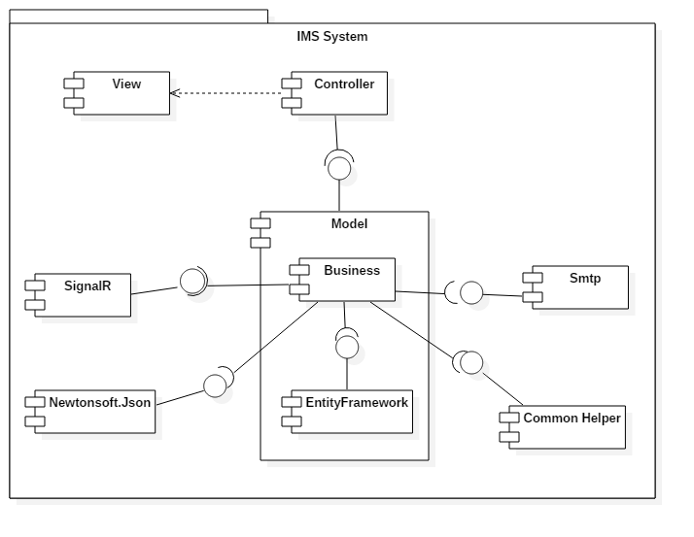

Figure 62 : Component Diagram

|  |  |
| --- | --- |
| Component Dictionary: Describes components | |
| Controller | Contain all controllers in the system. |
| View | Contain all views in the system. |
| Business | Contain all business logic processing in the system. |
| Model | Entity Framework 6 mapping models. |
| Smtp | Component is used to send asynchronous emails. |
| EntityFramework | Component is used to map database table, generate Model. |
| SignalR | Library which is used to add notification, a sort of "real-time" web functionality to ASP.NET application. |
| Newtonsoft.Json | A popular high-performance JSON framework for .NET. |
| Common Helper | Contain common libraries which are used to develop the system. |

Table 59: Component Dictionary

## Detailed Description

### Class Diagram

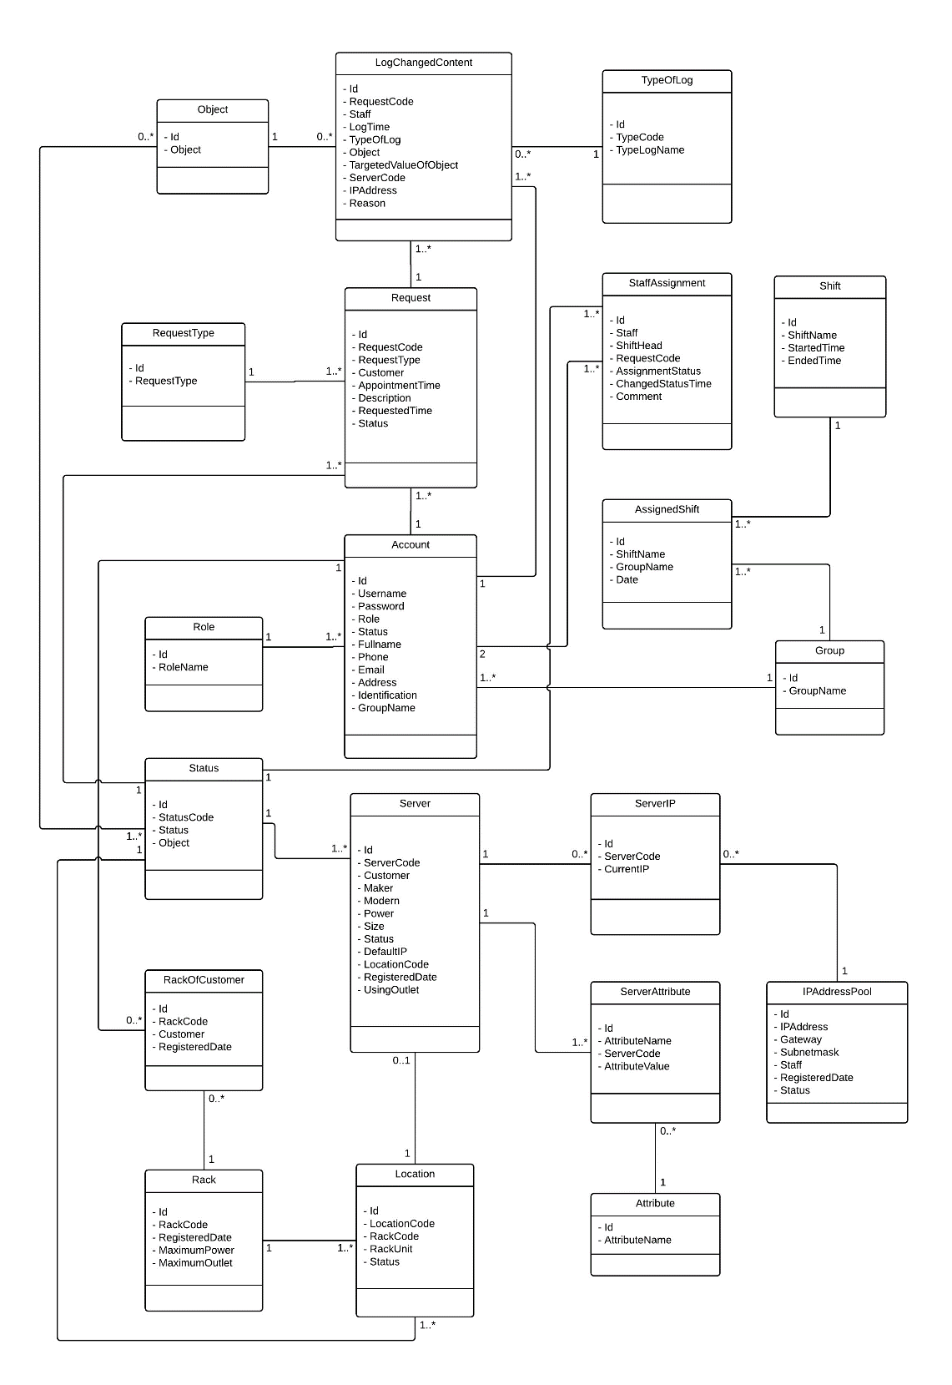

Figure 1 Class Diagram

### Interactive Diagram

#### <Customer> Add server

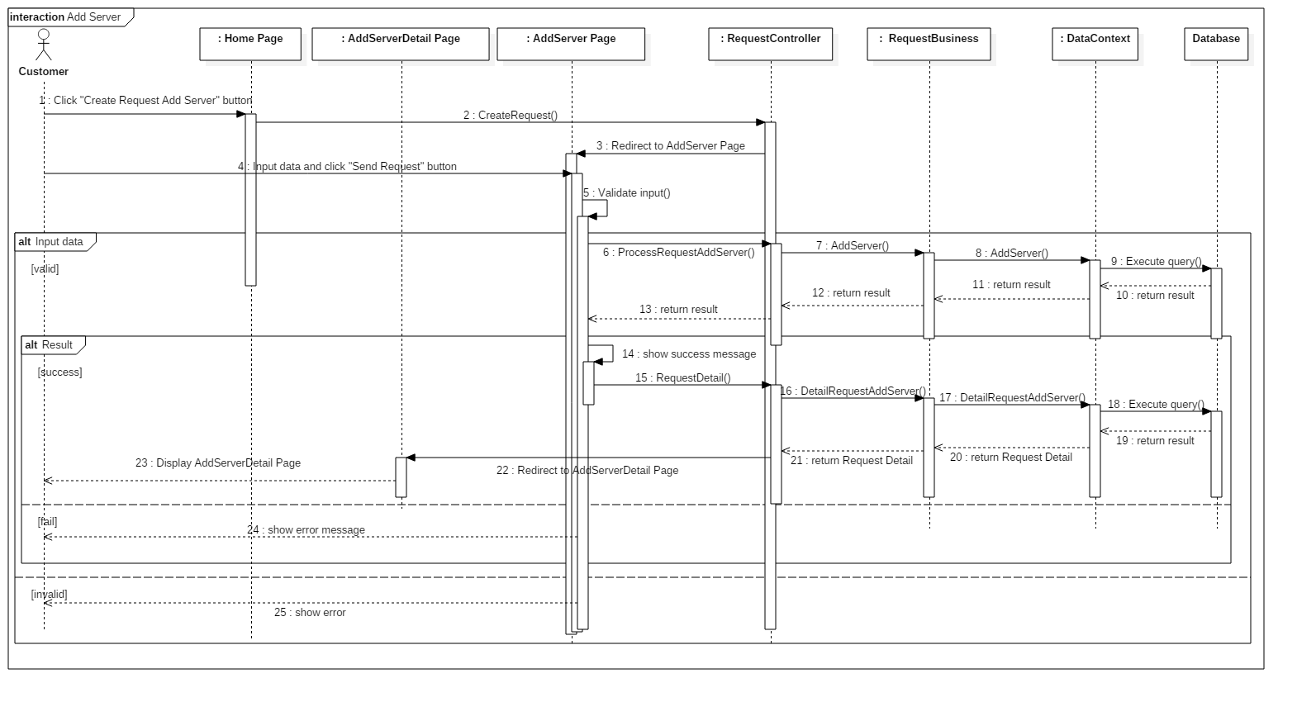**Summary:** This diagram shows how the customer add new server into data center.

Figure 38: Sequence Diagram <Customer> Add server

#### <Customer> Cancel request Add New Server

**Summary:** This diagram shows how customer cancel request Add New Server.

Figure 40: Sequence Diagram <Customer> Cancel request Add New Server

#### <Customer> Return IP

**Summary:** This diagram shows how customer return IP Address to data center.

Figure 41: Sequence Diagram <Customer> Return IP

#### <Customer> Rent rack

**Summary:** This diagram shows how to Customer rent rack from data center.

Figure 42: Sequence Diagram <Customer> Rent rack

#### <Shift Head> Approve request Assign IP

**Summary:** This diagram shows how Shift Head approve request Assign IP Address to server.

Figure 42: Sequence Diagram <Shift Head> Approve request Assign IP

#### <Shift Head> Approve request Add New Server

**Summary:** This diagram shows how Shift Head approve the request Add New Server

Figure 43: Sequence Diagram<Shift Head> Approve request Add New Server

#### <Shift Head> Approve request Change IP

**Summary:** This diagram shows how Shift Head approve request Change IP Address.

Figure 44: Sequence Diagram <Shift Head> Approve request Change IP

#### <Shift Head> Approve request Rent Rack

**Summary:** This diagram shows how Shift Head approve request Rent Rack.

Figure 45: Sequence Diagram <Shift Head> Approve request Change IP

#### <Shift Head> Reject Request Assign IP

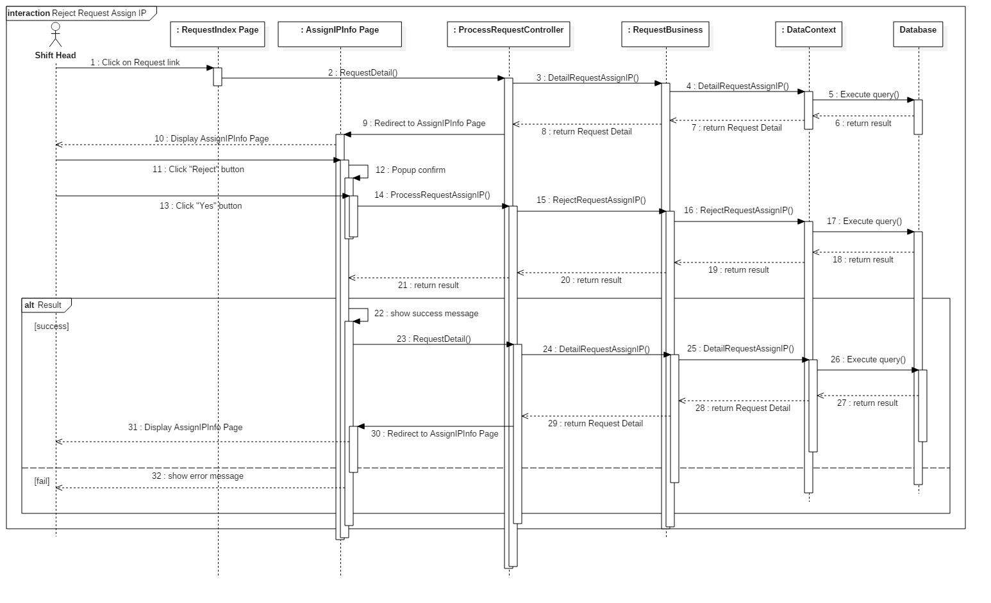**Summary:** This diagram shows how Shift Head reject request Assign IP Address

Figure 46: Sequence Diagram <Shift Head> Reject request Assign IP

#### <Shift Head> Reject request Add Server

**Summary:** This diagram shows how Shift Head reject request Add New Server.

Figure 47: Sequence Diagram <Shift Head> Reject request Add Server

#### <Shift Head> Assign Task

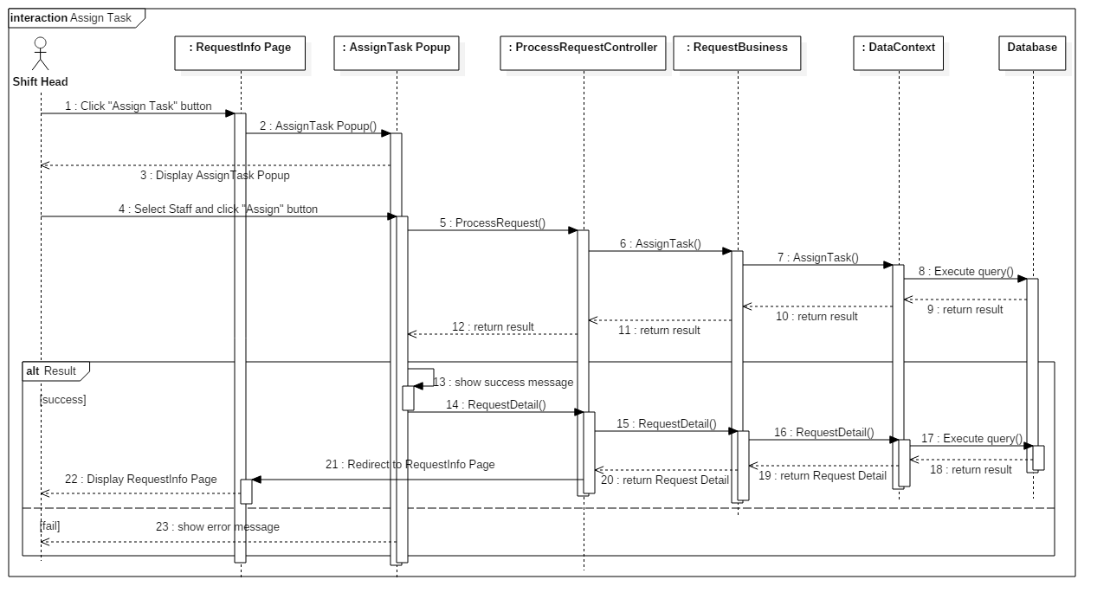**Summary:** This diagram shows how Shift Head assign task for Staff

Figure 48: Sequence Diagram <Shift Head> Assign Task

#### <Shift Head> Write note

**Summary:** This diagram shows how Shift Head write note for the next shift.

Figure 49: Sequence Diagram <Shift Head> Write note

#### <Shift Head> Add New IP

**Summary:** This diagram shows how Shift Head add new IP into data center

Figure 50: Sequence Diagram <Shift Head> Add New IP

#### <Shift Head> Add New Rack

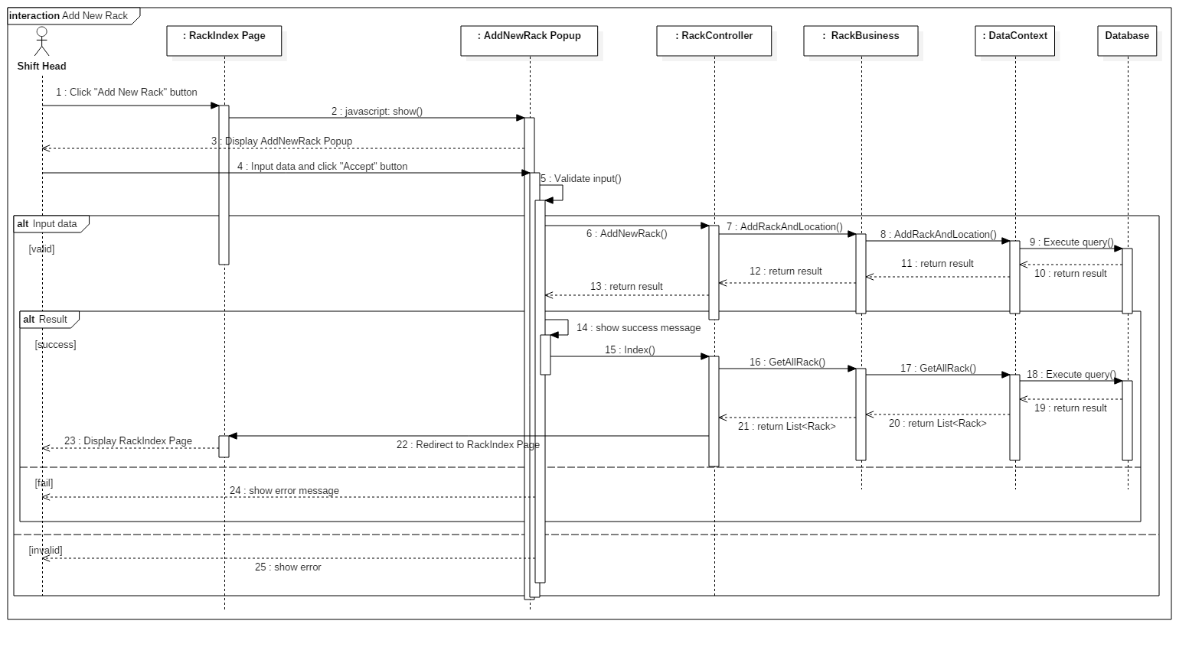**Summary:** This diagram shows how Shift Head add new rack into data center

Figure 51: Sequence Diagram <Shift Head> Add New Rack

#### <Shift Head> Export Procedure

**Summary:** This diagram shows how Shift Head export procedure for customer

Figure 51: Sequence Diagram <Shift Head> Export Procedure

#### <Shift Head> Block IP

**Summary:** This diagram shows how Shift Head Block IP

Figure 52: Sequence Diagram <Shift Head> Block IP

#### <Shift Head> Deactivate IP Range

**Summary:** This diagram shows how Shift Head deactivate IP Range

Figure 53: Sequence Diagram <Shift Head> Deactivate IP Range

#### <Shift Manager> Add New Staff

**Summary:** This diagram shows how Shift Manager add new Staff for data center

Figure 54: Sequence Diagram <Shift Manager> Add New Staff

#### <Shift Manager> Deactivate Account

**Summary:** This diagram shows how Shift Manager deactivate an Account

Figure 55: Sequence Diagram <Shift Manager> Deactivate Account

#### <Shift Manager> Edit Staff Profile

**Summary:** This diagram shows how Shift Manager edit Profile of Staff

Figure 56: Sequence Diagram <Shift Manager> Edit Staff Profile

## User Interface Design

### User Login

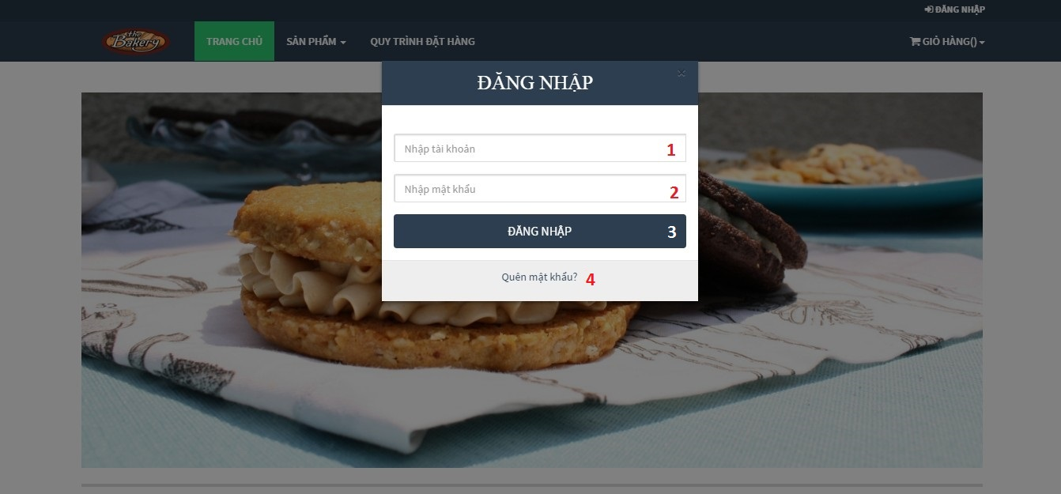

Figure 108: Login popup

**Fields**

|  |  |  |  |  |  |  |  |
| --- | --- | --- | --- | --- | --- | --- | --- |
| No. | Field name | Description | Read only | Mandatory | Control type | Data type | Length |
| 1 | Username | User enters Username | No | Yes | textbox | string | N/A |
| 2 | Password | User enters Password | No | Yes | textbox | string | N/A |

**Buttons/Hyperlinks**

|  |  |  |  |  |
| --- | --- | --- | --- | --- |
| No. | Function | Description | Validation | Outcome |
| 3 | Login | User press “Đăng nhập” button to login into system | N/A | Login to system |
| 4 | Forgot password | User click “Quên mật khẩu?” link if forgetting password | N/A | Navigate to forget password page. |

### Order A Product

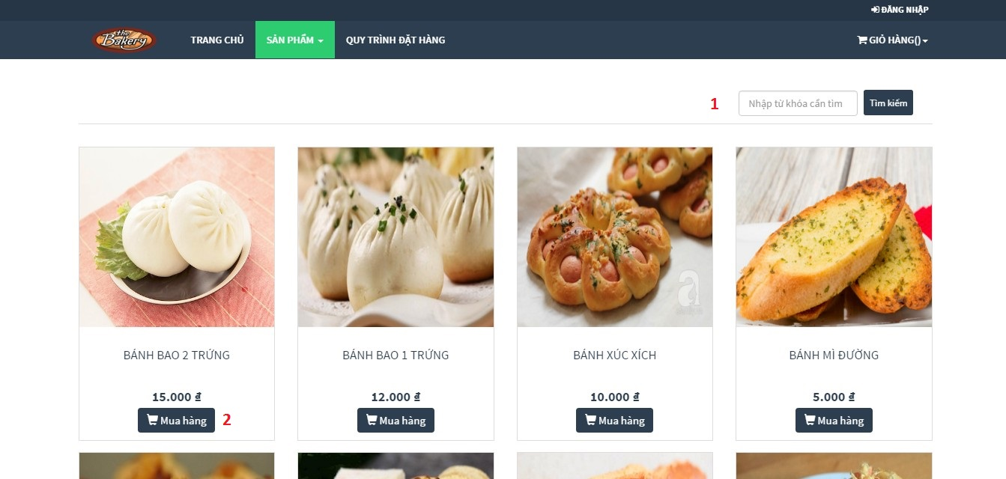

Figure 109: Order Product

**Buttons/ Hyperlinks**

|  |  |  |  |  |
| --- | --- | --- | --- | --- |
| No. | Function | Description | Validation | Outcome |
| 1 | Searching product | Searching product | N/A | List of product match with keyword |
| 2 | Add product to cart | User clicks “Mua hàng” button to order product | N/A | Popup add product to cart |

### Add to cart a product

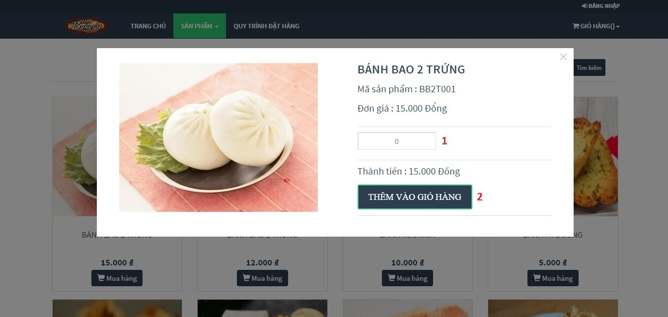

Figure 110: Add to cart a product

**Fields**:

|  |  |  |  |  |  |  |  |
| --- | --- | --- | --- | --- | --- | --- | --- |
| No. | Field name | Description | Read only | Mandatory | Control type | Data type | Length |
| 1 | Product quantity | Quantity of product that user want to order | No | Yes | textbox | number | N/A |

**Buttons/ Hyperlinks**

|  |  |  |  |  |
| --- | --- | --- | --- | --- |
| No. | Function | Description | Validation | Outcome |
| 2 | Add to cart | User click “Thêm vào giỏ hàng” button to add to cart this product | Product quantity must less than 5000 | Add this product to cart |

### Check cart

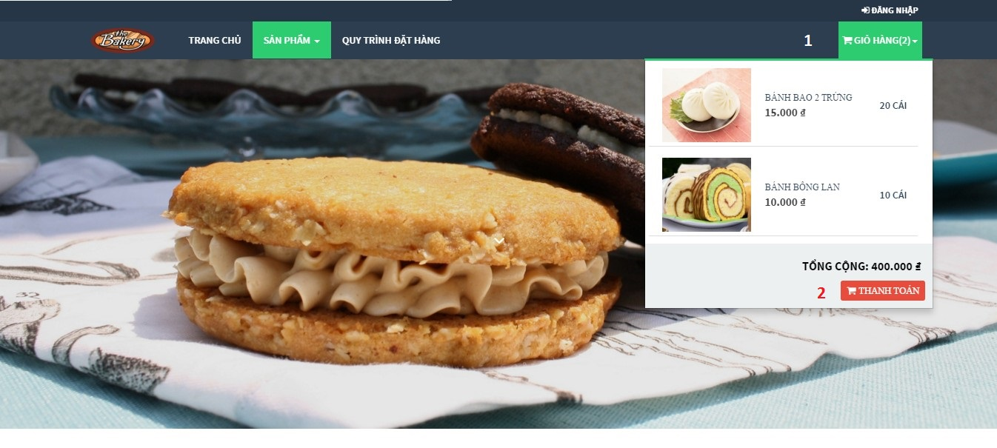

Figure 111: Check cart

**Buttons/ Hyperlinks**

|  |  |  |  |  |
| --- | --- | --- | --- | --- |
| Step | Function | Description | Validation | Outcome |
| 1 | View cart | Click “Giỏ hàng” button to view list of product in cart | N/A | List of products in cart |
| 2 | Cart information | User click “Thanh toán” button to view all of information in cart | N/A | View all of information in cart |

### View information in cart

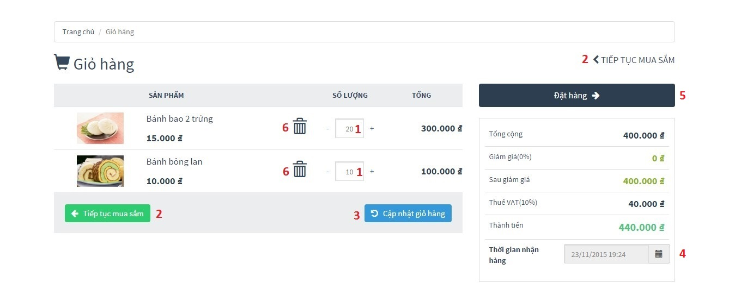

Figure 112: View information in cart

**Fields**:

|  |  |  |  |  |  |  |  |
| --- | --- | --- | --- | --- | --- | --- | --- |
| No. | Field name | Description | Read only | Mandatory | Control type | Data type | Length |
| 1 | Product quantity | Allow user can change quantity of product | No | Yes | textbox | number | N/A |
| 4 | Deliver date | User choose deliver date | Yes | Yes | textbox | Datetime | N/A |

**Buttons/Hyperlinks:**

|  |  |  |  |  |
| --- | --- | --- | --- | --- |
| No. | Function | Description | Validation | Outcome |
| 2 | Redirect to product index page | Come back to product page for user can continue order product | N/A | Redirect to product index page |
| 3 | Update cart | User click “Cập nhật giỏ hàng” button to update cart after edited | N/A | Update cart information after editing |
| 5 | Order | User click “Đặt hàng” button when wanting to finish order | Total number of products in cart must more than 20 and less than 10000 | Finish order, go to order information page |

### Confirm order

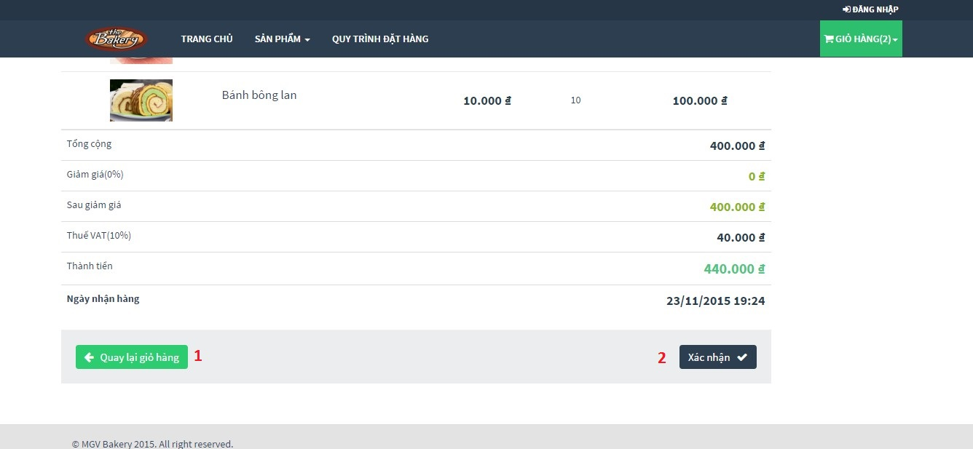

Figure 113: Confirm order

**Buttons/Hyperlinks**

|  |  |  |  |  |
| --- | --- | --- | --- | --- |
| No. | Function | Description | Validation | Outcome |
| 1 | Redirect to cart information page | Click “Quay lại giỏ hàng” button to come back to view information in cart | N/A | Redirect to cart information page |
| 2 | Customer/Guest confirms this order | Confirm order | N/A | If he/she had logged in to system by customer account, then go to order detail page. Else, go to add customer to order page |

### Add customer information to order

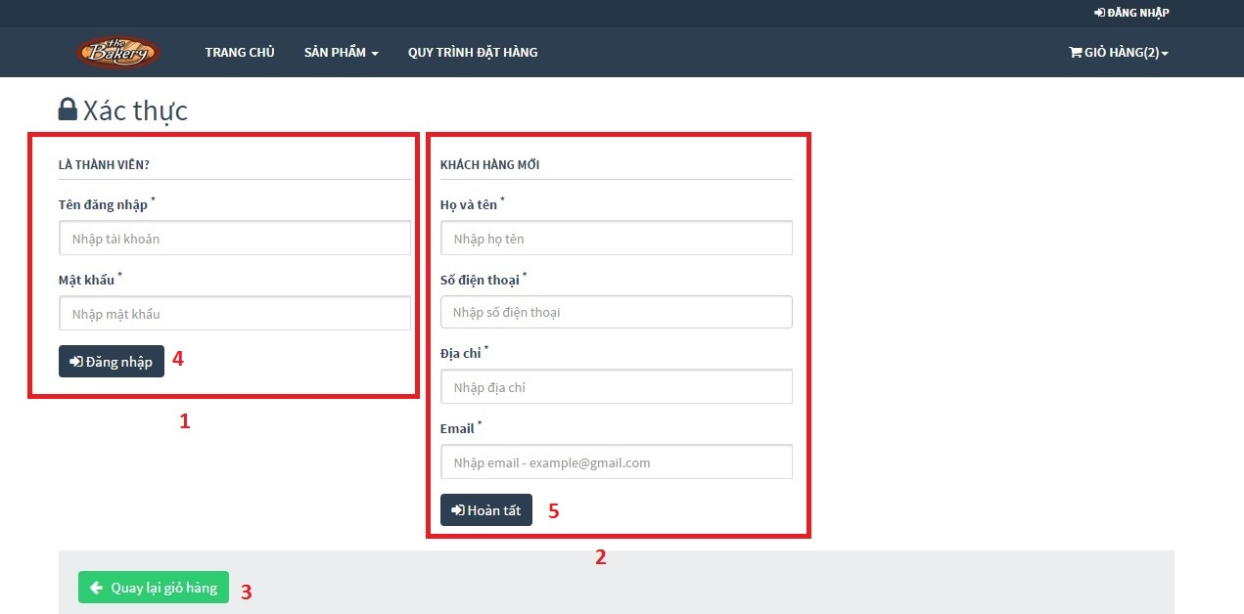

Figure 114: Add customer information to order

**Buttons/Hyperlinks**

|  |  |  |  |  |
| --- | --- | --- | --- | --- |
| No. | Function | Description | Validation | Outcome |
| 1 | Login form | Allow user can login here | N/A | Login to system |
| 2 | Guest adds information form | If user do not have account, he/she can enter personal information here | N/A | Create guest’s information successful |
| 3 | Redirect to product index page | User click “Quay lại giỏ hàng” button to come back confirm order page | N/A | Redirect to product index page |
| 4 | Login | After entering username and password, click “Đăng nhập” button to finish order | Check username and password in database | Login to system |
| 5 | Create guest’s information | After entering personal information, click “Hoàn tất” button to finish order | Check guest information | Create guest’s information successful |

### View order list

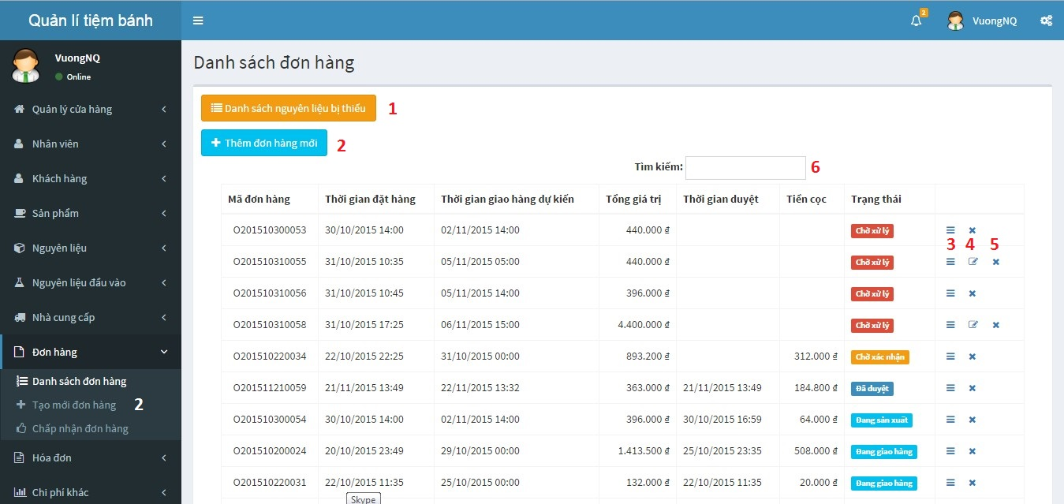

Figure 115: View order list

**Buttons/Hyperlinks**

|  |  |  |  |  |
| --- | --- | --- | --- | --- |
| No. | Function | Description | Validation | Outcome |
| 1 | List of materials are not enough in store | List of materials are not enough in store | N/A | Popup displays list of materials are not enough in store |
| 2 | Add new order | Create new order | N/A | Redirect to add new order page |
| 3 | View order detail | View order detail | N/A | Redirect to order detail page |
| 4 | Edit order | Edit order (when this order is created by customer) | N/A | Redirect to edit order page |
| 5 | Cancel order | Cancel order | N/A | Cancel order (with status “Chờ xử lí” only) |
| 6 | Search order | Search order | N/A | Show list of orders match with input keyword |

### Staff add product to order

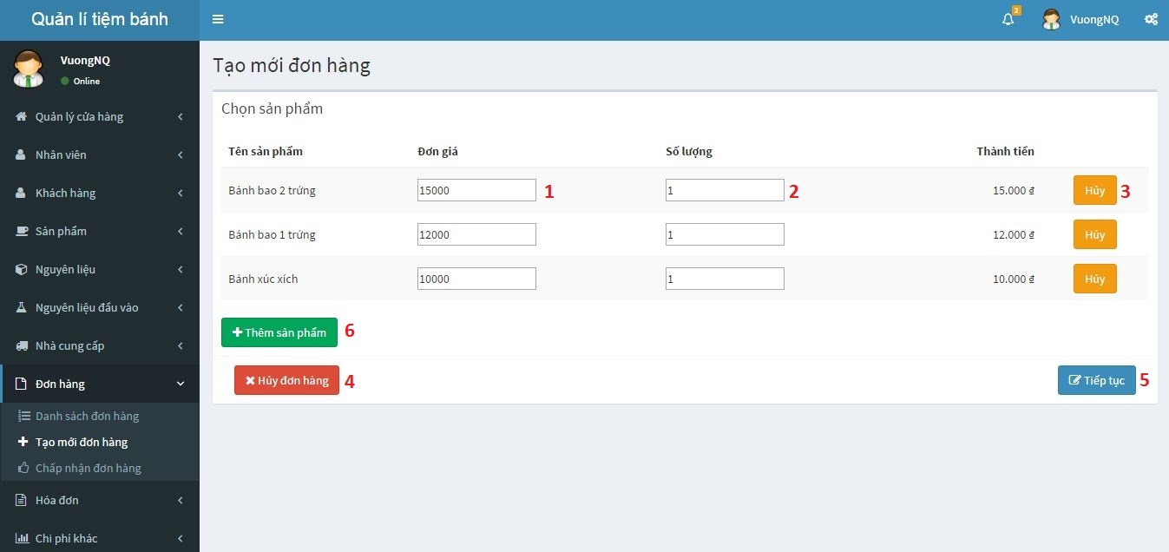

Figure 116: Staff add product to order

**Fields:**

|  |  |  |  |  |  |  |  |
| --- | --- | --- | --- | --- | --- | --- | --- |
| No. | Field name | Description | Read only | Mandatory | Control type | Data type | Length |
| 1 | Product price | Product unit price, allow editing | No | Yes | textbox | Number | N/A |
| 2 | Product quantity | Quantity of product | No | Yes | textbox | Number | N/A |

**Buttons/Hyperlinks:**

|  |  |  |  |  |
| --- | --- | --- | --- | --- |
| No. | Function | Description | Validation | Outcome |
| 3 | Delete product from cart | Delete product from list | N/A | Delete product from cart |
| 4 | Cancel to create order | Cancel to create order | N/A | Cancel to create order |
| 5 | Redirect to add customer to order | Continue order | N/A | Redirect to add customer to order |
| 6 | Add new product to order | Add new product to order |  | Popup display list of product |

### Add customer to order

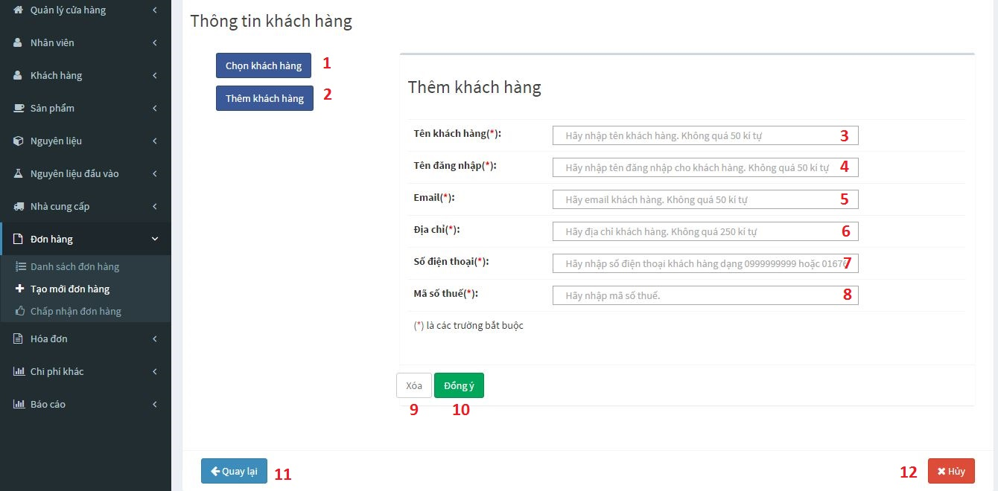

Figure 117: Add customer to order

**Field:**

|  |  |  |  |  |  |  |  |
| --- | --- | --- | --- | --- | --- | --- | --- |
| No. | Field name | Description | Read only | Mandatory | Control type | Data type | Length |
| 3 | Customer’s name | Customer’s name | No | Yes | textbox | string | N/A |
| 4 | Customer’s account name | Customer’s account name | No | Yes | textbox | string | N/A |
| 5 | Customer’s email | Customer’s email | No | Yes | textbox | string | N/A |
| 6 | Customer’s address | Customer’s address | No | Yes | textbox | string | N/A |
| 7 | Customer’s phone number | Customer’s phone number | No | Yes | textbox | number | From 10-11 number character |
| 8 | Customer’s tax code | Customer’s tax code | No | Yes | textbox | number | From 10-13 number character |

**Buttons/Hyperlinks:**

|  |  |  |  |  |
| --- | --- | --- | --- | --- |
| No. | Function | Description | Validation | Outcome |
| 1 | Add customer to order | Select to add customer to order (If this is order of customer had account in system) | N/A | Add this order for selected customer |
| 2 | Create new customer | Create customer account (If this is order of new customer) | N/A | Display add new customer form |
| 9 | Clear add new customer form | Clear data in add new customer form | N/A | Clear all fields in add new customer form |
| 10 | Add new customer | Create new customer and add this order to customer’s order history | Check customer information | Add new customer and redirect to check out with new customer page |
| 11 | Redirect to add product to order page | Redirect to add product to order page | N/A | Redirect to add product to order page |
| 12 | Cancel create order | Cancel create order | N/A | Cancel create order |

### Check out with new customer

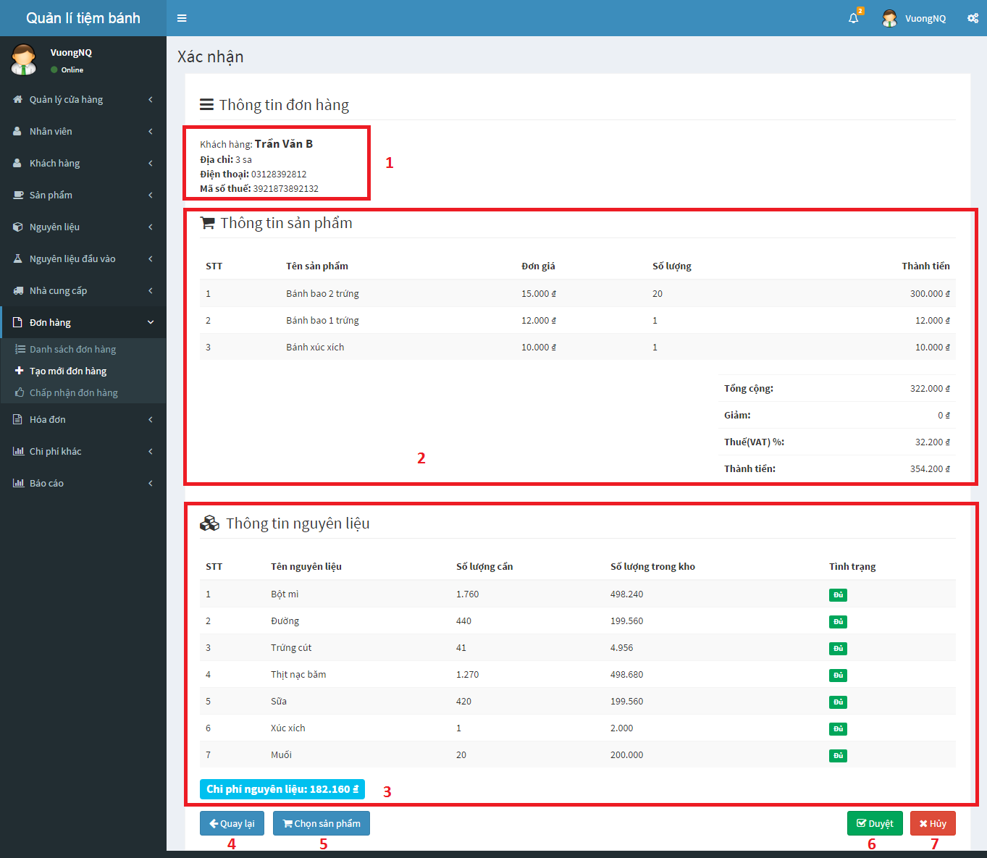

Figure 118: Check out with new customer

**Buttons/Hyperlinks:**

|  |  |  |  |  |
| --- | --- | --- | --- | --- |
| No. | Function | Description | Validation | Outcome |
| 1 | Get new customer information | New customer information | N/A | New customer information |
| 2 | Get order information | Order information | N/A | Order information |
| 3 | Get list of materials spend for this order | List of materials spend for this order | N/A | List of materials spend for this order |
| 4 | Redirect to add customer to order page | Come back to add customer to order page | N/A | Redirect to add customer to order page |
| 5 | Redirect to add product to order page | Come back to add product to order page | N/A | Redirect to add product to order page |
| 6 | Confirm order | Confirm this order | N/A | Confirm this order |
| 7 | Cancel add order | Cancel to create this order | N/A | Cancel to create this order |

### View input bill list

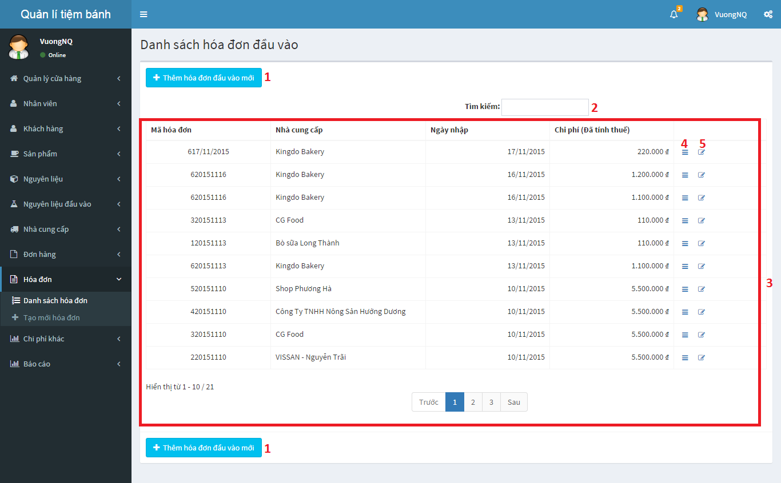

Figure 119: View input bill list

**Buttons/Hyperlinks:**

|  |  |  |  |  |
| --- | --- | --- | --- | --- |
| No. | Function | Description | Validation | Outcome |
| 1 | Add input bill | Add new input bill | N/A | Redirect to add input bill page |
| 2 | Search input bill | Search | N/A | Display list of input bills match with inputted keyword |
| 3 | Input bill index | List of all input bill in store | N/A | List of all input bill in store |
| 4 | Input bill detail | View input bill detail | N/A | Redirect to selected input bill detail page |
| 5 | Edit input bill | Edit input bill information | N/A | Redirect to selected input bill editing page |

### Add new input bill

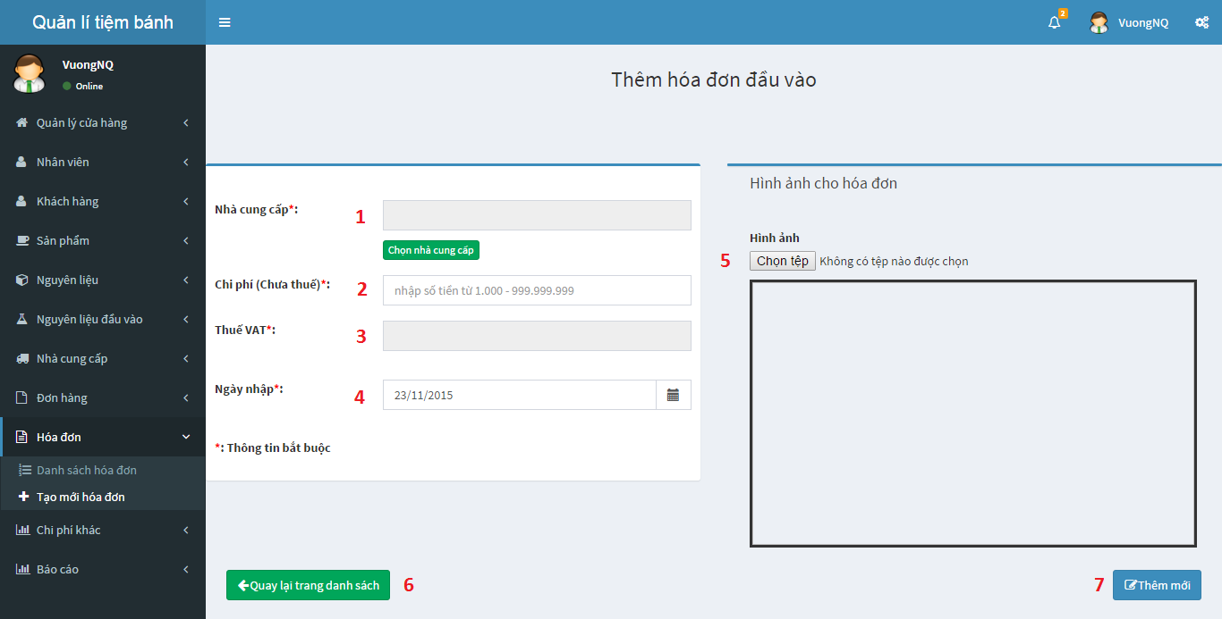

Figure 120: Add new input bill

**Fields:**

|  |  |  |  |  |  |  |  |
| --- | --- | --- | --- | --- | --- | --- | --- |
| No. | Field name | Description | Read only | Mandatory | Control type | Data type | Length |
| 1 | Supplier name | Select supplier name | Yes | Yes | textbox | string | N/A |
| 2 | Import cost | Cost in bill (not include VAT) | No | Yes | textbox | number | N/A |
| 3 | VAT cost | VAT cost (automatic render by cost in bill) | Yes | Yes | textbox | number | N/A |
| 4 | Import date | Import date | No | Yes | textbox | string | N/A |
| 5 | Input bill’s image | Input bill’s image | No | Yes | textbox | string | N/A |

**Buttons/Hyperlinks:**

|  |  |  |  |  |
| --- | --- | --- | --- | --- |
| No. | Function | Description | Validation | Outcome |
| 6 | Input bill index | Come back to input bill list | N/A | Redirect to Input Bill Index page |
| 7 | Add input bill | Add new input bill | N/A | Add new input bill |

### View input material list

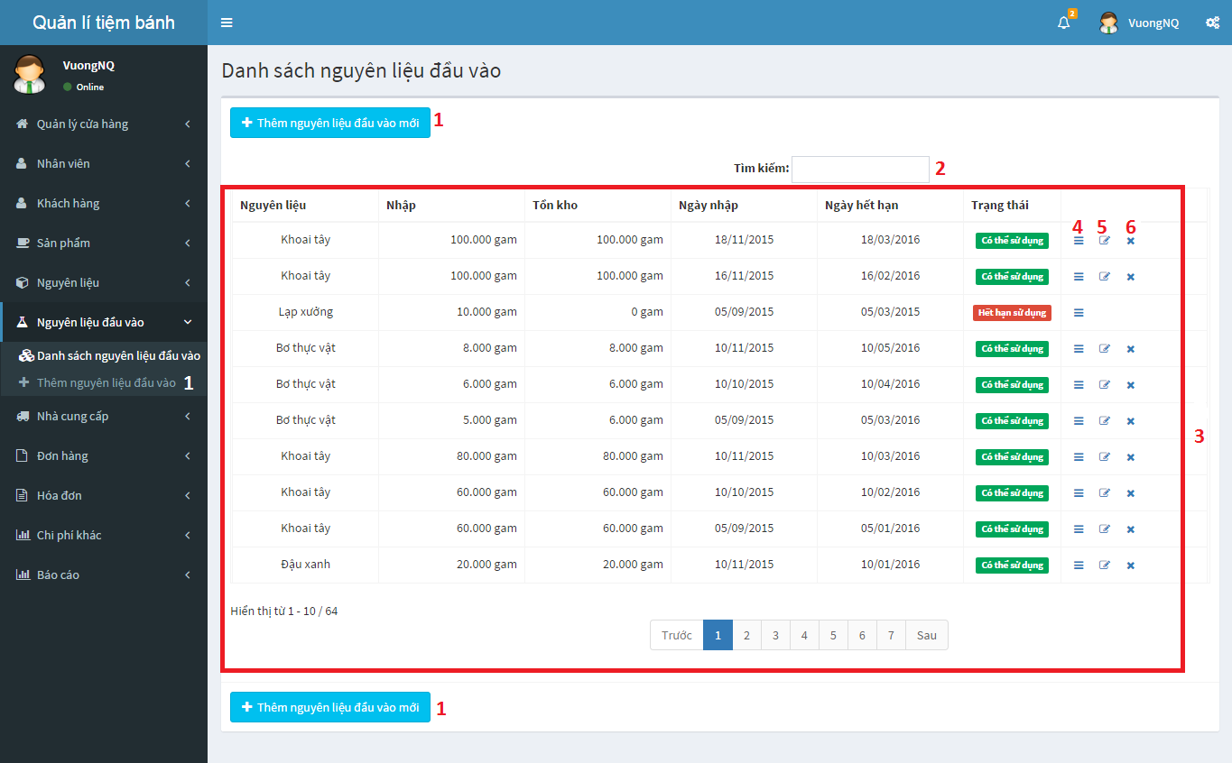

Figure 121: Input material list

**Buttons/Hyperlinks:**

|  |  |  |  |  |
| --- | --- | --- | --- | --- |
| No. | Function | Description | Validation | Outcome |
| 1 | Add input material | Add new input material | N/A | Redirect to add input material page |
| 2 | Search | Search | N/A | Display list of input materials match with inputted keyword |
| 3 | Input material index | List all of input materials in store | N/A | List all of input materials in store |
| 4 | Input material detail | View input material detail | N/A | View input material detail |
| 5 | Edit input material | Edit input material information | Only with input material that import quantity equal with remain quantity and status “Đang sử dụng” | Edit input material information |
| 6 | Discard input material | Discard input material | Only with input material that remain quantity is more than 0 and status is “Đang sử dụng” | Discard input material |

### View input material detail

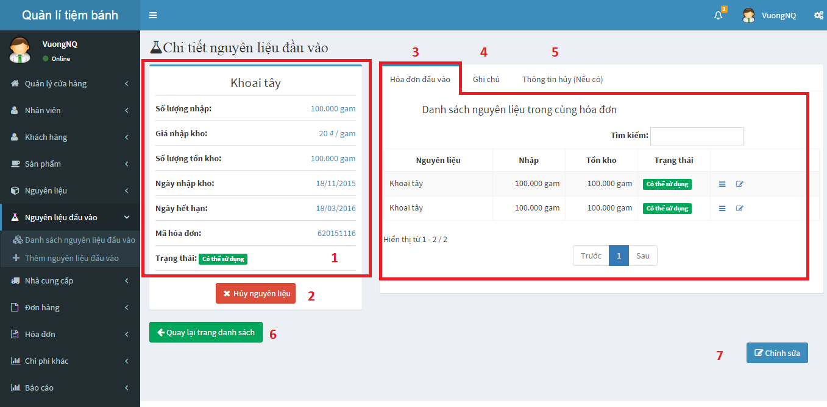

Figure 122: View input material detail

**Buttons/Hyperlinks:**

|  |  |  |  |  |
| --- | --- | --- | --- | --- |
| No. | Function | Description | Validation | Outcome |
| 1 | Input material information | Input material’s standard information | N/A | Input material’s standard information |
| 2 | Discard input material | Discard input material | Only with input material that remain quantity is more than 0 and status is “Đang sử dụng” | Discard input material |
| 3 | Input material index by input bill | List input materials in same input bill | N/A | List input materials in same input bill |
| 4 | Input material’s note | Input material’s note | N/A | Input material’s note |
| 5 | Discard input material detail | Discard input material’s detail list | N/A | Discard input material’s detail list |
| 6 | Input material index | Come back to input material list | N/A | Come back to input material list |
| 7 | Edit input material | Edit input material information | Only with input material that import quantity equal with remain quantity and status “Đang sử dụng | Edit input material information |

### Add new input material

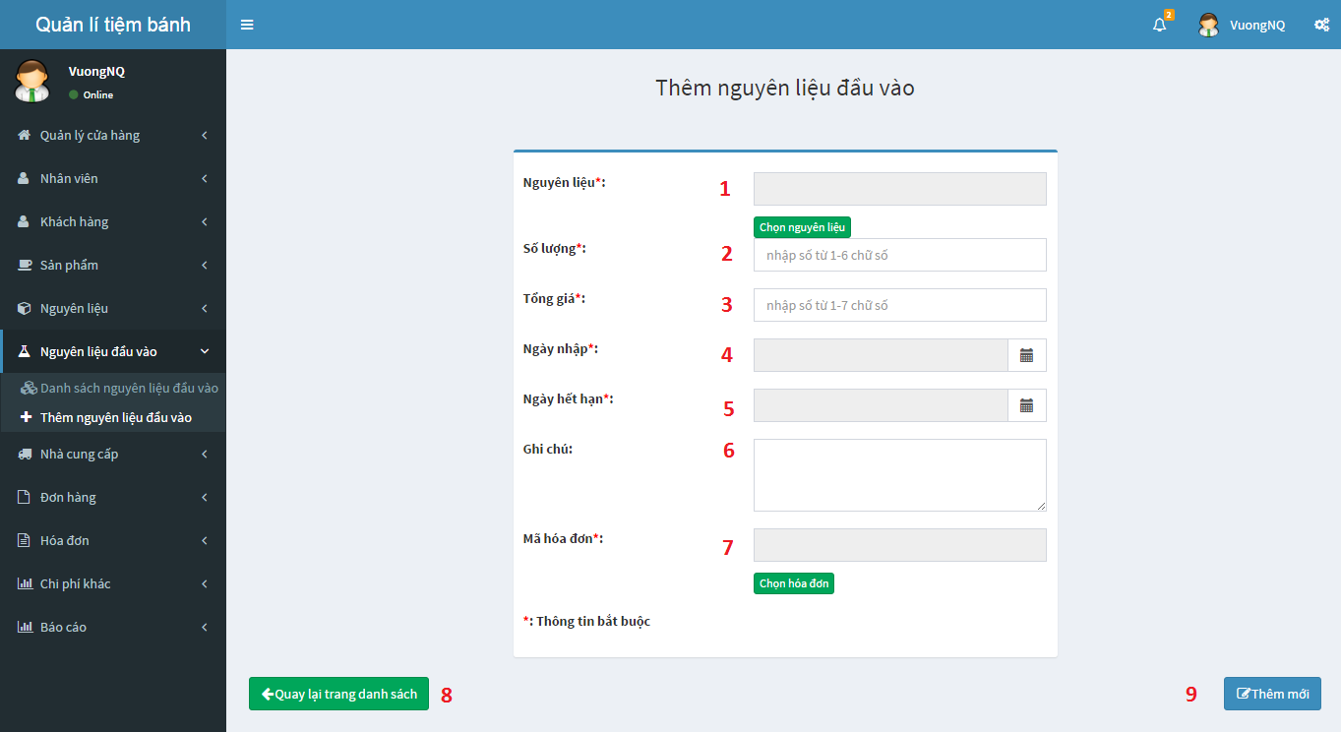

Figure 123: Add new input material

**Fields:**

|  |  |  |  |  |  |  |  |
| --- | --- | --- | --- | --- | --- | --- | --- |
| No. | Field name | Description | Read only | Mandatory | Control type | Data type | Length |
| 1 | Input material’s name | Input material’s name | Yes | Yes | textbox | string | N/A |
| 2 | Input material’s quantity | Input material’s quantity | No | Yes | textbox | string | N/A |
| 3 | Input material’s total price | Input material’s total price | No | Yes | textbox | number | N/A |
| 4 | Input material’s import date | Input material’s import date | No | Yes | textbox | number | N/A |
| 5 | Input material’s expire date | Input material’s expire date | No | Yes | textbox | string | N/A |
| 6 | Input material’s note | Input material’s note | No | Yes | textbox | string | N/A |
| 7 | Input material’s input bill code | Input material’s input bill code | Yes | Yes | textbox | string | N/A |

**Buttons/Hyperlinks:**

|  |  |  |  |  |
| --- | --- | --- | --- | --- |
| No. | Function | Description | Validation | Outcome |
| 8 | Input material index | Come back to input material list | N/A | Redirect to input material index |
| 9 | Add input bill | Add new input material | N/A | Add new input material |

### Review income by time

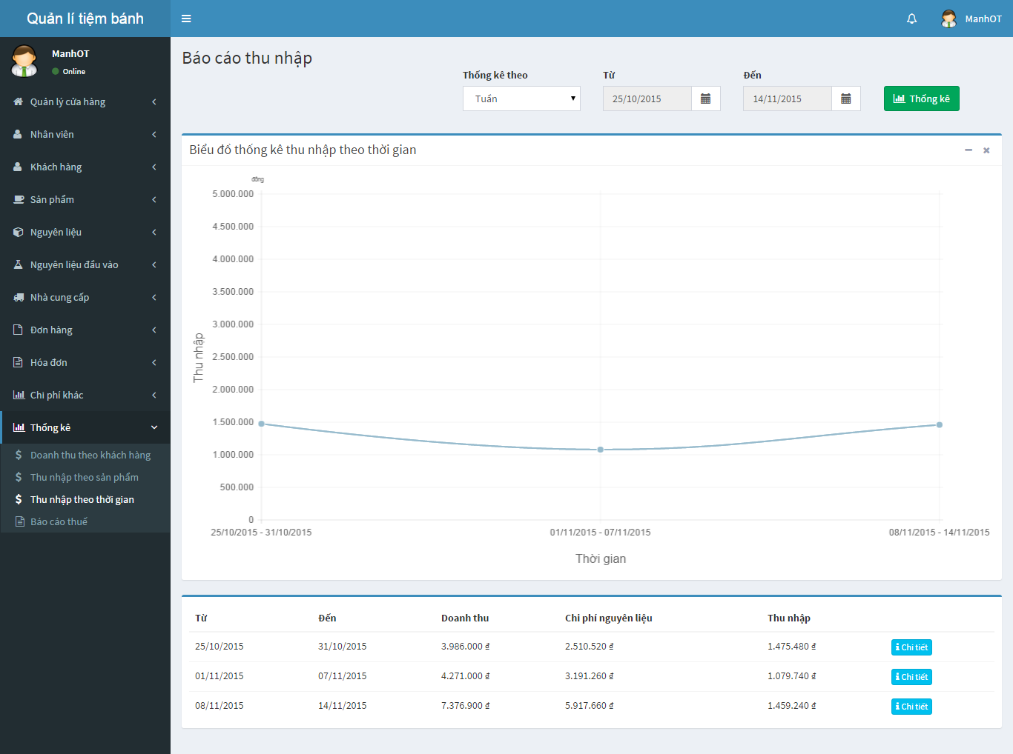

1

2

3

4

5

6

7

Figure 124: Review income by time

**Fields:**

|  |  |  |  |  |  |  |  |
| --- | --- | --- | --- | --- | --- | --- | --- |
| No. | Field name | Description | Read only | Mandatory | Control type | Data type | Length |
| 1 | Time type | Time type: week, month, year | Yes | Yes | Dropdown list | string | N/A |
| 2 | From Time | From time of chart | Yes | Yes | Datetimepicker | string | N/A |
| 3 | To Time | To time of chart | Yes | Yes | Datetimepicker | string | N/A |

**Buttons/Hyperlinks:**

|  |  |  |  |  |
| --- | --- | --- | --- | --- |
| No. | Function | Description | Validation | Outcome |
| 4 | Review income by time | Get review income by time | N/A | Show review income by time line chart |
| 5 | Get review income by time chart | Review income by time chart | N/A | Review income by time line chart |
| 6 | Get review income by time detail | Review income by time detail table | N/A | Review income by time detail table |
| 7 | Get detail of income of specified period | Get detail of income of specified period | N/A | Redirect to review income by time detail page |

### Review income weekly detail

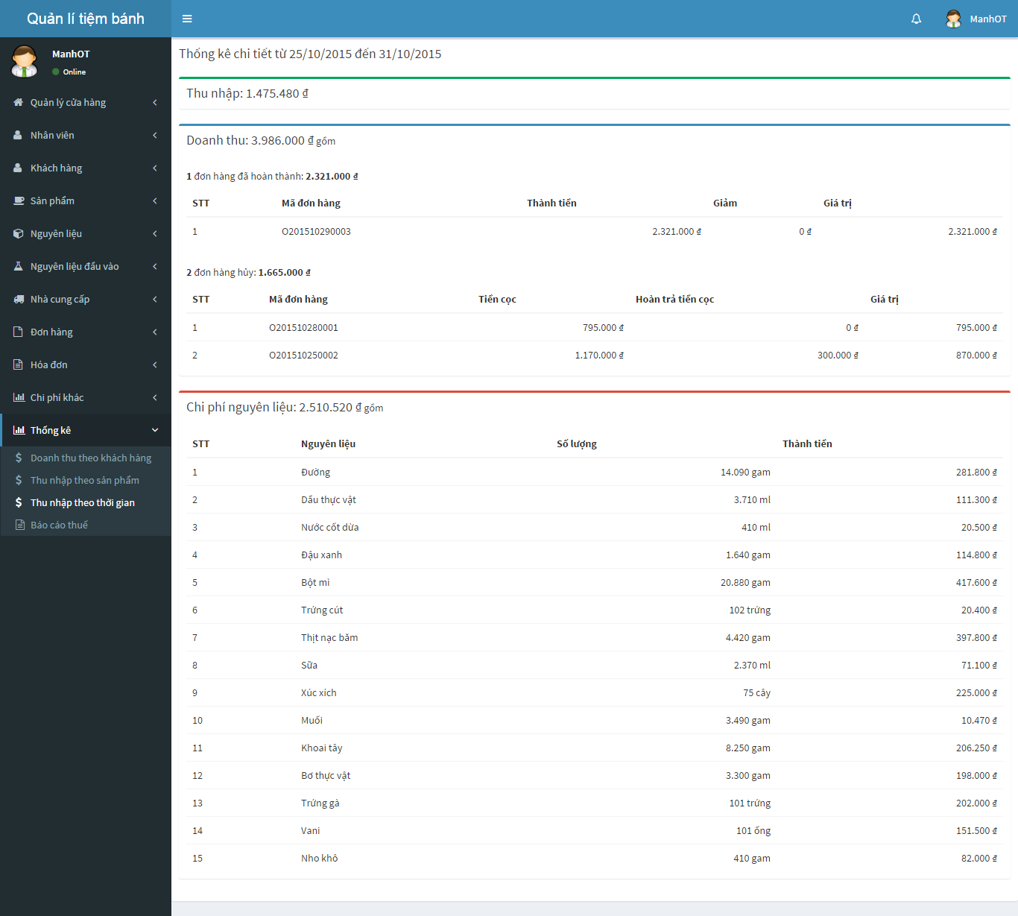

**3**

**2**

**1**

Figure 125: Review income weekly detail

**Buttons/Hyperlinks:**

|  |  |  |  |  |
| --- | --- | --- | --- | --- |
| No. | Function | Description | Validation | Outcome |
| 1 | Get income information of this period | Income information of this period | N/A | Show income information of this period |
| 2 | Get revenue information of this period | Revenue information of this period | N/A | Show revenue information of this period |
| 3 | Get material expense of this period | Material expense information of this period | N/A | Show material expense information of this period |

### VAT Tax Declaration – Appendix 1

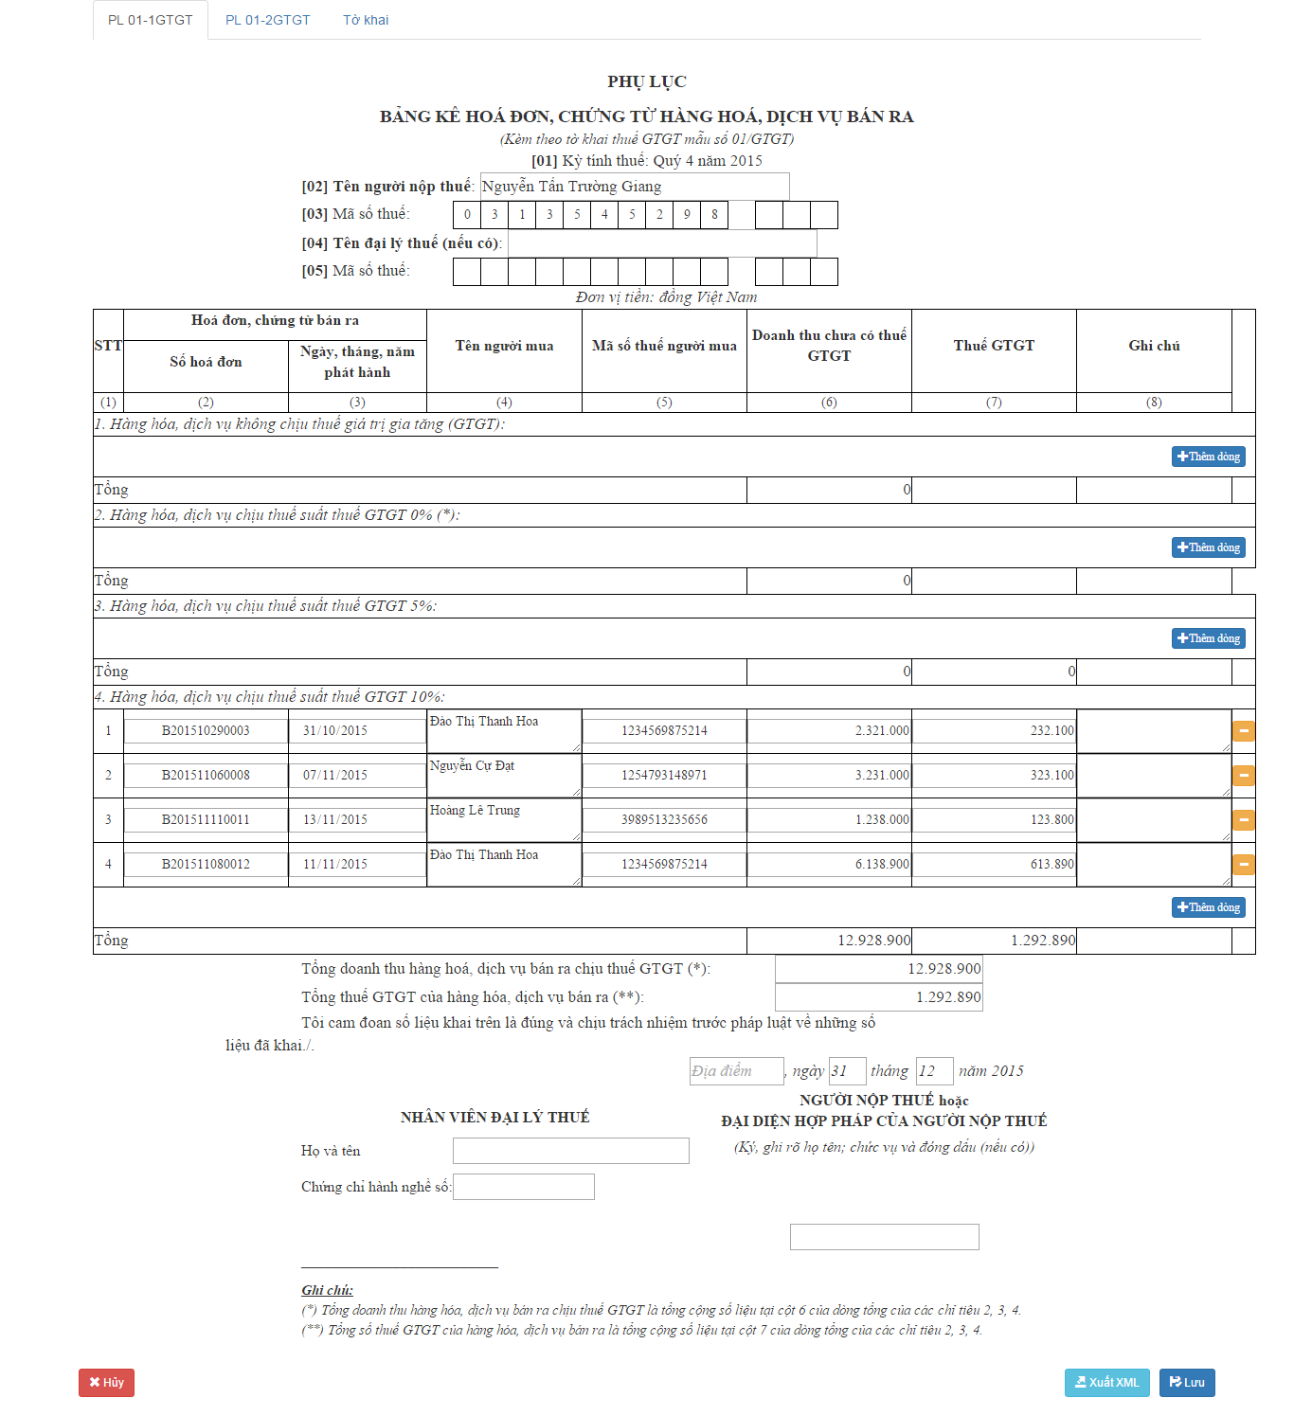

**27**

**26**

**25**

**24**

**23**

**22**

**21**

**20**

**19**

**18**

**17**

**15**

**16**

**14**

**13**

**12**

**11**

**10**

**9**

**8**

**7**

**6**

**5**

**4**

**2**

**3**

**1**

Figure 126: VAT Tax Declaration – Appendix 1

**Fields:**

|  |  |  |  |  |  |  |  |
| --- | --- | --- | --- | --- | --- | --- | --- |
| No. | Field name | Description | Read only | Mandatory | Control type | Data type | Length |
| 1 | Store owner name | Store owner name | No | Yes | Textbox | string | N/A |
| 2 | Store tax code | Store tax code | No | Yes | Number | string | 1letter/cell |
| 3 | Tax agent owner name | Tax agent owner name | No | No | Textbox | string | N/A |
| 4 | Tax agent tax code | Tax agent tax code | No | No | Number | string | 1letter/cell |
| 21 | Bill code | Bill code | No | No | Textbox | string | 15 |
| 22 | Bill date | Bill date | No | No | Date | string | 10 |
| 23 | Customer name | Customer name | No | No | Textbox | string | N/A |
| 24 | Customer tax code | Customer tax code | No | No | Textbox | string | 13 |
| 25 | Revenue | Revenue | No | No | Number | string | N/A |
| 26 | Tax amount | Tax amount | No | No | Number | string | N/A |
| 27 | Note | Note | No | No | Textbox | string | N/A |
| 10 | Total revenue | Total revenue | Yes | Yes | Number | string | N/A |
| 11 | Total tax amount | Total tax amount | Yes | Yes | Number | string | N/A |
| 12 | Create location | Create location | No | No | Textbox | string | N/A |
| 13 | Create day | Create day | No | No | Number | string | 2 |
| 14 | Create month | Create month | No | No | Number | string | 2 |
| 15 | Tax agent name | Tax agent name | No | No | Textbox | string | 30 |
| 16 | Tax agent certificate number | Tax agent certificate number | No | No | Textbox | string | 10 |
| 17 | Sign name | Sign name | No | No | Textbox | string | N/A |

**Buttons/Hyperlinks:**

|  |  |  |  |  |
| --- | --- | --- | --- | --- |
| No. | Function | Description | Validation | Outcome |
| 5 | Insert more row | Insert more row for products no VAT tax | N/A | Insert new row for products no VAT tax |
| 6 | Insert more row | Insert more row for products 0% VAT tax | N/A | Insert new row for products 0% VAT tax |
| 7 | Insert more row | Insert more row for products 5% VAT tax | N/A | Insert new row for products 5% VAT tax |
| 8 | Remove row | Remove the specified row | N/A | Remove the specified row |
| 9 | Insert more row | Insert more row for products 10% VAT tax | N/A | Insert new row for products 10% VAT tax |
| 18 | Cancel | Cancel this declaration | N/A | Cancel this declaration |
| 19 | Export XML file | Export XML file | N/A | Export XML file |
| 20 | Save the declaration | Save the declaration | N/A | Save the declaration |

## Database Design

### Entity relationship diagram

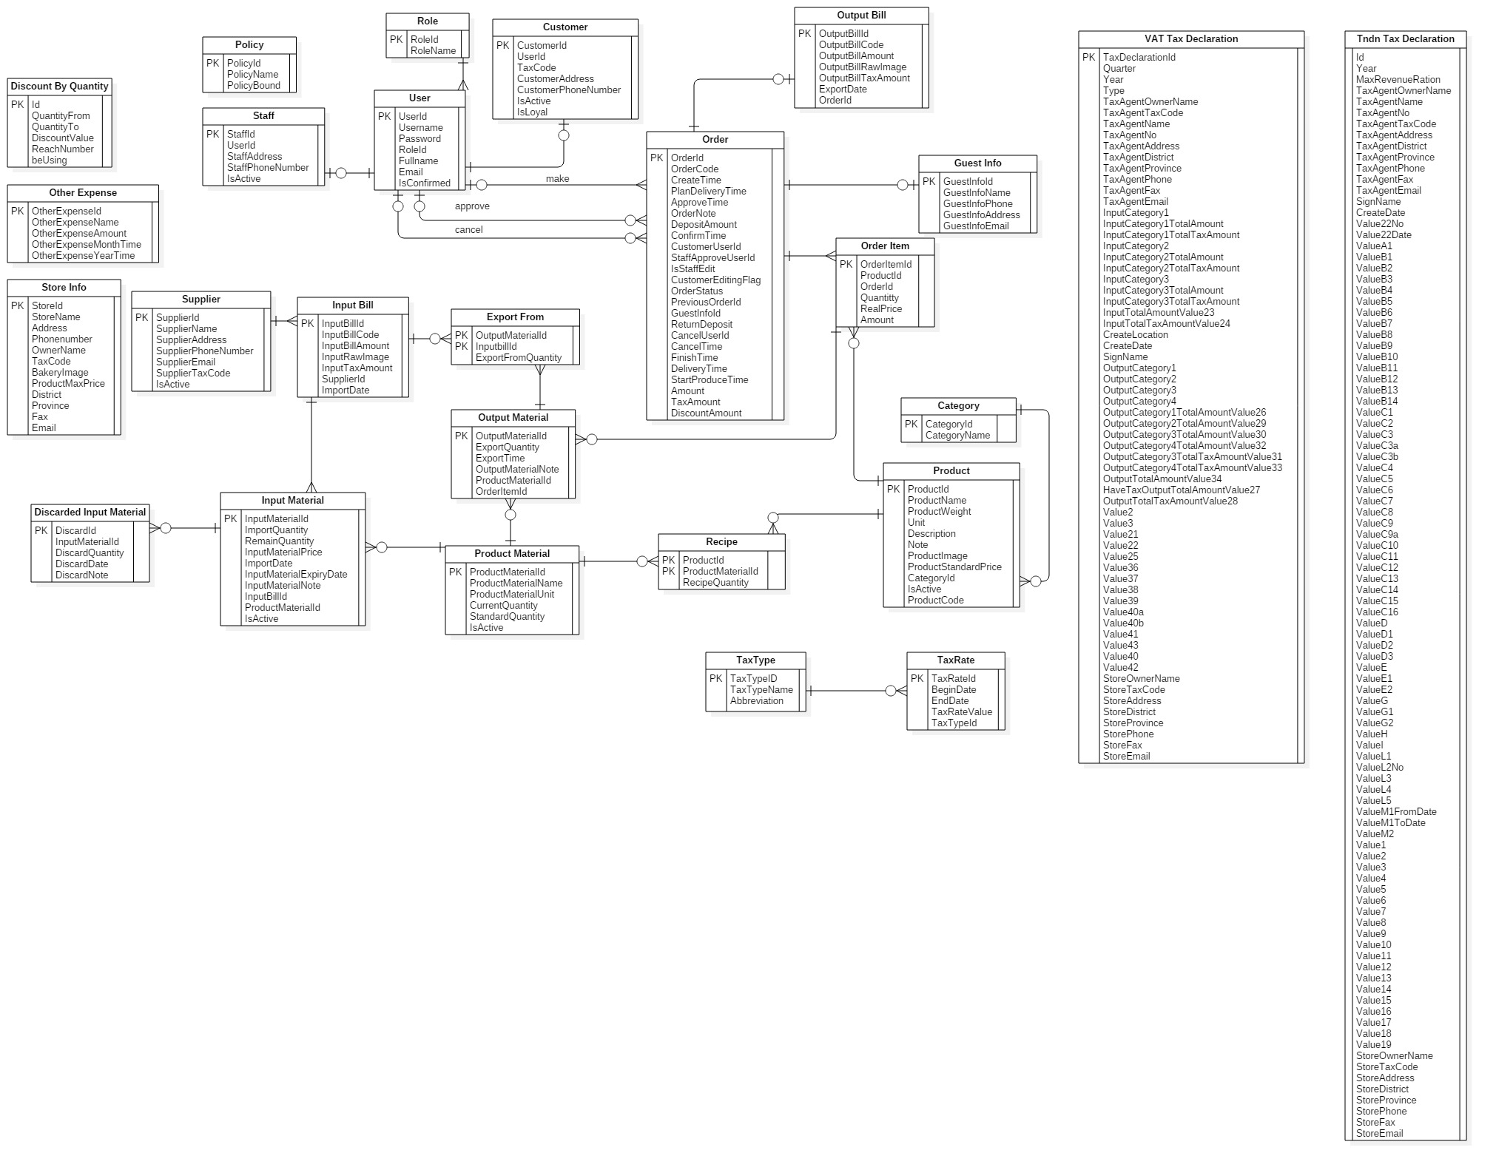

Figure 127 : Entity relationship diagram

### Entity Dictionary

|  |  |
| --- | --- |
| Entity Data Dictionary: describe content of all entities | |
| **Entity name** | **Description** |
| Discount By Quantity | Describe all discounts by quantity in the system |
| Other Expense | Describe all other expenses in the system |
| StoreInfo | Describe all information of store in the system |
| Policy | Describe all policies in the system |
| Role | Describe all roles in the system |
| User | Describe all users in the system |
| Customer | Describe all customers in the system |
| Staff | Describe all staffs in the system |
| Guest Info | Describe all guest information in the system |
| Orders | Describe all orders in the system |
| Output Bill | Describe all output bills in the system |
| Order Item | Describe all order items of an order in the system |
| Category | Describe all categories in the system |
| Product | Describe all products in the system |
| Supplier | Describe all suppliers in the system |
| Input Bill | Describe all input bills in the system |
| Discarded Input Material | Describe all discard information of an input material in the system |
| Input Material | Describe all input materials in the system |
| Export From | Describe all relationship information between output material and input bill |
| Product Material | Describe all product materials in the system |
| Output Material | Describe all output materials of an order item in the system |
| Recipe | Describe all of materials of each product in the system |
| Tax Rate | Describe all tax rates in the system |
| Tax Type | Describe all tax types in the system |
| VAT Tax Declaration | Describe all information in VAT tax declaration |
| Tndn Tax Declaration | Describe all information in Excise tax declaration |

Table 61 : Entity dictionary

|  |  |  |  |  |
| --- | --- | --- | --- | --- |
| **Entity name** | **Attribute** | **Description** | **Domain** | **Allow null** |
| **Discount By Quantity** | Id (PK) | Unique identifier of discount by quantity | int | No |
| QuantityFrom | Min quantity to get discount | int | No |
| QuantityTo | Max quantity to get discount | int | No |
| DiscountValue | Discount value | int | No |
| beUsing | Identifier for discount or not | int | No |
| **Other Expense** | OtherExpenseId (PK) | Unique identifier of other expense | int | No |
| OtherExpenseName | Other expense name | nvarchar(100) | No |
| OtherExpenseAmount | Other expense amount | int | No |
| OtherExpenseMonthTime | Other expense month | int | Yes |
| OtherExpenseYearTime | Other expense year | int | Yes |
| Type | Type of other expense | int | No |
| **StoreInfo** | StoreId (PK) | Unique identifier of store information | int | No |
| StoreName | Name of the store | nvarchar(50) | No |
| Address | Store address (include No, Street name) | nvarchar(200) | No |
| Phonenumber | Store phone number | nvarchar(20) | No |
| OwnerName | Store owner name | nvarchar(50) | No |
| TaxCode | Store tax code | varchar(20) |  |
| BakeryImage | Link of bakery’s logo | nvarchar(200) |  |
| District | Store address’s district | nvarchar(50) | No |
| Province | Store address’s province | nvarchar(50) | No |
| Fax | Store fax number | nvarchar(50) | Yes |
| Email | Store email | nvarchar(50) | Yes |
| **Policy** | PolicyId (PK) | Unique identifier of policy | int | No |
| PolicyName | Name of policy | nvarchar(50) | No |
| PolicyBound | Max value of policy | int | No |
| **Role** | RoleId (PK) | Unique identifier of role | int | No |
| Name | Role name | nvarchar(50) | No |
| **User** | UserId (PK) | Unique identifier of user | int | No |
| Username | User name in the system | nvarchar(50) | No |
| Password | User’s password | nvarchar(max) | Yes |
| RoleId (FK) | Foreign key, role identifier | int | No |
| Fullname | User’s fullname | nvarchar(50) | Yes |
| Email | User’s email | nvarchar(250) | Yes |
| IsConfirmed | Check the account is used or not | bit | No |
| **Customer** | CustomerId (PK) | Unique identifier of customer | int | No |
| UserId (FK) | Foreign key, user identifier | int | No |
| TaxCode | Customer’s tax code | nvarchar(20) | Yes |
| CustomerAddress | Customer’s address | nvarchar(200) | Yes |
| CustomerPhoneNumber | Customer’s phone number | nvarchar(20) | Yes |
| IsActive | Customer’s staus | bit | No |
| IsLoyal | Identifier for loyal customer | bit | No |
| **Staff** | StaffId (PK) | Unique identifier of staff | int | No |
| UserId (FK) | Foreign key, user identifier | int | No |
| StaffAddress | Staff’s address | nvarchar(200) | Yes |
| StaffPhoneNumber | Staff’s phone number | nvarchar(20) | Yes |
| IsActive | Staff’s status | bit | No |
| **Guest Info** | GuestInfoId (PK) | Unique identifier for guest information | int | No |
| GuestInfoName | Guest’s name | nvarchar(50) | No |
| GuestInfoPhone | Guest’s phone | nvarchar(20) | No |
| GuestInfoAddress | Guest’s address | nvarchar(200) | No |
| GuestInfoEmail | Guest’s email | nvarchar(200) | No |
| **Orders** | OrderId (PK) | Unique identifier for order | int | No |
| OrderCode | Order code | varchar(13) | No |
| CreateTime | Order create time | datetime | No |
| PlanDeliveryTime | Order plan delivery time | datetime | No |
| ApproveTime | Order approve time | datetime | Yes |
| OrderNote | Order note | nvarchar(200) | Yes |
| DepositAmount | Deposit amount | int | No |
| ConfirmTime | Order confirm time | datetime | Yes |
| CustomerUserId (FK) | Foreign key, customer user identifier | int | Yes |
| StaffApproveUserId (FK) | Foreign key, approved staff user identifier | int | Yes |
| IsStaffEdit | Check order staff edit or not | bit | No |
| CustomerEditingFlag | Check order customer edit or not | bit | No |
| OrderStatus | Order status | int | No |
| PreviousOrderId (FK) | The previous version of order before staff edit | int | Yes |
| GuestInfoId (FK) | Foreign key, guest identifier | int | Yes |
| ReturnDeposit | Return deposit when order is canceled | int | No |
| CancelUserId (FK) | Foreign key, canceled customer user identifier | int | Yes |
| CancelTime | Order’s cancel time | datetime | Yes |
| FinishTime | Order’s finish time | datetime | Yes |
| DeliveryTime | Order’s delivery time | datetime | Yes |
| StartProduceTime | Order’s start producing time | datetime | Yes |
| Amount | Order’s total amount | int | No |
| TaxAmount | Order’s total tax amount | int | No |
| DiscountAmount | Order’s discount amount | int | No |
| **Output Bill** | OutputBillId (PK) | Unique identifier for output bill | int | No |
| OutputBillCode | Output bill code | nvarchar(50) | No |
| OutputBillAmount | Output bill amount | float | No |
| OutputBillRawImage | Output bill raw image | nvarchar(200) | Yes |
| OutputBillTaxAmount | Output bill tax amount | float | No |
| ExportDate | Export date | date | No |
| OrderId (FK) | Foreign key, Order identifier | int | No |
| **Order Item** | OrderItemId (PK) | Unique identifier for order item | int | No |
| ProductId (FK) | Foreign key, product identifier | int | No |
| OrderId (FK) | Foreign key, order identifier | int | No |
| Quantity | Order item’s quantity | int | No |
| RealPrice | Order item’s real price | int | No |
| Amount | Order item’s total amount | int | No |
| **Category** | CategoryId (PK) | Unique identifier for category | int | No |
| CategoryName | Category name | nvarchar(200) | No |
| **Product** | ProductId (PK) | Unique identifier for product | int | No |
| ProductName | Product’s name | nvarchar(200) | No |
| ProductWeight | Product’s weight | float | No |
| Unit | Product’s unit | nvarchar(50) | No |
| Descriptions | Product’s description | nvarchar(500) | Yes |
| Note | Product’s note | nvarchar(500) | Yes |
| ProductImage | Product’s image | nvarchar(200) | Yes |
| ProductStandardPrice | Product’s standard price | int | No |
| CategoryId (FK) | Foreign key, category identifier | int | Yes |
| IsActive | Product’s status | bit | No |
| ProductCode | Product’s code | varchar(10) | No |
| **Supplier** | SupplierId (PK) | Unique identifier for supplier | int | No |
| SupplierName | Supplier’s name | nvarchar(200) | No |
| SupplierAddress | Supplier’s address | nvarchar(200) | No |
| SupplierPhoneNumber | Supplier’s phone number | char(12) | No |
| SupplierEmail | Supplier’s email | nvarchar(50) | No |
| SupplierTaxCode | Supplier’s tax code | char(20) | No |
| IsActive | Supplier’s status | bit | No |
| **Input Bill** | InputBillId (PK) | Unique identifier for input bill | int | No |
| InputBillCode | Input bill’s code | nvarchar(50) | No |
| InputBillAmount | Input bill’s amount | float | No |
| InputRawImage | Input bill’s raw image | nvarchar(200) | Yes |
| InputTaxAmount | Input bill’s tax amount | float | No |
| SupplierId (FK) | Foreign key, supplier identifier | int | No |
| ImportDate | Import date | date | No |
| **Discarded Input Material** | DiscardId (PK) | Unique identifier for discard input material | int | No |
| InputMaterialId (FK) | Foreign key, input material identifier | int | No |
| DiscardQuantity | Discard quantity | int | No |
| DiscardDate | Discard Date | date | No |
| DiscardNote | Discard’s Note | nvarchar(200) | No |
| **Input Material** | InputMaterialId (PK) | Unique identifier for input material | int | No |
| ImportQuantity | Import quantity | int | No |
| RemainQuantity | Remain quantity | int | No |
| InputMaterialPrice | Input material price per unit | float | No |
| ImportDate | Import Date | date | No |
| InputMaterialExpiryDate | Expiry Date | date | No |
| InputMaterialNote | Input material’s nore | nvarchar(500) | Yes |
| InputBillId (FK) | Foreign key, input bill identifier | int | No |
| ProductMaterialId (FK) | Foreign key, product material identifier | int | No |
| IsActive | Input materil’s status | bit | No |
| **Export From** | OutputMaterialId (PK,FK) | One member of composite primary key  Foreign key, output material identifier | int | No |
| InputbillId (PK,FK) | One member of composite primary key  Foreign key, input bill identifier | int | No |
| ExportFromQuantity | Export quantity | int | No |
| **Product Material** | ProductMaterialId (PK) | Unique identifier for product material | int | No |
| ProductMaterialName | Product material’s name | nvarchar(100) | No |
| ProductMaterialUnit | Product material’s unit | nvarchar(50) | No |
| CurrentQuantity | Current quantity | int | No |
| StandardQuantity | Standard quantity | int | Yes |
| IsActive | Product material’s status | bit | No |
| **Output Material** | OutputMaterialId (PK) | Unique identifier for output material | int | No |
| ExportQuantity | Export quantity | int | No |
| ExportTime | Export time | datetime | Yes |
| OutputMaterialNote | Output material’s note | nvarchar(500) | Yes |
| ProductMaterialId (FK) | Foreign key, product material identifier | int | No |
| OrderItemId (FK) | Foreign key, order item identifier | int | No |
| **Recipe** | ProductId (PK,FK) | One member of composite primary key  Foreign key, product identifier | int | No |
| ProductMaterialId (PK,FK) | One member of composite primary key  Foreign key, product material identifier | int | No |
| RecipeQuantity | Quantity | float | No |
| **Tax Rate** | TaxRateId (PK) | Unique identifier for tax rate | int | No |
| BeginDate | Valid begin date | date | No |
| EndDate | Valid end date | date | Yes |
| TaxRateValue | Tax rate value | int | No |
| TaxTypeId (FK) | Foreign key, tax type identifier | int | No |
| **Tax Type** | TaxTypeID (PK) | Unique identifier for tax type | int | No |
| TaxTypeName | Tax type’s name | nvarchar(200) | No |
| Abbreviation | Short name of tax type | varchar(10) | Yes |
| **VAT Tax Declaration** | TaxDeclarationId | Unique identifier for VAT Tax Declaration | int | No |
| Quarter | VAT Tax Declaration’s quarter | int | No |
| Year | VAT Tax Declaration’s year | int | No |
| Type | VAT Tax Declaration’s type | int | No |
| TaxAgentOwnerName | Tax agent owner name | nvarchar(50) | No |
| TaxAgentTaxCode | Tax agent tax code | varchar(15) | No |
| TaxAgentName | Tax agent name | nvarchar(50) | No |
| TaxAgentNo | Tax agent certificate number | varchar(15) | No |
| InputCategory1 | Category 1 in appendix 1 tax declaration | nvarchar(max) | Yes |
| InputCategory1TotalAmount | Category 1 in appendix 1 tax declaration total amount | int | Yes |
| InputCategory1TotalTaxAmount | Category 1 in appendix 1 tax declaration total tax amount | int | Yes |
| InputCategory2 | Category 2 in appendix 1 tax declaration | nvarchar(max) | Yes |
| InputCategory2TotalAmount | Category 2 in appendix 1 tax declaration total amount | int | Yes |
| InputCategory2TotalTaxAmount | Category 2 in appendix 1 tax declaration total tax amount | int | Yes |
| InputCategory3 | Category 3 in appendix 1 tax declaration | nvarchar(max) | Yes |
| InputCategory3TotalAmount | Category 3 in appendix 1 tax declaration total amount | int | Yes |
| InputCategory3TotalTaxAmount | Category 3 in appendix 1 tax declaration total tax amount | int | Yes |
| InputTotalAmountValue23 | Total value in appendix 1 | int | No |
| InputTotalTaxAmountValue24 | Total tax value in appendix 1 | int | No |
| CreateLocation | Create Location | nvarchar(50) | No |
| CreateDate | Create Date | date | No |
| SignName | Sign name | nvarchar(50) | No |
| OutputCategory1 | Category 1 in appendix 2 tax declaration | nvarchar(max) | Yes |
| OutputCategory2 | Category 2 in appendix 2 tax declaration | nvarchar(max) | Yes |
| OutputCategory3 | Category 3 in appendix 2 tax declaration | nvarchar(max) | Yes |
| OutputCategory4 | Category 4 in appendix 2 tax declaration | nvarchar(max) | Yes |
| OutputCategory1TotalAmountValue26 | Category 1 in appendix 2 tax declaration Total Amount | int | Yes |
| OutputCategory2TotalAmountValue29 | Category 2 in appendix 2 tax declaration Total Amount | int | Yes |
| OutputCategory3TotalAmountValue30 | Category 3 in appendix 2 tax declaration Total Amount | int | Yes |
| OutputCategory4TotalAmountValue32 | Category 4 in appendix 2 tax declaration Total Amount | int | Yes |
| OutputCategory3TotalTaxAmountValue31 | Category 3 in appendix 2 tax declaration Total Tax Amount | int | Yes |
| OutputCategory4TotalTaxAmountValue33 | Category 4 in appendix 2 tax declaration Total Tax Amount | int | Yes |
| OutputTotalAmountValue34 | Total value in appendix 2 | int | Yes |
| HaveTaxOutputTotalAmountValue27 | Total value which have tax in appendix 2 | int | No |
| OutputTotalTaxAmountValue28 | Total tax value in appendix 2 | int | No |
| Value2 | Value 2 in VAT tax declaration | bit | Yes |
| Value3 | Value3 in VAT tax declaration | int | Yes |
| Value21 | Value 21 in VAT tax declaration | bit | Yes |
| Value22 | Value 22 in VAT tax declaration | int | Yes |
| Value25 | Value 25 in VAT tax declaration | int | Yes |
| Value36 | Value 36 in VAT tax declaration | int | Yes |
| Value37 | Value 37 in VAT tax declaration | int | Yes |
| Value38 | Value 38 in VAT tax declaration | int | Yes |
| Value39 | Value 39 in VAT tax declaration | int | Yes |
| Value40a | Value 40a in VAT tax declaration | int | Yes |
| Value40b | Value 40b in VAT tax declaration | int | Yes |
| Value41 | Value 41 in VAT tax declaration | int | Yes |
| Value43 | Value 43 in VAT tax declaration | int | Yes |
| TaxAgentAddress | Tax agent address | nvarchar(200) | Yes |
| TaxAgentDistrict | Tax agent district | nvarchar(50) | Yes |
| TaxAgentProvince | Tax Agent Province | nvarchar(50) | Yes |
| TaxAgentPhone | Tax Agent Phone | varchar(20) | Yes |
| TaxAgentFax | Tax Agent Fax | varchar(20) | Yes |
| TaxAgentEmail | Tax Agent Email | varchar(50) | Yes |
| Value40 | Value 40 in VAT tax declaration | int | Yes |
| Value42 | Value 42 in VAT tax declaration | int | Yes |
| StoreOwnerName | Store owner name | nvarchar(50) | No |
| StoreTaxCode | Store tax code | varchar(15) | No |
| StoreAddress | Store address | nvarchar(200) | No |
| StoreDistrict | Store district | nvarchar(50) | No |
| StoreProvince | Store province | nvarchar(50) | No |
| StorePhone | Store phone | varchar(15) | No |
| StoreFax | Store fax | varchar(15) | Yes |
| StoreEmail | Store email | nvarchar(200) | No |
| **Tndn Tax Declaration** | Id | Unique identifier for Excise tax declaration | int | No |
| Year | Excise tax declaration’s year | int | No |
| MaxRevenueRatio | Max Revenue Ratio | int | Yes |
| TaxAgentOwnerName | Tax agent owner name | nvarchar(50) | Yes |
| TaxAgentName | Tax agent name | nvarchar(50) | Yes |
| TaxAgentNo | Tax agent certificate number | varchar(15) | Yes |
| TaxAgentTaxCode | Tax agent tax code | varchar(15) | Yes |
| TaxAgentAddress | Tax agent address | nvarchar(200) | Yes |
| TaxAgentDistrict | Tax agent district | nvarchar(50) | Yes |
| TaxAgentProvince | Tax Agent Province | nvarchar(50) | Yes |
| TaxAgentPhone | Tax Agent Phone | varchar(15) | Yes |
| TaxAgentFax | Tax Agent Fax | varchar(15) | Yes |
| TaxAgentEmail | Tax Agent Email | nvarchar(50) | Yes |
| SignName | Sign name | nvarchar(50) | Yes |
| CreateDate | Create Date | date | Yes |
| Value22No |  | int | Yes |
| Value22Date |  | date | Yes |
| ValueA1 | Value A1 in tax declaration | int | Yes |
| ValueB1 | Value B1 in tax declaration | int | Yes |
| ValueB2 | Value B2 in tax declaration | int | Yes |
| ValueB3 | Value B3 in tax declaration | int | Yes |
| ValueB4 | Value B4 in tax declaration | int | Yes |
| ValueB5 | Value B5 in tax declaration | int | Yes |
| ValueB6 | Value B6 in tax declaration | int | Yes |
| ValueB7 | Value B7 in tax declaration | int | Yes |
| ValueB8 | Value B8 in tax declaration | int | Yes |
| ValueB9 | Value B9 in tax declaration | int | Yes |
| ValueB10 | Value B10 in tax declaration | int | Yes |
| ValueB11 | Value B11 in tax declaration | int | Yes |
| ValueB12 | Value B12 in tax declaration | int | Yes |
| ValueB13 | Value B13 in tax declaration | int | Yes |
| ValueB14 | Value B14 in tax declaration | int | Yes |
| ValueC1 | Value C1 in tax declaration | int | Yes |
| ValueC2 | Value C2 in tax declaration | int | Yes |
| ValueC3 | Value C3 in tax declaration | int | Yes |
| ValueC3a | Value C3a in tax declaration | int | Yes |
| ValueC3b | Value C3b in tax declaration | int | Yes |
| ValueC4 | Value C4 in tax declaration | int | Yes |
| ValueC5 | Value C5 in tax declaration | int | Yes |
| ValueC6 | Value C6 in tax declaration | int | Yes |
| ValueC7 | Value C7 in tax declaration | int | Yes |
| ValueC8 | Value C8 in tax declaration | int | Yes |
| ValueC9 | Value C9 in tax declaration | int | Yes |
| ValueC9a | Value C9a in tax declaration | int | Yes |
| ValueC10 | Value C10 in tax declaration | int | Yes |
| ValueC11 | Value C11 in tax declaration | int | Yes |
| ValueC12 | Value C12 in tax declaration | int | Yes |
| ValueC13 | Value C13 in tax declaration | int | Yes |
| ValueC14 | Value C14 in tax declaration | int | Yes |
| ValueC15 | Value C15 in tax declaration | int | Yes |
| ValueC16 | Value C16 in tax declaration | int | Yes |
| ValueD | Value D in tax declaration | int | Yes |
| ValueD1 | Value D1 in tax declaration | int | Yes |
| ValueD2 | Value D2 in tax declaration | int | Yes |
| ValueD3 | Value D3 in tax declaration | int | Yes |
| ValueE | Value E in tax declaration | int | Yes |
| ValueE1 | Value E1 in tax declaration | int | Yes |
| ValueE2 | Value E2 in tax declaration | int | Yes |
| ValueE3 | Value E3 in tax declaration | int | Yes |
| ValueG | Value G in tax declaration | int | Yes |
| ValueG1 | Value G1 in tax declaration | int | Yes |
| ValueG2 | Value G2 in tax declaration | int | Yes |
| ValueG3 | Value G3 in tax declaration | int | Yes |
| ValueH | Value H in tax declaration | int | Yes |
| ValueI | Value I in tax declaration | int | Yes |
| ValueL1 | Value L1 in tax declaration | int | Yes |
| ValueL2 | Value L2 in tax declaration | int | Yes |
| ValueL3 | Value L3 in tax declaration | int | Yes |
| ValueL4 | Value L4 in tax declaration | int | Yes |
| ValueL5 | Value L5 in tax declaration | int | Yes |
| ValueM1FromDate | Value M1 From Date in tax declaration | date | Yes |
| ValueM1ToDate | Value M1 To Date in tax declaration | date | Yes |
| Value M2 | Value M2 in tax declaration | int | Yes |
| Value1 | Value1 in appendix | int | Yes |
| Value2 | Value 2 in appendix | int | Yes |
| Value3 | Value 3 in appendix | int | Yes |
| Value4 | Value 4 in appendix | int | Yes |
| Value5 | Value 5 in appendix | int | Yes |
| Value6 | Value 6 in appendix | int | Yes |
| Value7 | Value 7 in appendix | int | Yes |
| Value8 | Value 8 in appendix | int | Yes |
| Value9 | Value 9 in appendix | int | Yes |
| Value10 | Value 10 in appendix | int | Yes |
| Value11 | Value 11 in appendix | int | Yes |
| Value12 | Value 12 in appendix | int | Yes |
| Value13 | Value 13 in appendix | int | Yes |
| Value14 | Value 14 in appendix | int | Yes |
| Value15 | Value 15 in appendix | int | Yes |
| Value16 | Value 16 in appendix | int | Yes |
| Value17 | Value 17 in appendix | int | Yes |
| Value18 | Value 18 in appendix | int | Yes |
| Value19 | Value 19 in appendix | int | Yes |
| StoreOwnerName | Store owner name | nvarchar(50) | No |
| StoreTaxCode | Store tax code | varchar(15) | No |
| StoreAddress | Store address | nvarchar(200) | No |
| StoreDistrict | Store district | nvarchar(50) | No |
| StoreProvince | Store province | nvarchar(50) | No |
| StorePhone | Store phone | varchar(15) | No |
| StoreFax | Store fax | varchar(15) | Yes |
| StoreEmail | Store email | nvarchar(200) | No |

Table 62 : Detail data dictionary

* Business integrity constrains

Each user can only be in one single role and has his/her single profile. (If “member” is a username exist in Customer, it can not exist in Manager or Staff).

Each order can only has either customer information or guest information.

## Algorithms

### Order State

The orders in BMA system is complex and can be managed differently during the operation. The state chart below describes all the state of a order.

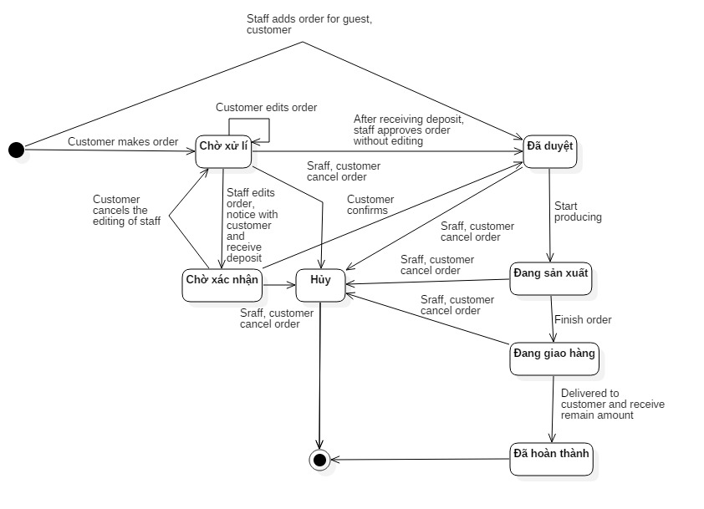

Figure 128: Order State Chart

|  |  |
| --- | --- |
| SStimulusion﷽﷽﷽﷽﷽> ERDquence numberecution bar em and database.tate | Description |
| Chờ xử lý | Order is made by customer and waiting for approve from the system. |
| Chờ xác nhận | Order is editted by staff and waiting for confirm from the customer. |
| Đã duyệt | Order is approved by staff or confirmed by customer. |
| Đang sản xuất | Order is producing. |
| Đang giao hàng | Order is delivering. |
| Đã hoàn thành | Order is finished after receiving money. |
| Hủy | Order is cancelled. |

Table 63: Contract State Dictionary

# 番５のレポート。システムの展開とテスト

## はじめに

### 概要

本節、物理データベースの詳細とその記述は表れています。その上、BMAのテストの方法やテストプランやテストケースも記載されています。

### テストアプローチ

* ゴール: 要求を満たすため、すべてのシステムが正常に実行されていること。
* 方法: システムテスト, ブラックボックステスト。

## データベース関係ダイアグラム

### ウェブアプリケーション物理的なダイアグラム

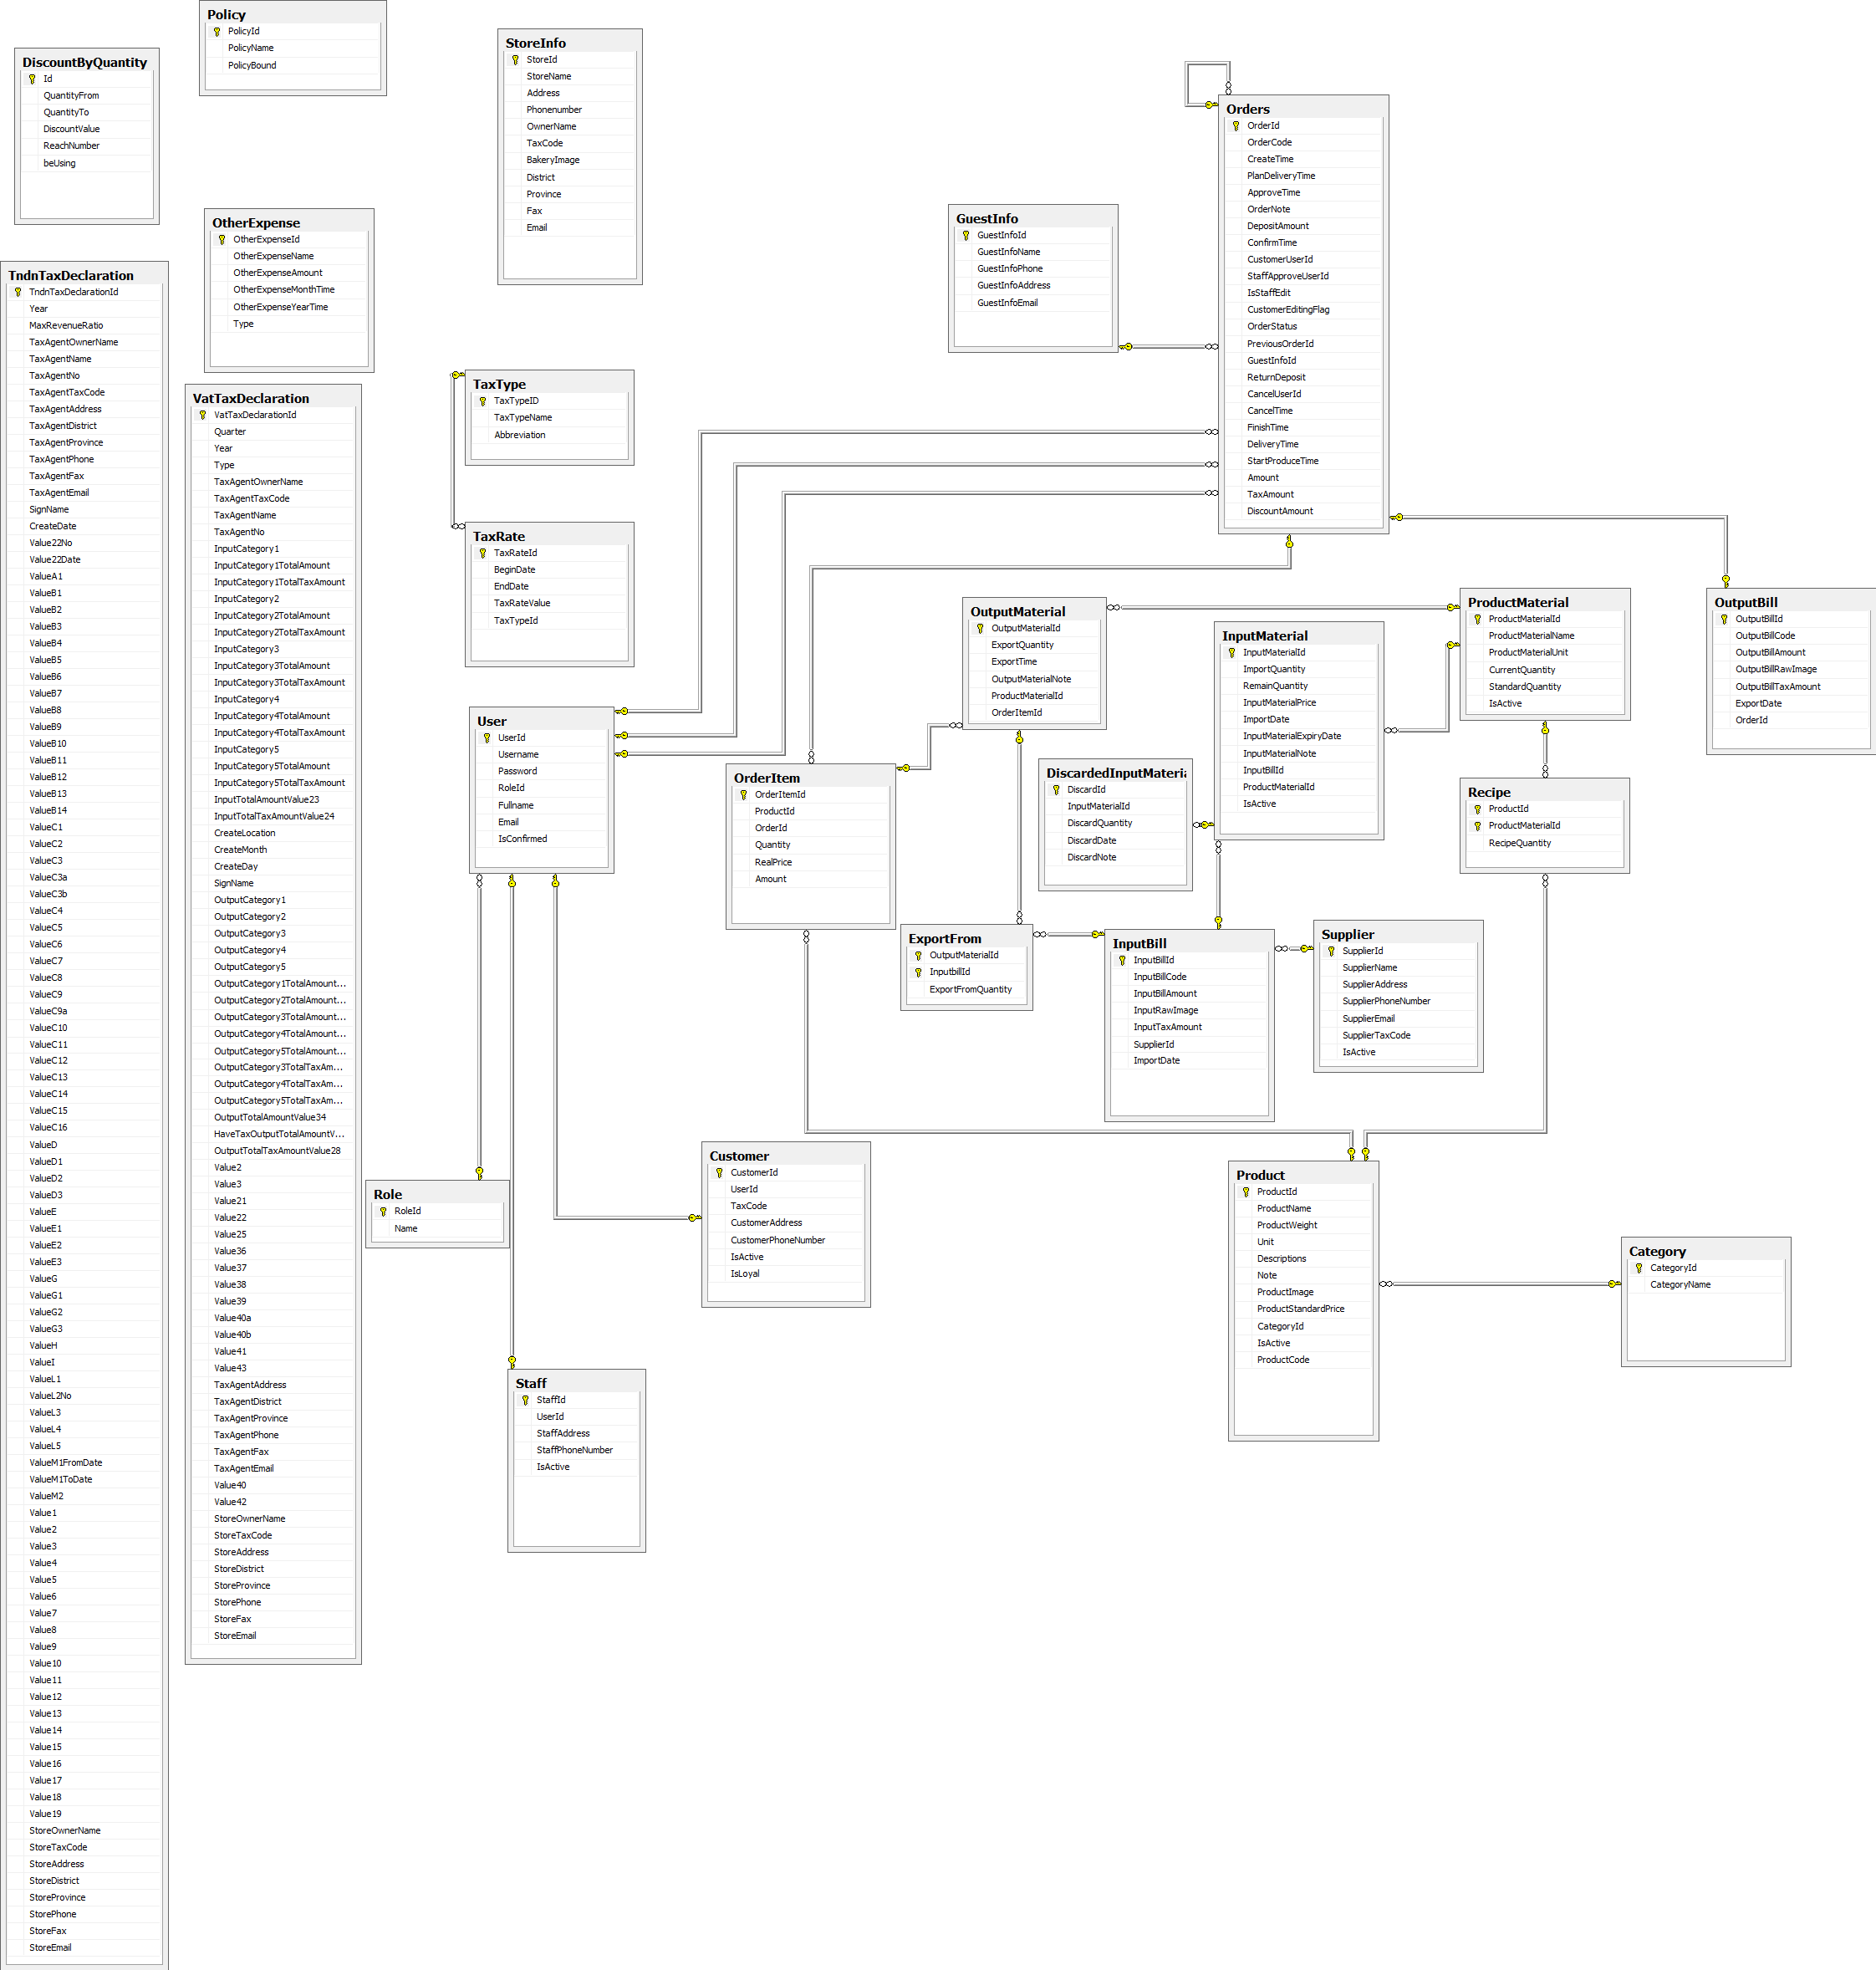

Figure 129: ウェブサイトアプリケーション物理的なダイアグラム

### 2.2 ウェブアプリケーションデータ辞書

|  |  |  |
| --- | --- | --- |
|  | Entity Data Dictionary: describe content of all entities | |
| 数字 | **実体名** | **記述** |
| 01 | Discount By Quantity | システムで分量で安売りを含有しています |
| 02 | Other Expense | システムで外の費を含有しています |
| 03 | StoreInfo | システムで店の見聞を含有しています |
| 04 | Policy | システムで政策を含有しています |
| 05 | Role | システムで役を含有しています |
| 06 | User | システムで利用者を含有しています |
| 07 | Customer | システムでメンバーを含有しています |
| 08 | Staff | システムで職員を含有しています |
| 09 | Guest Info | システムでお客員の見聞を含有しています |
| 10 | Orders | システムで注文を含有しています |
| 11 | Output Bill | システムで出力法案を含有しています |
| 12 | Order Item | システムで注文の項目を含有しています |
| 13 | Category | システムで種類を含有しています |
| 14 | Product | システムで製品を含有しています |
| 15 | Supplier | システムでサプライヤーを含有しています |
| 16 | Input Bill | システムで入力法案を含有しています |
| 17 | Discarded Input Material | システムで投入原料を捨てるのことを含有しています |
| 18 | Input Material | システムで投入原料を含有しています |
| 19 | Export From | システムで投入原料の注文の見聞を含有しています |
| 20 | Product Material | システムで製品の原料を含有しています |
| 21 | Output Material | システムで出力材料を含有しています |
| 22 | Recipe | システムで料理法を含有しています |
| 23 | Tax Rate | システムで税率を含有しています |
| 24 | Tax Type | システムで税金のタイプを含有しています |
| 25 | VAT Tax Declaration | システムでVATの税金申告を含有しています |

Table 64 : ウェブデータ•ディクショナリ

|  |  |  |  |  |
| --- | --- | --- | --- | --- |
| エンティティ名 | 属性 | 記述 | ドメイン | ヌル |
| **Discount By Quantity** | Id (PK) | 各安売りの唯一の識別子、量で安売りテーブルから自動インクリメント | int | No |
| QuantityFrom | 量で安売りから | int | No |
| QuantityTo | 量で安売りまで | int | No |
| DiscountValue | 量で安売りの値 | int | No |
| beUsing | 各量で安売りが使われるかどうかのステータス。 | int | No |
| **Other Expense** | OtherExpenseId (PK) | 各外の費の唯一の識別子、外の費テーブルから自動インクリメント | int | No |
| OtherExpenseName | 外の費の名 | nvarchar(100) | No |
| OtherExpenseAmount | 外の費の分量 | int | No |
| OtherExpenseMonthTime | 外の費の月 | int | Yes |
| OtherExpenseYearTime | 外の費の年 | int | Yes |
| **StoreInfo** | StoreId | 各店の唯一の識別子、店の見聞テーブルから自動インクリメント | int | No |
| StoreName | 店の名 | nvarchar(50) | No |
| Address | 店の住所 | nvarchar(200) | No |
| Phonenumber | 店の電話番号 | nvarchar(20) | No |
| OwnerName | 店の主の名前 | nvarchar(50) | No |
| TaxCode | 店の税金のコード | varchar(20) |  |
| BakeryImage | 店のケーキの映像 | nvarchar(200) |  |
| ProductMaxPrice | 店の最高の製品の値段 | int | Yes |
| District | 店の郡 | nvarchar(50) | No |
| Province | 店の州 | nvarchar(50) | No |
| Fax | 店のファクス | nvarchar(50) | Yes |
| Email | 店の電子メール | nvarchar(50) | Yes |
| **Policy** | PolicyId (PK) | 各政策の唯一の識別子、政策テーブルから自動インクリメント | int | No |
| PolicyName | 政策の名 | nvarchar(50) | No |
| PolicyBound | 政策の限界 | int | No |
| **Role** | RoleId (PK) | 各役の唯一の識別子、役テーブルから自動インクリメント | int | No |
| Name | 役の名 | nvarchar(50) | No |
| **User** | UserId (PK) | 各利用者の唯一の識別子、利用者テーブルから自動インクリメント | int | No |
| Username | 利用者のユーザ名 | nvarchar(50) | No |
| Password | 利用者のパスワード | nvarchar(max) | Yes |
| RoleId (FK) | 役のID | int | No |
| Fullname | 利用者の名前 | nvarchar(50) | Yes |
| Email | 利用者の電子メール | nvarchar(250) | Yes |
| IsConfirmed | 各量で役が確認されたかどうかのステータス。 | bit | No |
| **Customer** | CustomerId (PK) | 各メンバーの唯一の識別子、メンバーテーブルから自動インクリメント | int | No |
| UserId (FK) | 役のID | int | No |
| TaxCode | メンバーの税金のコード | nvarchar(20) | Yes |
| CustomerAddress | メンバーの住所 | nvarchar(200) | Yes |
| CustomerPhoneNumber | メンバーの電話番後 | nvarchar(20) | Yes |
| IsActive | 各量でメンバーがアクティブされたかどうかのステータス。 | bit | No |
| IsLoyal | 各量でメンバーがロイヤルかどうかのステータス。 | bit | No |
| **Staff** | StaffId (PK) | 各職員の唯一の識別子、職員テーブルから自動インクリメント | int | No |
| UserId (FK) | 役のID | int | No |
| StaffAddress | 職員の住所 | nvarchar(200) | Yes |
| StaffPhoneNumber | 職員の電話番後 | nvarchar(20) | Yes |
| IsActive | 各量で職員がアクティブされたかどうかのステータス。 | bit | No |
| **Guest Info** | GuestInfoId (PK) | 各お客員の唯一の識別子、お客員の見聞テーブルから自動インクリメント | int | No |
| GuestInfoName | お客員の名前 | nvarchar(50) | No |
| GuestInfoPhone | お客員の電話番後 | nvarchar(20) | No |
| GuestInfoAddress | お客員の住所 | nvarchar(200) | No |
| GuestInfoEmail | お客員の電子メール | nvarchar(200) | No |
| **Orders** | OrderId (PK) | 各注文の唯一の識別子、注文テーブルから自動インクリメント | int | No |
| OrderCode | 注文のコード | varchar(13) | No |
| CreateTime | 注文の作ったの時 | datetime | No |
| PlanDeliveryTime | 注文の配信の時の予定 | datetime | No |
| ApproveTime | 注文の認めたの時 | datetime | Yes |
| OrderNote | 注文のノート | nvarchar(200) | Yes |
| DepositAmount | 注文の分量 | int | No |
| ConfirmTime | 注文の確認の時 | datetime | Yes |
| CustomerUserId (FK) | メンバーのID | int | Yes |
| StaffApproveUserId (FK) | 認可されていた職員のID | int | Yes |
| IsStaffEdit | 各量で職員がエディトしているかどうかのステータス。 | bit | No |
| CustomerEditingFlag | 各量でメンバーがエディトしているかどうかのステータス | bit | No |
| OrderStatus | 注文のステータス | int | No |
| PreviousOrderId (FK) | 前の注文のID | int | Yes |
| GuestInfoId (FK) | お客員のID | int | Yes |
| ReturnDeposit | 注文の回帰の預金 | int | No |
| CancelUserId (FK) | 注文をキャンセルした役のID | int | Yes |
| CancelTime | 注文をキャンセルする時 | datetime | Yes |
| FinishTime | 注文の終わりの時 | datetime | Yes |
| DeliveryTime | 注文の配信の時 | datetime | Yes |
| StartProduceTime | 初めに注文の作る時 | datetime | Yes |
| Amount | 注文の分量 | int | No |
| TaxAmount | 注文の税金の分量 | int | No |
| DiscountAmount | 注文の割引の分量 | int | No |
| **Output Bill** | OutputBillId (PK) | 各出力法案の唯一の識別子、出力法案テーブルから自動インクリメント | int | No |
| OutputBillCode | 出力法案のコード | nvarchar(50) | No |
| OutputBillAmount | 出力法案の分量 | float | No |
| OutputBillRawImage | 出力法案の映像 | nvarchar(200) | Yes |
| OutputBillTaxAmount | 出力法案の税金の分量 | float | No |
| ExportDate | 出力法案の輸出の日 | date | No |
| FormNo | 出力法案の用紙のID | varchar(50) | No |
| Serial | 出力法案のシリアル | varchar(50) | No |
| OrderId (FK) | 注文のID | int | No |
| **Order Item** | OrderItemId (PK) | 各注文の項目の唯一の識別子、注文の項目テーブルから自動インクリメント | int | No |
| ProductId (FK) | 製品のID | int | No |
| OrderId (FK) | 注文のID | int | No |
| Quantity | 注文の項目量 | int | No |
| RealPrice | 注文の項目のリアル値段 | int | No |
| Amount | 注文の項目の分量 | int | No |
| **Category** | CategoryId (PK) | 各種類の唯一の識別子、種類テーブルから自動インクリメント | int | No |
| CategoryName | 種類の名 | nvarchar(200) | No |
| **Product** | ProductId (PK) | 各製品の唯一の識別子、製品テーブルから自動インクリメント | int | No |
| ProductName | 製品の名 | nvarchar(200) | No |
| ProductWeight | 製品の重さ | float | No |
| Unit | 製品のユニット | nvarchar(50) | No |
| Descriptions | 製品の記述 | nvarchar(500) | Yes |
| Note | 製品のノート | nvarchar(500) | Yes |
| ProductImage | 製品のの映像 | nvarchar(200) | Yes |
| ProductStandardPrice | 製品の標準価格 | int | No |
| CategoryId (FK) | 種類のID | int | Yes |
| IsActive | 各量で製品がアクティブされたかどうかのステータス。 | bit | No |
| ProductCode | 製品のコード | varchar(10) | No |
| **Supplier** | SupplierId (PK) | 各サプライヤーの唯一の識別子、サプライヤーテーブルから自動インクリメント | int | No |
| SupplierName | サプライヤーの名 | nvarchar(200) | No |
| SupplierAddress | サプライヤーの住所 | nvarchar(200) | No |
| SupplierPhoneNumber | サプライヤーの電話番後 | char(12) | No |
| SupplierEmail | サプライヤーの電子メール | nvarchar(50) | No |
| SupplierTaxCode | サプライヤーの税金のコード | char(20) | No |
| IsActive | 各量でサプライヤーがアクティブされたかどうかのステータス。 | bit | No |
| **Input Bill** | InputBillId (PK) | 各入力法案の唯一の識別子、入力法案テーブルから自動インクリメント | int | No |
| InputBillCode | 入力法案のコード | nvarchar(50) | No |
| InputBillAmount | 入力法案の分量 | float | No |
| InputRawImage | 入力法案の映像 | nvarchar(200) | Yes |
| InputTaxAmount | 入力法案の税金の分量 | float | No |
| SupplierId (FK) | サプライヤーのID | int | No |
| ImportDate | 入力法案の輸入の日 | date | No |
| FormNo | 入力法案の用紙のID | varchar(50) | No |
| Serial | 入力法案のシリアル | varchar(50) | No |
| **Discarded Input Material** | DiscardId (PK) | 各投入原料を捨てるのことの唯一の識別子、投入原料を捨てるのことテーブルから自動インクリメント | int | No |
| InputMaterialId (FK) | 投入原料を捨てるのことのID | int | No |
| DiscardQuantity | 投入原料を捨てるのことの量 | int | No |
| DiscardDate | 投入原料を捨てるのことの日 | date | No |
| DiscardNote | 投入原料を捨てるのことのノート | nvarchar(200) | No |
| **Input Material** | InputMaterialId (PK) | 各投入原料の唯一の識別子、投入原料テーブルから自動インクリメント | int | No |
| ImportQuantity | 投入原料の量 | int | No |
| RemainQuantity | 在留原料の量 | int | No |
| InputMaterialPrice | 在留原料の値段 | float | No |
| ImportDate | 在留原料の輸入の日 | date | No |
| InputMaterialExpiryDate | 在留原料の消費期限 | date | No |
| InputMaterialNote | 在留原料のノート | nvarchar(500) | Yes |
| InputBillId (FK) | 入力法案のID | int | No |
| ProductMaterialId (FK) | 製品の原料のID | int | No |
| IsActive | 各量で在留原料がアクティブされたかどうかのステータス。 | bit | No |
| **Export From** | OutputMaterialId (PK) | 出力材料のID | int | No |
| InputbillId (PK) | 入力法案のID | int | No |
| ExportFromQuantity | 入力法案の量 | int | No |
| **Product Material** | ProductMaterialId (PK) | 各製品の原料の唯一の識別子、製品の原料テーブルから自動インクリメント | int | No |
| ProductMaterialName | 製品の原料の名 | nvarchar(100) | No |
| ProductMaterialUnit | 製品の原料のユニット | nvarchar(50) | No |
| CurrentQuantity | 製品の原料の在留原料量 | int | No |
| StandardQuantity | 製品の原料の標準量 | int | Yes |
| IsActive | 各量で製品の原料がアクティブされたかどうかのステータス。 | bit | No |
| **Output Material** | OutputMaterialId (PK) | 各出力材料の唯一の識別子、出力材料テーブルから自動インクリメント | int | No |
| ExportQuantity | 出力材料の輸出量 | int | No |
| ExportTime | 出力材料の輸出の時 | datetime | Yes |
| OutputMaterialNote | 出力材料のノート | nvarchar(500) | Yes |
| ProductMaterialId (FK) | 製品の原料のID | int | No |
| OrderItemId (FK) | 注文の項目のID | int | No |
| **Recipe** | ProductId (PK) | 製品のID | int | No |
| ProductMaterialId (PK) | 製品の原料のID | int | No |
| RecipeQuantity | 料理法量 | float | No |
| **Tax Rate** | TaxRateId (PK) | 各税率の唯一の識別子、税率テーブルから自動インクリメント | int | No |
| BeginDate | 税率の初めの日 | date | No |
| EndDate | 税率の終わりの日 | date | Yes |
| TaxRateValue | 税率の値 | int | No |
| TaxTypeId (FK) | 税金のID | int | No |
| **Tax Type** | TaxTypeID (PK) | 各税金の唯一の識別子、税金テーブルから自動インクリメント | int | No |
| TaxTypeName | 税金の名 | nvarchar(200) | No |
| Abbreviation | 税金テーブルの省略形 | varchar(10) | Yes |
| **VAT Tax Declaration** | TaxDeclarationId | 消費税申告の唯一の識別子、消費税申告テーブルから自動インクリメント | int | No |
| Quarter | 消費税申告の季 | int | No |
| Year | 消費税申告の年 | int | No |
| Type | 消費税申告のタイプ | int | No |
| TaxAgentOwnerName | 代理人の組合の名前 | nvarchar(50) | No |
| TaxAgentTaxCode | 代理人の税法 | varchar(15) | No |
| TaxAgentName | 代理人の名前 | nvarchar(50) | No |
| TaxAgentNo | 代理人の許可番号 | varchar(15) | No |
| InputCategory1 | 消費税申告の付録1の種類1 | nvarchar(max) | Yes |
| InputCategory1TotalAmount | 消費税申告の付録1の種類1の金額 | int | Yes |
| InputCategory1TotalTaxAmount | 消費税申告の付録1の種類1の税金 | int | Yes |
| InputCategory2 | 消費税申告の付録1の種類2 | nvarchar(max) | Yes |
| InputCategory2TotalAmount | 消費税申告の付録1の種類2の金額 | int | Yes |
| InputCategory2TotalTaxAmount | 消費税申告の付録1の種類2の税金 | int | Yes |
| InputCategory3 | 消費税申告の付録1の種類3 | nvarchar(max) | Yes |
| InputCategory3TotalAmount | 消費税申告の付録1の種類3の金額 | int | Yes |
| InputCategory3TotalTaxAmount | 消費税申告の付録1の種類3の税金 | int | Yes |
| InputTotalAmountValue23 | 付録1の金額 | int | No |
| InputTotalTaxAmountValue24 | 付録1の税金 | int | No |
| CreateLocation | 作成する場所 | nvarchar(50) | No |
| CreateDate | 作成する日付 | date | No |
| SignName | サイン | nvarchar(50) | No |
| OutputCategory1 | 消費税申告の付録2の種類1 | nvarchar(max) | Yes |
| OutputCategory2 | 消費税申告の付録2の種類2 | nvarchar(max) | Yes |
| OutputCategory3 | 消費税申告の付録2の種類3 | nvarchar(max) | Yes |
| OutputCategory4 | 消費税申告の付録2の種類4 | nvarchar(max) | Yes |
| OutputCategory1TotalAmountValue26 | 消費税申告の付録2の種類1の金額 | int | Yes |
| OutputCategory2TotalAmountValue29 | 消費税申告の付録2の種類2の金額 | int | Yes |
| OutputCategory3TotalAmountValue30 | 消費税申告の付録2の種類3の金額 | int | Yes |
| OutputCategory4TotalAmountValue32 | 消費税申告の付録2の種類4の金額 | int | Yes |
| OutputCategory3TotalTaxAmountValue31 | 消費税申告の付録2の種類3の税金 | int | Yes |
| OutputCategory4TotalTaxAmountValue33 | 消費税申告の付録2の種類4の税金 | int | Yes |
| OutputTotalAmountValue34 | 付録2の金額 | int | Yes |
| HaveTaxOutputTotalAmountValue27 | 税金がある付録2の金額 | int | No |
| OutputTotalTaxAmountValue28 | 付録2の税金 | int | No |
| Value2 | 消費税申告のバリュー2 | bit | Yes |
| Value3 | 消費税申告のバリュー3 | int | Yes |
| Value21 | 消費税申告のバリュー21 | bit | Yes |
| Value22 | 消費税申告のバリュー22 | int | Yes |
| Value25 | 消費税申告のバリュー25 | int | Yes |
| Value36 | 消費税申告のバリュー36 | int | Yes |
| Value37 | 消費税申告のバリュー37 | int | Yes |
| Value38 | 消費税申告のバリュー38 | int | Yes |
| Value39 | 消費税申告のバリュー39 | int | Yes |
| Value40a | 消費税申告のバリュー40a | int | Yes |
| Value40b | 消費税申告のバリュー40b | int | Yes |
| Value41 | 消費税申告のバリュー41 | int | Yes |
| Value43 | 消費税申告のバリュー43 | int | Yes |
| TaxAgentAddress | 代理人の住所 | nvarchar(200) | Yes |
| TaxAgentDistrict | 代理人の地区 | nvarchar(50) | Yes |
| TaxAgentProvince | 代理人の県 | nvarchar(50) | Yes |
| TaxAgentPhone | 代理人の電話番号 | varchar(20) | Yes |
| TaxAgentFax | 代理人のファクス番号 | varchar(20) | Yes |
| TaxAgentEmail | 代理人のイー‐メール | varchar(50) | Yes |
| Value40 | 消費税申告のバリュー40 | int | Yes |
| Value42 | 消費税申告のバリュー42 | int | Yes |
| StoreOwnerName | オーナーの名前 | nvarchar(50) | No |
| StoreTaxCode | オーナーの税法 | varchar(15) | No |
| StoreAddress | オーナーの住所 | nvarchar(200) | No |
| StoreDistrict | オーナーの地区 | nvarchar(50) | No |
| StoreProvince | オーナーの県 | nvarchar(50) | No |
| StorePhone | オーナーの電話番号 | varchar(15) | No |
| StoreFax | オーナーのファクス番号 | varchar(15) | Yes |
| StoreEmail | オーナーのイー‐メール | nvarchar(200) | No |
| **Tndn Tax Declaration** | Id | 免許税申告の唯一の識別子、免許税申告テーブルから自動インクリメント | int | No |
| Year | 免許税申告の年 | int | No |
| MaxRevenueRatio | 最大歳入の比率 | int | Yes |
| TaxAgentOwnerName | 代理人の組合の名前 | nvarchar(50) | Yes |
| TaxAgentName | 代理人の名前 | nvarchar(50) | Yes |
| TaxAgentNo | 代理人の許可番号 | varchar(15) | Yes |
| TaxAgentTaxCode | 代理人の税法 | varchar(15) | Yes |
| TaxAgentAddress | 代理人の住所 | nvarchar(200) | Yes |
| TaxAgentDistrict | 代理人の地区 | nvarchar(50) | Yes |
| TaxAgentProvince | 代理人の県 | nvarchar(50) | Yes |
| TaxAgentPhone | 代理人の電話番号 | varchar(15) | Yes |
| TaxAgentFax | 代理人のファクス番号 | varchar(15) | Yes |
| TaxAgentEmail | 代理人のイー‐メール | nvarchar(50) | Yes |
| SignName | サイン | nvarchar(50) | Yes |
| CreateDate | 作成する日付 | date | Yes |
| Value22No | 免許税申告のバリュー22番号 | int | Yes |
| Value22Date | 免許税申告のバリュー22日付 | date | Yes |
| ValueA1 | 免許税申告のバリューA1 | int | Yes |
| ValueB1 | 免許税申告のバリューB1 | int | Yes |
| ValueB2 | 免許税申告のバリューB2 | int | Yes |
| ValueB3 | 免許税申告のバリューB3 | int | Yes |
| ValueB4 | 免許税申告のバリューB4 | int | Yes |
| ValueB5 | 免許税申告のバリューB5 | int | Yes |
| ValueB6 | 免許税申告のバリューB6 | int | Yes |
| ValueB7 | 免許税申告のバリューB7 | int | Yes |
| ValueB8 | 免許税申告のバリューB8 | int | Yes |
| ValueB9 | 免許税申告のバリューB9 | int | Yes |
| ValueB10 | 免許税申告のバリューB10 | int | Yes |
| ValueB11 | 免許税申告のバリューB11 | int | Yes |
| ValueB12 | 免許税申告のバリューB12 | int | Yes |
| ValueB13 | 免許税申告のバリューB13 | int | Yes |
| ValueB14 | 免許税申告のバリューB14 | int | Yes |
| ValueC1 | 免許税申告のバリューC1 | int | Yes |
| ValueC2 | 免許税申告のバリューC2 | int | Yes |
| ValueC3 | 免許税申告のバリューC3 | int | Yes |
| ValueC3a | 免許税申告のバリューC3a | int | Yes |
| ValueC3b | 免許税申告のバリューC3ｂ | int | Yes |
| ValueC4 | 免許税申告のバリューC4 | int | Yes |
| ValueC5 | 免許税申告のバリューC5 | int | Yes |
| ValueC6 | 免許税申告のバリューC6 | int | Yes |
| ValueC7 | 免許税申告のバリューC7 | int | Yes |
| ValueC8 | 免許税申告のバリューC8 | int | Yes |
| ValueC9 | 免許税申告のバリューC9 | int | Yes |
| ValueC9a | 免許税申告のバリューC9a | int | Yes |
| ValueC10 | 免許税申告のバリューC10 | int | Yes |
| ValueC11 | 免許税申告のバリューC11 | int | Yes |
| ValueC12 | 免許税申告のバリューC12 | int | Yes |
| ValueC13 | 免許税申告のバリューC13 | int | Yes |
| ValueC14 | 免許税申告のバリューC14 | int | Yes |
| ValueC15 | 免許税申告のバリューC15 | int | Yes |
| ValueC16 | 免許税申告のバリューC16 | int | Yes |
| ValueD | 免許税申告のバリューD | int | Yes |
| ValueD1 | 免許税申告のバリューD1 | int | Yes |
| ValueD2 | 免許税申告のバリューD2 | int | Yes |
| ValueD3 | 免許税申告のバリューD3 | int | Yes |
| ValueE | 免許税申告のバリューE | int | Yes |
| ValueE1 | 免許税申告のバリューE1 | int | Yes |
| ValueE2 | 免許税申告のバリューE2 | int | Yes |
| ValueE3 | 免許税申告のバリューE3 | int | Yes |
| ValueG | 免許税申告のバリューG | int | Yes |
| ValueG1 | 免許税申告のバリューG1 | int | Yes |
| ValueG2 | 免許税申告のバリューG2 | int | Yes |
| ValueG3 | 免許税申告のバリューG3 | int | Yes |
| ValueH | 免許税申告のバリューH | int | Yes |
| ValueI | 免許税申告のバリューI | int | Yes |
| ValueL1 | 免許税申告のバリューL1 | int | Yes |
| ValueL2 | 免許税申告のバリューL2 | int | Yes |
| ValueL3 | 免許税申告のバリューL3 | int | Yes |
| ValueL4 | 免許税申告のバリューL4 | int | Yes |
| ValueL5 | 免許税申告のバリューL5 | int | Yes |
| ValueM1FromDate | 免許税申告のバリューM1開始日 | date | Yes |
| ValueM1ToDate | 免許税申告のバリューM1終了日 | date | Yes |
| Value M2 | 免許税申告のバリューM2 | int | Yes |
| Value1 | 免許税申告のバリュー1 | int | Yes |
| Value2 | 免許税申告のバリュー2 | int | Yes |
| Value3 | 免許税申告のバリュー3 | int | Yes |
| Value4 | 免許税申告のバリュー4 | int | Yes |
| Value5 | 免許税申告のバリュー5 | int | Yes |
| Value6 | 免許税申告のバリュー6 | int | Yes |
| Value7 | 免許税申告のバリュー7 | int | Yes |
| Value8 | 免許税申告のバリュー8 | int | Yes |
| Value9 | 免許税申告のバリュー9 | int | Yes |
| Value10 | 免許税申告のバリュー10 | int | Yes |
| Value11 | 免許税申告のバリュー11 | int | Yes |
| Value12 | 免許税申告のバリュー12 | int | Yes |
| Value13 | 免許税申告のバリュー13 | int | Yes |
| Value14 | 免許税申告のバリュー14 | int | Yes |
| Value15 | 免許税申告のバリュー15 | int | Yes |
| Value16 | 免許税申告のバリュー16 | int | Yes |
| Value17 | 免許税申告のバリュー17 | int | Yes |
| Value18 | 免許税申告のバリュー18 | int | Yes |
| Value19 | 免許税申告のバリュー19 | int | Yes |
| StoreOwnerName | オーナーの名前 | nvarchar(50) | No |
| StoreTaxCode | オーナーの税法 | varchar(15) | No |
| StoreAddress | オーナーの住所 | nvarchar(200) | No |
| StoreDistrict | オーナーの地区 | nvarchar(50) | No |
| StoreProvince | オーナーの県 | nvarchar(50) | No |
| StorePhone | オーナーの電話番号 | varchar(15) | No |
| StoreFax | オーナーのファクス番号 | varchar(15) | Yes |
| StoreEmail | オーナーのイー‐メール | nvarchar(200) | No |

Table 65: ウェブ属性データディクショナリ

## パフォーマンス対策

パフォーマンスを測定するために、デプロイとともにazure ホスティングでテストして、予測を行いました。

### 製品検索、メンバーのパフォーマンス

一般的に、結果はユーザが検索フォームを提出した後、5秒未満を現されます。

### 送り状リストが展示されるパフォーマンス

一般的には、ユーザーが「送り状リスト」のリンクをクリックすると、注文リストはより5秒以内に展示されます。

### 収入統計など展示されるパフォーマンス

一般的に、時間を選んで、「統計」というボタンをクリックすると、10秒以内で収入統計など展示されます。

## テスト計画

### テストする機能

システムテストはコアワークフローに基づいて行うことになります。

テストする機能:

* ユーザログイン
* ゲスト：
  + 製品を注文します
* 顧客：
  + 製品を注文します
  + 送り状を確認します
* 人員
  + 送り状を造ります
  + 送り状を承認します
  + 送り状の状態を変化します
  + 送り状を編集します
  + 入力原料を付加します
  + 入力原料を捨てます
  + 入力法案を付加します
* 管理
  + 収入統計
  + 製品別収益
  + お客様による純益統計
  + 消費税申告
  + 免許税申告

### テストされない機能

* ログ‐アウト
* プロフィールを編集
* 消費税申告
* 免許税申告
* 顧客管理
* 人員管理

## システムテストのテストケース

### ウェブシステムのテストケース

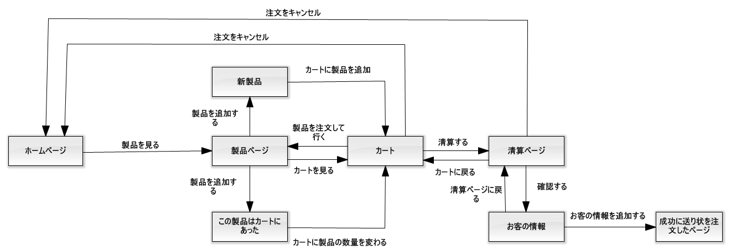

Figure 130: 「ゲスト」製品を注文すること

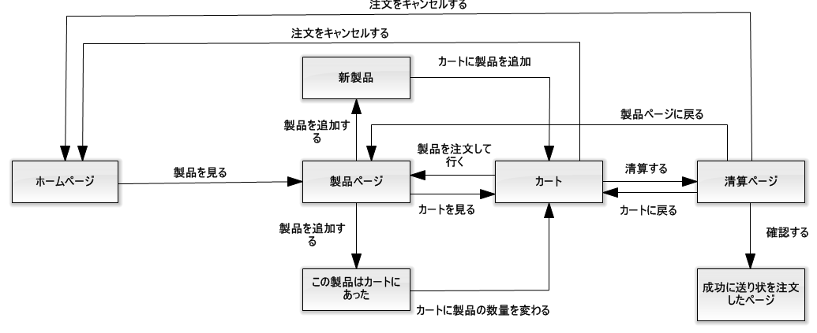

Figure 131: 「顧客」製品を注文すること

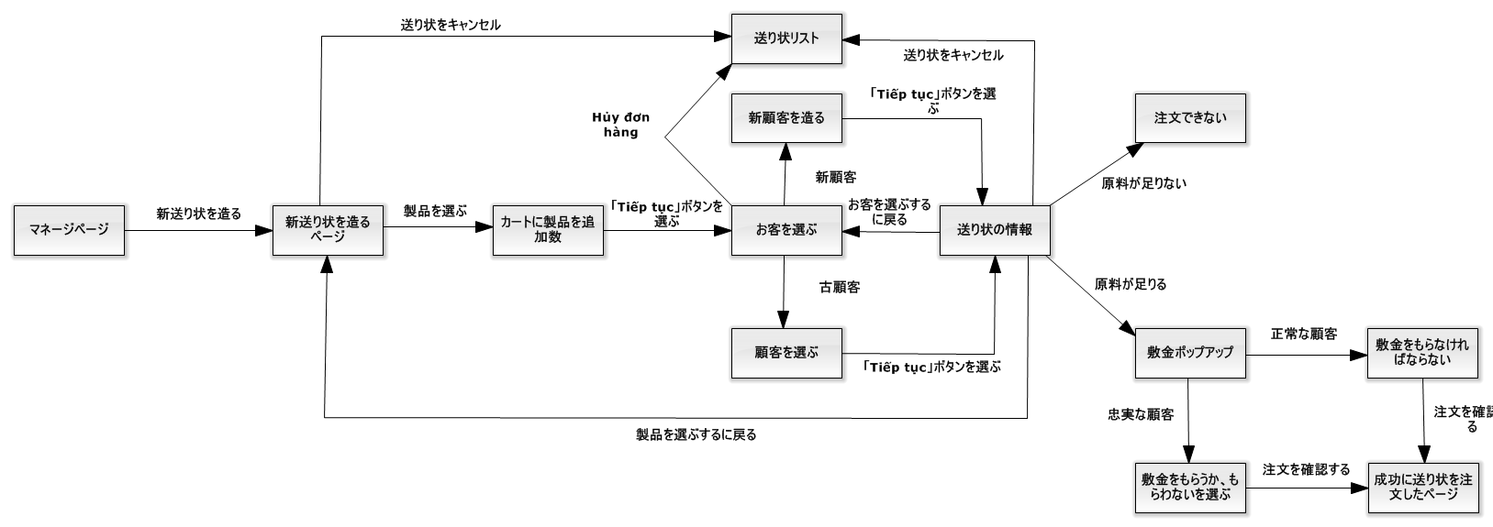

Figure 132: 「人員」送り状を造ること

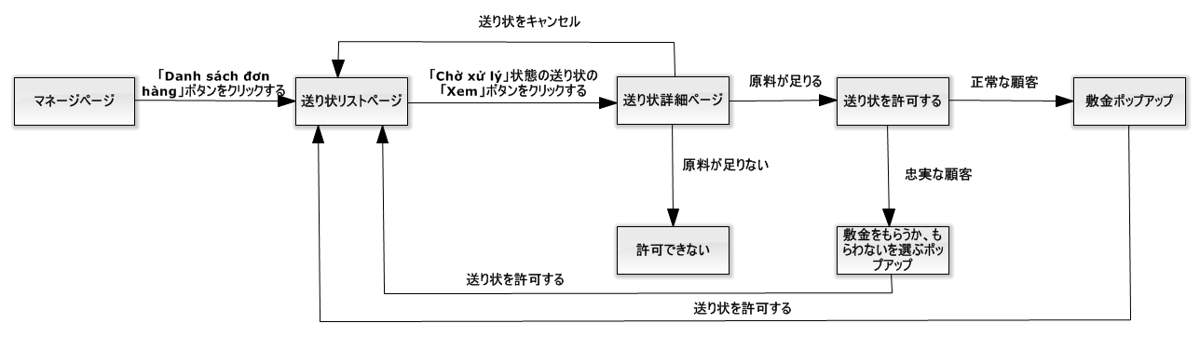

Figure 133: 「人員」送り状を造ること

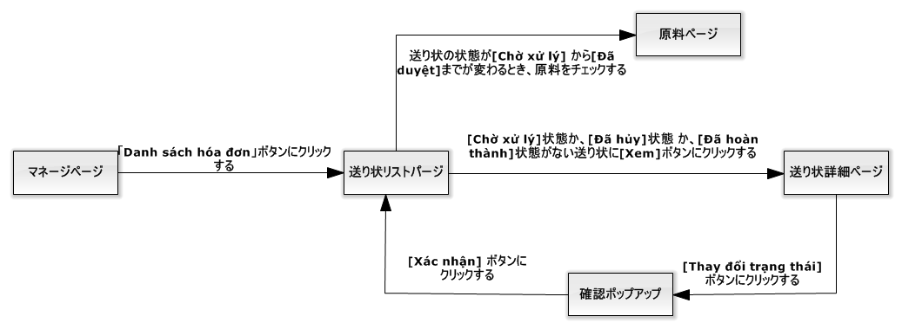

Figure 134: 「人員」送り状の状態を変化すること

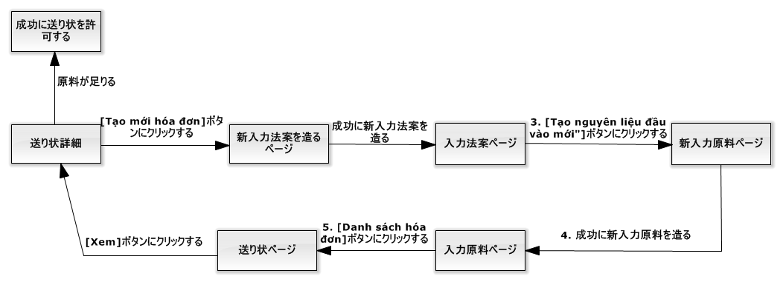

Figure 135: 「人員」入力原料を付加すること

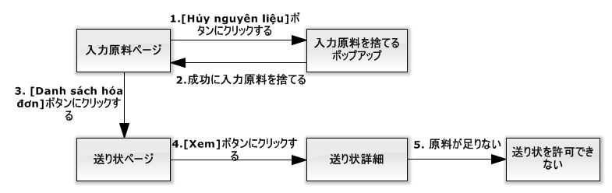

Figure 136: 「人員」入力原料を捨てること

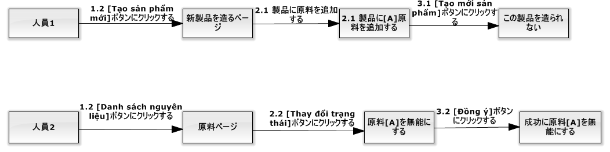

Figure 137: 「人員」新製品を造る前に、この製品の原料が無能にすること

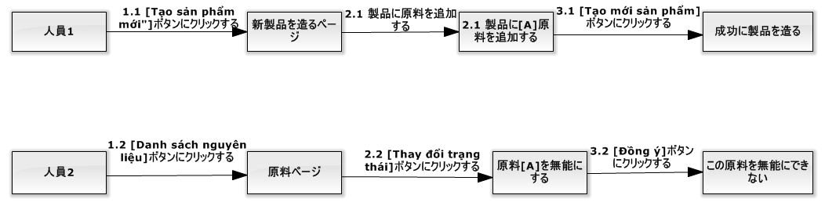

Figure 138: 「人員」新製品を造ったら、この製品の原料が無能にすること

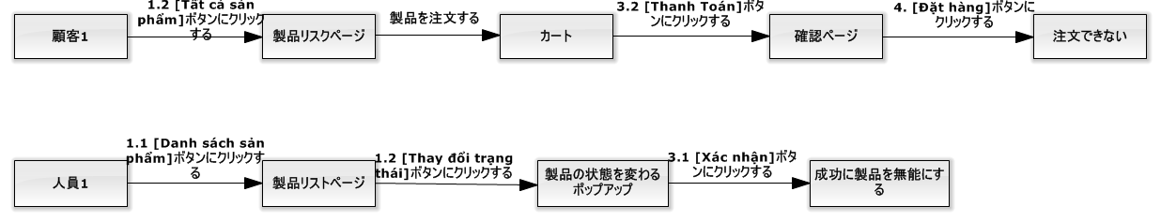

Figure 139: 「人員」注文することが終了する前に、この注文の製品が無能にすること

#### ユーザログイン

|  |  |  |  |  |  |  |  |
| --- | --- | --- | --- | --- | --- | --- | --- |
| **ID** | **説明** | **テストケース順序** | **出力** | **インターテストケース依存性** | **結果** | **テスト期日** | **注釈** |
| UL01 | ユーザ名が違う | １．ユーザは「Đăng nhập」ブタンをクリークする。  ２．ユーザ名：Hoadt  　　パスワード：123456  ３．ユーザは「Đăng nhập」ブタンをクリークする。 | ステップ３には、誤差「Tên đăng nhập hoặc mật khẩu không đúng」を通知する | なし | 合格 | 22/11/2015 | なし |
| UL02 | パスワードが違う | １．ユーザは「Đăng nhập」ブタンをクリークする。  ２．ユーザ名：Hoadtt  　　パスワード：1234  ３．ユーザは「Đăng nhập」ブタンをクリークする。 | ステップ３には、誤差「Tên đăng nhập hoặc mật khẩu không đúng」を通知する | なし | 合格 | 22/11/2015 | なし |
| UL03 | メンバーはログインする | １．ユーザは「Đăng nhập」ブタンをクリークする。  ２．ユーザ名：Hoadtt  　　パスワード：123456  ３．ユーザは「Đăng nhập」ブタンをクリークする。 | ステップ３には、システムにメンバー同上のユーザ名をログインする。 | なし | 合格 | 22/11/2015 | なし |
| UL04 | 職員はログインする | １．ユーザは「Đăng nhập」ブタンをクリークする。  ２．ユーザ名：VuongNQ  　　パスワード：123456  ３．ユーザは「Đăng nhập」ブタンをクリークする。 | ステップ３には、システムに職員同上のユーザ名をログインする。 | なし | 合格 | 22/11/2015 | なし |
| UL05 | 社長はログインする | １．ユーザは「Đăng nhập」ブタンをクリークする。  ２．ユーザ名：ManhOT  　　パスワード：123456  ３．ユーザは「Đăng nhập」ブタンをクリークする。 | ステップ３には、システムに社長のユーザ名をログインする。 | なし | 合格 | 22/11/2015 | なし |

#### 「顧客」製品を注文すること

|  |  |  |  |  |  |  |  |
| --- | --- | --- | --- | --- | --- | --- | --- |
| **ID** | **説明** | **テストケース順序** | **出力** | **インターテストケース依存性** | **結果** | **テスト期日** | **注釈** |
| COP01 | 製品の数量は数ではない | １．「Đặt hàng」ボタンをクリックして  ２．数量：eee  ３．「Thêm vào giỏ hàng」ボタンをクリックする | ステップ３には、誤差「Số lượng sản phẩm phải là số」を通知する | UL03 | 合格 | 22/11/2015 | なし |
| COP02 | 製品の数量は空白 | １．「Đặt hàng」ボタンをクリックして、「Bánh bao 2 trứng」製品を注文する  ２．数量：  ３．「Thêm vào giỏ hàng」ボタンをクリックする | ステップ３には、誤差「Số lượng sản phẩm không được trống」を通知する | UL03 | 合格 | 22/11/2015 | なし |
| COP03 | 製品の数量は０同等や０以下場合 | １．「Đặt hàng」ボタンをクリックして、「Bánh bao １ trứng」製品を注文する  ２．数量：－１００  ３．「Thêm vào giỏ hàng」ボタンをクリックする | ステップ３には、誤差「Số lượng sản phẩm không được nhỏ hơn 0」を通知する | UL03 | 合格 | 22/11/2015 | なし |
| COP04 | 製品の総量は足らない | １．「Đặt hàng」ボタンをクリックして、「Bánh bao 2 trứng」製品を注文する  ２．数量：１９  標準：「Min quantity-5000」  ３．「Thêm vào giỏ hàng」ボタンをクリックする  ４．「Giỏ hàng」ボタンをクリックして  ５．「Thanh toán」ボタンをクリックして  ６．「Xác nhận」ボタンをクリックして | ステップ6には、誤差「Số lượng sản phẩm trong đơn hàng không được nhỏ hơn “Min quantity”」を通知する | UL03 | 合格 | 22/11/2015 | なし |
| COP05 | 製品の総量は５０００オーバー | １．「Đặt hàng」ボタンをクリックして、「Bánh bao 2 trứng」製品を注文する  ２．数量：５００１  標準：「Min quantity-5000」  ３．「Thêm vào giỏ hàng」ボタンをクリックする  ４．「Giỏ hàng」ボタンをクリックして  ５．「Thanh toán」ボタンをクリックして  ６．「Xác nhận」ボタンをクリックして | ステップ6には、この製品の数量は５０００になります | UL03 | 合格 | 22/11/2015 | なし |
| COP06 | 顧客はカートにある製品を付加する | １．「Đặt hàng」ボタンをクリックして、「Bánh bao 2 trứng」製品を注文する | 「Add to Cart」ポープアップにはこの製品の数量を通知しなければならない | UL03 | 合格 | 22/11/2015 | なし |
| COP07 | カートは空白 | １．「Xác nhận」ボタンをクリックして | 製品のページをリダイレクトする | UL03 | 合格 | 22/11/2015 | なし |
| COP08 | カートに無効製品があるとき、「Xác nhận」ボタンをクリックして | １．「Đặt hàng」ボタンをクリックして、「Bánh bao 2 trứng」製品を注文する  ２．数量：１００  ３．「Thêm vào giỏ hàng」ボタンをクリックする  ４．「Thanh toán」ボタンをクリックして  ５．「Xác nhận」ボタンをクリックして  ６．人員は「Bánh bao 2 trứng」の状態を「Ngừng sử dụng」に変化する  ７．「Xác nhận」ボタンをクリックして | ステップ７には、誤差「Xin lỗi quý khách, sản phẩm ‘Bánh bao 2 trứng’ đã ngừng sản xuất. Qúy khách vui lòng gỡ khỏi giỏ hàng」を通知する | UL03 | 合格 | 22/11/2015 | なし |
| COP09 | 「Xác nhận」ボタンをクリックしたら、「人員」が製品の状態を「Ngừng sử dụng」に変化する | １．「Đặt hàng」ボタンをクリックして、「Bánh bao 2 trứng」製品を注文する  ２．数量：１００  ３．「Thêm vào giỏ hàng」ボタンをクリックする  ４．「Thanh toán」ボタンをクリックして  ５．「Xác nhận」ボタンをクリックして  ６．「Xác nhận」ボタンをクリックして  ７．人員は「Bánh bao 2 trứng」の状態を「Ngừng sử dụng」に変化する | ステップ７には、この送り状は注文したが、「Bánh bao 2 trứng」製品は製品ページに表示されない | UL03 | 合格 | 22/11/2015 | なし |

#### 「ゲスト」製品を注文すること

|  |  |  |  |  |  |  |  |
| --- | --- | --- | --- | --- | --- | --- | --- |
| **ID** | **説明** | **テストケース順序** | **出力** | **インターテストケース依存性** | **結果** | **テスト期日** | **注釈** |
| GOP01 | 製品の数量は数ではない | １．「Đặt hàng」ボタンをクリックして  ２．数量：eee  ３．「Thêm vào giỏ hàng」ボタンをクリックする | ステップ３には、誤差「Số lượng sản phẩm phải là số」を通知する | なし | 合格 | 22/11/2015 | なし |
| GOP02 | 製品の数量は空白 | １．「Đặt hàng」ボタンをクリックして、「Bánh bao 2 trứng」製品を注文する  ２．数量：  ３．「Thêm vào giỏ hàng」ボタンをクリックする | ステップ３には、誤差「Số lượng sản phẩm không được trống」を通知する | なし | 合格 | 22/11/2015 | なし |
| GOP03 | 製品の数量は０同等や０以下場合 | １．「Đặt hàng」ボタンをクリックして、「Bánh bao １ trứng」製品を注文する  ２．数量：－１００  ３．「Thêm vào giỏ hàng」ボタンをクリックする | ステップ３には、誤差「Số lượng sản phẩm không được nhỏ hơn 0」を通知する | なし | 合格 | 22/11/2015 | なし |
| GOP04 | ゲストの名前は空白 | １．「Đặt hàng」ボタンをクリックして、「Bánh bao 2 trứng」製品を注文する  ２．数量：２５０  ３．「Thêm vào giỏ hàng」ボタンをクリックする  ４．「Thanh toán」ボタンをクリックして  ５．「Xác nhận」ボタンをクリックして  ６．「Xác nhận」ボタンをクリックして  ７．  ゲストの名前：  ゲストの電話番号：０９０１２３１２３１  ゲストの住所：１０５０ Quang Trung, Gò Vấp  ゲストのメール：test@gmail.com  ８．「Hoàn tất」ボタンをクリックして | ステップ８には、誤差「Họ tên không được trống」を通知する | なし | 合格 | 22/11/2015 | なし |
| GOP05 | ゲストの電話番号は空白 | １．「Đặt hàng」ボタンをクリックして、「Bánh bao 2 trứng」製品を注文する  ２．数量：２５０  ３．「Thêm vào giỏ hàng」ボタンをクリックする  ４．「Thanh toán」ボタンをクリックして  ５．「Xác nhận」ボタンをクリックして  ６．「Xác nhận」ボタンをクリックして  ７．  ゲストの名前：Trà Văn Ân  ゲストの電話番号：  ゲストの住所：１０５０ Quang Trung, Gò Vấp  ゲストのメール：test@gmail.com  ８．「Hoàn tất」ボタンをクリックして | ステップ８には、誤差「Số điện thoại không được để trống」を通知する | なし | 合格 | 22/11/2015 | なし |
| GOP06 | ゲストの電話番号は８字より少ないや、１２時より多い | １．「Đặt hàng」ボタンをクリックして、「Bánh bao 2 trứng」製品を注文する  ２．数量：２５０  ３．「Thêm vào giỏ hàng」ボタンをクリックする  ４．「Thanh toán」ボタンをクリックして  ５．「Xác nhận」ボタンをクリックして  ６．「Xác nhận」ボタンをクリックして  ７．  ゲストの名前：Trà Văn Ân  ゲストの電話番号：01234  ゲストの住所：１０５０ Quang Trung, Gò Vấp  ゲストのメール：test@gmail.com  ８．「Hoàn tất」ボタンをクリックして | ステップ８には、誤差「Số điện thoại có độ dài từ 8 đến 12 kí tự」を通知する | なし | 合格 | 22/11/2015 | なし |
| GOP07 | ゲストの住所は空白 | １．「Đặt hàng」ボタンをクリックして、「Bánh bao 2 trứng」製品を注文する  ２．数量：２５０  ３．「Thêm vào giỏ hàng」ボタンをクリックする  ４．「Thanh toán」ボタンをクリックして  ５．「Xác nhận」ボタンをクリックして  ６．「Xác nhận」ボタンをクリックして  ７．  ゲストの名前：Trà Văn Ân  ゲストの電話番号：０９０１２３１２３１  ゲストの住所：  ゲストのメール：test@gmail.com  ８．「Hoàn tất」ボタンをクリックして | ステップ８には、誤差「Địa chỉ không được để trống」を通知する | なし | 合格 | 22/11/2015 | なし |
| GOP08 | ゲストのメールは空白 | １．「Đặt hàng」ボタンをクリックして、「Bánh bao 2 trứng」製品を注文する  ２．数量：２５０  ３．「Thêm vào giỏ hàng」ボタンをクリックする  ４．「Thanh toán」ボタンをクリックして  ５．「Xác nhận」ボタンをクリックして  ６．「Xác nhận」ボタンをクリックして  ７．  ゲストの名前：Trà Văn Ân  ゲストの電話番号：０９０１２３１２３１  ゲストの住所：１０５０ Quang Trung, Gò Vấp  ゲストのメール：８．「Hoàn tất」ボタンをクリックして | ステップ８には、誤差「Email không được để trống」を通知する | なし | 合格 | 22/11/2015 | なし |
| GOP09 | ゲストのメールは正しくない | １．「Đặt hàng」ボタンをクリックして、「Bánh bao 2 trứng」製品を注文する  ２．数量：２５０  ３．「Thêm vào giỏ hàng」ボタンをクリックする  ４．「Thanh toán」ボタンをクリックして  ５．「Xác nhận」ボタンをクリックして  ６．「Xác nhận」ボタンをクリックして  ７．  ゲストの名前：Trà Văn Ân  ゲストの電話番号：０９０１２３１２３１  ゲストの住所：１０５０ Quang Trung, Gò Vấp  ゲストのメール：test@mot  ８．「Hoàn tất」ボタンをクリックして | ステップ８には、誤差「Email không đúng định dạng – example@gmail.com」を通知する | なし | 合格 | 22/11/2015 | なし |
| GOP10 | 製品の総量は足らない | １．「Đặt hàng」ボタンをクリックして、「Bánh bao 2 trứng」製品を注文する  ２．数量：１９  標準：「Min quantity-5000」  ３．「Thêm vào giỏ hàng」ボタンをクリックする  ４．「Giỏ hàng」ボタンをクリックして  ５．「Thanh toán」ボタンをクリックして  ６．「Xác nhận」ボタンをクリックして | ステップ6には、誤差「Số lượng sản phẩm trong đơn hàng không được nhỏ hơn “Min quantity”」を通知する | なし | 合格 | 22/11/2015 | なし |
| GOP11 | 製品の総量は５０００オーバー | １．「Đặt hàng」ボタンをクリックして、「Bánh bao 2 trứng」製品を注文する  ２．数量：５００１  標準：「Min quantity-5000」  ３．「Thêm vào giỏ hàng」ボタンをクリックする  ４．「Giỏ hàng」ボタンをクリックして  ５．「Thanh toán」ボタンをクリックして  ６．「Xác nhận」ボタンをクリックして | ステップ6には、この製品の数量は５０００になります | なし | 合格 | 22/11/2015 | なし |
| GOP12 | 顧客はカートにある製品を付加する | １．「Đặt hàng」ボタンをクリックして、「Bánh bao 2 trứng」製品を注文する | 「Add to Cart」ポープアップにはこの製品の数量を通知しなければならない | なし | 合格 | 22/11/2015 | なし |
| GOP13 | カートは空白 | １．「Xác nhận」ボタンをクリックして | 製品のページをリダイレクトする | なし | 合格 | 22/11/2015 | なし |

#### 「人員」送り状を造ること

|  |  |  |  |  |  |  |  |
| --- | --- | --- | --- | --- | --- | --- | --- |
| **ID** | **説明** | **テストケース順序** | **出力** | **インターテストケース依存性** | **結果** | **テスト期日** | **注釈** |
| SAO01 | ショッピングカートの中で、製品がない | １．「Tạo mới đơn hàng」ボタンをクリックして  ２．「Tiếp tục」ボタンをクリックして | ステップ２には、誤差「Vui lòng chọn ít nhất 1 sản phẩm」を通知する | UL04 | 合格 | 22/11/2015 | なし |
| SAO02 | ショッピングカートの中で、製品が足れない | １．「Tạo mới đơn hàng」ボタンをクリックして  ２．「Thêm sản phẩm」ボタンをクリックして、「Bánh bao 2 trứng」製品を注文する  ３．「Tiếp tục」ボタンをクリックして | ステップ３には、誤差「Số lượng sản phẩm phải lớn hơn 20」を通知する | UL04 | 合格 | 22/11/2015 | なし |
| SAO03 | 注文のお客がいない | １．「Tạo mới đơn hàng」ボタンをクリックして  ２．「Thêm sản phẩm」ボタンをクリックして、「Bánh bao 2 trứng」製品を注文する  　　数量：２０  ３．「Tiếp tục」ボタンをクリックして  ４．「Chọn khách hàng」ボタンをクリックして  ５．「Chọn」ボタンをクリックして | ステップ5には、誤差「Vui lòng chọn khách hàng」を通知する | UL04 | 合格 | 22/11/2015 | なし |
| SAO04 | 新しいお客のアカウントを作って、お客の名前が空白 | １．「Tạo mới đơn hàng」ボタンをクリックして  ２．「Thêm sản phẩm」ボタンをクリックして、「Bánh bao 2 trứng」製品を注文する  　　数量：２０  ３．「Tiếp tục」ボタンをクリックして  ４．「Thêm khách hàng」ボタンをクリックして  　名前：「」  　ユーザ名：atv1  　電子メール：[atv1@gmail.com](mailto:atv1@gmail.com)  　住所：「1050 Quang Trung, Gò Vấp, TPHCM」  　電話番後：  0901231231  　税金のコード：091238213910  ５．「Đồng ý」ボタンをクリックして | ステップ5には、誤差「Tên khách hàng không được trống」を通知する | UL04 | 合格 | 22/11/2015 | なし |
| SAO05 | システムの中でユーザ名がある | １．「Tạo mới đơn hàng」ボタンをクリックして  ２．「Thêm sản phẩm」ボタンをクリックして、「Bánh bao 2 trứng」製品を注文する  　　数量：２０  ３．「Tiếp tục」ボタンをクリックして  ４．「Thêm khách hàng」ボタンをクリックして  　名前：「Trần văn A」  　ユーザ名：hoadtt  　電子メール：[atv1@gmail.com](mailto:atv1@gmail.com)  　住所：「1050 Quang Trung, Gò Vấp, TPHCM」  　電話番後：  0901231231  　税金のコード：091238213910  ５．「Đồng ý」ボタンをクリックして | ステップ5には、誤差「Tên tài khoản này đã có trong hệ thống」を通知する | UL04 | 合格 | 22/11/2015 | なし |
| SAO06 | システムの中で電話番後がある | １．「Tạo mới đơn hàng」ボタンをクリックして  ２．「Thêm sản phẩm」ボタンをクリックして、「Bánh bao 2 trứng」製品を注文する  　　数量：２０  ３．「Tiếp tục」ボタンをクリックして  ４．「Thêm khách hàng」ボタンをクリックして  　名前：「Trần văn A」  　ユーザ名：atv1  　電子メール：[atv1@gmail.com](mailto:atv1@gmail.com)  　住所：「1050 Quang Trung, Gò Vấp, TPHCM」  　電話番後：  0951236977  　税金のコード：091238213910  ５．「Đồng ý」ボタンをクリックして | ステップ5には、誤差「Số điện thoại này đã có trong hệ thống」を通知する | UL04 | 合格 | 22/11/2015 | なし |
| SAO07 | 電話番後が空白 | １．「Tạo mới đơn hàng」ボタンをクリックして  ２．「Thêm sản phẩm」ボタンをクリックして、「Bánh bao 2 trứng」製品を注文する  　　数量：２０  ３．「Tiếp tục」ボタンをクリックして  ４．「Thêm khách hàng」ボタンをクリックして  　名前：「Trần văn A」  　ユーザ名：atv1  　電子メール：[atv1@gmail.com](mailto:atv1@gmail.com)  　住所：「1050 Quang Trung, Gò Vấp, TPHCM」  　電話番後：「」  　税金のコード：091238213910  ５．「Đồng ý」ボタンをクリックして | ステップ5には、誤差「Số điện thoại không được trống」を通知する | UL04 | 合格 | 22/11/2015 | なし |
| SAO08 | 電話番後の書き方が違う | １．「Tạo mới đơn hàng」ボタンをクリックして  ２．「Thêm sản phẩm」ボタンをクリックして、「Bánh bao 2 trứng」製品を注文する  　　数量：２０  ３．「Tiếp tục」ボタンをクリックして  ４．「Thêm khách hàng」ボタンをクリックして  　名前：「Trần văn A」  　ユーザ名：atv1  　電子メール：[atv1@gmail.com](mailto:atv1@gmail.com)  　住所：「1050 Quang Trung, Gò Vấp, TPHCM」  　電話番後：  095  　税金のコード：091238213910  ５．「Đồng ý」ボタンをクリックして | ステップ5には、誤差「Vui lòng nhập số điện thoại đúng」を通知する | UL04 | 合格 | 22/11/2015 | なし |
| SAO09 | 住所が空白 | １．「Tạo mới đơn hàng」ボタンをクリックして  ２．「Thêm sản phẩm」ボタンをクリックして、「Bánh bao 2 trứng」製品を注文する  　　数量：２０  ３．「Tiếp tục」ボタンをクリックして  ４．「Thêm khách hàng」ボタンをクリックして  　名前：「Trần văn A」  　ユーザ名：atv1  　電子メール：[atv1@gmail.com](mailto:atv1@gmail.com)  　住所「」  　電話番後：  0951236977  　税金のコード：091238213910  ５．「Đồng ý」ボタンをクリックして | ステップ5には、誤差「Địa chỉ khách hàng không được trống」を通知する | UL04 | 合格 | 22/11/2015 | なし |
| SAO10 | 税金のコードが空白 | １．「Tạo mới đơn hàng」ボタンをクリックして  ２．「Thêm sản phẩm」ボタンをクリックして、「Bánh bao 2 trứng」製品を注文する  　　数量：２０  ３．「Tiếp tục」ボタンをクリックして  ４．「Thêm khách hàng」ボタンをクリックして  　名前：「Trần văn A」  　ユーザ名：atv1  　電子メール：[atv1@gmail.com](mailto:atv1@gmail.com)  　住所：「1050 Quang Trung, Gò Vấp, TPHCM」  　電話番後：  0951236977  　税金のコード：091238213910  ５．「Đồng ý」ボタンをクリックして | ステップ5には、誤差「Mã số thuế không được trống」を通知する | UL04 | 合格 | 22/11/2015 | なし |
| SAO11 | システムの中で税金のコードがある | １．「Tạo mới đơn hàng」ボタンをクリックして  ２．「Thêm sản phẩm」ボタンをクリックして、「Bánh bao 2 trứng」製品を注文する  　　数量：２０  ３．「Tiếp tục」ボタンをクリックして  ４．「Thêm khách hàng」ボタンをクリックして  　名前：「Trần văn A」  　ユーザ名：atv1  　電子メール：atv1@gmail.com  　住所：「1050 Quang Trung, Gò Vấp, TPHCM」  　電話番後：0951236977  　税金のコード：1234569875214  ５．「Đồng ý」ボタンをクリックして | ステップ5には、誤差「Mã số thuế này đã có trong hệ thống」を通知する | UL04 | 合格 | 22/11/2015 | なし |
| SAO12 | 税金のコードの書き方が違う | １．「Tạo mới đơn hàng」ボタンをクリックして  ２．「Thêm sản phẩm」ボタンをクリックして、「Bánh bao 2 trứng」製品を注文する  　　数量：２０  ３．「Tiếp tục」ボタンをクリックして  ４．「Thêm khách hàng」ボタンをクリックして  　名前：「Trần văn A」  　ユーザ名：atv1  　電子メール：atv1@gmail.com  　住所：「1050 Quang Trung, Gò Vấp, TPHCM」  　電話番後：0951236977  　税金のコード：09123  ５．「Đồng ý」ボタンをクリックして | ステップ5には、誤差「Vui lòng nhập mã số thuế đúng」を通知する | UL04 | 合格 | 22/11/2015 | なし |
| SAO13 | 確認のページの中で、他のお客を選んでほしいです。 | １．「Tạo mới đơn hàng」ボタンをクリックして  ２．「Thêm sản phẩm」ボタンをクリックして、「Bánh bao 2 trứng」製品を注文する  　　数量：２０  ３．具全の**メンバーをえらぶ**  ４．「Chọn」ボタンをクリックして  ５．「Quay lại」ボタンをクリックして | ステップ5には、選んだお客の名前を見所です。 | UL04 | 合格 | 22/11/2015 | なし |
| SAO14 | 確認のページの中で、お客の個人情報を改めてほしいです。 | １．「Tạo mới đơn hàng」ボタンをクリックして  ２．「Thêm sản phẩm」ボタンをクリックして、「Bánh bao 2 trứng」製品を注文する  　　数量：２０  ３．「Tiếp tục」ボタンをクリックして  ４．「Thêm khách hàng」ボタンをクリックして  　名前：「Trần văn A」  　ユーザ名：atv1  　電子メール：atv1@gmail.com  　住所：「1050 Quang Trung, Gò Vấp, TPHCM」  　電話番後：0951236977  　税金のコード：091238213910  ５．「Đồng ý」ボタンをクリックして  ６．「Quay lại」ボタンをクリックして | ステップ６には、入力した個人情報を見せて、改められる。 | UL04 | 合格 | 22/11/2015 | なし |
| SAO15 | 確認のページの中で、投入原料を足りない | １．「Tạo mới đơn hàng」ボタンをクリックして  ２．「Thêm sản phẩm」ボタンをクリックして、「Bánh bao 2 trứng」製品を注文する  　　数量：２００  ３．具全のメンバーをえらぶ  ４．「Chọn」ボタンをクリックして | ステップ4には、「Duyệt」ボタンを見せない | UL04 | 合格 | 22/11/2015 | なし |
| SAO16 | 確認のページの中で、届ける日は過去です。 | １．「Tạo mới đơn hàng」ボタンをクリックして  ２．「Thêm sản phẩm」ボタンをクリックして、「Bánh bao 2 trứng」製品を注文する  　　数量：２０  ３．具全のメンバーをえらぶ  ４．「Chọn」ボタンをクリックして  ５．「Duyệt」ボタンをクリックして | ステップ5には、最小の届ける日は明日です。 | UL04 | 合格 | 22/11/2015 | なし |
| SAO17 | 確認のページの中で、えらんだメンバーはロイヤルではない時、いつも入金を受ける | １．「Tạo mới đơn hàng」ボタンをクリックして  ２．「Thêm sản phẩm」ボタンをクリックして、「Bánh bao 2 trứng」製品を注文する  　　数量：２０  ３．具全のロイヤルではないメンバーをえらぶ  ４．「Chọn」ボタンをクリックして  ５．「Duyệt」ボタンをクリックして | ステップ5には、確認のポップアップで最小の入金は投入原料の費用です。 | UL04 | 合格 | 22/11/2015 | なし |
| SAO18 | 確認のページの中で、えらんだメンバーはロイヤルの時、職員は入金を受けないとか入金を受けるとか選べる | １．「Tạo mới đơn hàng」ボタンをクリックして  ２．「Thêm sản phẩm」ボタンをクリックして、「Bánh bao 2 trứng」製品を注文する  　　数量：２０  ３．具全のロイヤルでなメンバーをえらぶ  ４．「Chọn」ボタンをクリックして  ５．「Duyệt」ボタンをクリックして | ステップ5には、確認のポップアップで職員は入金を受けないとか入金を受けるとか選べる。最小の入金は投入原料の費用です | UL04 | 合格 | 22/11/2015 | なし |
| SAO19 | 確認のページの中で、これは新しいメンバーの時、いつも入金を受ける | １．「Tạo mới đơn hàng」ボタンをクリックして  ２．「Thêm sản phẩm」ボタンをクリックして、「Bánh bao 2 trứng」製品を注文する  　　数量：２０  ３．「Tiếp tục」ボタンをクリックして  ４．「Thêm khách hàng」ボタンをクリックして  　名前：「Trần văn A」  　ユーザ名：atv1  　電子メール：atv1@gmail.com  　住所：「1050 Quang Trung, Gò Vấp, TPHCM」  　電話番後：0951236977  　税金のコード：091238213910  ５．「Đồng ý」ボタンをクリックして  ６．「Duyệt」ボタンをクリックして | ステップ６には、確認のポップアップで最小の入金は投入原料の費用です。 | UL04 | 合格 | 22/11/2015 | なし |
| SAO20 | 注文を確認したあとで、この注文のステータスは「Đã duyệt」だし、製品の原料を減少する。 | １．「Tạo mới đơn hàng」ボタンをクリックして  ２．「Thêm sản phẩm」ボタンをクリックして、「Bánh bao 2 trứng」製品を注文する  　　数量：２０  ３．具全のメンバーをえらぶ  ４．「Chọn」ボタンをクリックして  ５．「Duyệt」ボタンをクリックして  ６．「Xác nhận」ボタンをクリックする。 | ステップ６には、この注文のステータスは「Đã duyệt」だし、製品の原料を減少する。 | UL04 | 合格 | 22/11/2015 | なし |
| SAO21 | 注文を確認したあとで、この注文のステータスは「Đã duyệt」だし、新しいメンバーのステータスは「Đang hoạt động」だし、製品の原料を減少する。 | １．「Tạo mới đơn hàng」ボタンをクリックして  ２．「Thêm sản phẩm」ボタンをクリックして、「Bánh bao 2 trứng」製品を注文する  　　数量：２０  ３．「Tiếp tục」ボタンをクリックして  ４．「Thêm khách hàng」ボタンをクリックして  　名前：「Trần văn A」  　ユーザ名：atv1  　電子メール：atv1@gmail.com  　住所：「1050 Quang Trung, Gò Vấp, TPHCM」  　電話番後：0951236977  　税金のコード：091238213910  ５．「Đồng ý」ボタンをクリックして  ６．「Duyệt」ボタンをクリックして  ７．「Xác nhận」ボタンをクリックする。 | ステップ６には、この注文のステータスは「Đã duyệt」だし、新しいメンバーのステータスは「Đang hoạt động」だし、製品の原料を減少する。 | UL04 | 合格 | 22/11/2015 | なし |

#### 「人員」送り状を承認すること

|  |  |  |  |  |  |  |  |
| --- | --- | --- | --- | --- | --- | --- | --- |
| **ID** | **説明** | **テストケース順序** | **出力** | **インターテストケース依存性** | **結果** | **テスト期日** | **注釈** |
| SapO01 | 注文のステータスが「Chờ xác nhận」の時は見とれられる。 | １．職員は「Danh sách đơn hàng」ボタンをクリックして  ２．注文のステータスが「Chờ xác nhận」で、職員は「Xem」ボタンをクリックする。 | ステップ２には、「Duyệt」ボタンを見せない | UL04 | 合格 | 22/11/2015 | なし |
| SapO02 | 注文のステータスが「Đã duyệt」の時は見とれられる。 | １．職員は「Danh sách đơn hàng」ボタンをクリックして  ２．注文のステータスが「Đã duyệt」で、職員は「Xem」ボタンをクリックする。 | ステップ２には、「Duyệt」ボタンを見せない | UL04 | 合格 | 22/11/2015 | なし |
| SapO03 | 注文のステータスが「Đang sản xuất」の時は見とれられる。 | １．職員は「Danh sách đơn hàng」ボタンをクリックして  ２．注文のステータスが「Chờ xác nhận」で、職員は「Xem」ボタンをクリックする。 | ステップ２には、「Duyệt」ボタンを見せない | UL04 | 合格 | 22/11/2015 | なし |
| SapO04 | 注文のステータスが「Đang giao hàng」の時は見とれられる。 | １．職員は「Danh sách đơn hàng」ボタンをクリックして  ２．注文のステータスが「Chờ xác nhận」で、職員は「Xem」ボタンをクリックする。 | ステップ２には、「Duyệt」ボタンを見せない | UL04 | 合格 | 22/11/2015 | なし |
| SapO05 | 注文のステータスが「Đã hoàn thành」の時は見とれられる。 | １．職員は「Danh sách đơn hàng」ボタンをクリックして  ２．注文のステータスが「Chờ xác nhận」で、職員は「Xem」ボタンをクリックする。 | ステップ２には、「Duyệt」ボタンを見せない | UL04 | 合格 | 22/11/2015 | なし |
| SapO07 | メンバーが注文をエディトする時、職員は注文を見とれる。 | １．職員は「Danh sách đơn hàng」ボタンをクリックして  ２．注文のステータスが「Chờ xử lí」で、職員は「Xem」ボタンをクリックする。  ３．メンバーはこの注文をエディトしている。  ４．職員は「Duyệt」ボタンをクリックして | ステップ３には、誤差「Đơn hàng đang được sửa, không thể duyệt」を通知する | UL04 | 合格 | 22/11/2015 | なし |

#### 「人員」送り状の状態を変化すること

|  |  |  |  |  |  |  |  |
| --- | --- | --- | --- | --- | --- | --- | --- |
| **ID** | **説明** | **テストケース順序** | **出力** | **インターテストケース依存性** | **結果** | **テスト期日** | **注釈** |
| SCOS01 | 注文のステータスが「Chờ xác nhận」です。 | 注文のステータスが「Chờ xác nhận」で、職員は「Xem」ボタンをクリックする。 | 「Thay đổi trạng thái」ボタンを見せない | UL04 | 合格 | 22/11/2015 | なし |
| SCOS02 | 注文のステータスが「Đã hủy」です。 | 注文のステータスが「Đã hủy」で、職員は「Xem」ボタンをクリックする。 | 「Thay đổi trạng thái」ボタンを見せない | UL04 | 合格 | 22/11/2015 | なし |
| SCOS03 | 注文のステータスが「Đã hoàn thành」です。 | 注文のステータスが「Đã hoàn thành」で、職員は「Xem」ボタンをクリックする。 | 「Thay đổi trạng thái」ボタンを見せない | UL04 | 合格 | 22/11/2015 | なし |
| SCOS04 | 注文のステータスが「Đã duyệt」から「Đang sản xuất」まで変化する | １．注文のステータスが「Đã duyệt」で、職員は「Xem」ボタンをクリックする。  ２．「Thay đổi trạng thái」ボタンをクリックする | ステップ２には、注文のステータスが「Đã duyệt」から「Đang sản xuất」まで変化する | UL04 | 合格 | 22/11/2015 | なし |
| SCOS05 | 注文のステータスが「Đang sản xuất」から「Đang giao hàng」まで変化する | １．注文のステータスが「Đang sản xuất」で、職員は「Xem」ボタンをクリックする。  ２．「Thay đổi trạng thái」ボタンをクリックする | ステップ２には、注文のステータスが「Đang sản xuất」から「Đang giao hàng」まで変化する | UL04 | 合格 | 22/11/2015 | なし |
| SCOS06 | 注文のステータスが「Đang giao hàng」から「Đã hoàn thành」まで変化する | １．注文のステータスが「Đang giao hàng」で、職員は「Xem」ボタンをクリックする。  ２．「Thay đổi trạng thái」ボタンをクリックする | ステップ２には、注文のステータスが「Đang giao hàng」から「Đã hoàn thành」まで変化する | UL04 | 合格 | 22/11/2015 | なし |

#### 「人員」入力原料を付加すること

|  |  |  |  |  |  |  |  |
| --- | --- | --- | --- | --- | --- | --- | --- |
| **ID** | **説明** | **テストケース順序** | **出力** | **インターテストケース依存性** | **結果** | **テスト期日** | **注釈** |
| SAIM01 | 投入原料の名は空白 | １．「Thêm nguyên liệu đầu vào」リンクをクリックして  ２．投入原料の名：「」  　　投入原料の量：10000  　　全部の値段：400000  　　輸入の日：「21/11/2015」  　　消費期限：「21/11/2016」  　　ノート：「Thơm ngon」  　　入力法案のコード：「111092015」  ３．職員は「Thêm mới」ボタンをクリックする。 | ステップ３には、誤差「Tên nguyên liệu đầu vào không được trống」を通知する | UL04 | 合格 | 22/11/2015 | なし |
| SAIM02 | 投入原料の量は空白 | １．「Thêm nguyên liệu đầu vào」リンクをクリックして  ２．投入原料の名：「Bột」  　　投入原料の量：  　　全部の値段：400000  　　輸入の日：「21/11/2015」  　　消費期限：「21/11/2016」  　　ノート：「Thơm ngon」  　　入力法案のコード：「111092015」  ３．職員は「Thêm mới」ボタンをクリックする。 | ステップ３には、誤差「số lượng nguyên liệu không được trống」を通知する | UL04 | 合格 | 22/11/2015 | なし |
| SAIM03 | 投入原料の量は数ではない | １．「Thêm nguyên liệu đầu vào」リンクをクリックして  ２．投入原料の名：「Bột」  　　投入原料の量：eee  　　全部の値段：400000  　　輸入の日：「21/11/2015」  　　消費期限：「21/11/2016」  　　ノート：「Thơm ngon」  　　入力法案のコード：「111092015」  ３．職員は「Thêm mới」ボタンをクリックする。 | ステップ３には、誤差「số lượng nguyên liệu phải là số」を通知する | UL04 | 合格 | 22/11/2015 | なし |
| SAIM04 | 全部の在留原料の値段が空白 | １．「Thêm nguyên liệu đầu vào」リンクをクリックして  ２．投入原料の名：「Bột」  　　投入原料の量：10000  　　全部の値段：  　　輸入の日：「21/11/2015」  　　消費期限：「21/11/2016」  　　ノート：「Thơm ngon」  　　入力法案のコード：「111092015」  ３．職員は「Thêm mới」ボタンをクリックする。 | ステップ３には、誤差「Tổng giá nguyên liệu không được trống」を通知する | UL04 | 合格 | 22/11/2015 | なし |
| SAIM05 | 全部の在留原料の値段が数ではない | １．「Thêm nguyên liệu đầu vào」リンクをクリックして  ２．投入原料の名：「Bột」  　　投入原料の量：10000  　　全部の値段：eee  　　輸入の日：「21/11/2015」  　　消費期限：「21/11/2016」  　　ノート：「Thơm ngon」  　　入力法案のコード：「111092015」  ３．職員は「Thêm mới」ボタンをクリックする。 | ステップ３には、誤差「Tổng giá nguyên liệu phải là số」を通知する | UL04 | 合格 | 22/11/2015 | なし |
| SAIM06 | 消費期限は輸入の日の前です。 | １．「Thêm nguyên liệu đầu vào」リンクをクリックして  ２．投入原料の名：「Bột」  　　投入原料の量：10000  　　全部の値段：400000  　　輸入の日：「21/11/2015」  　　消費期限：「21/10/2015」  　　ノート：「Thơm ngon」  　　入力法案のコード：「111092015」  ３．職員は「Thêm mới」ボタンをクリックする。 | ステップ３には、誤差「Ngày hết hạn không được trước ngày nhập vào」を通知する | UL04 | 合格 | 22/11/2015 | なし |
| SAIM07 | 入力法案のコードは空白 | １．「Thêm nguyên liệu đầu vào」リンクをクリックして  ２．投入原料の名：「Bột」  　　投入原料の量：10000  　　全部の値段：400000  　　輸入の日：「21/11/2015」  　　消費期限：「21/11/2016」  　　ノート：「Thơm ngon」  　　入力法案のコード：「」  ３．職員は「Thêm mới」ボタンをクリックする。 | ステップ３には、誤差「số lượng nguyên liệu phải là số」を通知する | UL04 | 合格 | 22/11/2015 | なし |
| SAIM08 | 投入原料を輸入するあとで、製品の原料を増える。 | １．「Thêm nguyên liệu đầu vào」リンクをクリックして  ２．投入原料の名：「Bột」  　　投入原料の量：10000  　　全部の値段：400000  　　輸入の日：「21/11/2015」  　　消費期限：「21/11/2016」  　　ノート：「Thơm ngon」  　　入力法案のコード：「111092015」  ３．職員は「Thêm mới」ボタンをクリックする。  ４．「Danh sách nguyên liệu」リンクをクリックする。 | ステップ４には、誤差「số lượng nguyên liệu phải là số」を通知する | UL04 | 合格 | 22/11/2015 | なし |
| SAIM09 | 製品の原料のステータスが「Ngừng sử dụng」が見られない。 | 「Thêm nguyên liệu đầu vào」リンクをクリックして | 製品の原料のステータスが「Ngừng sử dụng」が見られない。 | UL04 | 合格 | 22/11/2015 | なし |

#### 「人員」入力原料を捨てること

|  |  |  |  |  |  |  |  |
| --- | --- | --- | --- | --- | --- | --- | --- |
| **ID** | **説明** | **テストケース順序** | **出力** | **インターテストケース依存性** | **結果** | **テスト期日** | **注釈** |
| DIM01 | 製品の数量は数ではない | １．「Hủy nguyên liệu」ボタンをクリックして  ２．投入原料を捨てるのことの量：「」  　　ノート：「Hư hỏng trong quá trình bảo quản」  ３．「Xác nhận」ボタンをクリックして | ステップ３には、誤差「Số lượng hủy không được trống」を通知する | UL04 | 合格 | 22/11/2015 | なし |
| DIM02 | 投入原料を捨てるのことは在留原料が量多い | １．「Hủy nguyên liệu」ボタンをクリックして  ２．投入原料を捨てるのことの量：「１００００」  　　ノート：「Hư hỏng trong quá trình bảo quản」  在留原料の量：８０００  ３．「Xác nhận」ボタンをクリックして | ステップ３には、誤差「Số lượng hủy không được lớn hơn số lượng tồn kho」を通知する | UL04 | 合格 | 22/11/2015 | なし |
| DIM03 | 製品の数量は数ではない | １．「Hủy nguyên liệu」ボタンをクリックして  ２．投入原料を捨てるのことの量：「eee」  　　ノート：「Hư hỏng trong quá trình bảo quản」  ３．「Xác nhận」ボタンをクリックして | ステップ３には、誤差「Số lượng hủy phải là số」を通知する | UL04 | 合格 | 22/11/2015 | なし |
| DIM04 | 投入原料を捨てるのことの量はゼロ以内です | １．「Hủy nguyên liệu」ボタンをクリックして  ２．投入原料を捨てるのことの量：「－１００」  　　ノート：「Hư hỏng trong quá trình bảo quản」  ３．「Xác nhận」ボタンをクリックして | ステップ３には、誤差「Số lượng hủy phải lớn hơn 0」を通知する | UL04 | 合格 | 22/11/2015 | なし |
| DIM05 | 投入原料を捨てるのことのノットは空白 | １．「Hủy nguyên liệu」ボタンをクリックして  ２．投入原料を捨てるのことの量：「１００」  　　ノート：「」  ３．「Xác nhận」ボタンをクリックして | ステップ３には、誤差「Ghi chú không được trống」を通知する | UL04 | 合格 | 22/11/2015 | なし |

#### 「人員」入力法案を付加すること

|  |  |  |  |  |  |  |  |
| --- | --- | --- | --- | --- | --- | --- | --- |
| **ID** | **説明** | **テストケース順序** | **出力** | **インターテストケース依存性** | **結果** | **テスト期日** | **注釈** |
| SAIB01 | サプライヤーのステータスが「Ngừng hoạt động」が見られない。 | 「Tạo hóa đơn đẩu vào mới」リンクをクリックして | サプライヤーのステータスが「Ngừng hoạt động」が見られない。 | UL04 | 合格 | 22/11/2015 | なし |
| SAIB02 | サプライヤーの名は空白 | １．「Tạo hóa đơn đẩu vào mới」リンクをクリックして  ２．サプライヤーの名：「」  　　入力法案の分量：1000000  　　入力法案の税金の分量：100000  　　入力法案の輸入の日：「21/11/2015」  　　入力法案の映像：「InputBillDemo.jpg」  ３．「Tạo hóa đơn đẩu vào mới」ボタンをクリックして | ステップ3には、誤差「Tên nhà cung cấp không được trống」を通知する | UL04 | 合格 | 22/11/2015 | なし |
| SAIB03 | 入力法案の分量は空白 | １．「Tạo hóa đơn đẩu vào mới」リンクをクリックして  ２．サプライヤーの名：「Bò sữa long thành」  　　入力法案の分量：  　　入力法案の税金の分量：  　　入力法案の輸入の日：「21/11/2015」  　　入力法案の映像：「InputBillDemo.jpg」  ３．「Tạo hóa đơn đẩu vào mới」ボタンをクリックして | ステップ3には、誤差「Giá trị hóa đơn đầu vào không được trống」を通知する | UL04 | 合格 | 22/11/2015 | なし |
| SAIB04 | 入力法案の税金の分量は入力法案の分量から自動的に作られる。 | １．「Tạo hóa đơn đẩu vào mới」リンクをクリックして  ２．サプライヤーの名：「Bò sữa long thành」  　　入力法案の分量：1000000  　　入力法案の税金の分量：100000  　　入力法案の輸入の日：「21/11/2015」  　　入力法案の映像：「InputBillDemo.jpg」  ３．「Tạo hóa đơn đẩu vào mới」ボタンをクリックして | ステップ3には、合格「Thêm hóa đơn thành công」を通知する | UL04 | 合格 | 22/11/2015 | なし |
| SAIB05 | 入力法案の映像は空白 | １．「Tạo hóa đơn đẩu vào mới」リンクをクリックして  ２．サプライヤーの名：「Bò sữa long thành」  　　入力法案の分量：1000000  　　入力法案の税金の分量：100000  　　入力法案の輸入の日：「21/11/2015」  　　入力法案の映像：「」  ３．「Tạo hóa đơn đẩu vào mới」ボタンをクリックして | ステップ3には、誤差「Hình ảnh hóa đơn đầu vào không được trống」を通知する | UL04 | 合格 | 22/11/2015 | なし |
| SAIB06 | 入力法案を輸入したあとで、新しい投入原料を輸入する時、この入力法案を見られる。 | １．「Tạo hóa đơn đẩu vào mới」リンクをクリックして  ２．サプライヤーの名：「Bò sữa long thành」  　　入力法案の分量：1000000  　　入力法案の税金の分量：100000  　　入力法案の輸入の日：「21/11/2015」  　　入力法案の映像：「InputBillDemo.jpg」  ３．「Tạo hóa đơn đẩu vào mới」ボタンをクリックする。  ４．「Thêm nguyên liệu đầu vào mới」リンクをクリックして | ステップ4には、入力法案を輸入したあとで、新しい投入原料を輸入する時、この入力法案を見られる。 | UL04 | 合格 | 22/11/2015 | なし |

# 番６のレポート。ソフトウェアユーザーズマニュアル

## インストレーションガイド

### サーパ側の環境を設定

#### ハードウェア要件

**スムーズにウェブサイトを実行するてめには、以下の要件を備えたコンピュータが必要になります:**

* オペレーティングシステム: ウィンドウXPまたはウィンドウのそれ以降のバージョン。
* プロセッサ：１GHｚ以上。
* メモリ：2GB以上。
* ハードウェア：2GB以上のハードドライブスペース。
* Wifi インターネット(> 2Mbps)。

#### ソフトウェア要件

* + - ウェブサーバー ：Internet information system – IIS 8 With MVC5 enable
    - Microsoft Windows Server 2008 R2 Enterprise (Server Pack 1 64 bit): オペレイティングシ
    - .Net Framework 4.5.1
    - SQL Server 2008 R2

### サーパ側で展開

#### 展開パッケージの準備

* データベース　ファイル： BMA.mdf
* サーパーでのフォルダにソースコードファイル（BMA）をコピーする。
  + 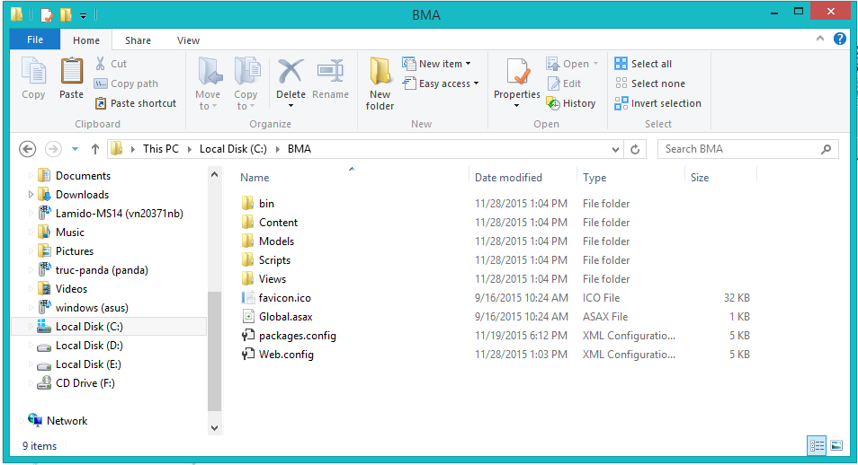例えば：C:\BMA

#### サーパーの構成前に展開

* **データベースの構成：**

<connectionString>

<add name = “DefaultConnection”

connectionString =”Datasource:(local);Initial Catalog=BMA;Persist Security Info = True;user id=sa;password=123456789” providerName = “System.Data.SqlClient” />

<add name = “BMAChangeDB”

connectionString =”Datasource:(local);Initial Catalog=BMA;Persist Security Info = True;user id=sa;password=123456789” providerName = “System.Data.SqlClient” />

</connectionString>

* Catalog : データベース名。
* User id :ユーザ名データベース。
* Password :パスワード

#### サーパ側でWebアプリケーションの展開

* **データベース展開：**
* ＳＱＬ Server 2008 R2 にBMA.mdfをアタックしてください。
* **ソースコードの展開：**
* オーペンIISマネージャ
* 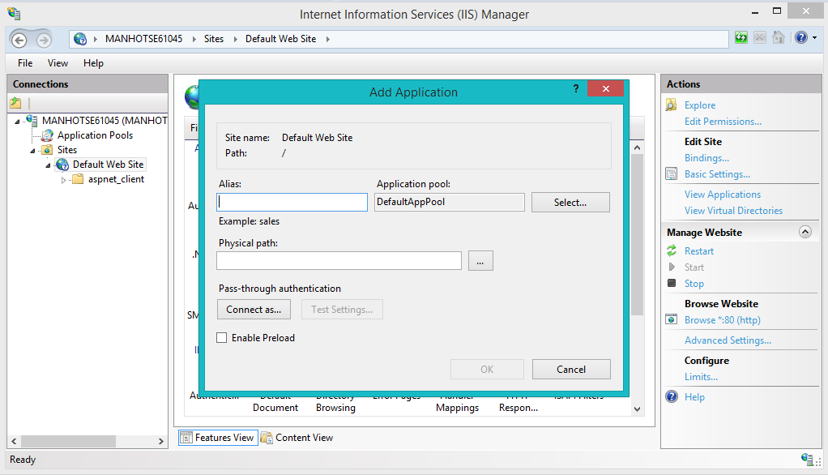“Default Web Site”にマウスを右クリックします。“Add Application”を選びます。
  + Alias : Aliasを入力してください。例えば：ＢMA
  + Application pool : ASP.NET v4.0 を選んでください
  + Physical path:サーパーのソースコードファイルを選んでください（C:\BMA）
* 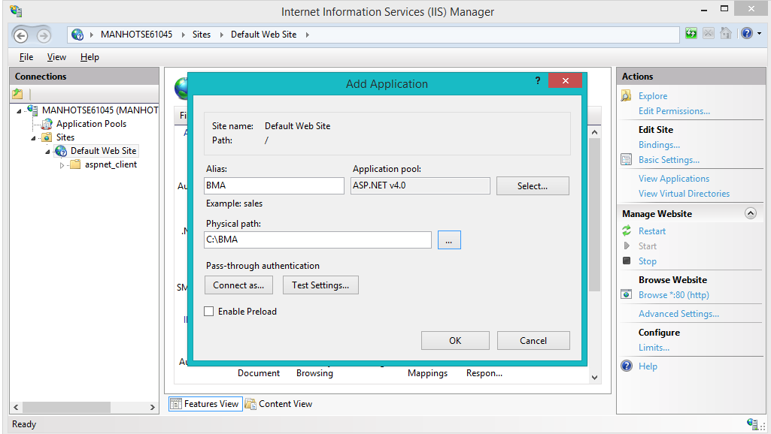“OK”ボタンをクリックしてください。
* 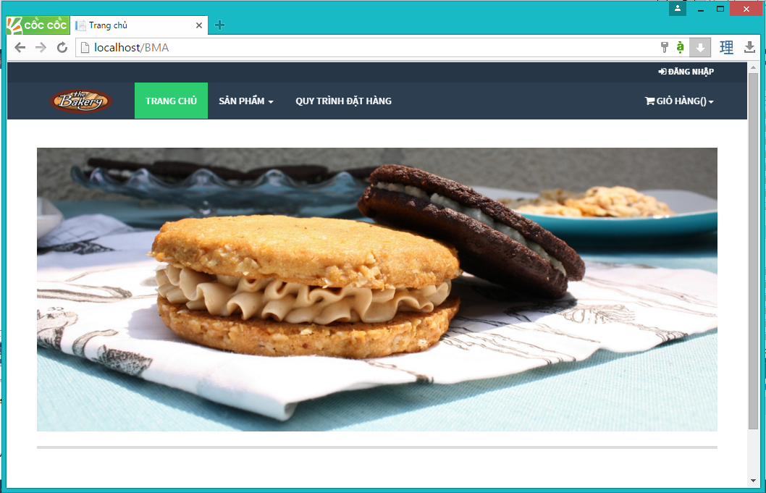オーペン：<http://localhost/BMA>

### クライアント側の環境の設定

#### コンピュータのための設定

* クライアントデバイスは、ウェブサイトを起動するには、以下のブラウザのいずれかを持っている必要があります：
  + Google Chrome(ダウンロードリンク):
    - <http://www.google.com/Chrome>
  + Coc Coc（コックコック）：
    - <http://www.coccoc.com/>

## ユーザーガイド

### ログイン



図面140: ログインポップアップ

|  |  |
| --- | --- |
| ステップ | 説明 |
| **1** | 口座を入力して |
| **2** | パスワードを入力して |
| **3** | 「Đăng nhập」ボタンをリックして |
| **4** | パスワードを忘れたら、「Quên mật khẩu」ボタンをリックして |

テーブル66: ログインポップアップ

### 製品を注文すること



図面 141:製品を注文すること

|  |  |
| --- | --- |
| ステップ | 説明 |
| **1** | 製品を探す |
| **2** | 「Mua hàng」 ボタンをクリックして、 製品を注文する |

テーブル 67:　製品を注文する

### カートに製品を追加すること



図面 142: カートに製品を追加すること

|  |  |
| --- | --- |
| ステップ | 説明 |
| **1** | この製品の数量 |
| **2** | 「Thêm vào giỏ hàng 」 ボタンをくりっくして、カートに製品を追加する |

テーブル 68: カートに製品を追加する

### かーとをチェックすること



図面 143: かーとをチェックすること

|  |  |
| --- | --- |
| Step | 説明 |
| **1** | 「Giỏ hàng 」 ボタン をクリックして、製品のリストが見える |
| **2** | 「Thanh toán 」 ボタン をクリックして、カートの精細を見える |

テーブル 69: かーとをチェックすること

### カーとの精細



図面 144: カートの精細

|  |  |
| --- | --- |
| ステップ | 説明 |
| **1** | 製品の数量を変われる |
| **2** | 製品のリストを戻って、製品を注文して行く |
| **3** | 「Cập nhật giỏ hàng 」 ボタンをクリックして、 カートを更新する |
| **4** | 配送日をセレクトする |
| **5** | 「Đặt hàng 」ボタン をクリックして、注文を完成する |

テーブル 70: カートの精細

### 送り状を確認すること



図面 145: 送り状を確認すること

|  |  |
| --- | --- |
| ステップ | 説明 |
| **1** | カートの精細を戻れば、「Quay lại giỏ hàng 」 ボタン をクリックする |
| **2** | 送り状の確認のボタン |

テーブル 71: 送り状を確認すること

### 送り状に顧客の情報を充実すること



図面 146: 送り状に顧客の情報を充実すること

|  |  |
| --- | --- |
| ステップ | 説明 |
| **1** | これに成員をログインする |
| **2** | 成員なければ、情報を充実するところ |
| **3** | 「Quay lại giỏ hàng 」 ボタン をクリックして、送り状の確認ページを戻る |
| **4** | 口座とパスワードを入力して,「Đăng nhập 」ボタンをクリックして、送り状を完成する |
| **5** | 顧客の情報を入力して,「Hoàn tất 」 ボタンをクリックして、送り状を完成する |

テーブル 72: 送り状に顧客の情報を充実すること

### 送り状のリストを見ること



図面 147: 送り状のリストを見ること

|  |  |
| --- | --- |
| ステップ | 説明 |
| **1** | 不足の原料のリスト |
| **2** | 新し送り状を造る |
| **3** | 送り状の精細 |
| **4** | 送り状を変わる |
| **5** | 送り状を取り消す |
| **6** | 探す |

テーブル 73: 送り状のリストを見ること

### 「人員」送り状を造ること



図面 148: 「人員」送り状を造ること

|  |  |
| --- | --- |
| ステップ | 説明 |
| **1** | 製品 の単価 |
| **2** | 製品の数量 |
| **3** | 送り状に製品をテーキオフする |
| **4** | 送り状をキャンセルこと |
| **5** | 送り状を続く |
| **6** | 送り状に製品を追加する |

テーブル 74: 「人員」送り状を造ること

### 送り状に顧客を追加すること



図面 149: 送り状に顧客を追加すること

|  |  |
| --- | --- |
| ステップ | 説明 |
| **1** | 顧客をセレクトする |
| **2** | 顧客なければ、口座を造る |
| **3** | お客さんの名前 |
| **4** | お客さんの口座 |
| **5** | お客さんのメール |
| **6** | お客さんの住所 |
| **7** | お客さんの電話番号 |
| **8** | お客さんの税額 |
| **9** | 入力をすべてリセット |
| **10** | 口座を造って、この口座にその送り状を追加する |
| **11** | 送り状を造るのページを戻る |
| **12** | 送り状をキャンセルする |

テーブル 75: 送り状に顧客を追加すること

### 新い顧客の口座で送り状をチェックアウト



図面 150: 新顧客の口座で送り状をチェックアウト

|  |  |
| --- | --- |
| ステップ | 説明 |
| **1** | 新顧客の情報 |
| **2** | 送り状の情報 |
| **3** | この送り状に原料数量 を過ごす |
| **4** | 送り状にお客さんを追加する ページを戻る |
| **5** | 送り状を造るのページを戻る |
| **6** | この送り状を確認する |
| **7** | この送り状をキャンセルする |

テーブル 76: 新顧客の口座で送り状をチェックアウト

### 入力法案 リスク



図面 151: 入力法案 リスク

|  |  |
| --- | --- |
| ステップ | 説明 |
| **1** | 新入力法案を造る |
| **2** | 探す |
| **3** | 入力法案 リスク |
| **4** | 入力法案 の精細を見る |
| **5** | 入力法案 の情報を変わる |

テーブル 77:入力法案 リスク

### 新入力法案を造ること



図面 152: 新入力法案を造ること

|  |  |
| --- | --- |
| ステップ | 説明 |
| **1** | サプライヤー をセレクトする |
| **2** | この入力法案料(VATがない) |
| **3** | VAT の料金 |
| **4** | 輸入日 |
| **5** | 入力法案の写真 |
| **6** | 入力法案 陸とを戻る |
| **7** | 新入力法案を造る |

テーブル 78: 新入力法案を造ること

### 入力原料 リスクを見る



図面 153: 入力原料 リスク

|  |  |
| --- | --- |
| ステップ | 説明 |
| **1** | 新入力原料を造ること |
| **2** | 探す |
| **3** | 入力原料 リスク |
| **4** | 入力原料 精細 |
| **5** | 入力原料 の情報を変わる |
| **6** | 入力原料をデリーとする |

テーブル 79: 入力原料リスク

### 入力原料 の精細を見ること



図面 154:入力原料 の精細を見ること

|  |  |
| --- | --- |
| ステップ | 説明 |
| **1** | 入力原料の情報 |
| **2** | 入力原料をデリートする |
| **3** | 同じ入力法案の入力原料リスク |
| **4** | 入力原料の脚注 |
| **5** | 入力原料デリーとの情報 |
| **6** | 入力原料 リスクを戻る |
| **7** | 入力原料 の情報を更新する |

テーブル 80:入力原料の精細を見ること

### 新入力原料を造ること



図面 155: 新入力原料を造ること

|  |  |
| --- | --- |
| ステップ | 説明 |
| **1** | 入力原料名 |
| **2** | 入力原料の数量 |
| **3** | 入力原料の総価格 |
| **4** | 入力原料の輸入日 |
| **5** | 入力原料の有効期限 |
| **6** | 入力原料の脚注 |
| **7** | 入力原料の 入力法案 のコード |
| **8** | 入力原料 リスクを戻る |
| **9** | 入力原料を造る |

テーブル 81:入力原料を造ること

# Appendix

1. How to get real time notification – Microsoft:

<http://www.asp.net/signalr/overview/getting-started>

1. Sashimi – Modified Waterfall Model:

<http://www.waterfall-model.com/sashimi-waterfall-model>

1. UML for drawing diagram (2.0 standard)

<http://www.omg.org/spec/UML/2.0>

1. Circular No. 119/2014/TT-BTC dated August 25, 2014, amendments to Circular No. 156/2013/TT-BTC, Circular No. 111/2013/TT-BTC, Circular No. 219/2013/TT-BTC, Circular No. 08/2013/TT-BTC, Circular No. 85/2011/TT-BTC, Circular No. 39/2014/TT-BTC and Circular No. 78/2014/TT-BTC in order to simplify tax formalities

<http://thuvienphapluat.vn/van-ban/Thue-Phi-Le-Phi/Circular-No-119-2014-TT-BTC-amendments-to-Circular-in-order-to-simplify-tax-formalities-247891.aspx?tab=1>

1. Circular No. 151/2014/TT-BTC dated October 10, 2014, on providing guidance on Decree No. 91/2014/ND-CP on amendments to Decrees on taxation

<http://thuvienphapluat.vn/van-ban/Doanh-nghiep/Circular-No-151-2014-TT-BTC-on-providing-guidance-No-91-2014-ND-CP-amendments-to-Decrees-on-taxation-258054.aspx?tab=1>